1. Ping Scan:
Command: nmap -sn scanme.nmap.org
This checks if host is alive.

2. TCP SYN Scan:
Command: nmap -sS scanme.nmap.org
This scans top ports quickly.

3. Service Version:
Command: nmap -sV -p 80 scanme.nmap.org
This finds service running on port 80.

4. OS Detection:
Command: nmap -O scanme.nmap.org
This detects operating system.

5. NSE Scripts:
Command: nmap -sC scanme.nmap.org
This runs default scripts.

1.Ping Scan
Command: nmap -sn scanme.nmap.org

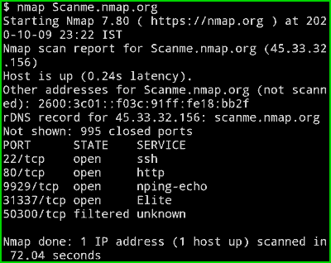

2.TCP SYN Scan
Command: nmap -sS scanme.nmap.org

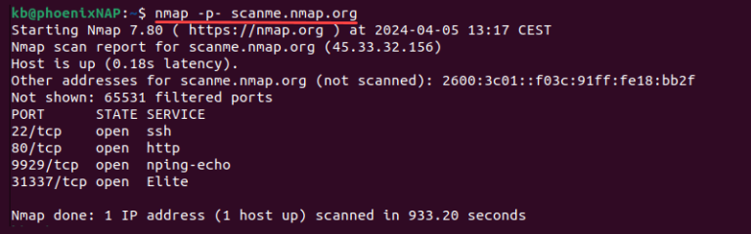

3.Service Version
Command: nmap -sV -p 80 scanme.nmap.org

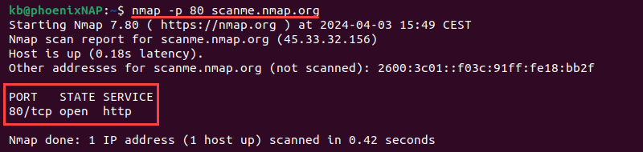

4. OS Detection
Command: nmap -O scanme.nmap.org



5.NSE Scripts
Command: nmap -sC scanme.nmap.org
