A
Project Report
On
“Pothole and Plain Road Classification Using Deep Learning”

(CE452 – Minor Project)



Prepared by
23CE107
23CE115

Under the Supervision of
Prof. Parmanand Patel (23CE107)
Prof. Bijal Suthar (23CE115)

Submitted to
Charotar University of Science & Technology (CHARUSAT)
for the Partial Fulfillment of the Requirements for the
Degree of Bachelor of Technology (B.Tech.)
in U & P U. Patel Department of Computer Engineering (CE)
for B.Tech Semester 7

Submitted at

Accredited with Grade A by NAAC



U & P U. PATEL DEPARTMENT OF COMPUTER ENGINEERING
Chandubhai S. Patel Institute of Technology (CSPIT)
Faculty of Technology & Engineering (FTE), CHARUSAT
At: Changa, Dist: Anand, Pin: 388421.
November, 2026
CERTIFICATE
This is to certify that the report entitled “Pothole and Plain Road Classification Using Deep Learning” is a bonafied work carried out by Priya Pedhadiya (23CE115) under the guidance and supervision of Prof. Bijal Suthar for the subject Minor Project (CE452) of 7th Semester of Bachelor of Technology in Computer Engineering at Faculty of Technology & Engineering (C.S.P.I.T.) – CHARUSAT, Gujarat.

To the best of my knowledge and belief, this work embodies the work of the candidate, has duly been completed, and fulfils the requirement of the ordinance relating to the B.Tech. Degree of the University and is up to the standard in respect of content, presentation and language for being referred to the examiner.

Under the supervision of,

Prof. Bijal Suthar
Project Guide
U. & P. U Patel Dept. of Computer Engg.
C.S.P.I.T., CHARUSAT-Changa.

Head of the Department
U. & P. U Patel Dept. of Computer Engg.
C.S.P.I.T., CHARUSAT-Changa.

Chandubhai S Patel Institute of Technology (C.S.P.I.T.)
Faculty of Technology & Engineering, CHARUSAT
At: Changa, Ta. Petlad, Dist. Anand, PIN: 388 421. Gujarat
CERTIFICATE
This is to certify that the report entitled “Pothole and Plain Road Classification Using Deep Learning” is a bonafied work carried out by Shruti Patel (23CE107) under the guidance and supervision of Prof. Parmanand Patel for the subject Minor Project (CE452) of 7th Semester of Bachelor of Technology in Computer Engineering at Faculty of Technology & Engineering (C.S.P.I.T.) – CHARUSAT, Gujarat.

To the best of my knowledge and belief, this work embodies the work of the candidate, has duly been completed, and fulfils the requirement of the ordinance relating to the B.Tech. Degree of the University and is up to the standard in respect of content, presentation and language for being referred to the examiner.

Under the supervision of,

Prof. Parmanand Patel
Project Guide
U. & P. U Patel Dept. of Computer Engg.
C.S.P.I.T., CHARUSAT-Changa.

Head of the Department
U. & P. U Patel Dept. of Computer Engg.
C.S.P.I.T., CHARUSAT-Changa.

Chandubhai S Patel Institute of Technology (C.S.P.I.T.)
Faculty of Technology & Engineering, CHARUSAT
At: Changa, Ta. Petlad, Dist. Anand, PIN: 388 421. Gujarat
DECLARATION BY THE CANDIDATES

We hereby declare that the project report entitled “Pothole and Plain Road Classification Using Deep Learning” submitted by us to Chandubhai S. Patel Institute of Technology, Changa in partial fulfilment of the requirements for the award of the degree of B.Tech Computer Engineering, from U & P U. Patel Department of Computer Engineering, CSPIT, FTE, is a record of bonafide CE452 Minor Project (project work) carried out by us under the guidance of Prof. Bijal Suthar (for 23CE115) and Prof. Parmanand Patel (for 23CE107) respectively. We further declare that the work carried out and documented in this project report has not been submitted anywhere else either in part or in full and it is the original work, for the award of any other degree or diploma in this institute or any other institute or university.

Signature of the candidates
Priya Pedhadiya – 23CE115
Shruti Patel – 23CE107

This is to certify that the above statement made by the candidates is correct to the best of my knowledge.

Prof. Bijal Suthar (Project Guide, 23CE115)
Prof. Parmanand Patel (Project Guide, 23CE107)
U & P U. Patel Department of Computer Engineering,
Chandubhai S Patel Institute of Technology (CSPIT)
Faculty of Technology (FTE)
Charotar University of Science and Technology (CHARUSAT) - Changa.
TABLE OF CONTENT

Abstract I
Acknowledgement II
Chapter 1: Introduction 1
1. Project Overview 1
2. Problem Statement 2
3. Objectives 2
4. Scope of the Project 2
5. Motivation 3
Chapter 2: Dataset Description 4
1. Dataset Source 4
2. Dataset Structure and Details 4
3. Data Preprocessing 5
4. Data Augmentation Techniques 6
Chapter 3: System Design 8
1. Architecture 8
2. Module Description 8
3. Data Flow / Use Case Diagram 9
4. Web Application Architecture (PotholeAI) 10
Chapter 4: Model Development 12
1. Baseline Transfer-Learning Model (Frozen MobileNetV2) 12
2. Fine-Tuned MobileNetV2 Model 13
3. Architecture Comparison and Hyperparameter Experiments 14
Chapter 5: Implementation 16
1. Tools and Technologies Used 16
2. Code Structure 17
3. Training and Validation Setup 18
4. Gradio Prototype in the Notebook 18
5. Web Application Implementation (PotholeAI) 19
Chapter 6: Testing and Results 24
1. Testing Methodology 24
2. Observations 24
3. ROC, Precision–Recall and Decision-Threshold Analysis 27
4. Explainability Using Grad-CAM 28
5. Robustness Testing 30
6. Discussion on Final Model Selection 31
7. Web Application Testing 31
Chapter 7: Conclusion and Future Scope 34
1. Summary of Work 34
2. Key Learnings 34
3. Limitations 35
4. Future Enhancements 35
References 37
TABLE OF FIGURES

Figure 1.1: End-to-End Project Workflow — From Road Images to Prediction 1
Figure 2.1: Dataset Class Distribution and Stratified Train/Validation/Test Split 4
Figure 2.2: Image Preprocessing Pipeline 6
Figure 3.1: High-Level System Architecture of the Pothole Classification System 8
Figure 3.2: Use Case Diagram 10
Figure 3.3: Client–Server Architecture of the PotholeAI Web Application 11
Figure 4.1: Transfer-Learning Model Architecture (MobileNetV2 Backbone and Classification Head) 12
Figure 4.2: Fine-Tuning Strategy for the MobileNetV2 Backbone 13
Figure 5.1: PotholeAI Landing Page 20
Figure 5.2: Detection Page Before an Image Is Uploaded 21
Figure 5.3: Model Dashboard Page 22
Figure 5.4: Model Information Page 23
Figure 6.1: Training Curves — Frozen MobileNetV2 Baseline 25
Figure 6.2: Training Curves — Fine-Tuned MobileNetV2 25
Figure 6.3: Architecture Comparison — Test-Set Performance 26
Figure 6.4: Confusion Matrix — Fine-Tuned MobileNetV2 (Test Set) 27
Figure 6.5: ROC Curve and Precision–Recall Curve — Fine-Tuned MobileNetV2 28
Figure 6.6: Grad-CAM Visualisations of the Fine-Tuned MobileNetV2 29
Figure 6.7: Robustness Under Simulated Real-World Conditions 30
Figure 6.8: Web Application Result for a Pothole Photograph 32
Figure 6.9: Web Application Result for a Plain-Road Photograph (Incorrect Prediction) 33

TABLE OF TABLES

Table 2.1: Number of Images in Each Subset After the 70/15/15 Split 5
Table 3.1: HTTP Endpoints of the PotholeAI Backend 11
Table 4.1: Training Configuration of the Frozen and Fine-Tuned MobileNetV2 Models 14
Table 4.2: Hyperparameter Experiments on Frozen MobileNetV2 (Validation Set) 15
Table 5.1: Tools and Technologies Used 16
Table 6.1: Test-Set Performance of the Compared Models 25
Table 6.2: Classification Report of the Fine-Tuned MobileNetV2 (Test Set) 27
Table 6.3: Decision-Threshold Sweep of the Fine-Tuned MobileNetV2 (Test Set) 28
Table 6.4: Robustness of the Fine-Tuned MobileNetV2 Under Simulated Degradation 30
Table 6.5: Functional Tests of the PotholeAI Application 31

ABSTRACT

This project presents the design, implementation and evaluation of a deep-learning system that classifies road photographs into two categories: roads containing a pothole and plain (intact) roads. Potholes are a direct safety hazard and a source of vehicle damage and traffic disruption, while manual road surveys are slow and inconsistent over large networks. The project therefore investigates whether an image classifier built through transfer learning can provide a quick and consistent first-pass triage of road images.
The work is implemented in a single Kaggle notebook using TensorFlow and Keras. A public Kaggle dataset of 365 pothole and 375 plain-road images is merged and re-divided into stratified training, validation and test subsets in the ratio 70:15:15. All images are resized to 224 × 224 pixels, rescaled by 1/255, and the training images are augmented with rotation, shift, zoom and horizontal-flip transformations. A MobileNetV2 backbone pretrained on ImageNet is combined with a compact classification head, trained first with a frozen backbone and then fine-tuned by unfreezing the top 36 backbone layers at a learning rate of 1e-5.
Under identical conditions, ResNet50 and EfficientNetB0 are trained for comparison, a small hyperparameter sweep is carried out, and the models are evaluated with accuracy, precision, recall, F1-score, ROC-AUC, the confusion matrix and a threshold sweep. On the 113-image test set, the frozen MobileNetV2 baseline reached an accuracy of 94.69% (F1 = 0.9474) and the fine-tuned MobileNetV2 reached 93.81% (F1 = 0.9391, ROC-AUC = 0.9875, pothole recall = 96.43%), whereas ResNet50 and EfficientNetB0 performed substantially worse in the same frozen set-up. Grad-CAM and a robustness study show that heavy blur sharply reduces pothole recall.
The model is made usable through a Gradio prototype and a stand-alone web application named PotholeAI, which combines a Flask prediction API with a four-page browser interface. In a local test, a pothole photograph was classified correctly with 100.00% confidence, whereas a motion-blurred close-up of plain asphalt was wrongly classified as a pothole with 99.94% confidence. The system classifies whole images only; localisation, severity grading and geotagging are left as future work.

ACKNOWLEDGEMENT

We wish to express our sincere gratitude to all those who contributed to the successful completion of this project. We are deeply thankful to our institution and faculty members for their constant guidance, encouragement and invaluable suggestions throughout the development of this project on pothole and plain road classification.
We extend our appreciation to the researchers and developers in the fields of Deep Learning, Computer Vision and Transfer Learning, whose published work and open-source contributions inspired and supported our implementation.
We are also grateful to the creators and maintainers of the dataset, frameworks and tools that we utilised, particularly the Kaggle community for the publicly available “Pothole and Plain Road Images” dataset, and the developers of TensorFlow, Keras, scikit-learn, Matplotlib, Seaborn, Gradio and Flask.
Finally, we thank our peers and team members for their cooperation, constructive feedback and unwavering support throughout the project lifecycle.

Chapter 1: Introduction

1. Project Overview
This project addresses the automatic recognition of potholes in road photographs using deep learning. A pothole is a bowl-shaped depression in the road surface that develops when water penetrates the pavement and traffic loads break the weakened material. Undetected potholes can contribute to accidents, vehicle damage and traffic disruption, and the cost of identifying them through manual field surveys grows quickly with the size of the road network.
The project develops an image classifier that separates road photographs containing a pothole from photographs of plain (intact) roads. Instead of training a convolutional neural network from scratch on a small dataset, the work applies transfer learning: convolutional backbones pretrained on the ImageNet dataset [4] are reused as feature extractors, and a small task-specific classification head is trained on top of them. The complete workflow, from data preparation to a deployable web interface, is implemented in one reproducible notebook and is summarised in Figure 1.1.
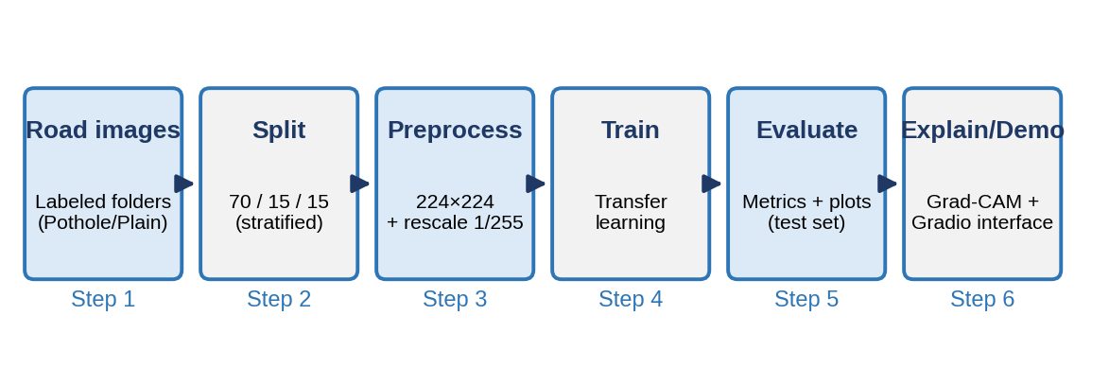
Figure 1.1: End-to-End Project Workflow — From Road Images to Prediction
The project covers data inspection and splitting, preprocessing and augmentation, training of a MobileNetV2 baseline, fine-tuning of the backbone, comparison with ResNet50 and EfficientNetB0, a small hyperparameter study, evaluation with several metrics, Grad-CAM based explainability, robustness testing under simulated image degradation, and two ways of using the trained model: a Gradio prototype in the notebook and a stand-alone Flask web application (PotholeAI) with a browser-based user interface.

2. Problem Statement
Road authorities and maintenance teams must examine large volumes of road photographs to decide where repairs are needed. Physical surveys take considerable time and can be inconsistent between inspectors, and there is a need for a quick, consistent first-pass classification of image collections so that human effort can be directed towards the roads that most need attention.
The central question of this project is therefore: can a transfer-learning image classifier reliably distinguish road photographs containing a pothole from plain-road photographs? The problem is formulated as a binary image classification task with two classes, Plain (label 0) and Pothole (label 1). Because the available dataset is small, the project must also address overfitting, ensure that model comparisons are made under identical conditions, and verify that the model bases its decisions on the road surface rather than on incidental image properties.

3. Objectives
The specific goals of this project are:
- To inspect the labelled road images and create reproducible, stratified training, validation and test splits.
- To build a pretrained CNN classifier using transfer learning and to compare different backbones (MobileNetV2, ResNet50 and EfficientNetB0) under identical training conditions.
- To adapt the higher-level features of the MobileNetV2 backbone to road-surface imagery through carefully controlled fine-tuning.
- To evaluate the models fairly using accuracy, precision, recall, F1-score, ROC-AUC, the confusion matrix and a decision-threshold analysis.
- To explain the predictions using Grad-CAM and to stress-test the model by simulating blur, lighting, contrast and noise changes.
- To demonstrate practical use by exposing single-image prediction through a Gradio prototype and a Flask-based web application (PotholeAI) with a browser user interface, and to test the deployed application on sample images.

4. Scope of the Project
The project is limited to image-level binary classification of road photographs into Pothole and Plain classes. The system outputs only a class label and a confidence value for an entire image; it does not produce bounding boxes, the exact position of a pothole, a severity grade, or GPS geotags. A web application (PotholeAI) is included as the user interface of the trained model, but it is a single-user demonstration application and not a production road-management platform. Input images are resized to 224 × 224 pixels, and the experiments use a single publicly available Kaggle dataset of 740 listed images.
The system is intended as a supplementary triage aid. Its predictions do not replace professional road inspection, and the results reported in this document are valid for the dataset and test conditions described in the following chapters. Testing on self-captured dashcam imagery is not included in the present work.

5. Motivation
The motivation for this project is both practical and technical. Practically, potholes affect road safety and vehicle maintenance costs, and an automated first-pass filter for road imagery could reduce the effort spent on manual inspection. A missed pothole is more costly than a false alarm, because a maintenance crew that re-checks a good road loses some time, whereas an unrepaired pothole can cause an accident. This asymmetry motivates the report’s emphasis on recall and on decision-threshold analysis.
Technically, pretrained convolutional networks make it possible to obtain strong image classifiers from only a few hundred training images, provided the transfer-learning setup is handled carefully. The project also offers an opportunity to study questions that are often skipped in small projects: whether fine-tuning really helps, whether a heavier backbone is automatically better, whether the model has learned the pothole rather than a shortcut, and how performance degrades under realistic image corruption.

Chapter 2: Dataset Description

1. Dataset Source
The experiments use the publicly available Kaggle dataset “Pothole and Plain Road Images” published by the user Virenbr11 [12]. The notebook reads the data from the path /kaggle/input/datasets/virenbr11/pothole-and-plain-rode-images/My Dataset, where the images are organised into train and test folders, each of which contains a Pothole and a Plain sub-folder. The images are ordinary road photographs in JPEG format of varying size, resolution and viewing conditions.
The original train and test folders of the dataset are not used as they are. Their contents are first merged class-wise and then re-divided with a fixed random seed (42), so that the validation and test sets are produced by the same procedure as the training set and the entire split can be reproduced exactly.

2. Dataset Structure and Details
Listing the original folders yields 365 Pothole images and 375 Plain-road images, i.e. 740 images in total, so the two classes are almost perfectly balanced and no class-weighting or resampling is required. Figure 2.1 shows the class distribution and the resulting split.
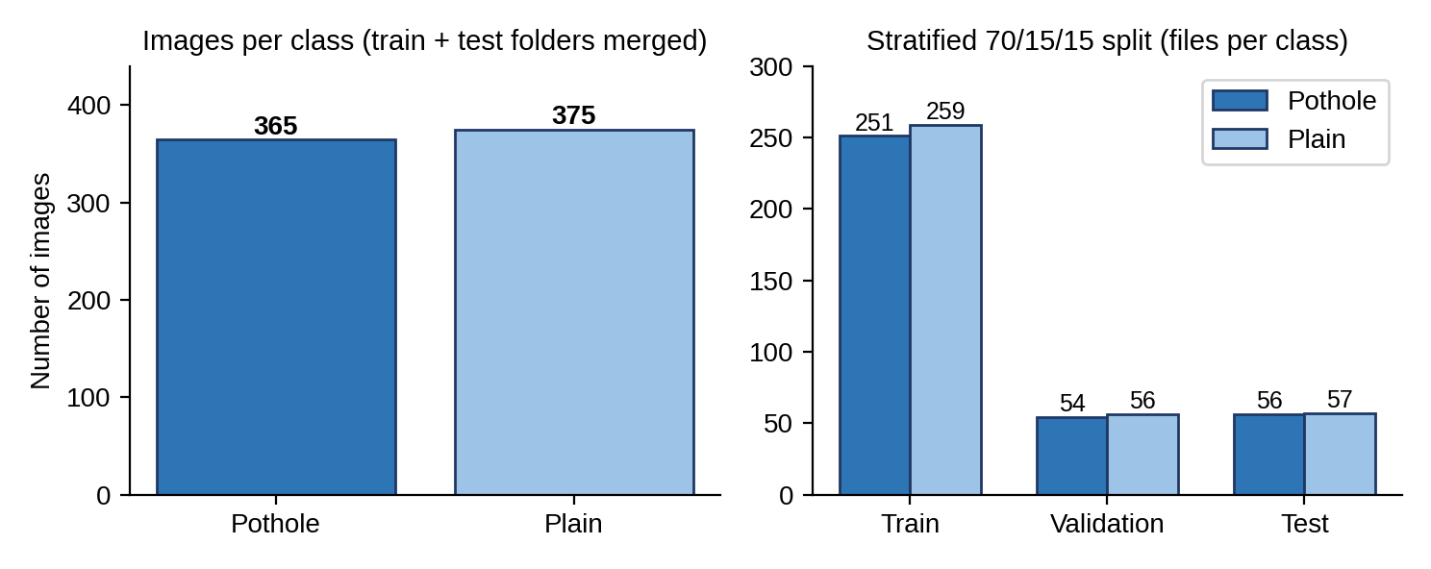
Figure 2.1: Dataset Class Distribution and Stratified Train/Validation/Test Split
The merged images of each class are divided separately into 70% training, 15% validation and 15% test images using scikit-learn’s train_test_split function, which keeps the class proportions the same in every subset. The numbers of files obtained in each subset are given in Table 2.1.
Table 2.1: Number of Images in Each Subset After the 70/15/15 Split
Subset | Pothole | Plain | Total
Training | 251 | 259 | 510
Validation | 54 | 56 | 110
Test | 56 | 57 | 113

The Keras data generators locate 510 training, 109 validation and 113 test images and assign the class indices Plain = 0 and Pothole = 1. Two small discrepancies are visible in the notebook outputs. First, the subset folders contain 733 files, which is seven fewer than the 740 files listed in the source folders. A probable cause, which has not been verified in the notebook, is that files with identical names in the original train and test folders (for example, 1.jpg) overwrite each other when they are copied into a single destination folder. Second, the generator reports 109 validation images whereas 110 files are present in the validation folders, which suggests that one file could not be read as an image. Both effects are small, but they are recorded here for transparency and are listed among the limitations.

3. Data Preprocessing
The preprocessing pipeline applied to every image is deliberately simple, and it is identical for the validation and test subsets so that evaluation is deterministic. The steps are:
- Merging and splitting: the train and test folders of each class are merged and divided into training, validation and test folders using a stratified 70/15/15 split with a fixed random seed.
- Resizing: every image is resized to 224 × 224 pixels with three colour channels, which is the input size expected by the pretrained backbones.
- Rescaling: pixel values are scaled from the range 0–255 to the range 0–1 by multiplying with 1/255.
- Label encoding: class labels are derived from the folder names in alphabetical order, giving Plain = 0 and Pothole = 1, and are supplied as binary labels (class_mode = “binary”).
- Batching: images are read in batches of 32 by the ImageDataGenerator flow_from_directory interface; the validation and test generators do not shuffle the images, so that predictions can be matched with the true labels.
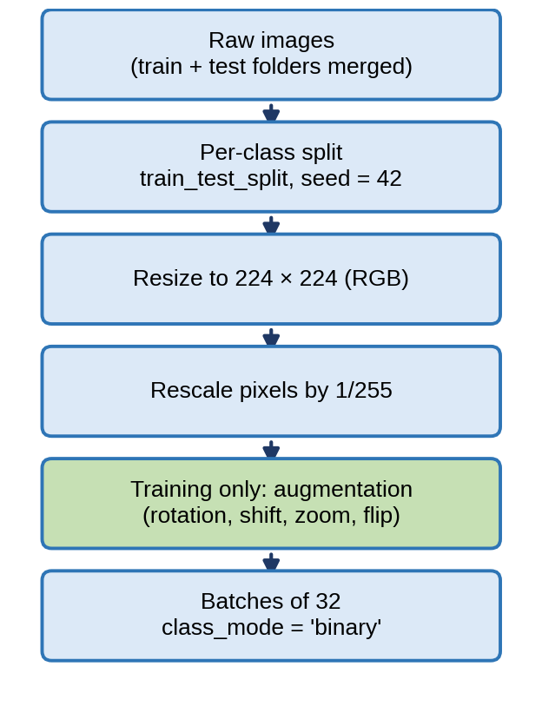
Figure 2.2: Image Preprocessing Pipeline
During training the Pillow library issued a warning that some images are palette-based images with transparency. The Keras loader converts such images to RGB, so this did not interrupt the experiments, but it indicates that the dataset contains images of heterogeneous format.

4. Data Augmentation Techniques
Because the training subset contains only 510 images, augmentation is used to expose the network to plausible variations of road scenes and to reduce overfitting. Augmentation is applied only to the training generator and is performed on the fly, so that each epoch sees slightly different versions of the images. The transformations used are listed below.
- Rotation: random rotations of up to 15 degrees.
- Width and height shifts: random horizontal and vertical translations of up to 10% of the image size.
- Zoom: random zooming of up to 10%.
- Horizontal flip: random mirroring of the image about the vertical axis.
- Fill mode: pixels exposed by a transformation are filled with the nearest pixel value (fill_mode = “nearest”).
The validation and test generators apply only the 1/255 rescaling and no random transformation, so that all models are evaluated on exactly the same unmodified images.

Chapter 3: System Design

1. Architecture
The system is organised into five layers, shown in Figure 3.1. The Data Layer holds the merged and split image folders. The Preprocessing Layer converts images into normalised, optionally augmented tensors. The Model Layer contains an ImageNet-pretrained convolutional backbone with a small classification head. The Evaluation and Explainability Layer computes quantitative metrics and visual diagnostics, and the Application Layer exposes the selected model through a Gradio prototype in the notebook and through the PotholeAI Flask web application.
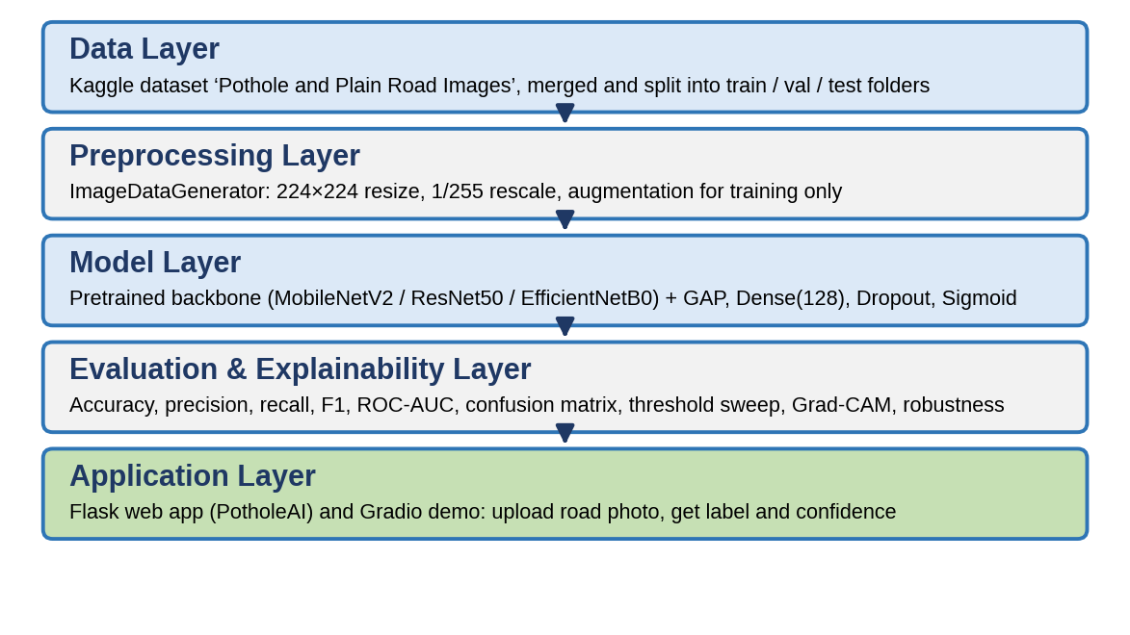
Figure 3.1: High-Level System Architecture of the Pothole Classification System
A central design decision is that every architecture is created through one parameterised model-builder function. All backbones receive an identical classification head, identical augmentation and an identical data split. Any difference in accuracy between the models can therefore be attributed to the backbone and the training strategy rather than to an inconsistent experimental set-up, which is what makes the comparison in Chapter 6 valid.

2. Module Description
The system is decomposed into the following software modules, each of which corresponds to a section or function of the project notebook:
- Data Preparation Module: lists the images of the source folders, performs the stratified 70/15/15 split and copies the files into the working directory.
- Data Generator Module: defines the training generator with augmentation and the validation/test generators with rescaling only.
- Model Builder Module (build_model): creates a MobileNetV2, ResNet50 or EfficientNetB0 backbone with the common head, and optionally unfreezes the upper layers of the backbone for fine-tuning while keeping Batch Normalization layers frozen.
- Evaluation Module (evaluate_model, plot_history): computes accuracy, precision, recall, F1-score and ROC-AUC on any generator and plots the training curves.
- Analysis Module: performs the hyperparameter sweep, the ROC and precision–recall analysis and the decision-threshold sweep.
- Explainability Module (make_gradcam_heatmap, show_gradcam): produces Grad-CAM heatmaps over the last convolutional feature map.
- Robustness Module (degrade, evaluate_degraded): applies blur, brightness, contrast and noise corruptions to the test images and measures the resulting accuracy and pothole recall.
- Gradio Prototype Module (classify_road): the notebook function that accepts an uploaded image, preprocesses it, predicts the class probability and formats the label, confidence and inspection note.
- Web Backend Module (app.py): a Flask application that loads the saved Keras model at start-up, validates uploaded files, preprocesses them and returns the prediction as JSON.
- Web Frontend Module (frontend/index.html, style.css, main.js): the single-page user interface for uploading images, displaying results and presenting the dashboard and model information.

3. Data Flow / Use Case Diagram
The use case diagram in Figure 3.2 illustrates the interaction between the user, for example a road inspector, and the system. The user uploads a road photograph; the system resizes and rescales the image, the trained CNN predicts the probability that the image contains a pothole, and the interface displays the predicted label together with the confidence and a short note. If the predicted label is Pothole, the note advises that the road segment be flagged for inspection; otherwise the note states that the road appears intact according to the model. In the PotholeAI web application the same flow is carried out through an HTTP request: the browser sends the image to the server, and the server returns the label, the confidence and the class probabilities, which the page displays as a result badge, a confidence bar and two probability cards.
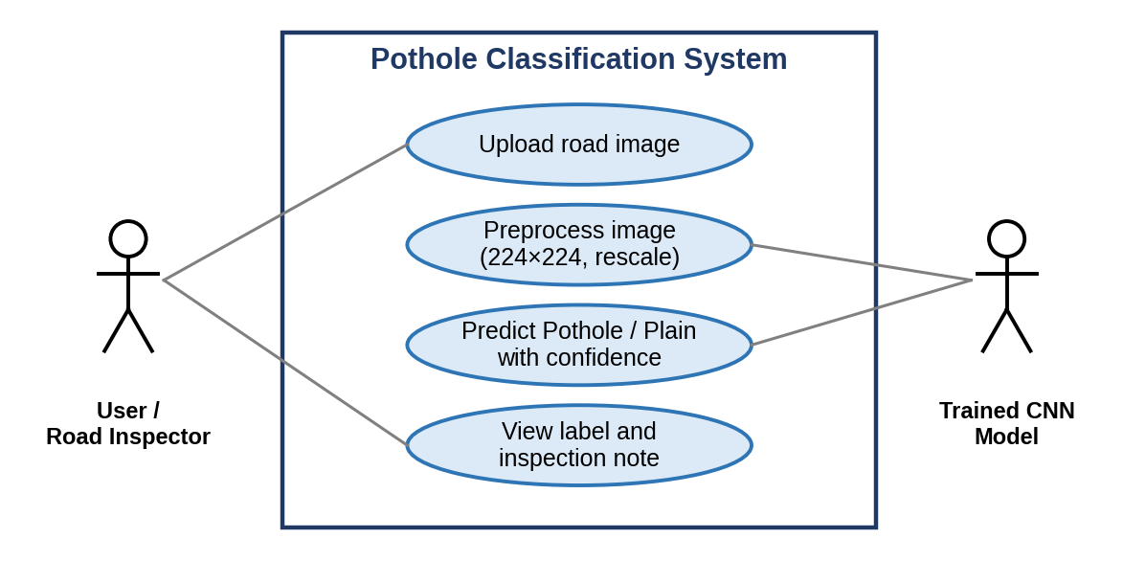
Figure 3.2: Use Case Diagram

4. Web Application Architecture (PotholeAI)
The PotholeAI web application follows a simple client–server design, shown in Figure 3.3. The browser loads a single-page frontend consisting of index.html, style.css and main.js, which are served as static files by the Flask backend. When the user presses the Analyse button, main.js sends the selected image to the backend as a multipart form request. The backend validates the file type, converts the image to the input format of the network, runs the Keras model and returns a JSON object containing the predicted class, the confidence and the probability of each class.
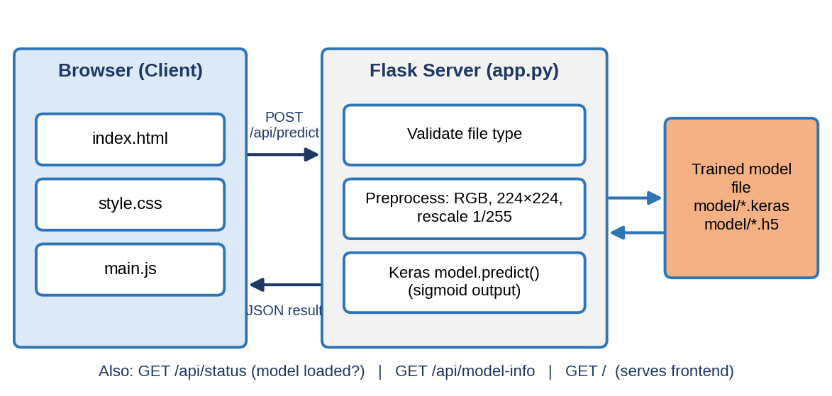
Figure 3.3: Client–Server Architecture of the PotholeAI Web Application
The backend exposes four routes, which are listed in Table 3.1. The status route allows the page to show, on loading, whether a trained model file was found, so that the user is told clearly when predictions are not available instead of receiving silent failures.
Table 3.1: HTTP Endpoints of the PotholeAI Backend
Endpoint | Method | Description
/ | GET | Serves the single-page frontend
/api/status | GET | Reports whether the model is loaded, the class names and the input size
/api/predict | POST | Accepts an image file and returns the prediction as JSON
/api/model-info | GET | Returns static model and dataset metadata shown in the interface

Chapter 4: Model Development

1. Baseline Transfer-Learning Model (Frozen MobileNetV2)

4.1.1 Architecture
The baseline model uses MobileNetV2 [1] with ImageNet weights as its backbone. MobileNetV2 is a lightweight convolutional network built from inverted residual blocks with linear bottlenecks, which makes it well suited to deployment on resource-limited devices. The backbone is loaded without its original classification layers (include_top = False) and with the input shape 224 × 224 × 3.
The output feature map of the backbone is reduced by a Global Average Pooling layer and passed through a fully connected Dense layer with 128 ReLU units, a Dropout layer with a rate of 0.3, and a final Dense layer with one unit and sigmoid activation. The single output is interpreted as the probability that the image shows a pothole, and a threshold of 0.5 converts it into a class label. In the baseline the whole backbone is frozen, so that only the 164K parameters of the head are learned. The architecture is shown in Figure 4.1.
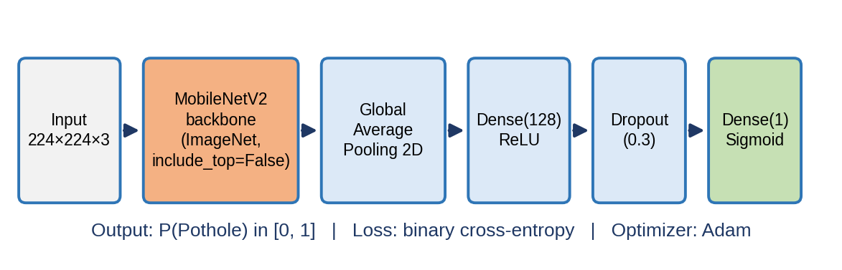
Figure 4.1: Transfer-Learning Model Architecture (MobileNetV2 Backbone and Classification Head)

4.1.2 Training Process
The baseline is compiled with the Adam optimiser [7], a learning rate of 1e-4 and binary cross-entropy loss. It is trained for a maximum of 25 epochs with a batch size of 32. An EarlyStopping callback monitors the validation loss with a patience of 5 epochs and restores the best weights, and a ModelCheckpoint callback saves the model with the best validation accuracy. All 25 epochs were completed, the training time was 347 seconds on a Kaggle GPU, and the training curves are presented in Chapter 6 (Figure 6.1).

2. Fine-Tuned MobileNetV2 Model

4.2.1 Fine-Tuning Strategy
In the baseline only the head learns; the pretrained features are used unchanged. Fine-tuning relaxes this restriction by unfreezing the upper part of the backbone, so that its high-level features can adapt to road surfaces. Early layers of a CNN learn generic features such as edges and textures that transfer well to new tasks, whereas the late layers encode concepts specific to ImageNet [5]. The model is therefore built with unfreeze_from = 100: layers with an index below 100 stay frozen and the remaining layers are trainable. The notebook reports 36 of the 154 backbone layers as trainable, giving 2,003,713 trainable parameters. Figure 4.2 illustrates the strategy.
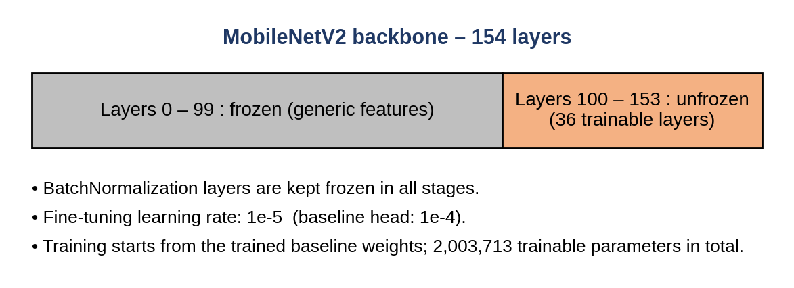
Figure 4.2: Fine-Tuning Strategy for the MobileNetV2 Backbone
Three safeguards are used. First, fine-tuning starts from the weights of the trained baseline, never from a randomly initialised head, because a random head would send large, noisy gradients into the pretrained layers. Second, a ten times smaller learning rate (1e-5) is used so that updates are small. Third, all Batch Normalization layers [8] remain frozen, because with only about 500 training images the batch statistics are noisy and updating the running means would damage the pretrained representation.

4.2.2 Training Process
The fine-tuned model is trained for a maximum of 20 epochs with the same data generators as the baseline, the Adam optimiser at 1e-5 and binary cross-entropy loss. The EarlyStopping callback uses a patience of 6 epochs on the validation loss and restores the best weights. Training stopped early after 13 epochs and took 187 seconds. The model with the best validation accuracy is also written to disk by a ModelCheckpoint callback. The training and evaluation set-ups of the two MobileNetV2 variants are compared in Table 4.1.
Table 4.1: Training Configuration of the Frozen and Fine-Tuned MobileNetV2 Models
Setting | Frozen baseline | Fine-tuned model
Backbone state | Fully frozen | Layers from index 100 trainable (36 of 154)
Learning rate | 1e-4 | 1e-5
Initial weights | ImageNet backbone, random head | Trained baseline weights
Maximum epochs | 25 | 20
Early-stopping patience | 5 (val_loss) | 6 (val_loss)
Epochs completed | 25 | 13
Training time | 347.0 s | 187.0 s

3. Architecture Comparison and Hyperparameter Experiments

4.3.1 Comparison with ResNet50 and EfficientNetB0
To position MobileNetV2 against other common backbones, ResNet50 [2] and EfficientNetB0 [3] are trained with the same builder, the same frozen-backbone set-up, the same head, a learning rate of 1e-4, a maximum of 20 epochs and early stopping with a patience of 5. Both use ImageNet weights, and both receive images rescaled by 1/255. The results of this comparison are presented in Chapter 6.

4.3.2 Hyperparameter Experiments
A small and deliberate sweep over the settings that matter most for a dataset of this size is performed on the frozen MobileNetV2 model: the learning rate, the dropout rate and the width of the dense layer. Four configurations are tested instead of an exhaustive grid, because with about 500 training images a large search would mostly measure noise. Each configuration is trained for at most 12 epochs with early stopping (patience 4), and all configurations are scored on the validation set so that the test set is never touched during tuning. The outcome is given in Table 4.2.
Table 4.2: Hyperparameter Experiments on Frozen MobileNetV2 (Validation Set)
Learning rate | Dropout | Dense units | Best val. accuracy | Best val. loss
1e-3 | 0.3 | 128 | 0.9633 | 0.0811
1e-4 | 0.3 | 256 | 0.9633 | 0.1057
1e-4 | 0.3 | 128 | 0.9541 | 0.1261
1e-4 | 0.5 | 128 | 0.9541 | 0.1435

Two configurations tie on validation accuracy (0.9633), and the configuration with a learning rate of 1e-3, dropout 0.3 and 128 units has the lowest validation loss (0.0811). The differences between the configurations are small, amounting to one validation image. The sweep was run as a stand-alone experiment; the final fine-tuned model continues from the baseline setting (learning rate 1e-4, dropout 0.3, 128 units) and does not adopt the sweep’s best configuration.

Chapter 5: Implementation

1. Tools and Technologies Used
The project is implemented in Python (version 3.13 in the Kaggle environment used) inside a Jupyter-style Kaggle notebook. The deep-learning models are built with TensorFlow 2.20.0 and its Keras API, which also provides the pretrained MobileNetV2, ResNet50 and EfficientNetB0 application models. Metrics are computed with scikit-learn, and the data tables with pandas and NumPy. Images are handled with Pillow, figures are drawn with Matplotlib and Seaborn, and the web interface is created with Gradio. The technologies are summarised in Table 5.1.
Table 5.1: Tools and Technologies Used
Component | Technology | Purpose
Language / environment | Python 3.13, Kaggle Notebook | Implementation and execution
Deep-learning framework | TensorFlow 2.20.0 / Keras | Model building, training, Grad-CAM
Pretrained backbones | MobileNetV2, ResNet50, EfficientNetB0 | ImageNet-pretrained feature extractors
Data handling | NumPy, pandas, Pillow | Arrays, result tables, image degradation
Evaluation | scikit-learn | Splitting, metrics, ROC and PR curves
Visualisation | Matplotlib, Seaborn | Training curves, charts, confusion matrix
Prototype interface | Gradio | Image-upload demo inside the notebook
Web backend | Flask, Flask-CORS, Gunicorn | Prediction API and static file serving
Web frontend | HTML5, CSS3, JavaScript | Single-page user interface
Hosting configuration | Procfile, render.yaml | Gunicorn start command for cloud hosting
Hardware | Two NVIDIA Tesla T4 GPUs (Kaggle) | Accelerated training

2. Code Structure
The notebook is organised as a sequence of numbered stages, each introduced by a short explanation and followed by the corresponding code cells. The main stages are listed below.
- Setup and folder structure: fixes the random seed (42) for Python, NumPy and TensorFlow, creates the dataset, models and results directories, and reports the TensorFlow version and available GPUs.
- Dataset and stratified split: lists the source images, performs the 70/15/15 split and creates the training, validation and test generators.
- Reusable model builder and evaluation helpers: defines build_model, evaluate_model and plot_history, and the RESULTS list in which every experiment records its metrics.
- Stage 1 – Baseline reproduction: trains the frozen MobileNetV2 under the same conditions as the earlier evaluation so that the baseline is measured and not quoted.
- Stage 2 – Fine-tuning: unfreezes the upper backbone layers and continues training at a lower learning rate.
- Stage 3 – Architecture comparison: trains ResNet50 and EfficientNetB0 and tabulates all models.
- Stage 4 – Hyperparameter experiments: evaluates four configurations on the validation set.
- Stage 5 – ROC, precision–recall and threshold analysis of the fine-tuned model.
- Stage 6 – Grad-CAM explainability; Stage 7 – robustness testing under simulated degradation.
- Stage 8 – Final model selection, confusion matrix, classification report and saving of the model together with a JSON metadata file.
- Stage 9 – Gradio web application, followed by a final results summary.
The trained models, the figures and the result tables are written to the models and results sub-directories of the working folder, for example the saved final model final_pothole_classifier.keras, the comparison table model_comparison.csv and the figures of the training curves, confusion matrix, Grad-CAM and robustness analysis. The metadata file stores the architecture description, the input size, the preprocessing rule, the class indices, the decision threshold and the test metrics so that an application can load the model without hard-coded assumptions.

3. Training and Validation Setup
All experiments were run on the Kaggle platform, which provided two NVIDIA Tesla T4 GPUs with about 13.7 GB of memory each. The random seed 42 is used for the data split, the generators and the framework, so that the experiments are repeatable. The common settings of all experiments are an input size of 224 × 224, a batch size of 32, the Adam optimiser, binary cross-entropy loss and the accuracy metric.
The validation set is used for early stopping, checkpoint selection and hyperparameter comparison, and the test set is used only for the reported evaluation. The validation and test generators do not shuffle the images, so the predicted probabilities can be compared directly with the true labels held in the generator. A single function, evaluate_model, computes accuracy, precision, recall, F1-score and ROC-AUC for every model at the default threshold of 0.5, which ensures that all models are scored in exactly the same way.

4. Gradio Prototype in the Notebook
The selected model is made available to non-technical users through a Gradio interface. The function classify_road receives the uploaded image as a NumPy array, converts it to RGB, resizes it to 224 × 224, rescales it by 1/255 and adds a batch dimension. The model returns the pothole probability p; the interface displays the scores for “Pothole” (p) and “Plain Road” (1 − p), and the predicted label is Pothole when p exceeds 0.5. The confidence shown is p for a pothole prediction and 1 − p otherwise. The result panel also displays an inspection note: a warning that the road segment should be flagged for inspection when a pothole is detected, or a message that the road appears intact according to the model.
When the notebook is run with internet access enabled, the interface is launched with the share option and Gradio generated a temporary public link in addition to the local address. The interface was launched successfully in the notebook run reported here. It performs only image-level classification and does not mark the location of a pothole on the image. The stand-alone application described in the next section was built to make the model available outside the notebook.

5. Web Application Implementation (PotholeAI)

5.5.1 Backend
The backend is a Flask application (app.py) that is started with the command python app.py and listens on port 5000. At start-up it searches a list of candidate file names in the model folder (for example model/pothole_model.keras and model/pothole_model.h5) and loads the first file found with tf.keras.models.load_model, with a fallback to the standalone keras package. The model is loaded without compilation because it is used only for inference. If TensorFlow or the model file is missing, an explanatory message is stored and returned by the status and prediction routes.
For each uploaded image, the backend accepts only the extensions .jpg, .jpeg, .png, .bmp and .webp, opens the file with Pillow, converts it to RGB, resizes it to 224 × 224 pixels with Lanczos resampling, scales the pixel values by 1/255 and adds a batch dimension. The sigmoid output of the model is taken as the probability of the Pothole class; the predicted class is Pothole when this probability is at least 0.5 and Plain otherwise, and the confidence is the probability of the predicted class. The response contains the predicted class, the confidence and the two class probabilities, rounded to two decimals, together with a flag showing that the real model was used. A missing file or an unsupported type results in an HTTP 400 response, a missing model in an HTTP 503 response, and an exception during inference in an HTTP 500 response.

5.5.2 Frontend
The frontend is a single page written in plain HTML, CSS and JavaScript without a framework. It consists of four parts that are reachable from a fixed navigation bar: Home, Detect, Dashboard and Model Info. A theme button switches between a light and a dark colour scheme, a menu button replaces the navigation links on narrow screens, and sections fade in as they are scrolled into view. When the page loads, main.js calls the status route and displays a banner that reports whether live predictions are available.
The landing page, shown in Figure 5.1, presents the project with a headline, a short description, four summary figures (input size 224 px, MobileNetV2 architecture, two classes and about 730 images) and buttons that lead to the detection page and the dashboard. The summary figure of 730 images is the total number of images in the dataset, not the size of the training set, which contains 510 images.
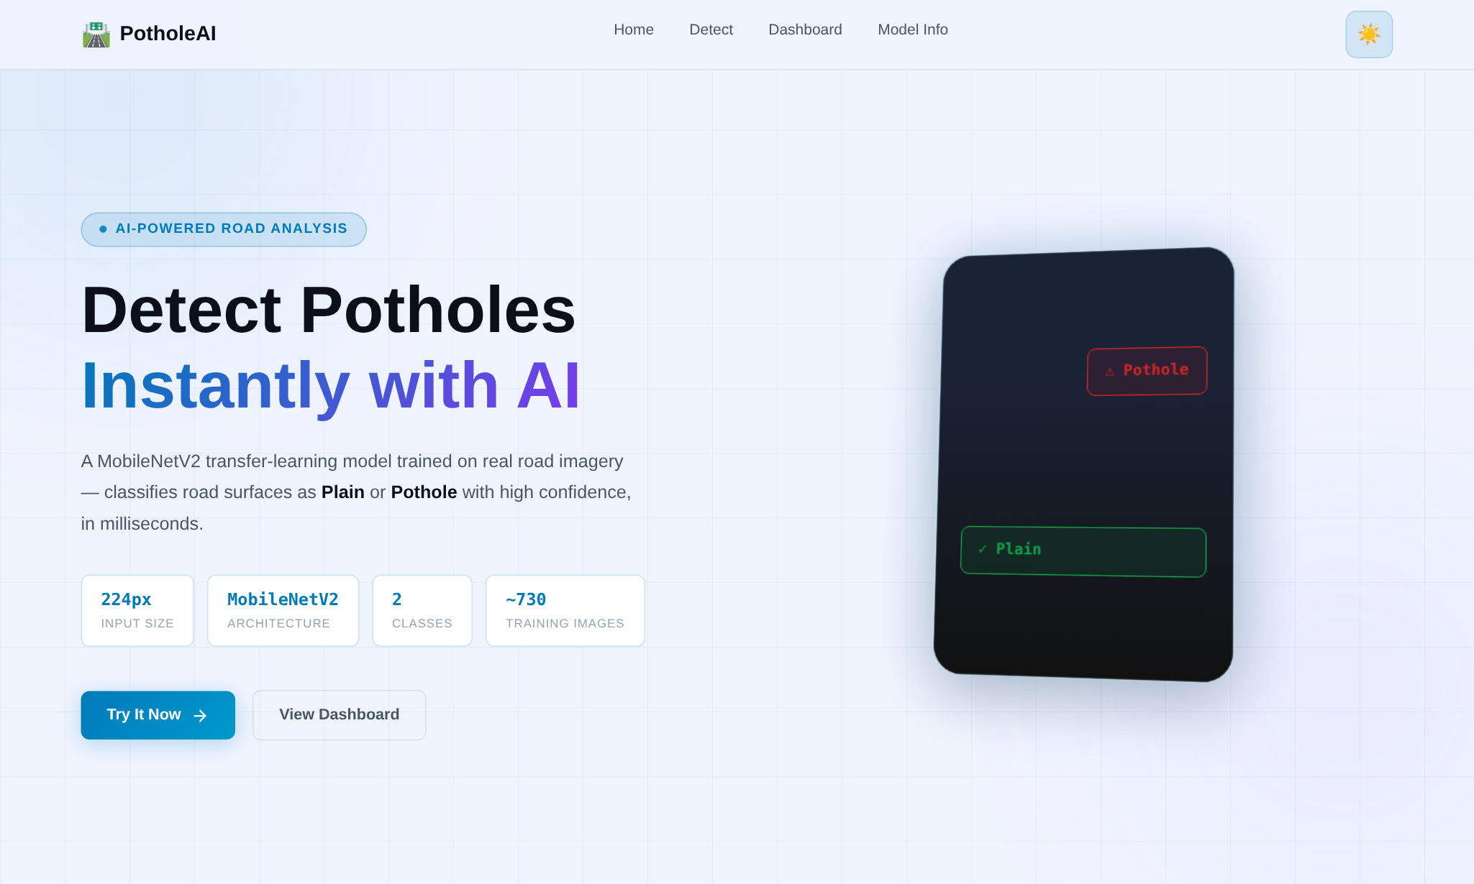
Figure 5.1: PotholeAI Landing Page
The detection page, shown in Figure 5.2, contains a drag-and-drop upload area with a Browse Files button. After an image has been chosen, a preview is shown together with a Reset button and an Analyse button. On pressing Analyse, the page shows a loading state and then displays the result in the panel on the right: a coloured badge with the predicted class, a confidence bar, one card for the probability of each class, and a line that names the model type and the file analysed. Errors returned by the server are shown in the same panel.
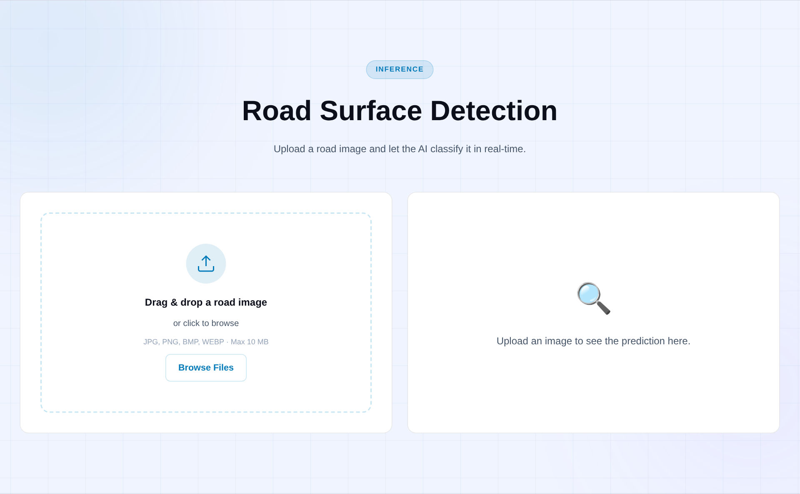
Figure 5.2: Detection Page Before an Image Is Uploaded
The dashboard page, shown in Figure 5.3, summarises the project in six cards: the dataset split (about 510 training, 109 validation and 113 test images), the model architecture from the 224 × 224 × 3 input through the MobileNetV2 backbone, Global Average Pooling and the Dense-128 layer with dropout to the sigmoid output, the training configuration (batch size 32, binary cross-entropy, TensorFlow / Keras), the data augmentation settings, the two output classes and a note on the evaluation metrics, which refers to the notebook for the exact values. The Model Info page, shown in Figure 5.4, explains transfer learning, the dataset, the preprocessing and the limitations of the classifier, and gives instructions for adding a trained model file to the model folder.
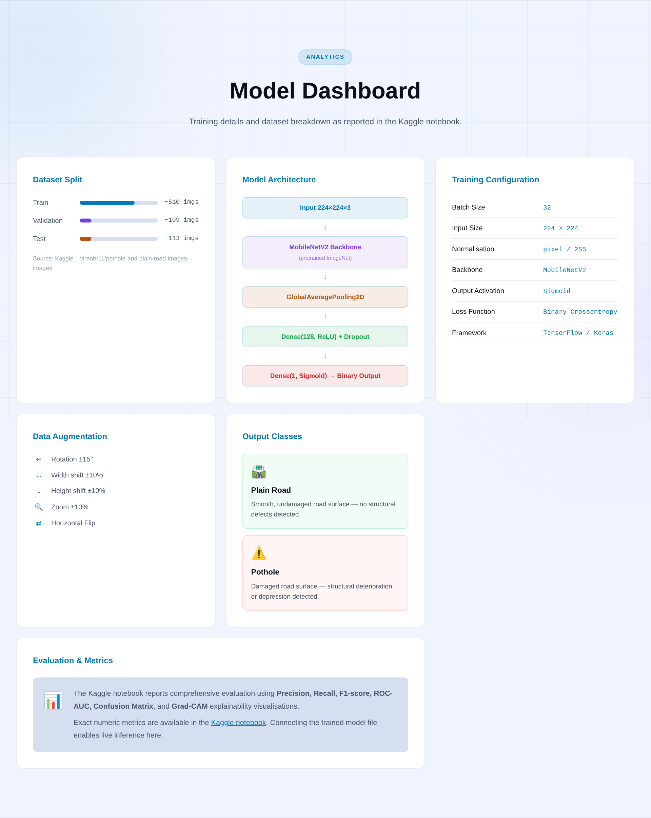
Figure 5.3: Model Dashboard Page

Figure 5.4: Model Information Page

5.5.3 Deployment Configuration
The project contains the files needed to run and host the application. The requirements file lists Flask, Flask-CORS, Pillow, NumPy and Gunicorn, with TensorFlow added separately for live predictions. A Procfile and a render.yaml file define the production start command (gunicorn app:app with one worker and a timeout of 120 seconds) and the Python version for hosting on a cloud platform, and a run.bat script starts the server and opens the browser on a Windows computer. The project is kept under Git version control, and the README documents the folder structure, the quick-start steps and the API.

Chapter 6: Testing and Results

1. Testing Methodology
All models are evaluated on the held-out test set of 113 images (56 Pothole and 57 Plain), which was not used for training, early stopping or hyperparameter selection. The following metrics are computed from the predicted probabilities at a threshold of 0.5, with the Pothole class treated as the positive class:
- Accuracy: the fraction of test images classified correctly.
- Precision: the fraction of images predicted as Pothole that really contain a pothole.
- Recall (sensitivity): the fraction of real potholes that are found. This is the most safety-relevant metric, because a missed pothole is costlier than a false alarm.
- F1-score: the harmonic mean of precision and recall.
- ROC-AUC: the area under the receiver operating characteristic curve, which measures how well the model ranks potholes above plain roads independently of the threshold.
- Confusion matrix and classification report: the counts of true and false predictions and the per-class precision, recall and F1-score.
In addition, a decision-threshold sweep, Grad-CAM visualisations and a robustness study under synthetic image degradation are performed on the fine-tuned model.

2. Observations
The training curves of the frozen baseline in Figure 6.1 show that the training and validation accuracy rise rapidly during the first epochs and that the validation accuracy settles at about 96%, while the validation loss decreases steadily and remains above the training loss. The curves of the fine-tuned model in Figure 6.2 start from a much lower loss because training continues from the trained baseline; the training accuracy approaches 100% while the validation accuracy fluctuates between about 94.5% and 97.2%, which is expected with a validation set of only 109 images, where one image corresponds to roughly 0.9 percentage points.
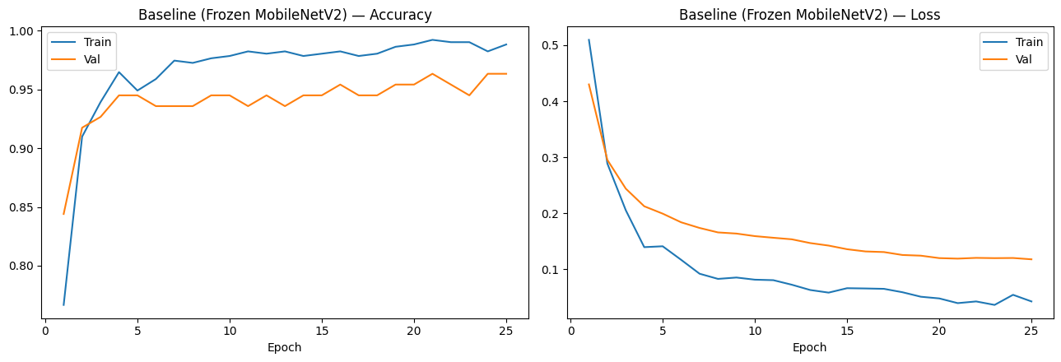
Figure 6.1: Training Curves — Frozen MobileNetV2 Baseline
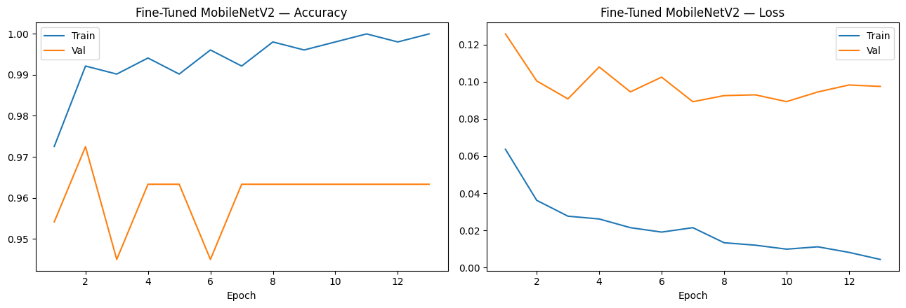
Figure 6.2: Training Curves — Fine-Tuned MobileNetV2
The test-set results of all four models trained in the notebook are listed in Table 6.1 and compared graphically in Figure 6.3.
Table 6.1: Test-Set Performance of the Compared Models
Model | Accuracy | Precision | Recall | F1-score | ROC-AUC | Train time (s)
Frozen MobileNetV2 (baseline) | 0.9469 | 0.9310 | 0.9643 | 0.9474 | 0.9774 | 347.0
Fine-tuned MobileNetV2 | 0.9381 | 0.9153 | 0.9643 | 0.9391 | 0.9875 | 187.0
ResNet50 (frozen) | 0.6903 | 0.6329 | 0.8929 | 0.7407 | 0.8133 | 272.4
EfficientNetB0 (frozen) | 0.5044 | 0.0000 | 0.0000 | 0.0000 | 0.5464 | 195.1

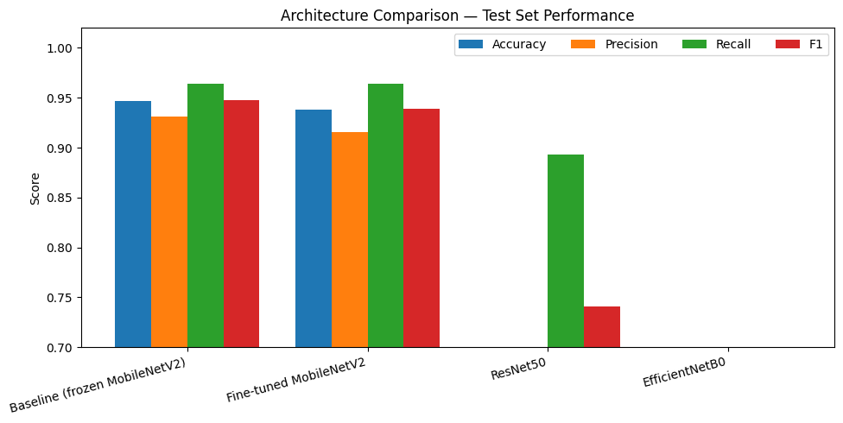
Figure 6.3: Architecture Comparison — Test-Set Performance
The key findings from these results are as follows:
- The frozen MobileNetV2 baseline achieved the highest test accuracy (94.69%) and F1-score (0.9474), followed closely by the fine-tuned MobileNetV2 (93.81%, F1 = 0.9391). The two models differ by one test image (107 versus 106 correct predictions out of 113), which is well within the variation expected for a test set of this size, and their pothole recall is identical (96.43%).
- The fine-tuned model has the highest ROC-AUC (0.9875 versus 0.9774 for the baseline), which indicates a slightly better ranking of potholes above plain roads, although this did not translate into a higher accuracy at the 0.5 threshold.
- ResNet50 reached only 69.03% accuracy with a high recall (89.29%) but low precision (63.29%), i.e. it labelled many plain roads as potholes.
- EfficientNetB0 did not learn the task: its accuracy of 50.44% equals the share of Plain images in the test set (57 of 113), and precision and recall are both zero, which is consistent with the model assigning every test image to the Plain class.
- The weak results of ResNet50 and EfficientNetB0 should not be read as a general ranking of these architectures. They were trained with a frozen backbone, the same 1/255 rescaling and a short schedule on about 500 images. A likely contributing factor, which was not tested in the notebook, is that these Keras backbones are designed for their own input preprocessing (their dedicated preprocess_input conventions) rather than plain 1/255 scaling.

6.2.1 Final Model and Confusion Matrix
The fine-tuned MobileNetV2 is the model that is saved as the final classifier and used in the web interface. Its confusion matrix on the test set is shown in Figure 6.4 and the corresponding classification report in Table 6.2. Of the 56 potholes, 54 were detected and 2 were missed; of the 57 plain roads, 52 were classified correctly and 5 were wrongly flagged as potholes. The model therefore makes more false alarms than missed potholes, which is the preferred direction of error for a safety-oriented screening tool.
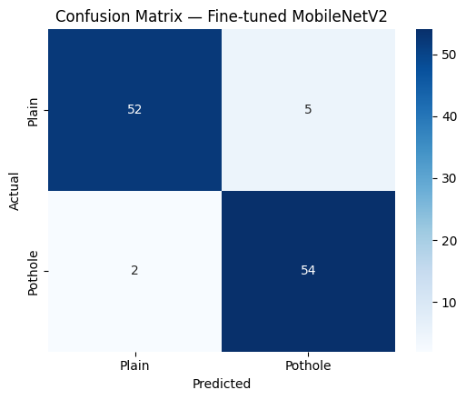
Figure 6.4: Confusion Matrix — Fine-Tuned MobileNetV2 (Test Set)
Table 6.2: Classification Report of the Fine-Tuned MobileNetV2 (Test Set)
Class | Precision | Recall | F1-score | Support
Plain | 0.96 | 0.91 | 0.94 | 57
Pothole | 0.92 | 0.96 | 0.94 | 56
Accuracy |  |  | 0.94 | 113
Macro average | 0.94 | 0.94 | 0.94 | 113
Weighted average | 0.94 | 0.94 | 0.94 | 113

3. ROC, Precision–Recall and Decision-Threshold Analysis
The ROC and precision–recall curves of the fine-tuned model are shown in Figure 6.5. The ROC curve rises steeply towards the top-left corner with an area under the curve of 0.9875, and the precision–recall curve stays at a precision of 1.0 for recall values up to about 0.84 before it decreases slowly, which shows that the highest-scoring images are almost always real potholes.
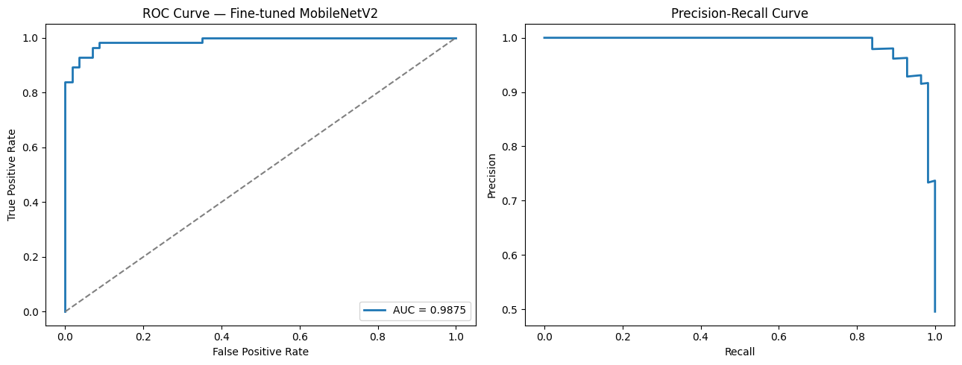
Figure 6.5: ROC Curve and Precision–Recall Curve — Fine-Tuned MobileNetV2
Accuracy alone hides the choice of the 0.5 decision threshold. For road safety a lower threshold, which increases the number of potholes found, could be preferred. The sweep of five thresholds recorded in the project presentation is reproduced in Table 6.3.
Table 6.3: Decision-Threshold Sweep of the Fine-Tuned MobileNetV2 (Test Set)
Threshold | Accuracy | Precision | Pothole recall | F1-score | Missed potholes
0.3 | 0.938 | 0.915 | 0.964 | 0.939 | 2
0.4 | 0.938 | 0.915 | 0.964 | 0.939 | 2
0.5 | 0.938 | 0.915 | 0.964 | 0.939 | 2
0.6 | 0.938 | 0.915 | 0.964 | 0.939 | 2
0.7 | 0.947 | 0.931 | 0.964 | 0.947 | 2

The metrics are identical for thresholds between 0.3 and 0.6, which means that the predicted probabilities are close to 0 or 1 and few images lie in the intermediate range; the number of missed potholes stays at two for every threshold. A threshold of 0.7 gives the highest accuracy and F1-score because one false alarm disappears. Since this sweep was evaluated on the test set, it cannot be used to select the threshold without a separate validation set, and the default threshold of 0.5 is therefore retained in the final model.

4. Explainability Using Grad-CAM
Grad-CAM [6] answers the question of whether the model has learned potholes or something incidental such as road colour or image brightness. It computes the gradient of the Pothole output with respect to the last convolutional feature map of the backbone (the out_relu layer of MobileNetV2) and produces a heatmap showing which regions of the image contributed most to the decision. Figure 6.6 shows four test images, three potholes and one plain road, with the original image on the left and the heatmap overlay on the right.
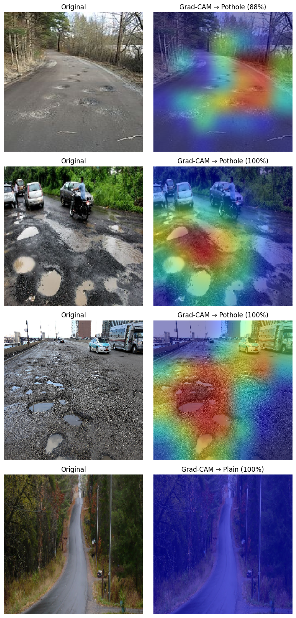
Figure 6.6: Grad-CAM Visualisations of the Fine-Tuned MobileNetV2
In the three pothole examples, the model predicts Pothole with 88%, 100% and 100% confidence, and the strongest activation (red) lies on the damaged central part of the road surface, in particular around clusters of potholes and water-filled depressions. The plain-road example is classified as Plain with 100% confidence and shows almost no activation. In the first example, some activation also extends to areas of vegetation at the roadside, and in the third example, a part of the activation reaches the vehicles and background, which shows that the heatmaps are coarse. A Grad-CAM heatmap is a diagnostic aid and does not prove that the model always reasons correctly; the four examples support, but do not establish, that the model attends to the road surface.

5. Robustness Testing
The test set consists of clean, curated photographs, whereas a deployed system will encounter blur, poor lighting and sensor noise. To measure this effect, seven conditions are simulated on the test images and the fine-tuned model is evaluated on each of them: Gaussian blur with σ = 2 and σ = 4, low light (brightness factor 0.5), overexposure (factor 1.6), low contrast (factor 0.5) and additive Gaussian sensor noise (σ = 25). The accuracy and pothole recall are listed in Table 6.4 and shown in Figure 6.7.
Table 6.4: Robustness of the Fine-Tuned MobileNetV2 Under Simulated Degradation
Condition | Accuracy | Pothole recall
Clean (baseline) | 0.9381 | 0.9464
Gaussian blur σ = 2 | 0.9115 | 0.8393
Heavy blur σ = 4 | 0.7257 | 0.4643
Low light (0.5×) | 0.9292 | 0.8929
Overexposed (1.6×) | 0.9381 | 0.9643
Low contrast (0.5×) | 0.9292 | 0.8929
Sensor noise σ = 25 | 0.9469 | 0.9464

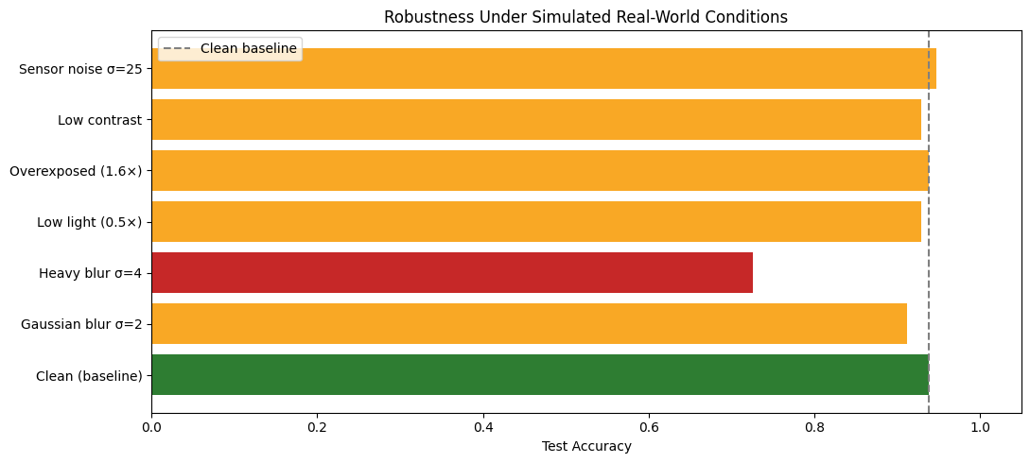
Figure 6.7: Robustness Under Simulated Real-World Conditions
The model is robust to moderate changes in brightness, contrast and additive noise, with an accuracy between 92.9% and 94.7%. Blur is the main weakness: at σ = 2 the pothole recall falls to 83.93% and at σ = 4 the accuracy falls to 72.57% and the recall to 46.43%, so that more than half of the potholes are missed. The clean-baseline recall in this table (0.9464) is slightly lower than the value in Table 6.1 (0.9643) because the robustness experiment loads and resizes the images directly with Pillow instead of the Keras generator, which changes the pixel values slightly; the accuracy is unchanged. The synthetic corruptions do not replace testing on real dashcam images.

6. Discussion on Final Model Selection
The notebook states the intended selection rule as choosing the model with the best validation F1 and reporting its test performance once. In the executed notebook, however, the final model variable is set manually to the fine-tuned MobileNetV2, and the closing summary table, which sorts models by test F1, ranks the frozen baseline first with an improvement of 0.00 percentage points. The honest conclusion is that on this test set the frozen and fine-tuned MobileNetV2 are practically equivalent: the baseline has one more correct prediction, and the fine-tuned model has a higher ROC-AUC and was the model used in the Grad-CAM, robustness and deployment stages. Fine-tuning did not give a measurable accuracy gain on this small dataset, but it also did not harm the pothole recall.

7. Web Application Testing
The PotholeAI application was run locally with Flask and TensorFlow on a CPU-only machine, using the model file supplied in the model folder of the project. The status route reported that the model was loaded, with the classes Plain and Pothole and an input size of 224 × 224. The behaviour of the API and of the interface was then tested with the two sample images supplied with the application and with invalid requests. The results are listed in Table 6.5.
Table 6.5: Functional Tests of the PotholeAI Application
Test | Input | Observed result
Model status | GET /api/status | model_loaded = true, classes Plain and Pothole
Pothole photograph | pothole_sample1.jpeg | Pothole, confidence 100.00%
Plain-road photograph | plain_road_sample1.jpeg | Pothole, confidence 99.94% (incorrect)
Request without a file | POST without image | HTTP 400: No image file provided
Unsupported file type | A .txt file | HTTP 400: Unsupported file type
Model information | GET /api/model-info | HTTP 200 with model metadata

Figure 6.8 shows the interface after the pothole photograph was analysed. The image shows a damaged patch of asphalt with exposed stones and loose gravel; the application displays the badge Pothole Detected, a confidence of 100.0% and the probabilities 0.0% for Plain and 100.0% for Pothole. The request took about 0.3 seconds, including the upload of a 12-megapixel image, on the test machine.
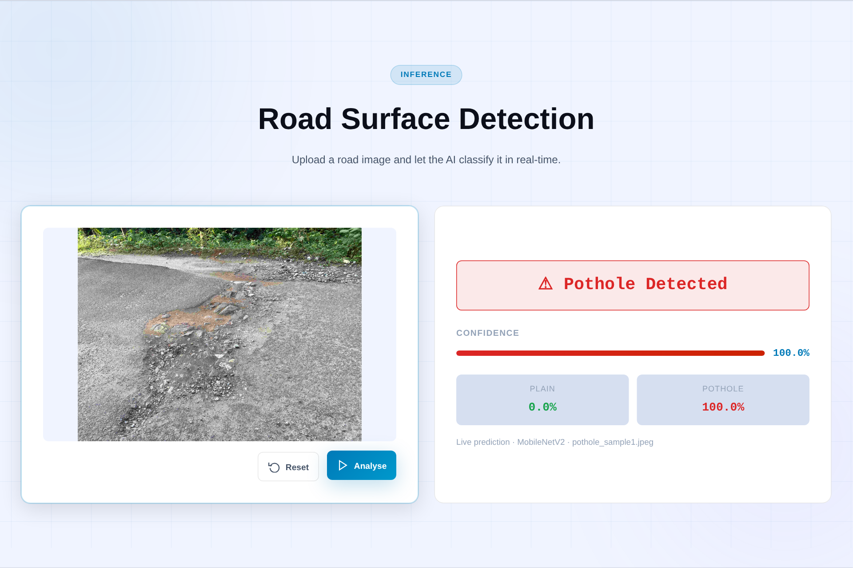
Figure 6.8: Web Application Result for a Pothole Photograph
Figure 6.9 shows the result for the image supplied as a plain-road sample. This image is a strongly motion-blurred close-up of asphalt with grass at the right edge and no visible pothole, but the application classified it as Pothole with a confidence of 99.94%. The application therefore produced a confident false alarm for this image.
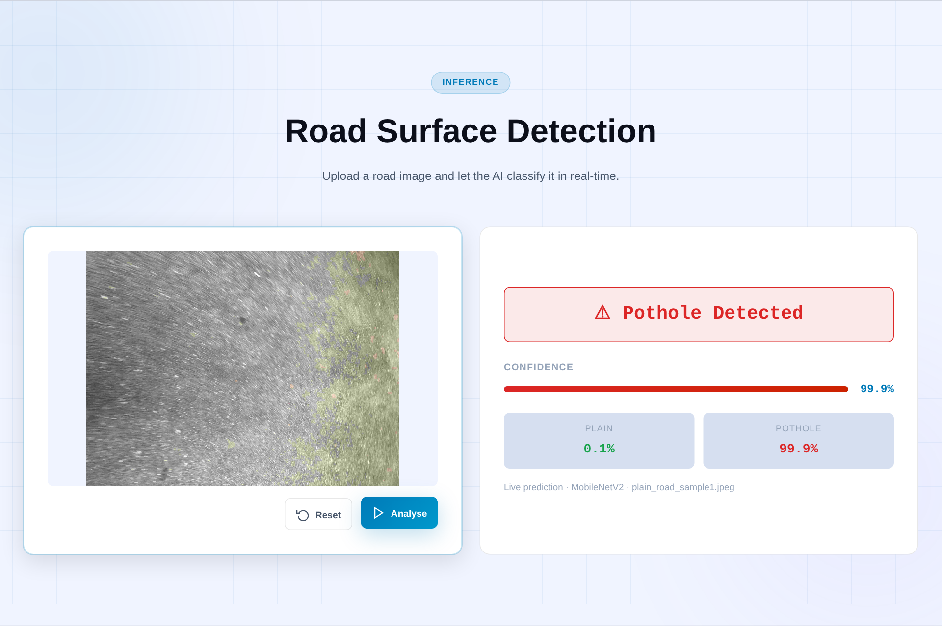
Figure 6.9: Web Application Result for a Plain-Road Photograph (Incorrect Prediction)
A single image does not permit a statistical conclusion, but it is an informative observation, because it differs from the test-set results in three respects. First, the image is a close-up with severe motion blur, which is unlike the road scenes of the dataset, so it is probably outside the distribution on which the model was trained; the robustness study of Section 5 examined blur only as a cause of missed potholes, and this case shows that unusual images can also cause false alarms. Second, the model output is almost saturated (0.06% for Plain), which shows that the confidence value of this model is not a reliable measure of correctness. Third, the web backend resizes images with Lanczos resampling, whereas the training pipeline used the default Keras image loader, and the effect of this difference on predictions was not evaluated. Which of the saved checkpoints (baseline or fine-tuned) is contained in the supplied model file is not recorded in the project files, so this test cannot be attributed to either of them. These observations support the future-work items of testing on self-captured images and of broadening the training data.

Chapter 7: Conclusion and Future Scope

1. Summary of Work
This report has presented the end-to-end design, implementation and evaluation of a deep-learning classifier for pothole and plain road images. A public dataset of 740 listed images was merged and re-split into stratified training, validation and test sets; MobileNetV2, ResNet50 and EfficientNetB0 backbones were compared under identical conditions; the MobileNetV2 model was fine-tuned; and the models were assessed with accuracy, precision, recall, F1-score, ROC-AUC, confusion matrices and a threshold sweep. The final fine-tuned MobileNetV2 achieved 93.81% test accuracy, 96.43% pothole recall and a ROC-AUC of 0.9875, and the frozen baseline achieved 94.69% accuracy. Grad-CAM, robustness testing and a Gradio prototype complete the notebook workflow. The model was then packaged as the PotholeAI web application, consisting of a Flask prediction API and a four-page browser interface, and tested locally: a pothole photograph was detected with 100.00% confidence, whereas a blurred close-up of plain asphalt was wrongly classified as a pothole with 99.94% confidence.

2. Key Learnings
- Transfer learning is effective on small datasets. A frozen ImageNet-pretrained MobileNetV2 with a small head reached about 95% test accuracy from only 510 training images, while the larger ResNet50 and EfficientNetB0 trained in the same set-up did not.
- Fine-tuning is not automatically better. Unfreezing 36 backbone layers at a low learning rate improved the ROC-AUC but not the accuracy on this test set, and the difference of one image shows how little a test set of 113 images can distinguish between models.
- Evaluation must go beyond accuracy. Recall, the confusion matrix and the threshold analysis show the asymmetric cost of missed potholes, and Grad-CAM and robustness tests reveal behaviour that a single accuracy figure hides, in particular the sharp loss of recall under heavy blur.
- Deployment testing reveals what a benchmark does not. The web application made the model usable by a non-technical user, and a single out-of-distribution image immediately produced a confident error, which shows that high confidence values must not be mistaken for reliability.
- Reporting must be honest about the experiment. Data-handling discrepancies, the difference between the selection rule and the selected model, and the failure of EfficientNetB0 are results in their own right and are documented instead of being hidden.

3. Limitations
The current limitations are as follows. The dataset is small (740 listed images, 113 test images), so metric differences of one or two images are not statistically meaningful. Seven images appear to be lost when the source folders are merged, and one validation file could not be read. The system performs image-level classification only, with no bounding box, exact pothole location, severity grade or GPS geotag. The pothole recall drops sharply under heavy blur, and robustness was only tested with synthetic corruptions and not on real dashcam images. The ResNet50 and EfficientNetB0 results were obtained with a frozen backbone and a short schedule, so they do not represent the best attainable performance of these architectures. The threshold sweep was evaluated on the test set, the Grad-CAM analysis is based on only four images, and the web application was tested with only two images. The web application does not limit the size of uploaded files although the interface announces a maximum of 10 MB, it is run with a development-style single-process server configuration, and its image resizing differs from the training pipeline.

4. Future Enhancements
- Test the model on self-captured road images and real dashcam footage, and extend the dataset with images taken in rain, at night and under motion blur.
- Improve robustness to blur through blur-based augmentation and by training on degraded images.
- Correct the file-naming collisions when merging the dataset, and use cross-validation or a larger test set to obtain more reliable estimates.
- Re-evaluate ResNet50 and EfficientNetB0 with their model-specific preprocessing and with fine-tuning, so that the architecture comparison is fair.
- Explore object detection models to localise potholes with bounding boxes, and add severity grading and GPS geotagging for maintenance planning.
- Select the decision threshold on a separate validation set, taking the higher cost of missed potholes into account.
- Improve the web application: use the same image loading and resizing as in training, enforce an upload size limit, display Grad-CAM heatmaps next to the prediction, warn the user when an image looks unlike the training data, and add batch upload with location tagging for road surveys.

REFERENCES

1. Sandler, M., Howard, A., Zhu, M., Zhmoginov, A., & Chen, L.-C. (2018). MobileNetV2: Inverted Residuals and Linear Bottlenecks. CVPR 2018. https://arxiv.org/abs/1801.04381
2. He, K., Zhang, X., Ren, S., & Sun, J. (2016). Deep Residual Learning for Image Recognition. CVPR 2016. https://arxiv.org/abs/1512.03385
3. Tan, M., & Le, Q. V. (2019). EfficientNet: Rethinking Model Scaling for Convolutional Neural Networks. ICML 2019. https://arxiv.org/abs/1905.11946
4. Deng, J., Dong, W., Socher, R., Li, L.-J., Li, K., & Fei-Fei, L. (2009). ImageNet: A Large-Scale Hierarchical Image Database. CVPR 2009. https://www.image-net.org
5. Yosinski, J., Clune, J., Bengio, Y., & Lipson, H. (2014). How Transferable Are Features in Deep Neural Networks? NeurIPS 2014. https://arxiv.org/abs/1411.1792
6. Selvaraju, R. R., et al. (2017). Grad-CAM: Visual Explanations from Deep Networks via Gradient-Based Localization. ICCV 2017. https://arxiv.org/abs/1610.02391
7. Kingma, D. P., & Ba, J. (2015). Adam: A Method for Stochastic Optimization. ICLR 2015. https://arxiv.org/abs/1412.6980
8. Ioffe, S., & Szegedy, C. (2015). Batch Normalization: Accelerating Deep Network Training by Reducing Internal Covariate Shift. ICML 2015. https://arxiv.org/abs/1502.03167
9. Abadi, M., et al. (2016). TensorFlow: Large-Scale Machine Learning on Heterogeneous Distributed Systems. https://arxiv.org/abs/1603.04467
10. Pedregosa, F., et al. (2011). Scikit-learn: Machine Learning in Python. Journal of Machine Learning Research, 12, 2825–2830. https://jmlr.org/papers/v12/pedregosa11a.html
11. Abid, A., et al. (2019). Gradio: Hassle-Free Sharing and Testing of ML Models in the Wild. https://arxiv.org/abs/1906.02569
12. Pallets Projects. (n.d.). Flask Documentation (Version 3). https://flask.palletsprojects.com
13. Virenbr11. (n.d.). Pothole and Plain Road Images [Dataset]. Kaggle. https://www.kaggle.com/datasets/virenbr11/pothole-and-plain-rode-images

