Bootstrap (Tailwinds)  
<head>   
 <script src="<https://cdn.tailwindcss.com>"></script>  
</head>

Components (Flowbite) - Use this to style Nav, Cards, Buttons, etc.  
<body>   
 <script src="<https://unpkg.com/flowbite@1.4.1/dist/flowbite.js>"></script>  
</body>

## Colors:

Nav: Blue #500

Cards: Blue #300

H1/P: Black

H1/P - Hover: Blue #200

## Wireframes:

Antara

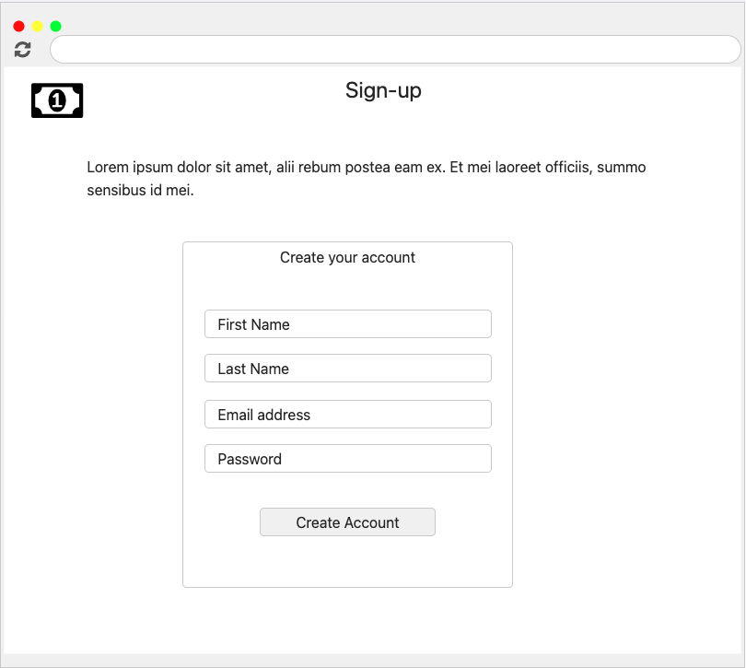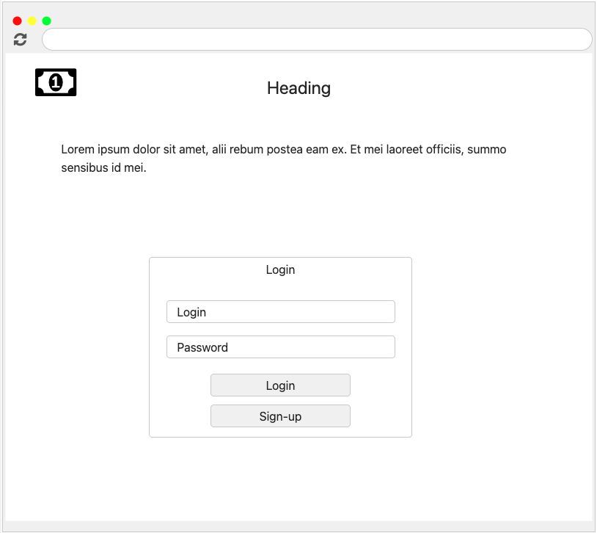

Jin

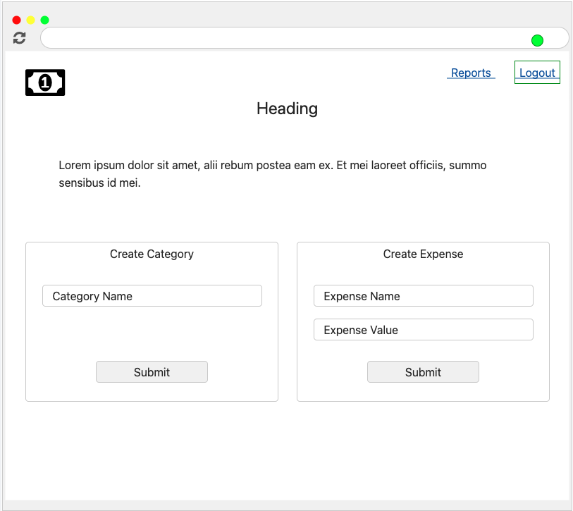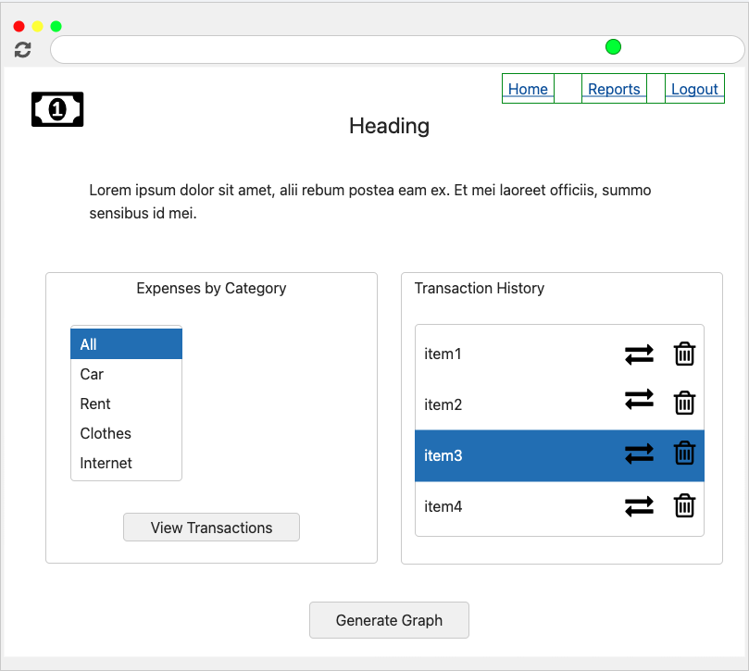

Ore

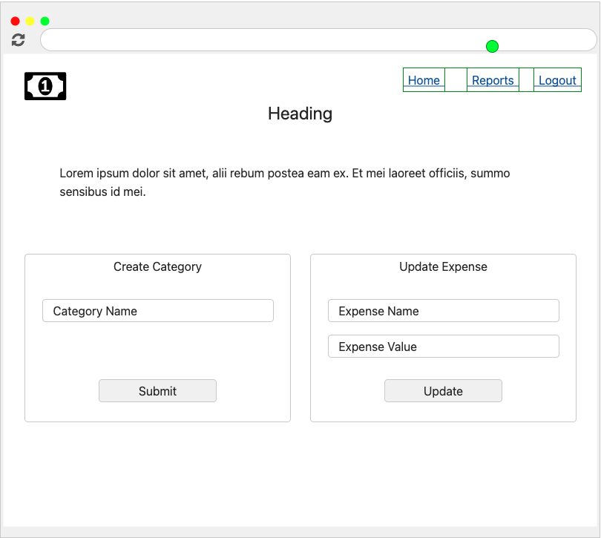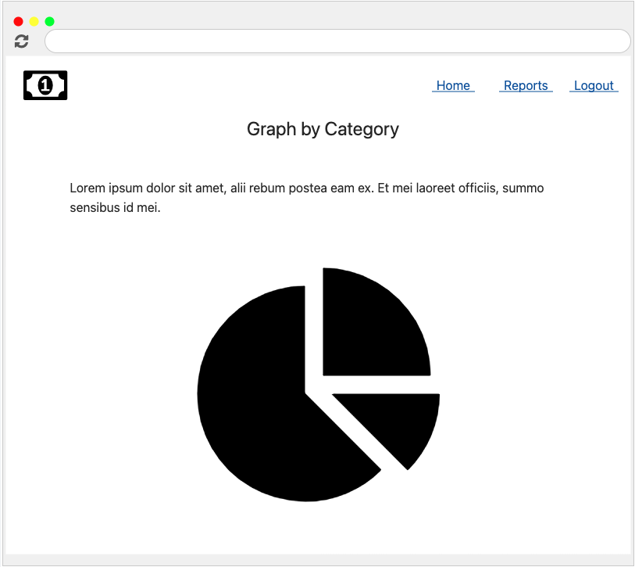

Senthol / Fernando

| **Person** | **Resource** | **URL** | **HTTP Verb (GET, POST)** | **Used For** |
| --- | --- | --- | --- | --- |
| Fernando | DB/Tables |  |  |  |
| Fernando | MySql | /api/getExpenses | GET | Get All Expenses |
| Fernando | MySql | /api/createExpense | POST | Create new Expense |
| Senthol | MySql | /api/createCategory | POST | Create new Category |
| Fernando | MySql | /api/updateExpense | PUT | Update Selected Expense |
| Fernando | MySql | /api/deleteExpense | DELETE | Delete Selected Expense |
| Senthol | MySql | /api/generateReport | GET | Get All Expenses and Summarize by type |
| Senthol | MySql | /api/createUser | POST | Create new users |
| Senthol | MySql | /api/getUser | GET | Validate users during login phase |

## 