Server Info Gather commands to retrieve CPU, Memory, and Storage ( On-Prem / Azure VM )



SERVER HARDWARE INFO (CPU, DISK CAPACITY, MEMORY)
LINUX
- CPU -- cat /proc/cpuinfo
- Disk -- df -h
- Memory -- cat /proc/meminfo
***************************************************************************
WINDOWS
If wmic is installed:
- CPU
wmic cpu get caption, name, numberofcores, maxclockspeed, status, numberoflogicalprocessors
echo %NUMBER_OF_PROCESSORS% (logical processors returned)
- Memory
wmic memorychip get capacity, speed, memorytype
wmic computersystem get totalphysicalmemory
- Storage
wmic logicaldisk get Caption,FileSystem,FreeSpace,Size,Status
***************************************************************************
Azure VM ( Share JSON File )
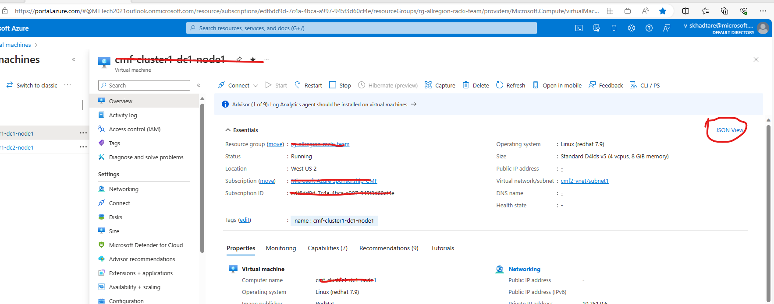
id | sku.name | fullyQualifiedDomainName | sku.capacity | sku.storage | sku.tier | version | logname | region | location | ha | read_replica | environment | server_type | migration_path | approved
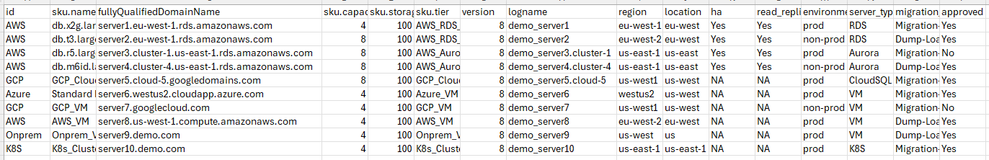
Note:- Update Factory_PostgreSQL_Server_List.csv file as per below format and ensure “logname” matching with logfile name.

