SNYK Handson

1. Register to Synk : <https://snyk.io/> [Using the GitHub or Gmail account]
2. Get the API token and copy it : Token can be get from https://app.snyk.io/account/ (for getting AUTH TOKEN)
3. Install the Snyk-Security plugin to the Jenkins .
4. Configure the API security in Jenkins Kind select as

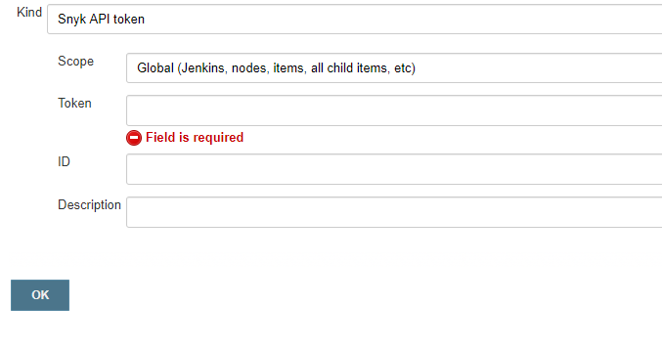

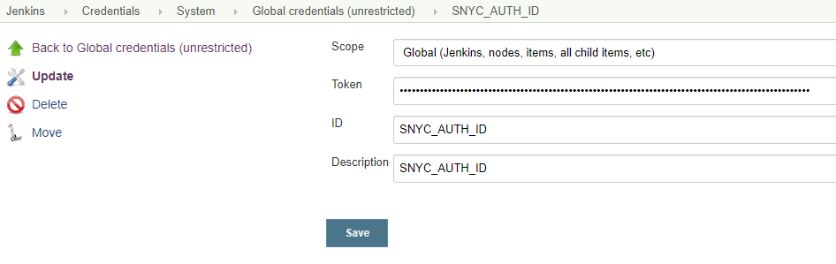

1. Install Synk installable via this command : first create a directory [ mkdir –p ~/tools/snyk] && [cd ~/tools/snyk] do wget this software : **wget** <https://github.com/snyk/snyk/releases/download/v1.258.1/snyk-linux>
2. Now in Jenkins Global tools section provide the installable path : name it like UBUNTU1_PATH

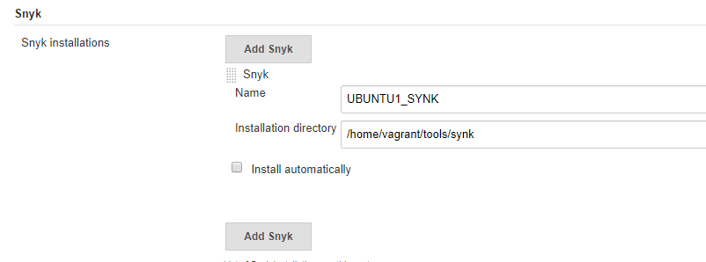

1. Go to any of the maven example project and enable the Synk Security under “Build Section”

Target file : Give the POM file path for the project that we want to scan

Additional Arguments : give the path of the settings.xml that Synk can use.

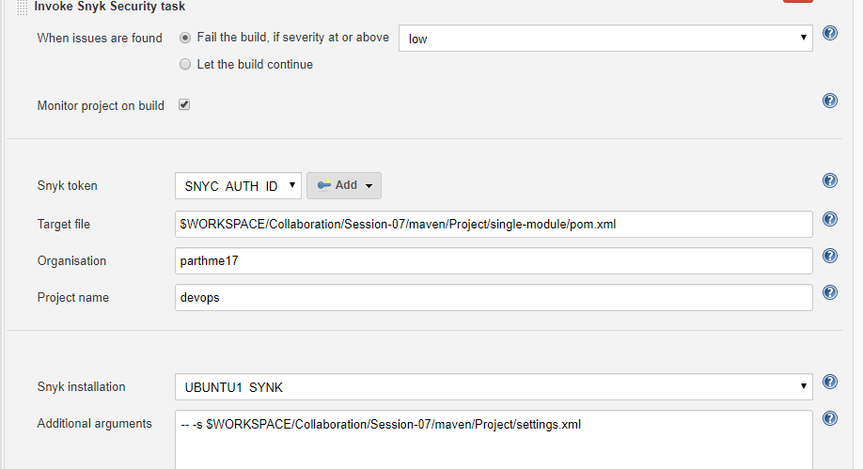

1. Run the BUILD to get the Vulnerability report like this below screen

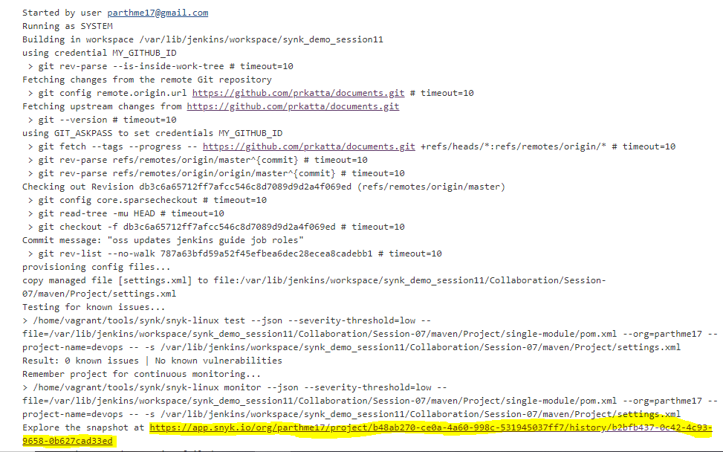

1. Now click the link that Jenkins provides which will take you to Synk and show the report : Report looks like this : It will list the reports for all the dependencies inside our project

