IDEATHON 2.0
CrewYard.
A searchable yard of builders by skill, by campus, by what they're stuck on right now.
Brief Abstract: Category 2: Best Business Model & Start-up Idea
Idea Title: CrewYard : Verified Peer Problem-Solving & Team Formation for Tier-3 College Builders
Category: Category 2: Best Business Model & Start-up Idea / Best Research-to-Start-up Proposal
Team: YellowDuck – Prakhar Jaiswal , Ayush Singh

1. Problem Statement
Ambitious students at under-resourced (Tier-3) engineering colleges lack a persistent, trust-verified peer group for skill-building. Existing channels are transactional (hackathon platforms like Unstop and Devfolio, which end the moment an opportunity is found), performative (LinkedIn), ephemeral and unsearchable (Discord, WhatsApp), or have no social layer at all (GitHub).
The real failure mode is not “I can’t find anyone to talk to” it is “I found a teammate once, for one hackathon, and we never spoke again after submission.” Within a single college, realistically only 15–30 genuinely active builders exist, which is enough for a group chat but not a network, so students consistently hit a density ceiling they cannot self-organize past.

2. Proposed Solution & Core Innovation
CrewYard is a structured, filterable board of verified “asks” tagged Teammate, Help, or Build Log rather than a chat app or an infinite social feed. The anchor use case is peer problem-solving: a student stuck on a technical issue gets a real, checkable fix from a verified peer at another college, and that answer attaches reputation to the answerer’s profile reputation a future teammate can actually verify, not a claimed skill or a vanity badge.
- GitHub-synced profiles replace self-reported skills with verifiable activity.
- College-email verification gives a cheap, high-trust identity signal that Discord and Reddit structurally lack.
- Deadline-anchored team formation ties asks to a specific hackathon or GSoC cycle so they expire instead of going stale.
- Search returns the specific, checkable reason each match fits not a vague relevance score.
- Messaging is deliberately minimal: once two people match, CrewYard hosts just enough conversation to build trust, then hands off day-to-day coordination to WhatsApp or Discord competing on identity and reputation, not on chat infrastructure.

3. Product Walkthrough
The product is designed in a clean, editorial, brutalist style built to feel like a searchable yard of builders, not another generic social feed. Below are the core surfaces:
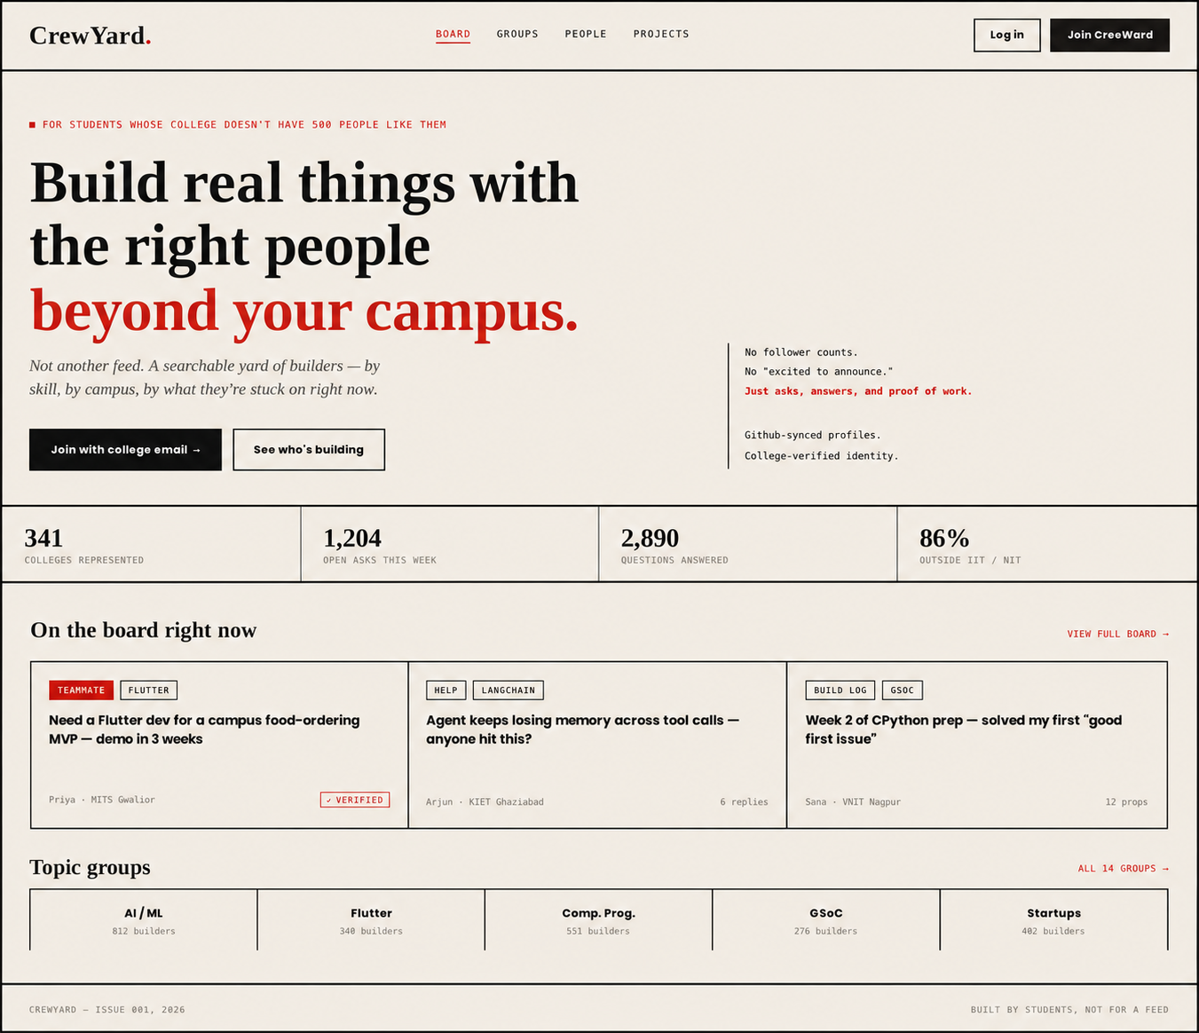
HOMEPAGE — MASTHEAD, HERO, AND LIVE BOARD PREVIEW
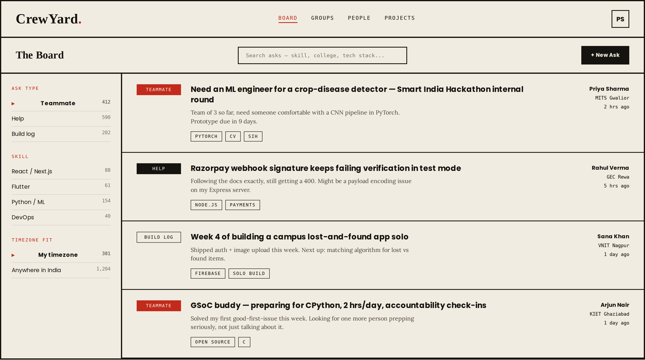
THE BOARD — FILTERABLE ASKS, NOT AN INFINITE FEED
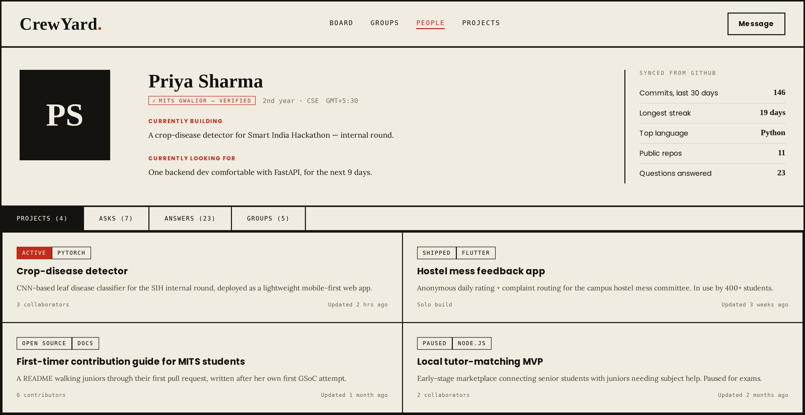
PROFILE — GITHUB-SYNCED ACTIVITY, NOT SELF-REPORTED CLAIMS

4. Why This, Not Team-Formation Alone
Team-formation requests alone are seasonal and capped by thin per-college density. Peer problem-solving is the loop that actually survives the weeks between hackathons: builders get stuck far more often than they need a new teammate, a good answer needs zero local network to matter, and answered questions become durable, searchable content that pulls in new users much like Stack Overflow’s own early growth engine. Team formation and build-in-public are not dropped; they become features hanging off the same “ask” primitive, sequenced after the help loop proves out.

5. Target Audience & Market Potential
Primary user: a 2nd- or 3rd-year CSE/IT student at a Tier-3 engineering college who has already built one or two small projects, has entered at least one hackathon through Unstop or Devfolio without placing, is preparing for GSoC or an ML internship, and sits in a 30–150-member college coding-club WhatsApp group where the handful of genuinely active peers are scattered and unfindable beyond that group. This segment motivated builders outside the IITs/NITs is large in absolute numbers across India’s Tier-2/3 institutions, and is underserved by platforms built for professionals (LinkedIn, Peerlist) or one-time opportunity discovery (Unstop, Devfolio).

6. Business Model
The model deliberately avoids ads and avoids a student subscription, since this demographic has close to zero willingness to pay directly. Revenue instead comes from the organizations around students:
- B2B team-formation tooling hackathon organizers and college tech fests pay for structured team formation in place of an ad-hoc WhatsApp group.
- Sponsored topic groups companies running GSoC-adjacent or open-source programs sponsor a group transparently and opt-in, never as an algorithmic ad.
- Recruiter or founder visibility paid, and kept clearly separate from the student-to-student core so it never reintroduces LinkedIn’s performative tone.

7. Competitive Landscape
Unstop and Devfolio own opportunity discovery and hackathon-specific team formation but stop once the opportunity is found, with no persistent peer layer. LinkedIn is performative and penalizes students with no experience. Discord and WhatsApp offer real-time chat but are fragmented, unsearchable, and hold no persistent identity or reputation. GitHub has no discovery or social layer. Peerlist has attempted a similar identity layer since 2021 but skews professional and remains niche after years of effort confirming the identity-and-community layer is real, open ground, not a solved problem. CrewYard’s wedge is structured, queryable, trust-verified matching not better design, which compounds retention once the core loop works.

8. Roadmap & Growth Plan
A phased path from proof-of-loop to a self-sustaining, revenue-generating network:
Phase | Focus | Signal of Success
Phase 1: Prove the Loop | College-email signup, GitHub-synced profile, one board with Teammate / Help / Build Log asks, seeded across 2–3 partner colleges. | Questions get real answers within hours; matches turn into shipped work.
Phase 2: Deepen Trust | Reputation scores attached to verified profiles, deadline-anchored team formation, topic groups. | Answerers return without prompting; reputation is checked before teaming up.
Phase 3: Scale & Monetize | B2B tooling for hackathon organizers and college fests, sponsored topic groups, cross-college challenges. | Organizers pay for structured formation; density compounds across campuses.

Manual, high-touch seeding at 2–3 partner colleges de-risks the launch: density starts concentrated and real, not thin and spread out, so the very first users get genuine value from day one.

9. Why CrewYard Wins
- Founder-market fit is the strongest asset here built from lived experience of the exact problem, at the exact type of institution being targeted.
- A daily-use anchor (getting unstuck) instead of a seasonal one (finding a teammate) durable engagement, not hackathon-week spikes.
- Verified identity and checkable reputation are structurally hard for chat-first incumbents (Discord, WhatsApp) to retrofit.
- A B2B revenue path with provable willingness to pay, sidestepping the near-zero willingness of students to pay directly.
- A focused wedge not “GitHub plus Reddit plus LinkedIn” built to prove one loop works before earning the right to expand.

10. Future Scope
As the anchor loop compounds, later phases layer in inter-college challenges and public, shareable “who’s building what” pages to grow through search and sharing while deliberately staying a focused problem-solving and team-formation tool rather than expanding into a daily, general-purpose social network.

