Hw6

Robin Baldeo

February 17, 2019

### 2.4.1

## (a)

$\overline{Y}$ $\frac{n}{n+m}$ $±$ 1.96 $σ$ $(n+m)^{−.5}$

## (b)

n<- 100000  
set.seed(100)  
#random numbers generated  
data<- rnorm(n, 0, 1)  
#mean  
me<- mean(data)  
#variance  
v<- var(data)  
  
  
#frequentist ci  
#y-bar +/- (var/n)^.5  
  
fLow<- me-1.96* (v/n)^.5;   
  
fHigh<- me+1.96 * (v/n)^.5;fHigh

## [1] 0.007754023

#frequentist ci  
cbind(fLow, fHigh)

## fLow fHigh  
## [1,] -0.004631306 0.007754023

#using formula from a with m = 0  
bCi<- function(m){  
 w = n/(n+m)  
 bm= (w * me) + (1-w) * 0  
 bv= (v/(n+m))^.5  
 return(cbind("bLow" = bm- 1.96* bv, "bHi" = bm+ 1.96* bv))  
}  
  
#bayes ci  
bCi(0)

## bLow bHi  
## [1,] -0.004631306 0.007754023

We can achieve the frequentist confidence interval by using m = 0.As shown in the above simulation, when m = 0 the frequentist ci upper and lower bounds matches the upper and lower bounds after using the formula in part a.

### 2.4.5

#function used to do simulation   
sp<- function( c){  
 x<- rnorm(1000000, 0,1)  
 a = rnorm(1000000, 0,c^2)  
 b = rnorm(1000000, 0, c^ 2)  
 return(exp(a + x* b)/ (1 + exp(a + x* b)))  
}  
  
  
  
  
#plots  
op <- par(pty="m", mfrow=c(5, 2), mar=c(4.2, 4.2, 1, 1))  
  
 pwalk(list((seq(1, 1.25, length = 10))), ~{hist(sp(..1), col = "wheat", freq= F, main = paste("c =", ..1))})

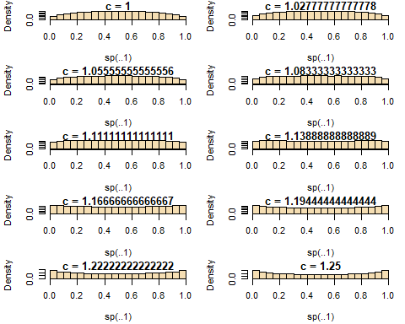

par(op)

the final c = 1.13889, and since the histogram looks uniform I would say the prior is uninformative.

### 2.4.6

## (a)

#question 6  
  
#y = 1.5 * 50 = 75  
#n = 50  
  
#function to plot  
gammaPost<- function(a, b){  
 x<- seq(0,10, length = 100)  
 y<- dgamma(x, 75 + a, 50 + b)  
   
 plot(x,y , type = "l", main = paste("Posterior with a =", a, "b=", b))  
 lines(x, dgamma(x, a,b), col = "red")  
 legend("topright", legend = c("posterior", "prior"),col=c("black", "red"), lty=c(1,1), bty = "n")  
}  
  
#funcation for summary  
postSum<- function(a,b){  
 #ci  
 ci = qgamma(c(.025, .975), 75 + a, 50 + b);  
 #mean  
 mean= (75 + a)/ (50 + b)  
 #std  
 std= sqrt((75 + a)/ (50 + b)^2)  
 cbind("a" = a, "b" = b, "lowCi" = ci[1], "upperCi" = ci[2], "mean" = mean, "std" = std)%>%as.data.frame()%>%return()  
}  
  
  
#a  
# a=b=.01  
gammaPost(.01, .01)

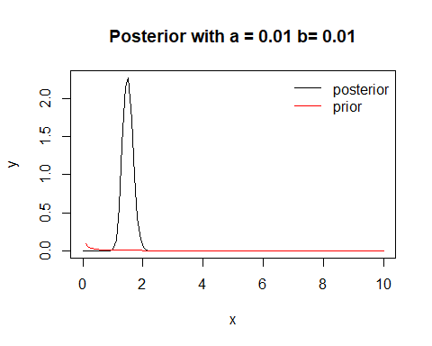

postSum(.01, .01)

## a b lowCi upperCi mean std  
## 1 0.01 0.01 1.179787 1.857856 1.4999 0.173182

## (b)

#b  
# a=b=.1  
gammaPost(.1, .1)

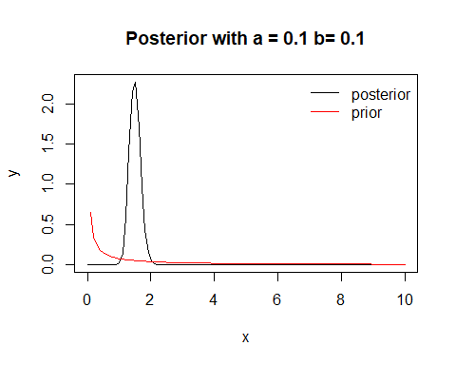

postSum(.1, .1)

## a b lowCi upperCi mean std  
## 1 0.1 0.1 1.17926 1.856518 1.499002 0.1729746

When a=b=.1 it appears the posterior is not too sensitive to the prior. The summary statistics have not changed too much when compared to part(a)

# a= b = 1  
gammaPost(1, 1)

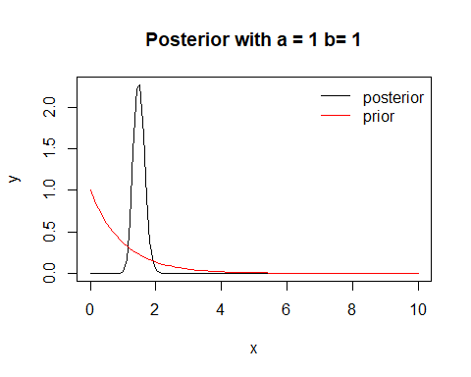

postSum(1, 1)

## a b lowCi upperCi mean std  
## 1 1 1 1.174105 1.843395 1.490196 0.1709372

Comapred to a=b=.01 and a=b=.1, the summary has changed slightly. So it appears the posterior is slightly sensitive to the prior when a=b=1.

## (c)

1. Gamma(.015, .01) gives an expectation of 1.5.
2. Gamma(.014, .01) gives an expectation of 1.4 which is within the 10% range of the mayo rate.
3. Uniform(0,1), gives a prior that is not a function of the mayo rate.