HW7

Robin

March 5, 2019

### Part C

library(invgamma)

#yi  
Y<- c(1:10)  
  
#n  
n<- length(Y)  
  
  
# of simulations  
S<- 25000  
  
samples<- matrix(NA, nrow = S, ncol = 11)  
  
#names to assign to matrix  
colnames(samples)<- c("s1", "s2", "s3", "s4", "s5", "s6", "s7", "s8", "s9", "s10", "B")  
  
  
#inital values   
sigma <- 1  
b<- .1  
  
#assign by Dr Reich  
a<- 1  
  
  
  
  
#Gibbs sampler   
for(s in 1:S){  
 for(i in 1:n){  
 #sigma  
 sigma[i] <- 1/(rgamma(1,.5 + a, (Y[i]^2 + 2* b)/2))  
 }  
 #b  
 b <- rgamma(1,n*a + 1, 1+sum(1/sigma))   
 samples[s,] <- c(sigma, b)  
}  
  
  
# getting the inverse gamma rate and shape  
para<- function(x){  
 m = mean(x)  
 v = var(x)  
 a = (m^2/v) + 2  
 b = m * (a- 1)  
 return(c(a, b))  
}  
  
#Plot of sigma  
# op <- par(pty="m", mfrow=c(5, 2), mar=c(4.2, 4.2, 1, 1))  
for(i in 1:10){  
 temp=samples[,i]  
 #selecting only the values less than 200 for hist  
 values= temp[temp<200]  
 hist(values, freq = F, col = "Wheat", xlab =paste("sigma^2", i), main = paste("Histogram of sigma^2", i), ylim = c(0, .04))  
 x= seq(0, 200, length = length(values))  
   
 #gamma distrubtion overlay  
 curve(dinvgamma(x,para(values)[1],para(values)[2]), add = TRUE, col = "red");  
}

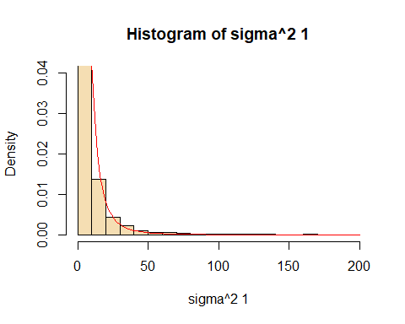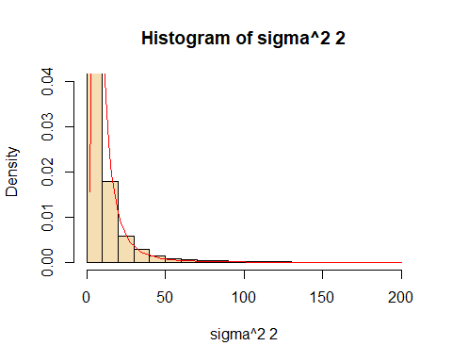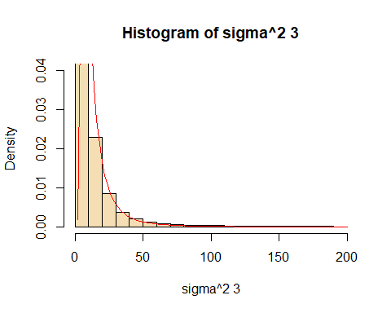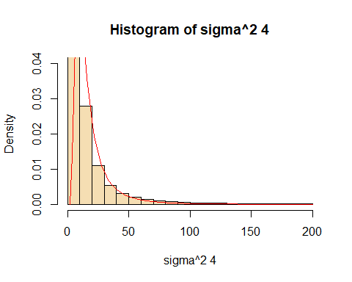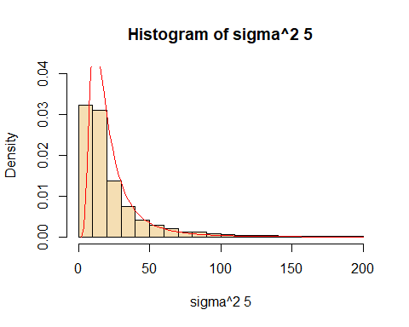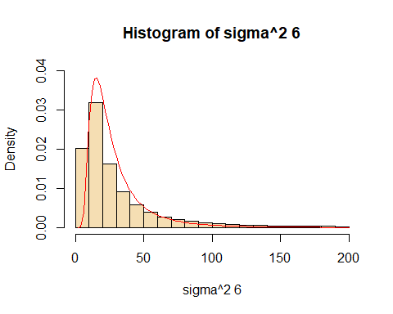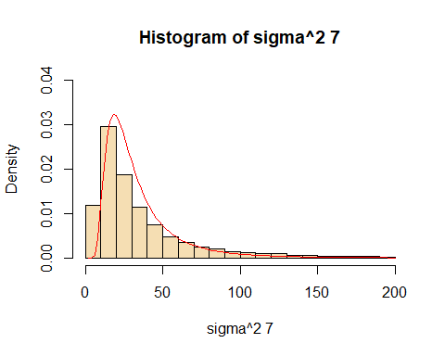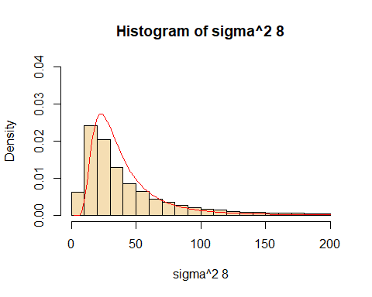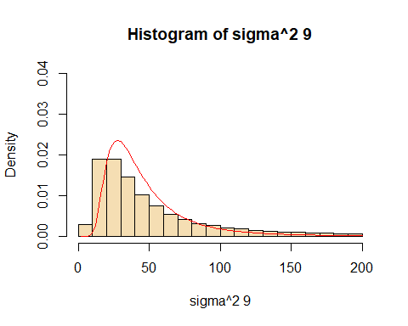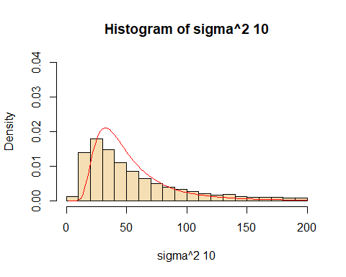

# par(op)  
  
  
#histogram of B  
hist(samples[,11], freq = F, col = "wheat", main = "Histogram of b")

