HW 10

Robin

April 9, 2019

library(rjags)  
 library(geoR)  
 data("gambia")

# Question 5

# raw data from question 5  
y<- c(2, 15, 14, 16, 18, 22, 28)  
x<- c(29.9,1761, 1807, 2984, 3230, 5040, 5654)  
n<- length(y)  
  
#list to be passed to jag  
data <- list(Y=y,X=x,n=n)  
  
  
model_string <- textConnection("model{  
 for(i in 1:n){  
 Y[i]~ dgamma((a*mu[i]*mu[i]),(a*mu[i]))  
 logit(mu[i]) <- inprod(X[i],beta)  
  
 }  
 beta ~ dnorm(0,0.01)  
 a ~ dgamma(0.1, 0.1)  
}")  
  
  
model <- jags.model(model_string,data = data, n.chains=2 ,quiet=TRUE)  
  
update(model, 10000, progress.bar="none")  
  
  
params <- c("a", "beta")  
samples <- coda.samples(model, variable.names=params, n.iter=25000, progress.bar="none")  
  
#summary   
summary(samples)

##   
## Iterations = 11001:36000  
## Thinning interval = 1   
## Number of chains = 2   
## Sample size per chain = 25000   
##   
## 1. Empirical mean and standard deviation for each variable,  
## plus standard error of the mean:  
##   
## Mean SD Naive SE Time-series SE  
## a 0.06734 0.02612 0.0001168 0.0001674  
## beta 8.00916 6.06109 0.0271060 0.0456313  
##   
## 2. Quantiles for each variable:  
##   
## 2.5% 25% 50% 75% 97.5%  
## a 0.02646 0.04834 0.064 0.08245 0.1281  
## beta 0.34746 3.15948 6.752 11.55616 22.5876

#plots   
plot(samples)

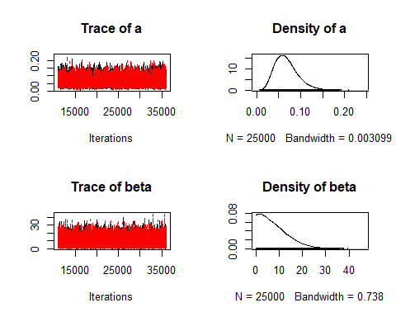

# Low ESS indicates poor convergence, size sample apperas to be large  
effectiveSize(samples)

## a beta   
## 24349.67 17657.58

# R greater than 1.1 indicates poor convergence   
gelman.diag(samples)

## Potential scale reduction factors:  
##   
## Point est. Upper C.I.  
## a 1 1  
## beta 1 1  
##   
## Multivariate psrf  
##   
## 1

sub<- samples[[1]]  
  
plot(density(y), main = "Actual vs Fitted Plot")  
lines(density(sub[,2]), col = "red")  
legend("topright", legend = c("True", "fitted"),col=c("black", "red"), lty=c(1,1), bty = "n")

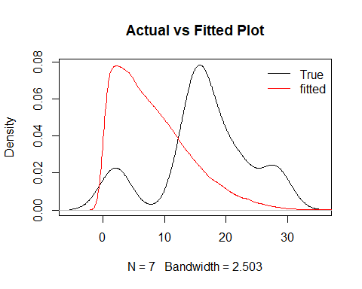

ToDO Comments and review of resutls

# Question 7

# (A)

par(mar=c(1,1,1,1))  
  
#y variable  
y<- gambia$pos  
  
#corvars   
x<- as.matrix(gambia[-3])  
  
data <- list(n=nrow(x),p=ncol(x),Y=y,X=x)  
  
model_string <- textConnection("model{  
  
 # Likelihood  
 for(i in 1:n){  
 Y[i] ~ dbern(pr[i])  
 logit(pr[i]) = inprod(X[i,],beta[])  
 }  
  
 # Priors  
 for(j in 1:p){beta[j] ~ dnorm(0, 0.01)}  
 }")  
  
  
  
model <- jags.model(model_string,data = data, n.chains=2 ,quiet=TRUE)  
  
  
  
update(model, 10000, progress.bar="none")  
  
  
params <- c("beta")  
samples <- coda.samples(model, variable.names=params, n.iter=25000, progress.bar="none")  
  
summary(samples)

##   
## Iterations = 11001:36000  
## Thinning interval = 1   
## Number of chains = 2   
## Sample size per chain = 25000   
##   
## 1. Empirical mean and standard deviation for each variable,  
## plus standard error of the mean:  
##   
## Mean SD Naive SE Time-series SE  
## beta[1] 2.894e-06 9.626e-07 4.305e-09 7.234e-08  
## beta[2] -1.731e-06 2.628e-07 1.175e-09 1.530e-08  
## beta[3] 6.537e-04 1.152e-04 5.153e-07 2.376e-06  
## beta[4] -5.582e-01 1.152e-01 5.152e-04 1.734e-03  
## beta[5] -2.331e-01 1.361e-01 6.088e-04 1.563e-03  
## beta[6] 1.001e-02 1.340e-02 5.991e-05 1.341e-03  
## beta[7] -2.995e-01 1.170e-01 5.231e-04 1.930e-03  
##   
## 2. Quantiles for each variable:  
##   
## 2.5% 25% 50% 75% 97.5%  
## beta[1] 8.374e-07 2.279e-06 2.953e-06 3.558e-06 4.654e-06  
## beta[2] -2.277e-06 -1.895e-06 -1.726e-06 -1.557e-06 -1.227e-06  
## beta[3] 4.309e-04 5.754e-04 6.534e-04 7.315e-04 8.790e-04  
## beta[4] -7.842e-01 -6.359e-01 -5.586e-01 -4.804e-01 -3.336e-01  
## beta[5] -5.011e-01 -3.242e-01 -2.327e-01 -1.415e-01 3.506e-02  
## beta[6] -1.439e-02 1.021e-03 8.814e-03 1.807e-02 3.960e-02  
## beta[7] -5.293e-01 -3.778e-01 -2.996e-01 -2.205e-01 -6.970e-02

plot(samples)

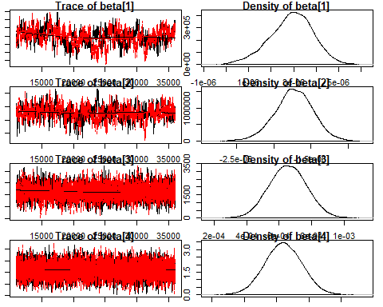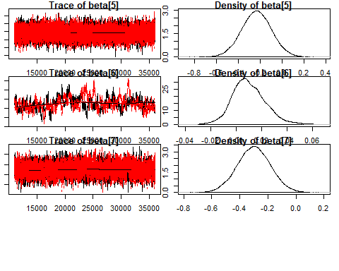

# Low ESS indicates poor convergence, size sample apperas to be large  
effectiveSize(samples)

## beta[1] beta[2] beta[3] beta[4] beta[5] beta[6] beta[7]   
## 179.9811 295.2678 2351.7204 4486.2973 7595.5101 102.2609 3838.0177

# R greater than 1.1 indicates poor convergence   
gelman.diag(samples)

## Potential scale reduction factors:  
##   
## Point est. Upper C.I.  
## beta[1] 1.01 1.01  
## beta[2] 1.00 1.01  
## beta[3] 1.00 1.00  
## beta[4] 1.00 1.00  
## beta[5] 1.00 1.00  
## beta[6] 1.03 1.03  
## beta[7] 1.00 1.01  
##   
## Multivariate psrf  
##   
## 1

sub<- samples[[1]]

ToDO Comments and review of resutls

# b

par(mar=c(1,1,1,1))  
gam<- gambia  
  
y<- gam$pos  
  
x<- as.matrix(gam[-3])  
  
a<- 0  
b<- 0  
id<- 0  
  
r<- 65  
# to store unique locations   
tag<- rep(0, r)  
#unique x value  
x_<- rep(0, r)  
#unique y value   
y_<- rep(0, r)  
  
#creating id of all the various locations 1-65  
for(i in 1:nrow(x)){  
 if(x[i,1] != a && x[i,2] != b){  
 id= id + 1  
 x_[id]= x[i,1]  
 y_[id]=x[i,2]  
 }  
 tag[i]= id  
 a= x[i,1]  
 b= x[i,2]  
}  
  
  
  
data <- list(n=nrow(x),p=ncol(x),Y=y,X=x, r= r, tag = tag)  
  
  
model_string <- textConnection("model{  
   
 # Likelihood  
 for(i in 1:n){  
 Y[i] ~ dbern(pr[i])  
 logit(pr[i]) = inprod(X[i,],beta[]) + re[tag[i]]  
 }  
   
 # Priors  
 for(j in 1:p){  
 beta[j] ~ dnorm(0, 0.01)  
 }  
 for(j in 1:r){  
 re[j] ~ dnorm(0, tau1)  
 }  
 tau1 ~ dgamma(0.01,0.01)  
 }")  
  
  
  
model <- jags.model(model_string,data = data, n.chains=2 ,quiet=TRUE)  
  
  
  
update(model, 10000, progress.bar="none")  
  
  
params <- c("beta", "re")  
samples <- coda.samples(model, variable.names=params, n.iter=25000, progress.bar="none")  
  
summary(samples)

##   
## Iterations = 11001:36000  
## Thinning interval = 1   
## Number of chains = 2   
## Sample size per chain = 25000   
##   
## 1. Empirical mean and standard deviation for each variable,  
## plus standard error of the mean:  
##   
## Mean SD Naive SE Time-series SE  
## beta[1] 4.614e-06 2.099e-06 9.389e-09 3.043e-07  
## beta[2] -1.844e-06 5.455e-07 2.440e-09 6.188e-08  
## beta[3] 6.790e-04 1.237e-04 5.533e-07 2.504e-06  
## beta[4] -4.339e-01 1.593e-01 7.126e-04 2.924e-03  
## beta[5] -3.712e-01 2.167e-01 9.692e-04 3.389e-03  
## beta[6] -4.058e-03 2.768e-02 1.238e-04 5.064e-03  
## beta[7] -4.465e-01 2.676e-01 1.197e-03 8.317e-03  
## re[1] 1.124e+00 4.019e-01 1.797e-03 9.950e-03  
## re[2] 4.818e-01 3.475e-01 1.554e-03 1.013e-02  
## re[3] 4.262e-01 4.767e-01 2.132e-03 8.049e-03  
## re[4] -1.457e-01 4.513e-01 2.018e-03 9.921e-03  
## re[5] 3.211e-01 4.247e-01 1.899e-03 8.335e-03  
## re[6] 1.508e-01 4.643e-01 2.076e-03 8.310e-03  
## re[7] 1.254e+00 3.794e-01 1.697e-03 9.357e-03  
## re[8] -6.600e-01 4.075e-01 1.822e-03 7.190e-03  
## re[9] -1.350e+00 4.291e-01 1.919e-03 1.061e-02  
## re[10] 7.950e-02 4.403e-01 1.969e-03 7.707e-03  
## re[11] 1.064e-01 4.738e-01 2.119e-03 1.119e-02  
## re[12] 8.910e-01 4.006e-01 1.791e-03 7.148e-03  
## re[13] 1.078e+00 4.734e-01 2.117e-03 2.460e-02  
## re[14] -2.697e-01 4.764e-01 2.130e-03 6.980e-03  
## re[15] -7.855e-01 4.562e-01 2.040e-03 1.113e-02  
## re[16] -3.740e-01 4.783e-01 2.139e-03 5.689e-03  
## re[17] 5.055e-01 4.345e-01 1.943e-03 7.030e-03  
## re[18] 1.358e+00 4.558e-01 2.038e-03 7.287e-03  
## re[19] -1.035e-01 4.456e-01 1.993e-03 5.782e-03  
## re[20] 2.972e-01 3.979e-01 1.779e-03 8.097e-03  
## re[21] 9.466e-01 3.953e-01 1.768e-03 6.349e-03  
## re[22] 9.530e-02 4.211e-01 1.883e-03 9.397e-03  
## re[23] 1.216e-01 4.099e-01 1.833e-03 6.553e-03  
## re[24] -1.069e+00 5.823e-01 2.604e-03 7.198e-03  
## re[25] 8.244e-01 4.628e-01 2.070e-03 9.255e-03  
## re[26] -4.579e-01 4.352e-01 1.946e-03 4.569e-03  
## re[27] 2.875e-01 3.918e-01 1.752e-03 3.980e-03  
## re[28] -1.047e+00 5.093e-01 2.278e-03 4.033e-03  
## re[29] -1.380e+00 6.165e-01 2.757e-03 4.504e-03  
## re[30] -1.376e+00 6.371e-01 2.849e-03 5.708e-03  
## re[31] -1.112e+00 4.217e-01 1.886e-03 6.085e-03  
## re[32] -4.767e-01 4.775e-01 2.136e-03 5.470e-03  
## re[33] -1.040e+00 4.334e-01 1.938e-03 8.802e-03  
## re[34] -8.747e-01 4.848e-01 2.168e-03 5.211e-03  
## re[35] -2.600e-01 3.927e-01 1.756e-03 7.806e-03  
## re[36] -7.115e-01 4.994e-01 2.234e-03 5.914e-03  
## re[37] -8.577e-02 4.124e-01 1.844e-03 4.606e-03  
## re[38] -5.196e-01 4.298e-01 1.922e-03 4.684e-03  
## re[39] -6.917e-01 3.906e-01 1.747e-03 9.076e-03  
## re[40] -4.681e-01 4.143e-01 1.853e-03 3.966e-03  
## re[41] -8.269e-01 3.883e-01 1.737e-03 5.847e-03  
## re[42] 3.824e-01 4.152e-01 1.857e-03 1.199e-02  
## re[43] 2.800e-01 4.005e-01 1.791e-03 7.436e-03  
## re[44] -4.722e-01 4.031e-01 1.803e-03 6.193e-03  
## re[45] -4.989e-01 3.146e-01 1.407e-03 5.364e-03  
## re[46] -6.443e-01 4.164e-01 1.862e-03 5.212e-03  
## re[47] 2.592e-02 4.215e-01 1.885e-03 7.630e-03  
## re[48] 7.993e-01 5.739e-01 2.566e-03 5.728e-03  
## re[49] 1.352e+00 5.720e-01 2.558e-03 6.225e-03  
## re[50] 3.067e-01 4.101e-01 1.834e-03 9.660e-03  
## re[51] 4.893e-01 4.013e-01 1.795e-03 6.794e-03  
## re[52] 9.454e-01 3.961e-01 1.772e-03 5.618e-03  
## re[53] 2.035e-02 4.184e-01 1.871e-03 9.842e-03  
## re[54] 8.204e-01 4.062e-01 1.817e-03 7.095e-03  
## re[55] 3.226e-01 3.794e-01 1.697e-03 2.018e-02  
## re[56] 9.139e-01 4.197e-01 1.877e-03 9.345e-03  
## re[57] -2.119e-01 4.123e-01 1.844e-03 7.205e-03  
## re[58] 1.338e-01 5.852e-01 2.617e-03 5.018e-03  
## re[59] -1.266e-02 3.940e-01 1.762e-03 8.707e-03  
## re[60] 6.700e-01 4.259e-01 1.905e-03 7.119e-03  
## re[61] 6.501e-01 4.250e-01 1.901e-03 8.531e-03  
## re[62] -9.832e-01 3.606e-01 1.613e-03 1.129e-02  
## re[63] -4.270e-01 4.023e-01 1.799e-03 9.397e-03  
## re[64] 1.114e+00 5.851e-01 2.617e-03 4.925e-03  
## re[65] -1.219e-01 4.053e-01 1.813e-03 1.093e-02  
##   
## 2. Quantiles for each variable:  
##   
## 2.5% 25% 50% 75% 97.5%  
## beta[1] 3.422e-07 3.271e-06 4.591e-06 5.998e-06 8.695e-06  
## beta[2] -2.907e-06 -2.216e-06 -1.817e-06 -1.462e-06 -8.409e-07  
## beta[3] 4.393e-04 5.960e-04 6.783e-04 7.611e-04 9.227e-04  
## beta[4] -7.444e-01 -5.408e-01 -4.341e-01 -3.259e-01 -1.204e-01  
## beta[5] -7.954e-01 -5.181e-01 -3.702e-01 -2.244e-01 5.155e-02  
## beta[6] -5.728e-02 -2.412e-02 -3.953e-03 1.544e-02 4.951e-02  
## beta[7] -9.727e-01 -6.272e-01 -4.472e-01 -2.655e-01 7.253e-02  
## re[1] 3.359e-01 8.542e-01 1.123e+00 1.394e+00 1.915e+00  
## re[2] -2.025e-01 2.491e-01 4.833e-01 7.138e-01 1.164e+00  
## re[3] -5.018e-01 1.052e-01 4.241e-01 7.479e-01 1.362e+00  
## re[4] -1.039e+00 -4.467e-01 -1.433e-01 1.606e-01 7.376e-01  
## re[5] -5.262e-01 3.566e-02 3.245e-01 6.069e-01 1.152e+00  
## re[6] -7.767e-01 -1.555e-01 1.555e-01 4.591e-01 1.054e+00  
## re[7] 5.246e-01 9.977e-01 1.249e+00 1.507e+00 2.007e+00  
## re[8] -1.490e+00 -9.295e-01 -6.492e-01 -3.815e-01 1.187e-01  
## re[9] -2.222e+00 -1.630e+00 -1.341e+00 -1.056e+00 -5.324e-01  
## re[10] -8.001e-01 -2.137e-01 8.244e-02 3.760e-01 9.407e-01  
## re[11] -8.483e-01 -2.079e-01 1.150e-01 4.295e-01 1.020e+00  
## re[12] 1.048e-01 6.217e-01 8.922e-01 1.159e+00 1.677e+00  
## re[13] 1.473e-01 7.583e-01 1.076e+00 1.398e+00 2.001e+00  
## re[14] -1.228e+00 -5.822e-01 -2.626e-01 5.175e-02 6.402e-01  
## re[15] -1.715e+00 -1.085e+00 -7.749e-01 -4.737e-01 7.961e-02  
## re[16] -1.351e+00 -6.862e-01 -3.612e-01 -4.555e-02 5.278e-01  
## re[17] -3.646e-01 2.160e-01 5.111e-01 8.025e-01 1.337e+00  
## re[18] 4.906e-01 1.047e+00 1.346e+00 1.659e+00 2.286e+00  
## re[19] -1.004e+00 -3.986e-01 -9.527e-02 2.019e-01 7.439e-01  
## re[20] -4.893e-01 3.055e-02 2.972e-01 5.676e-01 1.072e+00  
## re[21] 1.731e-01 6.806e-01 9.474e-01 1.212e+00 1.722e+00  
## re[22] -7.385e-01 -1.890e-01 9.598e-02 3.806e-01 9.176e-01  
## re[23] -6.840e-01 -1.524e-01 1.247e-01 3.986e-01 9.232e-01  
## re[24] -2.281e+00 -1.442e+00 -1.041e+00 -6.675e-01 -8.429e-03  
## re[25] -6.908e-02 5.104e-01 8.192e-01 1.132e+00 1.744e+00  
## re[26] -1.335e+00 -7.452e-01 -4.483e-01 -1.585e-01 3.703e-01  
## re[27] -4.889e-01 2.515e-02 2.913e-01 5.522e-01 1.047e+00  
## re[28] -2.111e+00 -1.375e+00 -1.026e+00 -6.976e-01 -1.054e-01  
## re[29] -2.683e+00 -1.771e+00 -1.344e+00 -9.527e-01 -2.711e-01  
## re[30] -2.717e+00 -1.781e+00 -1.345e+00 -9.375e-01 -2.086e-01  
## re[31] -1.967e+00 -1.387e+00 -1.104e+00 -8.218e-01 -3.160e-01  
## re[32] -1.456e+00 -7.894e-01 -4.658e-01 -1.511e-01 4.342e-01  
## re[33] -1.922e+00 -1.323e+00 -1.026e+00 -7.471e-01 -2.195e-01  
## re[34] -1.875e+00 -1.189e+00 -8.575e-01 -5.409e-01 2.732e-02  
## re[35] -1.041e+00 -5.232e-01 -2.539e-01 4.088e-03 4.979e-01  
## re[36] -1.731e+00 -1.036e+00 -6.986e-01 -3.717e-01 2.336e-01  
## re[37] -9.138e-01 -3.585e-01 -7.951e-02 1.943e-01 7.035e-01  
## re[38] -1.394e+00 -8.028e-01 -5.099e-01 -2.275e-01 2.967e-01  
## re[39] -1.474e+00 -9.508e-01 -6.879e-01 -4.253e-01 6.508e-02  
## re[40] -1.301e+00 -7.402e-01 -4.630e-01 -1.883e-01 3.309e-01  
## re[41] -1.600e+00 -1.086e+00 -8.213e-01 -5.618e-01 -8.310e-02  
## re[42] -4.290e-01 1.007e-01 3.779e-01 6.614e-01 1.211e+00  
## re[43] -4.946e-01 8.704e-03 2.737e-01 5.491e-01 1.070e+00  
## re[44] -1.272e+00 -7.389e-01 -4.695e-01 -1.975e-01 3.037e-01  
## re[45] -1.126e+00 -7.076e-01 -4.953e-01 -2.869e-01 1.120e-01  
## re[46] -1.480e+00 -9.215e-01 -6.367e-01 -3.618e-01 1.518e-01  
## re[47] -8.094e-01 -2.580e-01 2.826e-02 3.068e-01 8.479e-01  
## re[48] -2.848e-01 4.053e-01 7.857e-01 1.180e+00 1.969e+00  
## re[49] 2.849e-01 9.582e-01 1.336e+00 1.724e+00 2.535e+00  
## re[50] -4.944e-01 2.896e-02 3.088e-01 5.829e-01 1.113e+00  
## re[51] -2.831e-01 2.169e-01 4.859e-01 7.555e-01 1.289e+00  
## re[52] 1.768e-01 6.786e-01 9.437e-01 1.208e+00 1.733e+00  
## re[53] -7.975e-01 -2.605e-01 1.789e-02 3.001e-01 8.479e-01  
## re[54] 3.687e-02 5.440e-01 8.166e-01 1.092e+00 1.628e+00  
## re[55] -4.216e-01 6.663e-02 3.218e-01 5.779e-01 1.066e+00  
## re[56] 1.078e-01 6.293e-01 9.085e-01 1.195e+00 1.744e+00  
## re[57] -1.028e+00 -4.880e-01 -2.094e-01 6.726e-02 5.834e-01  
## re[58] -9.978e-01 -2.605e-01 1.273e-01 5.248e-01 1.303e+00  
## re[59] -7.829e-01 -2.762e-01 -1.358e-02 2.524e-01 7.608e-01  
## re[60] -1.539e-01 3.821e-01 6.660e-01 9.551e-01 1.521e+00  
## re[61] -1.657e-01 3.641e-01 6.425e-01 9.297e-01 1.506e+00  
## re[62] -1.704e+00 -1.224e+00 -9.772e-01 -7.398e-01 -2.860e-01  
## re[63] -1.225e+00 -6.955e-01 -4.261e-01 -1.575e-01 3.530e-01  
## re[64] 2.451e-02 7.117e-01 1.092e+00 1.495e+00 2.319e+00  
## re[65] -9.108e-01 -3.951e-01 -1.232e-01 1.493e-01 6.753e-01

su<- summary(samples)  
  
# Low ESS indicates poor convergence, size sample apperas to be large  
effectiveSize(samples)

## beta[1] beta[2] beta[3] beta[4] beta[5] beta[6]   
## 47.54952 82.43096 2440.95655 2976.23093 4108.06151 31.29610   
## beta[7] re[1] re[2] re[3] re[4] re[5]   
## 1033.71457 1622.62513 1171.30998 3509.32895 2074.64614 2596.95923   
## re[6] re[7] re[8] re[9] re[10] re[11]   
## 3136.79696 1643.39827 3205.47073 1647.99409 3307.77330 1900.79455   
## re[12] re[13] re[14] re[15] re[16] re[17]   
## 3142.96445 403.19596 4737.79432 1758.78487 7059.71306 3823.73493   
## re[18] re[19] re[20] re[21] re[22] re[23]   
## 3913.52236 5938.80237 2417.30819 3872.16723 2029.12649 3907.73211   
## re[24] re[25] re[26] re[27] re[28] re[29]   
## 6626.08083 2667.58622 9070.28019 9748.95622 16185.64469 18728.33029   
## re[30] re[31] re[32] re[33] re[34] re[35]   
## 12475.39432 4800.95604 8053.93885 2484.65554 8881.72233 2548.10882   
## re[36] re[37] re[38] re[39] re[40] re[41]   
## 7483.92570 8600.82826 8436.65851 1861.94892 10979.83866 4416.22334   
## re[42] re[43] re[44] re[45] re[46] re[47]   
## 1294.54164 2961.33651 4383.58075 3488.08972 7042.10139 3077.37275   
## re[48] re[49] re[50] re[51] re[52] re[53]   
## 10160.22220 8447.30385 1915.96192 3603.39103 5275.71525 1806.02319   
## re[54] re[55] re[56] re[57] re[58] re[59]   
## 3450.68468 379.91978 2154.35099 3272.16573 13600.09645 2051.88754   
## re[60] re[61] re[62] re[63] re[64] re[65]   
## 3584.40440 2553.53205 1024.09267 1850.45487 14114.93758 1417.70115

# R greater than 1.1 indicates poor convergence   
gelman.diag(samples)

## Potential scale reduction factors:  
##   
## Point est. Upper C.I.  
## beta[1] 1.07 1.28  
## beta[2] 1.01 1.02  
## beta[3] 1.00 1.00  
## beta[4] 1.00 1.00  
## beta[5] 1.00 1.00  
## beta[6] 1.07 1.27  
## beta[7] 1.00 1.02  
## re[1] 1.01 1.05  
## re[2] 1.01 1.04  
## re[3] 1.00 1.00  
## re[4] 1.00 1.01  
## re[5] 1.00 1.01  
## re[6] 1.00 1.00  
## re[7] 1.00 1.01  
## re[8] 1.00 1.02  
## re[9] 1.00 1.01  
## re[10] 1.00 1.01  
## re[11] 1.00 1.00  
## re[12] 1.00 1.01  
## re[13] 1.01 1.05  
## re[14] 1.00 1.00  
## re[15] 1.00 1.00  
## re[16] 1.00 1.01  
## re[17] 1.00 1.02  
## re[18] 1.00 1.01  
## re[19] 1.00 1.01  
## re[20] 1.00 1.00  
## re[21] 1.00 1.01  
## re[22] 1.00 1.00  
## re[23] 1.00 1.02  
## re[24] 1.00 1.02  
## re[25] 1.00 1.00  
## re[26] 1.00 1.00  
## re[27] 1.00 1.00  
## re[28] 1.00 1.00  
## re[29] 1.00 1.00  
## re[30] 1.00 1.01  
## re[31] 1.00 1.01  
## re[32] 1.00 1.02  
## re[33] 1.00 1.01  
## re[34] 1.00 1.00  
## re[35] 1.00 1.01  
## re[36] 1.00 1.01  
## re[37] 1.00 1.00  
## re[38] 1.00 1.00  
## re[39] 1.00 1.02  
## re[40] 1.00 1.01  
## re[41] 1.00 1.00  
## re[42] 1.01 1.04  
## re[43] 1.00 1.01  
## re[44] 1.00 1.00  
## re[45] 1.00 1.00  
## re[46] 1.00 1.00  
## re[47] 1.00 1.00  
## re[48] 1.00 1.00  
## re[49] 1.00 1.00  
## re[50] 1.00 1.02  
## re[51] 1.00 1.01  
## re[52] 1.00 1.00  
## re[53] 1.01 1.03  
## re[54] 1.00 1.02  
## re[55] 1.03 1.11  
## re[56] 1.00 1.01  
## re[57] 1.00 1.01  
## re[58] 1.00 1.00  
## re[59] 1.00 1.02  
## re[60] 1.00 1.00  
## re[61] 1.00 1.02  
## re[62] 1.01 1.03  
## re[63] 1.00 1.02  
## re[64] 1.00 1.00  
## re[65] 1.01 1.03  
##   
## Multivariate psrf  
##   
## 1.04

#mean of random effects  
re<- (su$statistics)  
  
re_<- re[8:nrow(re),1]  
  
pch<- rep(NA, 65)  
  
for(i in 1:65){  
 if(re_[i] >1 ){  
 pch[i]= 19  
 }else if(re_[i] <1 && re_[i] > 0){  
 pch[i]= 20  
 }else{  
 pch[i]= 1  
 }  
}  
  
#plot(x= x_, y =y_, pch = 16, col = "red" )  
plot(gambia.borders, type="l", asp=1,axes=F,cex.main=1.5,xlab="",ylab="",main = "Posterior based on spartial location")  
points(x_, y_, pch = pch)  
legend("topright", legend = c("> 1", "0< RE <1", "<1"),pch= c(19, 20, 1), bty = "n")

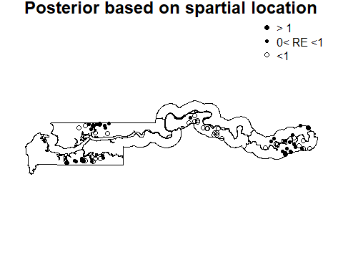

ToDO Comments and review of resutls