HW 10

Robin

April 9, 2019

library(rjags)  
 library(geoR)  
 data("gambia")

# Question 5

# raw data from question 5  
y<- c(2, 15, 14, 16, 18, 22, 28)  
x<- c(29.9,1761, 1807, 2984, 3230, 5040, 5654)  
n<- length(y)  
  
#list to be passed to jag  
data <- list(Y=y,X=x,n=n)  
  
  
model_string <- textConnection("model{  
 for(i in 1:n){  
 Y[i]~ dgamma((a*mu[i]*mu[i]),(a*mu[i]))  
 logit(mu[i]) <- inprod(X[i],beta)  
  
 }  
 beta ~ dnorm(0,0.01)  
 a ~ dgamma(0.1, 0.1)  
}")  
  
  
model <- jags.model(model_string,data = data, n.chains=2 ,quiet=TRUE)  
  
update(model, 10000, progress.bar="none")  
  
  
params <- c("a", "beta")  
samples <- coda.samples(model, variable.names=params, n.iter=25000, progress.bar="none")  
  
#summary   
summary(samples)

##   
## Iterations = 11001:36000  
## Thinning interval = 1   
## Number of chains = 2   
## Sample size per chain = 25000   
##   
## 1. Empirical mean and standard deviation for each variable,  
## plus standard error of the mean:  
##   
## Mean SD Naive SE Time-series SE  
## a 0.06744 0.02604 0.0001165 0.0001671  
## beta 7.99635 6.06866 0.0271399 0.0472126  
##   
## 2. Quantiles for each variable:  
##   
## 2.5% 25% 50% 75% 97.5%  
## a 0.02682 0.04849 0.06398 0.08242 0.1282  
## beta 0.34305 3.19948 6.71799 11.47743 22.6702

#plots   
plot(samples)

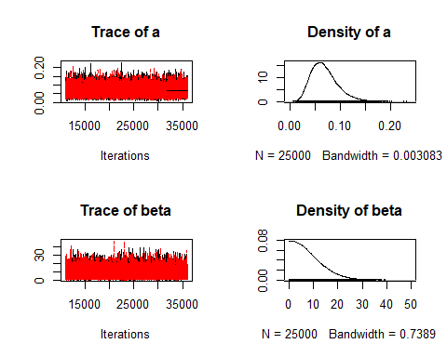

# Low ESS indicates poor convergence, size sample apperas to be large  
effectiveSize(samples)

## a beta   
## 24289.39 16560.91

# R greater than 1.1 indicates poor convergence   
gelman.diag(samples)

## Potential scale reduction factors:  
##   
## Point est. Upper C.I.  
## a 1 1  
## beta 1 1  
##   
## Multivariate psrf  
##   
## 1

sub<- samples[[1]]  
  
plot(density(y), main = "Actual vs Fitted Plot")  
lines(density(sub[,2]), col = "red")  
legend("topright", legend = c("True", "fitted"),col=c("black", "red"), lty=c(1,1), bty = "n")

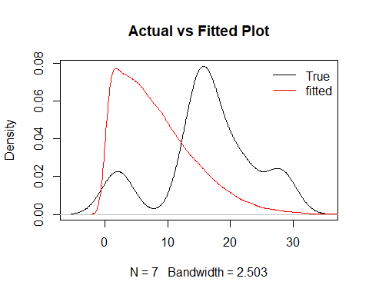

ToDO Comments and review of resutls

# Question 7

# (A)

par(mar=c(1,1,1,1))  
  
#y variable  
y<- gambia$pos  
  
#corvars   
x<- as.matrix(gambia[-3])  
  
data <- list(n=nrow(x),p=ncol(x),Y=y,X=x)  
  
model_string <- textConnection("model{  
  
 # Likelihood  
 for(i in 1:n){  
 Y[i] ~ dbern(pr[i])  
 logit(pr[i]) = inprod(X[i,],beta[])  
 }  
  
 # Priors  
 for(j in 1:p){beta[j] ~ dnorm(0, 0.01)}  
 }")  
  
  
  
model <- jags.model(model_string,data = data, n.chains=2 ,quiet=TRUE)  
  
  
  
update(model, 10000, progress.bar="none")  
  
  
params <- c("beta")  
samples <- coda.samples(model, variable.names=params, n.iter=25000, progress.bar="none")  
  
summary(samples)

##   
## Iterations = 11001:36000  
## Thinning interval = 1   
## Number of chains = 2   
## Sample size per chain = 25000   
##   
## 1. Empirical mean and standard deviation for each variable,  
## plus standard error of the mean:  
##   
## Mean SD Naive SE Time-series SE  
## beta[1] 2.895e-06 9.144e-07 4.090e-09 6.465e-08  
## beta[2] -1.726e-06 2.587e-07 1.157e-09 1.470e-08  
## beta[3] 6.563e-04 1.144e-04 5.118e-07 2.272e-06  
## beta[4] -5.597e-01 1.149e-01 5.140e-04 1.588e-03  
## beta[5] -2.329e-01 1.365e-01 6.104e-04 1.588e-03  
## beta[6] 9.796e-03 1.279e-02 5.720e-05 1.215e-03  
## beta[7] -3.004e-01 1.170e-01 5.231e-04 1.920e-03  
##   
## 2. Quantiles for each variable:  
##   
## 2.5% 25% 50% 75% 97.5%  
## beta[1] 1.047e-06 2.291e-06 2.908e-06 3.521e-06 4.619e-06  
## beta[2] -2.264e-06 -1.893e-06 -1.716e-06 -1.549e-06 -1.243e-06  
## beta[3] 4.328e-04 5.791e-04 6.550e-04 7.335e-04 8.804e-04  
## beta[4] -7.860e-01 -6.371e-01 -5.593e-01 -4.820e-01 -3.344e-01  
## beta[5] -4.990e-01 -3.249e-01 -2.331e-01 -1.406e-01 3.614e-02  
## beta[6] -1.300e-02 8.053e-04 9.038e-03 1.833e-02 3.563e-02  
## beta[7] -5.269e-01 -3.795e-01 -3.004e-01 -2.213e-01 -7.067e-02

plot(samples)

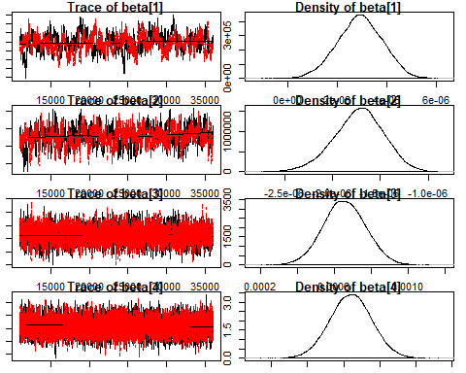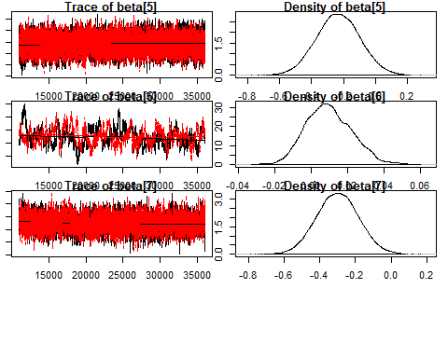

# Low ESS indicates poor convergence, size sample apperas to be large  
effectiveSize(samples)

## beta[1] beta[2] beta[3] beta[4] beta[5] beta[6] beta[7]   
## 200.0733 312.4057 2537.8973 5259.4831 7582.7464 114.5631 4126.2931

# R greater than 1.1 indicates poor convergence   
gelman.diag(samples)

## Potential scale reduction factors:  
##   
## Point est. Upper C.I.  
## beta[1] 1.01 1.04  
## beta[2] 1.00 1.01  
## beta[3] 1.00 1.00  
## beta[4] 1.00 1.00  
## beta[5] 1.00 1.01  
## beta[6] 1.01 1.04  
## beta[7] 1.00 1.01  
##   
## Multivariate psrf  
##   
## 1.01

sub<- samples[[1]]

ToDO Comments and review of resutls

# b

par(mar=c(1,1,1,1))  
gam<- gambia  
  
y<- gam$pos  
  
x<- as.matrix(gam[-3])  
  
a<- 0  
b<- 0  
id<- 0  
  
r<- 65  
# to store unique locations   
tag<- rep(0, r)  
#unique x value  
x_<- rep(0, r)  
#unique y value   
y_<- rep(0, r)  
  
#creating id of all the various locations 1-65  
for(i in 1:nrow(x)){  
 if(x[i,1] != a && x[i,2] != b){  
 id= id + 1  
 x_[id]= x[i,1]  
 y_[id]=x[i,2]  
 }  
 tag[i]= id  
 a= x[i,1]  
 b= x[i,2]  
}  
  
  
  
data <- list(n=nrow(x),p=ncol(x),Y=y,X=x, r= r, tag = tag)  
  
  
model_string <- textConnection("model{  
   
 # Likelihood  
 for(i in 1:n){  
 Y[i] ~ dbern(pr[i])  
 logit(pr[i]) = inprod(X[i,],beta[]) + re[tag[i]]  
 }  
   
 # Priors  
 for(j in 1:p){  
 beta[j] ~ dnorm(0, 0.01)  
 }  
 for(j in 1:r){  
 re[j] ~ dnorm(0, tau1)  
 }  
 tau1 ~ dgamma(0.01,0.01)  
 }")  
  
  
  
model <- jags.model(model_string,data = data, n.chains=2 ,quiet=TRUE)  
  
  
  
update(model, 10000, progress.bar="none")  
  
  
params <- c("beta", "re")  
samples <- coda.samples(model, variable.names=params, n.iter=25000, progress.bar="none")  
  
summary(samples)

##   
## Iterations = 11001:36000  
## Thinning interval = 1   
## Number of chains = 2   
## Sample size per chain = 25000   
##   
## 1. Empirical mean and standard deviation for each variable,  
## plus standard error of the mean:  
##   
## Mean SD Naive SE Time-series SE  
## beta[1] 3.426e-06 2.523e-06 1.128e-08 4.868e-07  
## beta[2] -1.952e-06 6.166e-07 2.758e-09 8.170e-08  
## beta[3] 6.771e-04 1.220e-04 5.454e-07 2.456e-06  
## beta[4] -4.355e-01 1.608e-01 7.193e-04 3.027e-03  
## beta[5] -3.765e-01 2.176e-01 9.732e-04 3.635e-03  
## beta[6] 1.138e-02 3.471e-02 1.552e-04 8.873e-03  
## beta[7] -4.200e-01 2.796e-01 1.250e-03 9.243e-03  
## re[1] 1.057e+00 4.099e-01 1.833e-03 1.267e-02  
## re[2] 4.191e-01 3.523e-01 1.576e-03 1.147e-02  
## re[3] 4.025e-01 4.760e-01 2.129e-03 8.986e-03  
## re[4] -1.697e-01 4.532e-01 2.027e-03 1.183e-02  
## re[5] 2.892e-01 4.269e-01 1.909e-03 9.636e-03  
## re[6] 1.233e-01 4.691e-01 2.098e-03 9.005e-03  
## re[7] 1.224e+00 3.863e-01 1.727e-03 1.015e-02  
## re[8] -7.091e-01 4.107e-01 1.837e-03 8.964e-03  
## re[9] -1.372e+00 4.277e-01 1.913e-03 1.169e-02  
## re[10] 4.072e-02 4.414e-01 1.974e-03 8.524e-03  
## re[11] 1.602e-01 4.859e-01 2.173e-03 1.423e-02  
## re[12] 8.670e-01 3.999e-01 1.788e-03 7.160e-03  
## re[13] 1.202e+00 5.181e-01 2.317e-03 3.758e-02  
## re[14] -2.800e-01 4.799e-01 2.146e-03 7.220e-03  
## re[15] -7.295e-01 4.695e-01 2.100e-03 1.401e-02  
## re[16] -4.020e-01 4.844e-01 2.166e-03 5.989e-03  
## re[17] 4.802e-01 4.393e-01 1.965e-03 7.092e-03  
## re[18] 1.335e+00 4.602e-01 2.058e-03 7.831e-03  
## re[19] -1.282e-01 4.463e-01 1.996e-03 6.748e-03  
## re[20] 2.920e-01 4.024e-01 1.800e-03 8.175e-03  
## re[21] 9.169e-01 3.955e-01 1.769e-03 6.838e-03  
## re[22] 9.224e-02 4.250e-01 1.901e-03 1.018e-02  
## re[23] 1.002e-01 4.033e-01 1.803e-03 7.347e-03  
## re[24] -1.143e+00 5.831e-01 2.608e-03 1.109e-02  
## re[25] 8.308e-01 4.681e-01 2.093e-03 1.101e-02  
## re[26] -4.236e-01 4.339e-01 1.940e-03 4.762e-03  
## re[27] 3.031e-01 3.944e-01 1.764e-03 4.193e-03  
## re[28] -1.087e+00 5.145e-01 2.301e-03 5.591e-03  
## re[29] -1.428e+00 6.223e-01 2.783e-03 7.017e-03  
## re[30] -1.429e+00 6.457e-01 2.887e-03 7.463e-03  
## re[31] -1.162e+00 4.273e-01 1.911e-03 7.229e-03  
## re[32] -5.258e-01 4.800e-01 2.147e-03 6.927e-03  
## re[33] -9.714e-01 4.485e-01 2.006e-03 1.126e-02  
## re[34] -8.321e-01 4.907e-01 2.195e-03 5.646e-03  
## re[35] -1.958e-01 4.031e-01 1.803e-03 9.829e-03  
## re[36] -7.741e-01 5.125e-01 2.292e-03 9.729e-03  
## re[37] -4.071e-02 4.113e-01 1.840e-03 5.387e-03  
## re[38] -4.819e-01 4.369e-01 1.954e-03 5.621e-03  
## re[39] -6.266e-01 3.998e-01 1.788e-03 1.106e-02  
## re[40] -4.845e-01 4.150e-01 1.856e-03 4.387e-03  
## re[41] -8.234e-01 3.892e-01 1.741e-03 6.249e-03  
## re[42] 3.111e-01 4.309e-01 1.927e-03 1.779e-02  
## re[43] 2.377e-01 4.066e-01 1.818e-03 9.250e-03  
## re[44] -4.805e-01 4.106e-01 1.836e-03 6.898e-03  
## re[45] -4.779e-01 3.175e-01 1.420e-03 5.690e-03  
## re[46] -6.479e-01 4.167e-01 1.864e-03 6.254e-03  
## re[47] -1.522e-02 4.349e-01 1.945e-03 1.015e-02  
## re[48] 7.742e-01 5.785e-01 2.587e-03 6.847e-03  
## re[49] 1.339e+00 5.783e-01 2.586e-03 6.558e-03  
## re[50] 2.571e-01 4.246e-01 1.899e-03 1.324e-02  
## re[51] 4.661e-01 4.047e-01 1.810e-03 8.261e-03  
## re[52] 9.456e-01 3.981e-01 1.780e-03 6.626e-03  
## re[53] 1.040e-01 4.352e-01 1.946e-03 1.167e-02  
## re[54] 8.935e-01 4.126e-01 1.845e-03 9.172e-03  
## re[55] 4.640e-01 4.165e-01 1.863e-03 3.170e-02  
## re[56] 8.781e-01 4.281e-01 1.915e-03 1.171e-02  
## re[57] -1.688e-01 4.195e-01 1.876e-03 7.213e-03  
## re[58] 1.436e-01 5.823e-01 2.604e-03 5.166e-03  
## re[59] 6.041e-02 4.067e-01 1.819e-03 1.087e-02  
## re[60] 6.587e-01 4.344e-01 1.943e-03 7.413e-03  
## re[61] 7.249e-01 4.377e-01 1.957e-03 1.050e-02  
## re[62] -8.975e-01 3.706e-01 1.657e-03 1.346e-02  
## re[63] -3.509e-01 4.123e-01 1.844e-03 1.178e-02  
## re[64] 1.110e+00 5.929e-01 2.652e-03 5.892e-03  
## re[65] -3.375e-02 4.158e-01 1.859e-03 1.322e-02  
##   
## 2. Quantiles for each variable:  
##   
## 2.5% 25% 50% 75% 97.5%  
## beta[1] -2.431e-06 1.932e-06 3.493e-06 5.183e-06 8.025e-06  
## beta[2] -3.221e-06 -2.367e-06 -1.934e-06 -1.542e-06 -7.692e-07  
## beta[3] 4.397e-04 5.948e-04 6.774e-04 7.592e-04 9.139e-04  
## beta[4] -7.512e-01 -5.427e-01 -4.357e-01 -3.290e-01 -1.143e-01  
## beta[5] -8.071e-01 -5.230e-01 -3.767e-01 -2.302e-01 4.571e-02  
## beta[6] -5.447e-02 -1.208e-02 9.006e-03 3.178e-02 8.875e-02  
## beta[7] -9.612e-01 -6.056e-01 -4.214e-01 -2.353e-01 1.324e-01  
## re[1] 2.586e-01 7.824e-01 1.054e+00 1.330e+00 1.867e+00  
## re[2] -2.759e-01 1.851e-01 4.178e-01 6.526e-01 1.108e+00  
## re[3] -5.380e-01 8.248e-02 4.054e-01 7.223e-01 1.332e+00  
## re[4] -1.069e+00 -4.687e-01 -1.672e-01 1.325e-01 7.192e-01  
## re[5] -5.521e-01 5.109e-03 2.887e-01 5.755e-01 1.124e+00  
## re[6] -8.053e-01 -1.884e-01 1.264e-01 4.397e-01 1.031e+00  
## re[7] 4.752e-01 9.647e-01 1.222e+00 1.479e+00 1.996e+00  
## re[8] -1.548e+00 -9.769e-01 -6.990e-01 -4.312e-01 7.228e-02  
## re[9] -2.235e+00 -1.654e+00 -1.363e+00 -1.080e+00 -5.531e-01  
## re[10] -8.353e-01 -2.524e-01 4.504e-02 3.382e-01 8.947e-01  
## re[11] -8.050e-01 -1.599e-01 1.628e-01 4.847e-01 1.105e+00  
## re[12] 8.284e-02 5.967e-01 8.674e-01 1.139e+00 1.648e+00  
## re[13] 2.188e-01 8.489e-01 1.190e+00 1.546e+00 2.251e+00  
## re[14] -1.241e+00 -5.987e-01 -2.739e-01 4.554e-02 6.412e-01  
## re[15] -1.660e+00 -1.040e+00 -7.269e-01 -4.132e-01 1.785e-01  
## re[16] -1.389e+00 -7.197e-01 -3.869e-01 -7.315e-02 5.090e-01  
## re[17] -3.937e-01 1.884e-01 4.847e-01 7.770e-01 1.332e+00  
## re[18] 4.529e-01 1.020e+00 1.328e+00 1.639e+00 2.263e+00  
## re[19] -1.025e+00 -4.234e-01 -1.196e-01 1.740e-01 7.197e-01  
## re[20] -5.028e-01 2.392e-02 2.925e-01 5.637e-01 1.080e+00  
## re[21] 1.492e-01 6.515e-01 9.137e-01 1.180e+00 1.698e+00  
## re[22] -7.438e-01 -1.921e-01 9.262e-02 3.782e-01 9.251e-01  
## re[23] -7.095e-01 -1.653e-01 1.032e-01 3.712e-01 8.853e-01  
## re[24] -2.366e+00 -1.516e+00 -1.117e+00 -7.417e-01 -6.967e-02  
## re[25] -7.023e-02 5.134e-01 8.228e-01 1.140e+00 1.767e+00  
## re[26] -1.303e+00 -7.108e-01 -4.156e-01 -1.260e-01 4.037e-01  
## re[27] -4.811e-01 3.992e-02 3.053e-01 5.701e-01 1.070e+00  
## re[28] -2.168e+00 -1.417e+00 -1.063e+00 -7.307e-01 -1.438e-01  
## re[29] -2.752e+00 -1.819e+00 -1.393e+00 -9.916e-01 -3.188e-01  
## re[30] -2.798e+00 -1.840e+00 -1.398e+00 -9.832e-01 -2.523e-01  
## re[31] -2.035e+00 -1.441e+00 -1.152e+00 -8.720e-01 -3.507e-01  
## re[32] -1.507e+00 -8.390e-01 -5.126e-01 -1.976e-01 3.847e-01  
## re[33] -1.881e+00 -1.259e+00 -9.646e-01 -6.715e-01 -1.118e-01  
## re[34] -1.843e+00 -1.148e+00 -8.151e-01 -4.962e-01 8.183e-02  
## re[35] -9.960e-01 -4.636e-01 -1.933e-01 7.155e-02 5.934e-01  
## re[36] -1.826e+00 -1.106e+00 -7.573e-01 -4.275e-01 1.914e-01  
## re[37] -8.553e-01 -3.159e-01 -3.754e-02 2.407e-01 7.506e-01  
## re[38] -1.360e+00 -7.679e-01 -4.723e-01 -1.835e-01 3.507e-01  
## re[39] -1.422e+00 -8.914e-01 -6.250e-01 -3.601e-01 1.571e-01  
## re[40] -1.327e+00 -7.577e-01 -4.743e-01 -2.031e-01 3.058e-01  
## re[41] -1.602e+00 -1.081e+00 -8.188e-01 -5.603e-01 -7.775e-02  
## re[42] -5.339e-01 1.993e-02 3.144e-01 6.020e-01 1.154e+00  
## re[43] -5.508e-01 -3.736e-02 2.346e-01 5.095e-01 1.049e+00  
## re[44] -1.306e+00 -7.535e-01 -4.719e-01 -2.033e-01 3.077e-01  
## re[45] -1.110e+00 -6.887e-01 -4.769e-01 -2.628e-01 1.379e-01  
## re[46] -1.493e+00 -9.225e-01 -6.381e-01 -3.634e-01 1.443e-01  
## re[47] -8.671e-01 -3.090e-01 -1.385e-02 2.788e-01 8.311e-01  
## re[48] -3.210e-01 3.858e-01 7.631e-01 1.148e+00 1.957e+00  
## re[49] 2.655e-01 9.415e-01 1.317e+00 1.711e+00 2.531e+00  
## re[50] -5.781e-01 -2.684e-02 2.551e-01 5.441e-01 1.080e+00  
## re[51] -3.146e-01 1.914e-01 4.636e-01 7.363e-01 1.265e+00  
## re[52] 1.654e-01 6.757e-01 9.439e-01 1.212e+00 1.733e+00  
## re[53] -7.349e-01 -1.905e-01 9.723e-02 3.914e-01 9.742e-01  
## re[54] 9.377e-02 6.140e-01 8.899e-01 1.170e+00 1.715e+00  
## re[55] -3.357e-01 1.859e-01 4.561e-01 7.327e-01 1.317e+00  
## re[56] 4.864e-02 5.894e-01 8.718e-01 1.165e+00 1.723e+00  
## re[57] -9.923e-01 -4.501e-01 -1.646e-01 1.106e-01 6.501e-01  
## re[58] -9.882e-01 -2.462e-01 1.350e-01 5.285e-01 1.297e+00  
## re[59] -7.399e-01 -2.133e-01 6.036e-02 3.323e-01 8.583e-01  
## re[60] -1.712e-01 3.608e-01 6.531e-01 9.487e-01 1.521e+00  
## re[61] -1.180e-01 4.257e-01 7.175e-01 1.016e+00 1.607e+00  
## re[62] -1.634e+00 -1.141e+00 -8.943e-01 -6.508e-01 -1.724e-01  
## re[63] -1.155e+00 -6.291e-01 -3.516e-01 -6.990e-02 4.600e-01  
## re[64] 1.227e-02 7.050e-01 1.085e+00 1.489e+00 2.346e+00  
## re[65] -8.477e-01 -3.143e-01 -3.218e-02 2.424e-01 7.881e-01

su<- summary(samples)  
  
# Low ESS indicates poor convergence, size sample apperas to be large  
effectiveSize(samples)

## beta[1] beta[2] beta[3] beta[4] beta[5] beta[6]   
## 41.55162 63.57458 2465.70030 2823.49160 3727.96016 28.26830   
## beta[7] re[1] re[2] re[3] re[4] re[5]   
## 929.93905 1210.20383 1045.74711 2941.50065 1572.00665 2051.79357   
## re[6] re[7] re[8] re[9] re[10] re[11]   
## 2768.35480 1493.89744 2638.63130 1344.64169 2809.87631 1531.64959   
## re[12] re[13] re[14] re[15] re[16] re[17]   
## 3139.52911 331.39218 4701.29494 1331.42723 6786.81815 3839.82264   
## re[18] re[19] re[20] re[21] re[22] re[23]   
## 3481.16005 4640.75527 2509.77638 3503.72109 1819.84877 3017.58698   
## re[24] re[25] re[26] re[27] re[28] re[29]   
## 5063.85699 2000.78708 8580.34227 8850.74133 11907.97622 10069.75127   
## re[30] re[31] re[32] re[33] re[34] re[35]   
## 9616.27647 3615.70767 7512.71549 2456.87806 9511.02877 2525.21180   
## re[36] re[37] re[38] re[39] re[40] re[41]   
## 4723.40868 7951.25628 6146.67539 2033.86199 9623.17927 3880.90093   
## re[42] re[43] re[44] re[45] re[46] re[47]   
## 1052.38909 2446.67814 3666.82484 3174.08225 4458.99832 2019.76875   
## re[48] re[49] re[50] re[51] re[52] re[53]   
## 7264.29172 8052.59225 1335.51526 2624.33161 3803.89989 1835.76906   
## re[54] re[55] re[56] re[57] re[58] re[59]   
## 2412.16923 329.96791 1546.63100 3406.07563 12703.26188 1662.07637   
## re[60] re[61] re[62] re[63] re[64] re[65]   
## 3443.31896 2192.41332 882.27975 1572.08543 10141.49994 1219.85129

# R greater than 1.1 indicates poor convergence   
gelman.diag(samples)

## Potential scale reduction factors:  
##   
## Point est. Upper C.I.  
## beta[1] 1.06 1.11  
## beta[2] 1.02 1.05  
## beta[3] 1.00 1.00  
## beta[4] 1.00 1.00  
## beta[5] 1.00 1.00  
## beta[6] 1.08 1.08  
## beta[7] 1.00 1.02  
## re[1] 1.00 1.01  
## re[2] 1.00 1.00  
## re[3] 1.00 1.01  
## re[4] 1.00 1.01  
## re[5] 1.00 1.02  
## re[6] 1.00 1.02  
## re[7] 1.01 1.03  
## re[8] 1.00 1.00  
## re[9] 1.00 1.02  
## re[10] 1.00 1.00  
## re[11] 1.00 1.00  
## re[12] 1.00 1.00  
## re[13] 1.01 1.01  
## re[14] 1.00 1.01  
## re[15] 1.00 1.00  
## re[16] 1.00 1.00  
## re[17] 1.00 1.00  
## re[18] 1.00 1.00  
## re[19] 1.00 1.00  
## re[20] 1.00 1.02  
## re[21] 1.00 1.00  
## re[22] 1.00 1.01  
## re[23] 1.00 1.00  
## re[24] 1.00 1.01  
## re[25] 1.00 1.01  
## re[26] 1.00 1.00  
## re[27] 1.00 1.00  
## re[28] 1.00 1.00  
## re[29] 1.00 1.00  
## re[30] 1.00 1.00  
## re[31] 1.00 1.00  
## re[32] 1.00 1.00  
## re[33] 1.00 1.00  
## re[34] 1.00 1.00  
## re[35] 1.00 1.00  
## re[36] 1.00 1.00  
## re[37] 1.00 1.01  
## re[38] 1.00 1.00  
## re[39] 1.00 1.00  
## re[40] 1.00 1.00  
## re[41] 1.00 1.00  
## re[42] 1.00 1.01  
## re[43] 1.00 1.01  
## re[44] 1.00 1.01  
## re[45] 1.01 1.03  
## re[46] 1.00 1.01  
## re[47] 1.00 1.00  
## re[48] 1.00 1.00  
## re[49] 1.00 1.00  
## re[50] 1.00 1.01  
## re[51] 1.00 1.01  
## re[52] 1.00 1.01  
## re[53] 1.00 1.01  
## re[54] 1.00 1.02  
## re[55] 1.02 1.05  
## re[56] 1.00 1.01  
## re[57] 1.00 1.00  
## re[58] 1.00 1.00  
## re[59] 1.01 1.02  
## re[60] 1.00 1.00  
## re[61] 1.01 1.03  
## re[62] 1.01 1.04  
## re[63] 1.01 1.02  
## re[64] 1.00 1.00  
## re[65] 1.01 1.03  
##   
## Multivariate psrf  
##   
## 1.02

#mean of random effects  
re<- (su$statistics)  
  
re_<- re[8:nrow(re),1]  
  
#plot(x= x_, y =y_, pch = 16, col = "red" )  
plot(x_, y_, type='n', ylab = "Y", xlab= "X", main = "Posterior of mean based on spartial location")  
text(x_, y_, label = 1:65, cex=0.6)

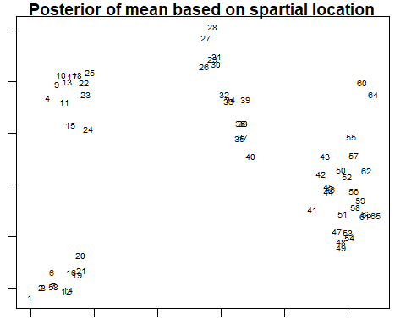 ToDO Comments and review of resutls