HW 10

Robin

April 9, 2019

library(rjags)  
 library(geoR)  
 data("gambia")

# Question 5

# raw data from question 5  
y<- c(2, 15, 14, 16, 18, 22, 28)  
x<- c(29.9,1761, 1807, 2984, 3230, 5040, 5654)  
n<- length(y)  
  
#list to be passed to jag  
data <- list(Y=y,X=x,n=n)  
  
  
model_string <- textConnection("model{  
 for(i in 1:n){  
 Y[i]~ dgamma((a*mu[i]*mu[i]),(a*mu[i]))  
 logit(mu[i]) <- inprod(X[i],beta)  
  
 }  
 beta ~ dnorm(0,0.01)  
 a ~ dgamma(0.1, 0.1)  
}")  
  
  
model <- jags.model(model_string,data = data, n.chains=2 ,quiet=TRUE)  
  
update(model, 10000, progress.bar="none")  
  
  
params <- c("a", "beta")  
samples <- coda.samples(model, variable.names=params, n.iter=25000, progress.bar="none")  
  
#summary   
summary(samples)

##   
## Iterations = 11001:36000  
## Thinning interval = 1   
## Number of chains = 2   
## Sample size per chain = 25000   
##   
## 1. Empirical mean and standard deviation for each variable,  
## plus standard error of the mean:  
##   
## Mean SD Naive SE Time-series SE  
## a 0.06734 0.02612 0.0001168 0.0001674  
## beta 8.00916 6.06109 0.0271060 0.0456313  
##   
## 2. Quantiles for each variable:  
##   
## 2.5% 25% 50% 75% 97.5%  
## a 0.02646 0.04834 0.064 0.08245 0.1281  
## beta 0.34746 3.15948 6.752 11.55616 22.5876

#plots   
plot(samples)

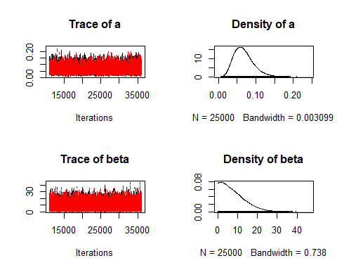

# Low ESS indicates poor convergence, size sample apperas to be large  
effectiveSize(samples)

## a beta   
## 24349.67 17657.58

# R greater than 1.1 indicates poor convergence   
gelman.diag(samples)

## Potential scale reduction factors:  
##   
## Point est. Upper C.I.  
## a 1 1  
## beta 1 1  
##   
## Multivariate psrf  
##   
## 1

sub<- samples[[1]]  
  
plot(density(y), main = "Actual vs Fitted Plot")  
lines(density(sub[,2]), col = "red")  
legend("topright", legend = c("True", "fitted"),col=c("black", "red"), lty=c(1,1), bty = "n")

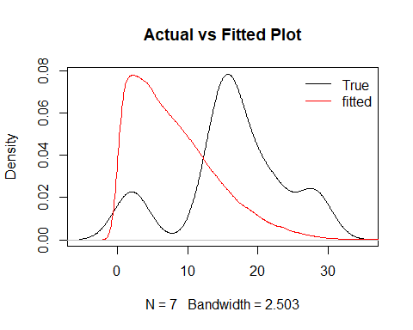

I think we have good convergence based on the Gelman and sample size. Overlaying the actual data to my model density. I don’t see a really great fit.

# Question 7

# (a)

par(mar=c(1,1,1,1))  
  
#y variable  
y<- gambia$pos  
  
#corvars   
x<- as.matrix(gambia[-3])  
  
data <- list(n=nrow(x),p=ncol(x),Y=y,X=x)  
  
model_string <- textConnection("model{  
  
 # Likelihood  
 for(i in 1:n){  
 Y[i] ~ dbern(pr[i])  
 logit(pr[i]) = inprod(X[i,],beta[])  
 }  
  
 # Priors  
 for(j in 1:p){beta[j] ~ dnorm(0, 0.01)}  
 }")  
  
  
  
model <- jags.model(model_string,data = data, n.chains=2 ,quiet=TRUE)  
  
  
  
update(model, 10000, progress.bar="none")  
  
  
params <- c("beta")  
samples <- coda.samples(model, variable.names=params, n.iter=25000, progress.bar="none")  
  
summary(samples)

##   
## Iterations = 11001:36000  
## Thinning interval = 1   
## Number of chains = 2   
## Sample size per chain = 25000   
##   
## 1. Empirical mean and standard deviation for each variable,  
## plus standard error of the mean:  
##   
## Mean SD Naive SE Time-series SE  
## beta[1] 2.894e-06 9.626e-07 4.305e-09 7.234e-08  
## beta[2] -1.731e-06 2.628e-07 1.175e-09 1.530e-08  
## beta[3] 6.537e-04 1.152e-04 5.153e-07 2.376e-06  
## beta[4] -5.582e-01 1.152e-01 5.152e-04 1.734e-03  
## beta[5] -2.331e-01 1.361e-01 6.088e-04 1.563e-03  
## beta[6] 1.001e-02 1.340e-02 5.991e-05 1.341e-03  
## beta[7] -2.995e-01 1.170e-01 5.231e-04 1.930e-03  
##   
## 2. Quantiles for each variable:  
##   
## 2.5% 25% 50% 75% 97.5%  
## beta[1] 8.374e-07 2.279e-06 2.953e-06 3.558e-06 4.654e-06  
## beta[2] -2.277e-06 -1.895e-06 -1.726e-06 -1.557e-06 -1.227e-06  
## beta[3] 4.309e-04 5.754e-04 6.534e-04 7.315e-04 8.790e-04  
## beta[4] -7.842e-01 -6.359e-01 -5.586e-01 -4.804e-01 -3.336e-01  
## beta[5] -5.011e-01 -3.242e-01 -2.327e-01 -1.415e-01 3.506e-02  
## beta[6] -1.439e-02 1.021e-03 8.814e-03 1.807e-02 3.960e-02  
## beta[7] -5.293e-01 -3.778e-01 -2.996e-01 -2.205e-01 -6.970e-02

plot(samples)

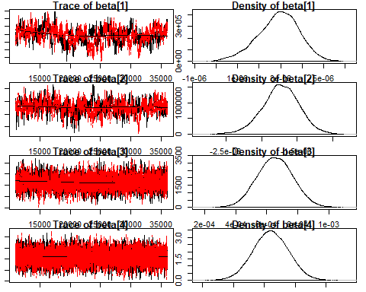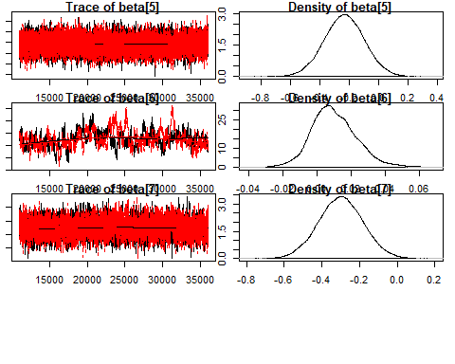

# Low ESS indicates poor convergence, size sample apperas to be large  
effectiveSize(samples)

## beta[1] beta[2] beta[3] beta[4] beta[5] beta[6] beta[7]   
## 179.9811 295.2678 2351.7204 4486.2973 7595.5101 102.2609 3838.0177

# R greater than 1.1 indicates poor convergence   
gelman.diag(samples)

## Potential scale reduction factors:  
##   
## Point est. Upper C.I.  
## beta[1] 1.01 1.01  
## beta[2] 1.00 1.01  
## beta[3] 1.00 1.00  
## beta[4] 1.00 1.00  
## beta[5] 1.00 1.00  
## beta[6] 1.03 1.03  
## beta[7] 1.00 1.01  
##   
## Multivariate psrf  
##   
## 1

sub<- samples[[1]]

Overall, I think the sample size is good. I don’t think the x and y (beta[1] and beta[2]) are not important. We might have a bit of concern about beta6[6] green with low sample size. However, overall over Gelman test shows good convergence. I think it hard to come to a conclusion, because the intervals of the covariates a so close to zero.

# (b)

par(mar=c(1,1,1,1))  
gam<- gambia  
  
y<- gam$pos  
  
x<- as.matrix(gam[-3])  
  
a<- 0  
b<- 0  
id<- 0  
  
r<- 65  
# to store unique locations   
tag<- rep(0, r)  
#unique x value  
x_<- rep(0, r)  
#unique y value   
y_<- rep(0, r)  
  
#creating id of all the various locations 1-65  
for(i in 1:nrow(x)){  
 if(x[i,1] != a && x[i,2] != b){  
 id= id + 1  
 x_[id]= x[i,1]  
 y_[id]=x[i,2]  
 }  
 tag[i]= id  
 a= x[i,1]  
 b= x[i,2]  
}  
  
  
  
data <- list(n=nrow(x),p=ncol(x),Y=y,X=x, r= r, tag = tag)  
  
  
model_string <- textConnection("model{  
   
 # Likelihood  
 for(i in 1:n){  
 Y[i] ~ dbern(pr[i])  
 logit(pr[i]) = inprod(X[i,],beta[]) + re[tag[i]]  
 }  
   
 # Priors  
 for(j in 1:p){  
 beta[j] ~ dnorm(0, 0.01)  
 }  
 for(j in 1:r){  
 re[j] ~ dnorm(0, tau1)  
 }  
 tau1 ~ dgamma(0.01,0.01)  
 }")  
  
  
  
model <- jags.model(model_string,data = data, n.chains=2 ,quiet=TRUE)  
  
  
  
update(model, 10000, progress.bar="none")  
  
  
params <- c("beta", "re")  
samples <- coda.samples(model, variable.names=params, n.iter=25000, progress.bar="none")  
  
summary(samples)

##   
## Iterations = 11001:36000  
## Thinning interval = 1   
## Number of chains = 2   
## Sample size per chain = 25000   
##   
## 1. Empirical mean and standard deviation for each variable,  
## plus standard error of the mean:  
##   
## Mean SD Naive SE Time-series SE  
## beta[1] 4.614e-06 2.099e-06 9.389e-09 3.043e-07  
## beta[2] -1.844e-06 5.455e-07 2.440e-09 6.188e-08  
## beta[3] 6.790e-04 1.237e-04 5.533e-07 2.504e-06  
## beta[4] -4.339e-01 1.593e-01 7.126e-04 2.924e-03  
## beta[5] -3.712e-01 2.167e-01 9.692e-04 3.389e-03  
## beta[6] -4.058e-03 2.768e-02 1.238e-04 5.064e-03  
## beta[7] -4.465e-01 2.676e-01 1.197e-03 8.317e-03  
## re[1] 1.124e+00 4.019e-01 1.797e-03 9.950e-03  
## re[2] 4.818e-01 3.475e-01 1.554e-03 1.013e-02  
## re[3] 4.262e-01 4.767e-01 2.132e-03 8.049e-03  
## re[4] -1.457e-01 4.513e-01 2.018e-03 9.921e-03  
## re[5] 3.211e-01 4.247e-01 1.899e-03 8.335e-03  
## re[6] 1.508e-01 4.643e-01 2.076e-03 8.310e-03  
## re[7] 1.254e+00 3.794e-01 1.697e-03 9.357e-03  
## re[8] -6.600e-01 4.075e-01 1.822e-03 7.190e-03  
## re[9] -1.350e+00 4.291e-01 1.919e-03 1.061e-02  
## re[10] 7.950e-02 4.403e-01 1.969e-03 7.707e-03  
## re[11] 1.064e-01 4.738e-01 2.119e-03 1.119e-02  
## re[12] 8.910e-01 4.006e-01 1.791e-03 7.148e-03  
## re[13] 1.078e+00 4.734e-01 2.117e-03 2.460e-02  
## re[14] -2.697e-01 4.764e-01 2.130e-03 6.980e-03  
## re[15] -7.855e-01 4.562e-01 2.040e-03 1.113e-02  
## re[16] -3.740e-01 4.783e-01 2.139e-03 5.689e-03  
## re[17] 5.055e-01 4.345e-01 1.943e-03 7.030e-03  
## re[18] 1.358e+00 4.558e-01 2.038e-03 7.287e-03  
## re[19] -1.035e-01 4.456e-01 1.993e-03 5.782e-03  
## re[20] 2.972e-01 3.979e-01 1.779e-03 8.097e-03  
## re[21] 9.466e-01 3.953e-01 1.768e-03 6.349e-03  
## re[22] 9.530e-02 4.211e-01 1.883e-03 9.397e-03  
## re[23] 1.216e-01 4.099e-01 1.833e-03 6.553e-03  
## re[24] -1.069e+00 5.823e-01 2.604e-03 7.198e-03  
## re[25] 8.244e-01 4.628e-01 2.070e-03 9.255e-03  
## re[26] -4.579e-01 4.352e-01 1.946e-03 4.569e-03  
## re[27] 2.875e-01 3.918e-01 1.752e-03 3.980e-03  
## re[28] -1.047e+00 5.093e-01 2.278e-03 4.033e-03  
## re[29] -1.380e+00 6.165e-01 2.757e-03 4.504e-03  
## re[30] -1.376e+00 6.371e-01 2.849e-03 5.708e-03  
## re[31] -1.112e+00 4.217e-01 1.886e-03 6.085e-03  
## re[32] -4.767e-01 4.775e-01 2.136e-03 5.470e-03  
## re[33] -1.040e+00 4.334e-01 1.938e-03 8.802e-03  
## re[34] -8.747e-01 4.848e-01 2.168e-03 5.211e-03  
## re[35] -2.600e-01 3.927e-01 1.756e-03 7.806e-03  
## re[36] -7.115e-01 4.994e-01 2.234e-03 5.914e-03  
## re[37] -8.577e-02 4.124e-01 1.844e-03 4.606e-03  
## re[38] -5.196e-01 4.298e-01 1.922e-03 4.684e-03  
## re[39] -6.917e-01 3.906e-01 1.747e-03 9.076e-03  
## re[40] -4.681e-01 4.143e-01 1.853e-03 3.966e-03  
## re[41] -8.269e-01 3.883e-01 1.737e-03 5.847e-03  
## re[42] 3.824e-01 4.152e-01 1.857e-03 1.199e-02  
## re[43] 2.800e-01 4.005e-01 1.791e-03 7.436e-03  
## re[44] -4.722e-01 4.031e-01 1.803e-03 6.193e-03  
## re[45] -4.989e-01 3.146e-01 1.407e-03 5.364e-03  
## re[46] -6.443e-01 4.164e-01 1.862e-03 5.212e-03  
## re[47] 2.592e-02 4.215e-01 1.885e-03 7.630e-03  
## re[48] 7.993e-01 5.739e-01 2.566e-03 5.728e-03  
## re[49] 1.352e+00 5.720e-01 2.558e-03 6.225e-03  
## re[50] 3.067e-01 4.101e-01 1.834e-03 9.660e-03  
## re[51] 4.893e-01 4.013e-01 1.795e-03 6.794e-03  
## re[52] 9.454e-01 3.961e-01 1.772e-03 5.618e-03  
## re[53] 2.035e-02 4.184e-01 1.871e-03 9.842e-03  
## re[54] 8.204e-01 4.062e-01 1.817e-03 7.095e-03  
## re[55] 3.226e-01 3.794e-01 1.697e-03 2.018e-02  
## re[56] 9.139e-01 4.197e-01 1.877e-03 9.345e-03  
## re[57] -2.119e-01 4.123e-01 1.844e-03 7.205e-03  
## re[58] 1.338e-01 5.852e-01 2.617e-03 5.018e-03  
## re[59] -1.266e-02 3.940e-01 1.762e-03 8.707e-03  
## re[60] 6.700e-01 4.259e-01 1.905e-03 7.119e-03  
## re[61] 6.501e-01 4.250e-01 1.901e-03 8.531e-03  
## re[62] -9.832e-01 3.606e-01 1.613e-03 1.129e-02  
## re[63] -4.270e-01 4.023e-01 1.799e-03 9.397e-03  
## re[64] 1.114e+00 5.851e-01 2.617e-03 4.925e-03  
## re[65] -1.219e-01 4.053e-01 1.813e-03 1.093e-02  
##   
## 2. Quantiles for each variable:  
##   
## 2.5% 25% 50% 75% 97.5%  
## beta[1] 3.422e-07 3.271e-06 4.591e-06 5.998e-06 8.695e-06  
## beta[2] -2.907e-06 -2.216e-06 -1.817e-06 -1.462e-06 -8.409e-07  
## beta[3] 4.393e-04 5.960e-04 6.783e-04 7.611e-04 9.227e-04  
## beta[4] -7.444e-01 -5.408e-01 -4.341e-01 -3.259e-01 -1.204e-01  
## beta[5] -7.954e-01 -5.181e-01 -3.702e-01 -2.244e-01 5.155e-02  
## beta[6] -5.728e-02 -2.412e-02 -3.953e-03 1.544e-02 4.951e-02  
## beta[7] -9.727e-01 -6.272e-01 -4.472e-01 -2.655e-01 7.253e-02  
## re[1] 3.359e-01 8.542e-01 1.123e+00 1.394e+00 1.915e+00  
## re[2] -2.025e-01 2.491e-01 4.833e-01 7.138e-01 1.164e+00  
## re[3] -5.018e-01 1.052e-01 4.241e-01 7.479e-01 1.362e+00  
## re[4] -1.039e+00 -4.467e-01 -1.433e-01 1.606e-01 7.376e-01  
## re[5] -5.262e-01 3.566e-02 3.245e-01 6.069e-01 1.152e+00  
## re[6] -7.767e-01 -1.555e-01 1.555e-01 4.591e-01 1.054e+00  
## re[7] 5.246e-01 9.977e-01 1.249e+00 1.507e+00 2.007e+00  
## re[8] -1.490e+00 -9.295e-01 -6.492e-01 -3.815e-01 1.187e-01  
## re[9] -2.222e+00 -1.630e+00 -1.341e+00 -1.056e+00 -5.324e-01  
## re[10] -8.001e-01 -2.137e-01 8.244e-02 3.760e-01 9.407e-01  
## re[11] -8.483e-01 -2.079e-01 1.150e-01 4.295e-01 1.020e+00  
## re[12] 1.048e-01 6.217e-01 8.922e-01 1.159e+00 1.677e+00  
## re[13] 1.473e-01 7.583e-01 1.076e+00 1.398e+00 2.001e+00  
## re[14] -1.228e+00 -5.822e-01 -2.626e-01 5.175e-02 6.402e-01  
## re[15] -1.715e+00 -1.085e+00 -7.749e-01 -4.737e-01 7.961e-02  
## re[16] -1.351e+00 -6.862e-01 -3.612e-01 -4.555e-02 5.278e-01  
## re[17] -3.646e-01 2.160e-01 5.111e-01 8.025e-01 1.337e+00  
## re[18] 4.906e-01 1.047e+00 1.346e+00 1.659e+00 2.286e+00  
## re[19] -1.004e+00 -3.986e-01 -9.527e-02 2.019e-01 7.439e-01  
## re[20] -4.893e-01 3.055e-02 2.972e-01 5.676e-01 1.072e+00  
## re[21] 1.731e-01 6.806e-01 9.474e-01 1.212e+00 1.722e+00  
## re[22] -7.385e-01 -1.890e-01 9.598e-02 3.806e-01 9.176e-01  
## re[23] -6.840e-01 -1.524e-01 1.247e-01 3.986e-01 9.232e-01  
## re[24] -2.281e+00 -1.442e+00 -1.041e+00 -6.675e-01 -8.429e-03  
## re[25] -6.908e-02 5.104e-01 8.192e-01 1.132e+00 1.744e+00  
## re[26] -1.335e+00 -7.452e-01 -4.483e-01 -1.585e-01 3.703e-01  
## re[27] -4.889e-01 2.515e-02 2.913e-01 5.522e-01 1.047e+00  
## re[28] -2.111e+00 -1.375e+00 -1.026e+00 -6.976e-01 -1.054e-01  
## re[29] -2.683e+00 -1.771e+00 -1.344e+00 -9.527e-01 -2.711e-01  
## re[30] -2.717e+00 -1.781e+00 -1.345e+00 -9.375e-01 -2.086e-01  
## re[31] -1.967e+00 -1.387e+00 -1.104e+00 -8.218e-01 -3.160e-01  
## re[32] -1.456e+00 -7.894e-01 -4.658e-01 -1.511e-01 4.342e-01  
## re[33] -1.922e+00 -1.323e+00 -1.026e+00 -7.471e-01 -2.195e-01  
## re[34] -1.875e+00 -1.189e+00 -8.575e-01 -5.409e-01 2.732e-02  
## re[35] -1.041e+00 -5.232e-01 -2.539e-01 4.088e-03 4.979e-01  
## re[36] -1.731e+00 -1.036e+00 -6.986e-01 -3.717e-01 2.336e-01  
## re[37] -9.138e-01 -3.585e-01 -7.951e-02 1.943e-01 7.035e-01  
## re[38] -1.394e+00 -8.028e-01 -5.099e-01 -2.275e-01 2.967e-01  
## re[39] -1.474e+00 -9.508e-01 -6.879e-01 -4.253e-01 6.508e-02  
## re[40] -1.301e+00 -7.402e-01 -4.630e-01 -1.883e-01 3.309e-01  
## re[41] -1.600e+00 -1.086e+00 -8.213e-01 -5.618e-01 -8.310e-02  
## re[42] -4.290e-01 1.007e-01 3.779e-01 6.614e-01 1.211e+00  
## re[43] -4.946e-01 8.704e-03 2.737e-01 5.491e-01 1.070e+00  
## re[44] -1.272e+00 -7.389e-01 -4.695e-01 -1.975e-01 3.037e-01  
## re[45] -1.126e+00 -7.076e-01 -4.953e-01 -2.869e-01 1.120e-01  
## re[46] -1.480e+00 -9.215e-01 -6.367e-01 -3.618e-01 1.518e-01  
## re[47] -8.094e-01 -2.580e-01 2.826e-02 3.068e-01 8.479e-01  
## re[48] -2.848e-01 4.053e-01 7.857e-01 1.180e+00 1.969e+00  
## re[49] 2.849e-01 9.582e-01 1.336e+00 1.724e+00 2.535e+00  
## re[50] -4.944e-01 2.896e-02 3.088e-01 5.829e-01 1.113e+00  
## re[51] -2.831e-01 2.169e-01 4.859e-01 7.555e-01 1.289e+00  
## re[52] 1.768e-01 6.786e-01 9.437e-01 1.208e+00 1.733e+00  
## re[53] -7.975e-01 -2.605e-01 1.789e-02 3.001e-01 8.479e-01  
## re[54] 3.687e-02 5.440e-01 8.166e-01 1.092e+00 1.628e+00  
## re[55] -4.216e-01 6.663e-02 3.218e-01 5.779e-01 1.066e+00  
## re[56] 1.078e-01 6.293e-01 9.085e-01 1.195e+00 1.744e+00  
## re[57] -1.028e+00 -4.880e-01 -2.094e-01 6.726e-02 5.834e-01  
## re[58] -9.978e-01 -2.605e-01 1.273e-01 5.248e-01 1.303e+00  
## re[59] -7.829e-01 -2.762e-01 -1.358e-02 2.524e-01 7.608e-01  
## re[60] -1.539e-01 3.821e-01 6.660e-01 9.551e-01 1.521e+00  
## re[61] -1.657e-01 3.641e-01 6.425e-01 9.297e-01 1.506e+00  
## re[62] -1.704e+00 -1.224e+00 -9.772e-01 -7.398e-01 -2.860e-01  
## re[63] -1.225e+00 -6.955e-01 -4.261e-01 -1.575e-01 3.530e-01  
## re[64] 2.451e-02 7.117e-01 1.092e+00 1.495e+00 2.319e+00  
## re[65] -9.108e-01 -3.951e-01 -1.232e-01 1.493e-01 6.753e-01

su<- summary(samples)  
  
# Low ESS indicates poor convergence, size sample apperas to be large  
effectiveSize(samples)

## beta[1] beta[2] beta[3] beta[4] beta[5] beta[6]   
## 47.54952 82.43096 2440.95655 2976.23093 4108.06151 31.29610   
## beta[7] re[1] re[2] re[3] re[4] re[5]   
## 1033.71457 1622.62513 1171.30998 3509.32895 2074.64614 2596.95923   
## re[6] re[7] re[8] re[9] re[10] re[11]   
## 3136.79696 1643.39827 3205.47073 1647.99409 3307.77330 1900.79455   
## re[12] re[13] re[14] re[15] re[16] re[17]   
## 3142.96445 403.19596 4737.79432 1758.78487 7059.71306 3823.73493   
## re[18] re[19] re[20] re[21] re[22] re[23]   
## 3913.52236 5938.80237 2417.30819 3872.16723 2029.12649 3907.73211   
## re[24] re[25] re[26] re[27] re[28] re[29]   
## 6626.08083 2667.58622 9070.28019 9748.95622 16185.64469 18728.33029   
## re[30] re[31] re[32] re[33] re[34] re[35]   
## 12475.39432 4800.95604 8053.93885 2484.65554 8881.72233 2548.10882   
## re[36] re[37] re[38] re[39] re[40] re[41]   
## 7483.92570 8600.82826 8436.65851 1861.94892 10979.83866 4416.22334   
## re[42] re[43] re[44] re[45] re[46] re[47]   
## 1294.54164 2961.33651 4383.58075 3488.08972 7042.10139 3077.37275   
## re[48] re[49] re[50] re[51] re[52] re[53]   
## 10160.22220 8447.30385 1915.96192 3603.39103 5275.71525 1806.02319   
## re[54] re[55] re[56] re[57] re[58] re[59]   
## 3450.68468 379.91978 2154.35099 3272.16573 13600.09645 2051.88754   
## re[60] re[61] re[62] re[63] re[64] re[65]   
## 3584.40440 2553.53205 1024.09267 1850.45487 14114.93758 1417.70115

# R greater than 1.1 indicates poor convergence   
gelman.diag(samples)

## Potential scale reduction factors:  
##   
## Point est. Upper C.I.  
## beta[1] 1.07 1.28  
## beta[2] 1.01 1.02  
## beta[3] 1.00 1.00  
## beta[4] 1.00 1.00  
## beta[5] 1.00 1.00  
## beta[6] 1.07 1.27  
## beta[7] 1.00 1.02  
## re[1] 1.01 1.05  
## re[2] 1.01 1.04  
## re[3] 1.00 1.00  
## re[4] 1.00 1.01  
## re[5] 1.00 1.01  
## re[6] 1.00 1.00  
## re[7] 1.00 1.01  
## re[8] 1.00 1.02  
## re[9] 1.00 1.01  
## re[10] 1.00 1.01  
## re[11] 1.00 1.00  
## re[12] 1.00 1.01  
## re[13] 1.01 1.05  
## re[14] 1.00 1.00  
## re[15] 1.00 1.00  
## re[16] 1.00 1.01  
## re[17] 1.00 1.02  
## re[18] 1.00 1.01  
## re[19] 1.00 1.01  
## re[20] 1.00 1.00  
## re[21] 1.00 1.01  
## re[22] 1.00 1.00  
## re[23] 1.00 1.02  
## re[24] 1.00 1.02  
## re[25] 1.00 1.00  
## re[26] 1.00 1.00  
## re[27] 1.00 1.00  
## re[28] 1.00 1.00  
## re[29] 1.00 1.00  
## re[30] 1.00 1.01  
## re[31] 1.00 1.01  
## re[32] 1.00 1.02  
## re[33] 1.00 1.01  
## re[34] 1.00 1.00  
## re[35] 1.00 1.01  
## re[36] 1.00 1.01  
## re[37] 1.00 1.00  
## re[38] 1.00 1.00  
## re[39] 1.00 1.02  
## re[40] 1.00 1.01  
## re[41] 1.00 1.00  
## re[42] 1.01 1.04  
## re[43] 1.00 1.01  
## re[44] 1.00 1.00  
## re[45] 1.00 1.00  
## re[46] 1.00 1.00  
## re[47] 1.00 1.00  
## re[48] 1.00 1.00  
## re[49] 1.00 1.00  
## re[50] 1.00 1.02  
## re[51] 1.00 1.01  
## re[52] 1.00 1.00  
## re[53] 1.01 1.03  
## re[54] 1.00 1.02  
## re[55] 1.03 1.11  
## re[56] 1.00 1.01  
## re[57] 1.00 1.01  
## re[58] 1.00 1.00  
## re[59] 1.00 1.02  
## re[60] 1.00 1.00  
## re[61] 1.00 1.02  
## re[62] 1.01 1.03  
## re[63] 1.00 1.02  
## re[64] 1.00 1.00  
## re[65] 1.01 1.03  
##   
## Multivariate psrf  
##   
## 1.04

#mean of random effects  
re<- (su$statistics)  
  
re_<- re[8:nrow(re),1]  
  
pch<- rep(NA, 65)  
  
for(i in 1:65){  
 if(re_[i] >1 ){  
 pch[i]= 19  
 }else if(re_[i] <1 && re_[i] > 0){  
 pch[i]= 20  
 }else{  
 pch[i]= 1  
 }  
}  
  
#plot(x= x_, y =y_, pch = 16, col = "red" )  
plot(gambia.borders, type="l", asp=1,axes=F,cex.main=1.5,xlab="",ylab="",main = "Posterior based on spartial location")  
points(x_, y_, pch = pch)  
legend("topright", legend = c("Higher Outbreak", "Outbreak", "Not Affected"),pch= c(19, 20, 1), bty = "n")

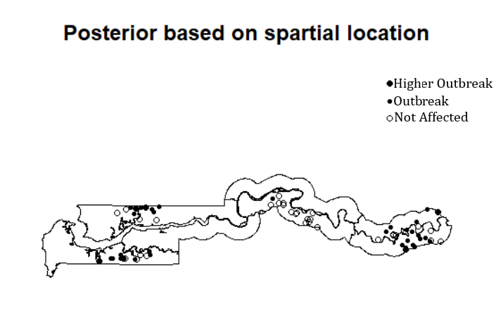

I think we have good convergence for most of the parameters. There a few parameters with low sample size. However, overall according to our Gelman test we appear to have good convergence and large sample size.

The random effect model is the best because we have covariates grouped according to the location(gam$x and gam$y) or villages. With the previous model in part a we did not account for correlation within the same location. In part b we have posterior mean based on the spatial location which is not the case in part a. Since we have the posterior mean we can identify the areas where malaria is more active based on the map above. Researcher can advocate for more mosquito control with these highly affected areas shown on the map above.