RB_HW9

Robin Baldeo

March 30, 2019

library("rjags")  
 library("MASS")

## Question 1

y1<- c(2,-3.1, -1, .2, .3, .4)  
y2<- c(-3.5, -1.6, -4.6, -.9, -5.1, .1)  
  
#using frequentist way  
t.test(y1,y2)

##   
## Welch Two Sample t-test  
##   
## data: y1 and y2  
## t = 2.164, df = 9.5951, p-value = 0.05685  
## alternative hypothesis: true difference in means is not equal to 0  
## 95 percent confidence interval:  
## -0.08533306 4.88533306  
## sample estimates:  
## mean of x mean of y   
## -0.2 -2.6

#mean   
y1bar<- mean(y1)  
y2bar<- mean(y2)  
  
# baysian using formula for pop variance unkown  
s21<- var(y1)  
  
s22<- var(y2)  
  
sp<- sqrt((s21 + s22)/ 2)  
  
# using t table degeee of freedom n1 + n2 = 2.179 from t table  
#low bound   
(y1bar- y2bar) - 2.179 * sp*sqrt(1/length(y1) +1/length(y2) )

## [1] -0.0166279

# upper bound   
(y1bar- y2bar) + 2.179 * sp* sqrt(1/length(y1) + 1/length(y2) )

## [1] 4.816628

Based on the results I don’t think the prior has too much of an effect. When compared to the conventional t- test I get a ci of [-.085, 4.8853] which is close to the Bayesian Ci [-.016, 4.82]. Both methods signify that there is no difference between the placebo and treatment at the 95% ci, because 0 is within the interval.

## Question 2

## (A)

par(mar=c(1,1,1,1))  
data(Boston)  
  
#View(Boston)  
  
#response   
y<- Boston$medv  
  
#covar  
x<- Boston[1:13]  
  
x<- as.matrix(x)  
  
  
n <- length(y)  
p <- ncol(x)  
  
# building a list   
data <- list(Y=y,X=x,n=n,p=p)  
  
model_string <- textConnection("model{  
 # Likelihood  
 for(i in 1:n){  
 Y[i] ~ dnorm(alpha+inprod(X[i,],beta[]),taue)  
 }  
 # Priors  
 for(j in 1:p){  
 beta[j] ~ dnorm(0,0.001)  
 }  
 alpha ~ dnorm(0,0.001)  
 taue ~ dgamma(0.1, 0.1)  
}")  
  
  
model <- jags.model(model_string,data = data, n.chains=2,quiet=TRUE)  
  
update(model, 10000, progress.bar="none")  
  
params <- c("beta", "alpha")  
samples <- coda.samples(model,variable.names=params,n.iter=20000,thin=10, progress.bar="none")  
  
#summary of beta and alpha  
summary(samples)

##   
## Iterations = 10010:30000  
## Thinning interval = 10   
## Number of chains = 2   
## Sample size per chain = 2000   
##   
## 1. Empirical mean and standard deviation for each variable,  
## plus standard error of the mean:  
##   
## Mean SD Naive SE Time-series SE  
## alpha 3.560e+01 4.867957 7.697e-02 6.323e-01  
## beta[1] -1.072e-01 0.032169 5.086e-04 5.264e-04  
## beta[2] 4.613e-02 0.013987 2.212e-04 3.828e-04  
## beta[3] 1.714e-02 0.064434 1.019e-03 2.135e-03  
## beta[4] 2.684e+00 0.859901 1.360e-02 1.516e-02  
## beta[5] -1.736e+01 3.899600 6.166e-02 2.765e-01  
## beta[6] 3.852e+00 0.429029 6.784e-03 3.745e-02  
## beta[7] 7.588e-04 0.013161 2.081e-04 4.760e-04  
## beta[8] -1.462e+00 0.202221 3.197e-03 8.279e-03  
## beta[9] 2.989e-01 0.066205 1.047e-03 2.865e-03  
## beta[10] -1.197e-02 0.003744 5.920e-05 1.930e-04  
## beta[11] -9.413e-01 0.123762 1.957e-03 8.345e-03  
## beta[12] 9.469e-03 0.002698 4.266e-05 9.244e-05  
## beta[13] -5.241e-01 0.051842 8.197e-04 2.154e-03  
##   
## 2. Quantiles for each variable:  
##   
## 2.5% 25% 50% 75% 97.5%  
## alpha 25.47738 32.432465 3.571e+01 38.971992 44.735563  
## beta[1] -0.16931 -0.129230 -1.070e-01 -0.085091 -0.044584  
## beta[2] 0.01785 0.036586 4.632e-02 0.055562 0.073544  
## beta[3] -0.11172 -0.024989 1.764e-02 0.060718 0.144375  
## beta[4] 0.98291 2.103714 2.668e+00 3.248996 4.360080  
## beta[5] -24.65141 -20.076636 -1.746e+01 -14.775249 -9.390641  
## beta[6] 2.99703 3.568384 3.864e+00 4.134161 4.683054  
## beta[7] -0.02438 -0.008209 3.763e-04 0.009916 0.026580  
## beta[8] -1.85341 -1.593139 -1.468e+00 -1.330152 -1.056005  
## beta[9] 0.16672 0.254361 2.989e-01 0.343577 0.427336  
## beta[10] -0.01936 -0.014476 -1.192e-02 -0.009492 -0.004499  
## beta[11] -1.18458 -1.023139 -9.440e-01 -0.860659 -0.688820  
## beta[12] 0.00417 0.007648 9.497e-03 0.011304 0.014795  
## beta[13] -0.62739 -0.558808 -5.229e-01 -0.489942 -0.425297

# convergence diagnostics  
# plots  
plot(samples)

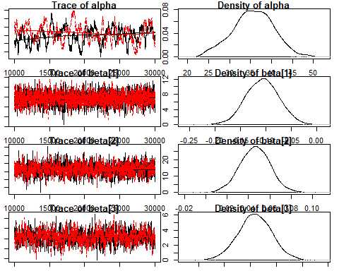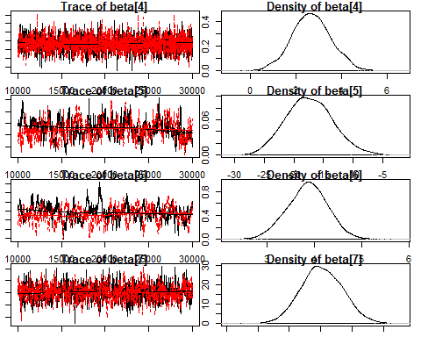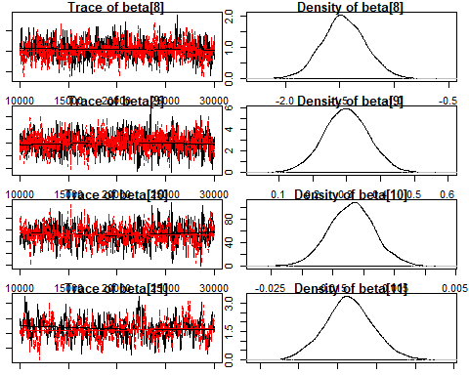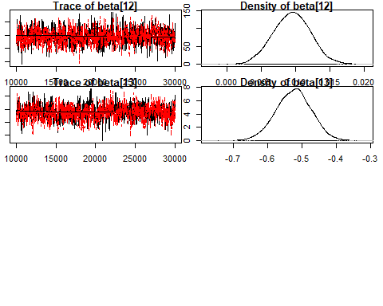

# Low ESS indicates poor convergence, beta10 and the intercept have low sample size  
effectiveSize(samples)

## alpha beta[1] beta[2] beta[3] beta[4] beta[5]   
## 57.80722 3749.15313 1337.63562 940.72272 3266.49737 197.99810   
## beta[6] beta[7] beta[8] beta[9] beta[10] beta[11]   
## 128.59837 806.96170 597.18940 546.15103 376.87984 220.28229   
## beta[12] beta[13]   
## 850.80605 579.33063

# R greater than 1.1 indicates poor convergence, therefore we have good convergence.  
gelman.diag(samples)

## Potential scale reduction factors:  
##   
## Point est. Upper C.I.  
## alpha 1.01 1.02  
## beta[1] 1.00 1.00  
## beta[2] 1.00 1.00  
## beta[3] 1.00 1.00  
## beta[4] 1.00 1.00  
## beta[5] 1.00 1.00  
## beta[6] 1.01 1.03  
## beta[7] 1.00 1.02  
## beta[8] 1.00 1.01  
## beta[9] 1.00 1.00  
## beta[10] 1.00 1.00  
## beta[11] 1.00 1.00  
## beta[12] 1.00 1.00  
## beta[13] 1.00 1.00  
##   
## Multivariate psrf  
##   
## 1.01

My sample size for ptratio appear a bit low, but according to the plots and the gelman test there appears to be good convergence.

## (B)

#liner model  
lsModel<- lm(medv~., data= Boston)  
summary(lsModel)

##   
## Call:  
## lm(formula = medv ~ ., data = Boston)  
##   
## Residuals:  
## Min 1Q Median 3Q Max   
## -15.595 -2.730 -0.518 1.777 26.199   
##   
## Coefficients:  
## Estimate Std. Error t value Pr(>|t|)   
## (Intercept) 3.646e+01 5.103e+00 7.144 3.28e-12 ***  
## crim -1.080e-01 3.286e-02 -3.287 0.001087 **   
## zn 4.642e-02 1.373e-02 3.382 0.000778 ***  
## indus 2.056e-02 6.150e-02 0.334 0.738288   
## chas 2.687e+00 8.616e-01 3.118 0.001925 **   
## nox -1.777e+01 3.820e+00 -4.651 4.25e-06 ***  
## rm 3.810e+00 4.179e-01 9.116 < 2e-16 ***  
## age 6.922e-04 1.321e-02 0.052 0.958229   
## dis -1.476e+00 1.995e-01 -7.398 6.01e-13 ***  
## rad 3.060e-01 6.635e-02 4.613 5.07e-06 ***  
## tax -1.233e-02 3.760e-03 -3.280 0.001112 **   
## ptratio -9.527e-01 1.308e-01 -7.283 1.31e-12 ***  
## black 9.312e-03 2.686e-03 3.467 0.000573 ***  
## lstat -5.248e-01 5.072e-02 -10.347 < 2e-16 ***  
## ---  
## Signif. codes: 0 '***' 0.001 '**' 0.01 '*' 0.05 '.' 0.1 ' ' 1  
##   
## Residual standard error: 4.745 on 492 degrees of freedom  
## Multiple R-squared: 0.7406, Adjusted R-squared: 0.7338   
## F-statistic: 108.1 on 13 and 492 DF, p-value: < 2.2e-16

confint(lsModel)

## 2.5 % 97.5 %  
## (Intercept) 26.432226009 46.486750761  
## crim -0.172584412 -0.043438304  
## zn 0.019448778 0.073392139  
## indus -0.100267941 0.141385193  
## chas 0.993904193 4.379563446  
## nox -25.271633564 -10.261588893  
## rm 2.988726773 4.631003640  
## age -0.025262320 0.026646769  
## dis -1.867454981 -1.083678710  
## rad 0.175692169 0.436406789  
## tax -0.019723286 -0.004945902  
## ptratio -1.209795296 -0.695699168  
## black 0.004034306 0.014589060  
## lstat -0.624403622 -0.425113133

Comparing the Bayesian linear regression model in part a (uninformative prior) to the frequentist linear regression model. I don’t see in major difference in the parameter means , sd and ci. It appears that both methods produce near identical results.

## (C)

#model with double exponential prior  
model_string <- textConnection("model{  
 # Likelihood  
 for(i in 1:n){  
 Y[i] ~ dnorm(alpha+inprod(X[i,],beta[]),taue)  
 }  
 # Priors  
 for(j in 1:p){  
 beta[j] ~ dnorm(0,taue * taub)  
 }  
 alpha ~ dnorm(0,0.001)  
 taue ~ dgamma(0.1, 0.1)  
 taub ~ dgamma(0.1, 0.1)  
}")  
  
  
model <- jags.model(model_string,data = data, n.chains=2,quiet=TRUE)  
  
  
update(model, 10000, progress.bar="none")  
  
  
params <- c("beta", "alpha")  
samples <- coda.samples(model,variable.names=params,n.iter=20000,thin=10, progress.bar="none")  
  
#summary data  
summary(samples)

##   
## Iterations = 10010:30000  
## Thinning interval = 10   
## Number of chains = 2   
## Sample size per chain = 2000   
##   
## 1. Empirical mean and standard deviation for each variable,  
## plus standard error of the mean:  
##   
## Mean SD Naive SE Time-series SE  
## alpha 27.831367 4.250489 6.721e-02 5.318e-01  
## beta[1] -0.101683 0.032434 5.128e-04 5.230e-04  
## beta[2] 0.049216 0.013777 2.178e-04 3.737e-04  
## beta[3] -0.036235 0.059961 9.481e-04 2.072e-03  
## beta[4] 2.086782 0.814635 1.288e-02 1.480e-02  
## beta[5] -3.579076 2.501056 3.955e-02 1.260e-01  
## beta[6] 3.746640 0.400827 6.338e-03 3.295e-02  
## beta[7] -0.009966 0.012987 2.053e-04 4.595e-04  
## beta[8] -1.261064 0.194179 3.070e-03 7.544e-03  
## beta[9] 0.281388 0.064072 1.013e-03 2.664e-03  
## beta[10] -0.013873 0.003768 5.958e-05 1.895e-04  
## beta[11] -0.807703 0.123789 1.957e-03 8.516e-03  
## beta[12] 0.010007 0.002792 4.415e-05 9.886e-05  
## beta[13] -0.554019 0.051443 8.134e-04 1.873e-03  
##   
## 2. Quantiles for each variable:  
##   
## 2.5% 25% 50% 75% 97.5%  
## alpha 20.217494 24.670462 27.678692 30.846340 36.349122  
## beta[1] -0.165496 -0.123039 -0.101379 -0.079803 -0.040353  
## beta[2] 0.023006 0.039930 0.049094 0.058270 0.075835  
## beta[3] -0.154627 -0.078353 -0.036328 0.005273 0.080614  
## beta[4] 0.540570 1.525112 2.076819 2.632478 3.718103  
## beta[5] -9.790344 -4.907032 -3.216946 -1.802903 0.289694  
## beta[6] 2.946193 3.469627 3.750413 4.021908 4.523951  
## beta[7] -0.035712 -0.018676 -0.009768 -0.001108 0.015120  
## beta[8] -1.651951 -1.392012 -1.260056 -1.131954 -0.877538  
## beta[9] 0.157248 0.237572 0.280705 0.322946 0.411491  
## beta[10] -0.021446 -0.016334 -0.013850 -0.011401 -0.006524  
## beta[11] -1.069384 -0.889713 -0.801395 -0.721662 -0.577755  
## beta[12] 0.004386 0.008163 0.009995 0.011899 0.015507  
## beta[13] -0.657355 -0.587783 -0.553368 -0.519917 -0.455526

Comparing the Bayesian linear regression model in part a (uninformative prior) to part c, we see the all the summary values are different. It appears the prior has a greater effect on the data than in part a. Also, the ci in part c appears much more narrow , the means and sd for each parameter appears much smaller when compared to part a.

## (D)

##data  
#taking the frist 500 rows   
y<- Boston$medv[1:500]  
  
#taking the covar, 500 rows  
x<- (Boston[1:13])[1:500,]  
  
##ppd data to be passed to JAGS  
yPp<- y[495:500]  
xPp<- x[495:500, ]  
#scaling matrix  
X_<- as.matrix(xPp)  
  
  
#obs Data to be passed to JAGS  
Y<- y[1:494]  
xob<- x[1:494, ]  
#scaling   
X<- as.matrix(xob)  
  
  
# of obs in obs matrix  
n <- length(Y)  
p <- ncol(xob)  
  
# of obs in predi matrix  
n_<- length(yPp)  
  
data <- list(Y=Y,X=X,n=n,p=p, n_= n_, X_= X_)  
  
#jags model  
model_string <- textConnection("model{  
 # Likelihood  
 for(i in 1:n){  
 Y[i] ~ dnorm(alpha+inprod(X[i,],beta[]),taue)  
 }  
  
 # Priors  
 for(j in 1:p){  
 beta[j] ~ dnorm(0,0.001)  
   
 }  
   
 alpha ~ dnorm(0,0.001)  
 taue ~ dgamma(0.1, 0.1)  
   
 #prediction  
 for(i in 1:n_){  
 Y_[i] ~ dnorm(alpha+inprod(X_[i,],beta[]),taue)  
 }  
  
}")  
  
  
model <- jags.model(model_string,data = data, n.chains=2,quiet=TRUE)  
update(model, 10000, progress.bar="none")  
params <- c("Y_")  
  
samples <- coda.samples(model,variable.names=params,n.iter=20000,thin=10, progress.bar="none")  
  
preM<- summary(samples)  
  
pMean<- preM$statistics[,1]  
  
sub<- samples[[1]]  
  
#plot the ppd   
for(i in 1:length(yPp)){  
 plot(density(sub[,i]),xlab="Y",main=paste("PPD", i))  
 #true means  
 abline(v = yPp[i], col= "red")  
 #pred means  
 abline(v= pMean[i], col = "blue")  
 legend("topright", legend = c("True", "Predicted"),col=c("red", "blue"), lty=c(1,1), bty = "n")  
}

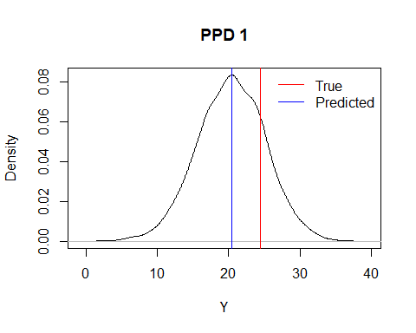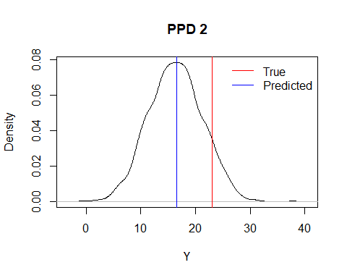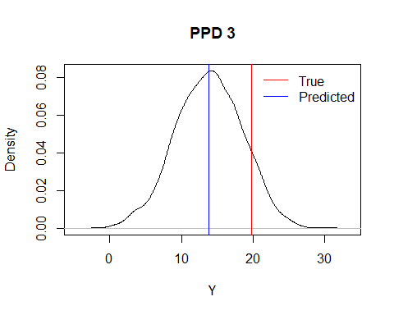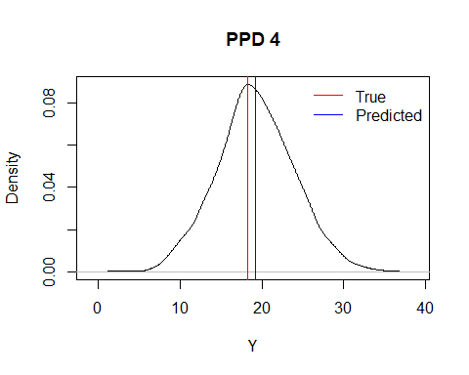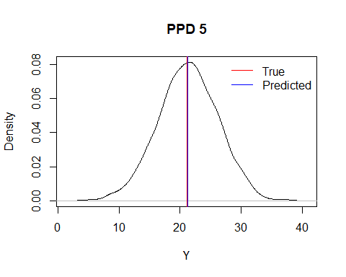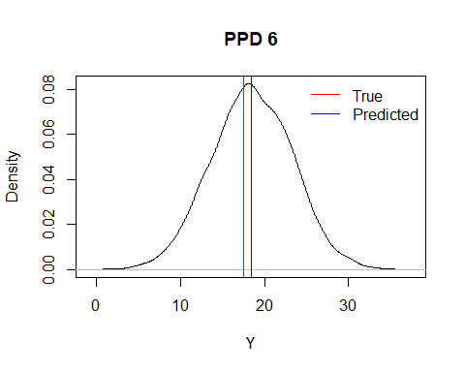

I think the predictions are reasonable, The above plots indicate this for each of the 6 plots showing the predicted means(blue) with the true means( red). As we can see these values are not too far apart.