Midterm 2

Robin

April 14, 2019

## Introduction

The data consist of metrological data over the past 50 years, each year has 10 measurements of sea surface temperature taken at 10 spatial location in the Atlantic Ocean within the past 6 months. The response is the number of tropical storms that make landfall in the US Atlantic Coast. The goal of my investigation is model the data using three models then pick the best model and use this model to predict the number of storms to make landfall in the 50th year and the locations most predictive of these tropical storms.

## Methods

For my experiment I used three models. All models are Poisson regression models with three different shrinkage priors. Poisson was used because the response consists of count data. Shrinkage priors were used because the numbers of covariates(p) exceeds the numbers of observations(n) and because of this I think some of the covariates were not significant and contributed noise to the overall model. Let $Y_{i}$ be the number of tropical storms $i=1,...,50$.

First model:

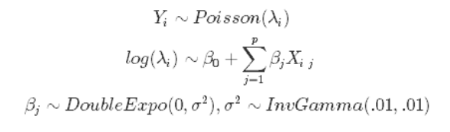

Second model:

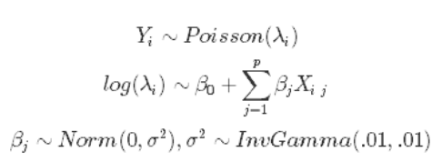

Third model:

