**JSON Data with BMIRange and BMICategory-**

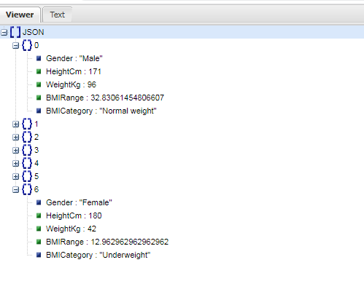

**Group by BMICategory-**

