HOW TO: Installing Find-Object
By Pablo Moreira

This HOW-TO was performed on an Ubuntu 14.04 64 bits machine.

1 – Installing the dependencies

OpenCV Library

To install all dependencies for Find-Object, open the terminal and follow the instructions bellow.

First thing is to make sure that your system is updated and upgraded.

$ sudo apt-get update
$ sudo apt-get upgrade
Now, you need to install many dependencies.
$ sudo apt-get install build-essential libgtk2.0-dev libjpeg-dev libtiff4-dev libjasper-dev libopenexr-dev cmake python-dev python-numpy python-tk libtbb-dev libeigen3-dev yasm libfaac-dev libopencore-amrnb-dev libopencore-amrwb-dev libtheora-dev libvorbis-dev libxvidcore-dev libx264-dev libqt4-dev libqt4-opengl-dev sphinx-common texlive-latex-extra libv4l-dev libdc1394-22-dev libavcodec-dev libavformat-dev libswscale-dev default-jdk ant libvtk5-qt4-dev
Now, it is time to get OpenCV Source Code.
$ cd ~
$ wget http://sourceforge.net/projects/opencvlibrary/files/opencv-unix/2.4.9/opencv-2.4.9.zip
$ unzip opencv-2.4.9.zip
$ cd opencv-2.4.9
$ mkdir build
$ cd build
$ cmake -D WITH_TBB=ON -D BUILD_NEW_PYTHON_SUPPORT=ON -D WITH_V4L=ON -D INSTALL_C_EXAMPLES=ON -D INSTALL_PYTHON_EXAMPLES=ON -D BUILD_EXAMPLES=ON -D WITH_QT=ON -D WITH_OPENGL=ON -D WITH_VTK=ON ..
Now, we are ready to compile and install OpenCV 2.4.9.
$ make
$ sudo make install
Open the file bellow and add the next line to the end of this file.
$ sudo gedit /etc/ld.so.conf.d/opencv.conf
/usr/local/lib

The line bellow configure the library.
$ sudo ldconfig
You have to edit another file. Open the file below and add the next two lines to the end of it.
$ sudo gedit /etc/bash.bashrc
PKG_CONFIG_PATH=$PKG_CONFIG_PATH:/usr/local/lib/pkgconfig
export PKG_CONFIG_PATH
Close your terminal and open it again, logout or restart the computer and you are set.
2 – Downloading, compiling and installing Find-object

$ wget http://find-object.googlecode.com/files/Find-Object-0.4.0-Source.zip
$ unzip Find-Object-0.4.0-Source.zip
$ cd Find-Object-0.4.0-Source/build
$ cmake ..
$ make
$ sudo make install

3 – Running and using Find-Object

To run Find-Object, open the terminal, type find_object and then press [ENTER].

$ find_object

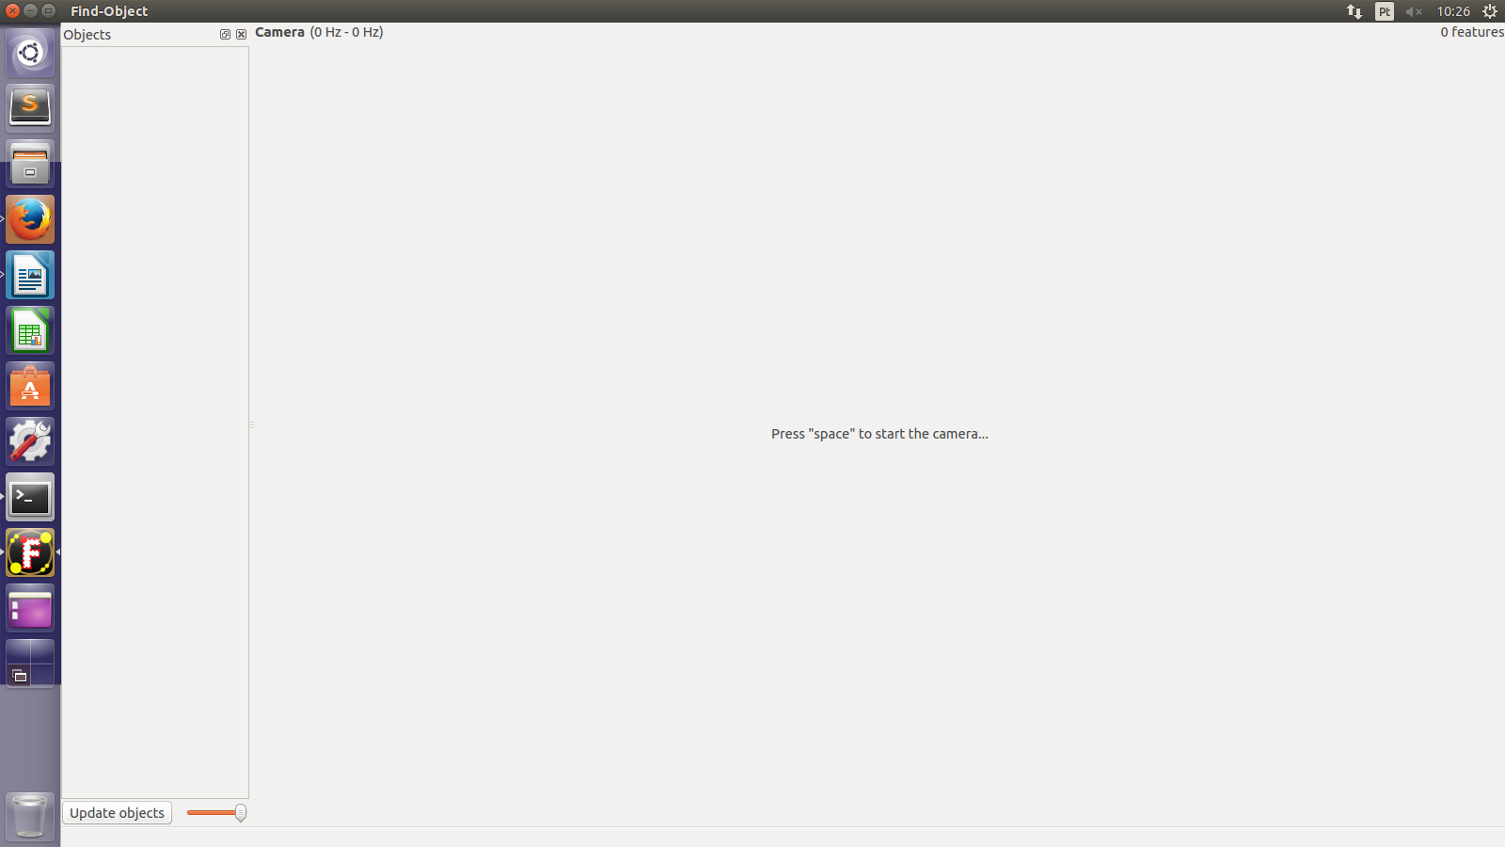
Figure 1. Find-Object running.
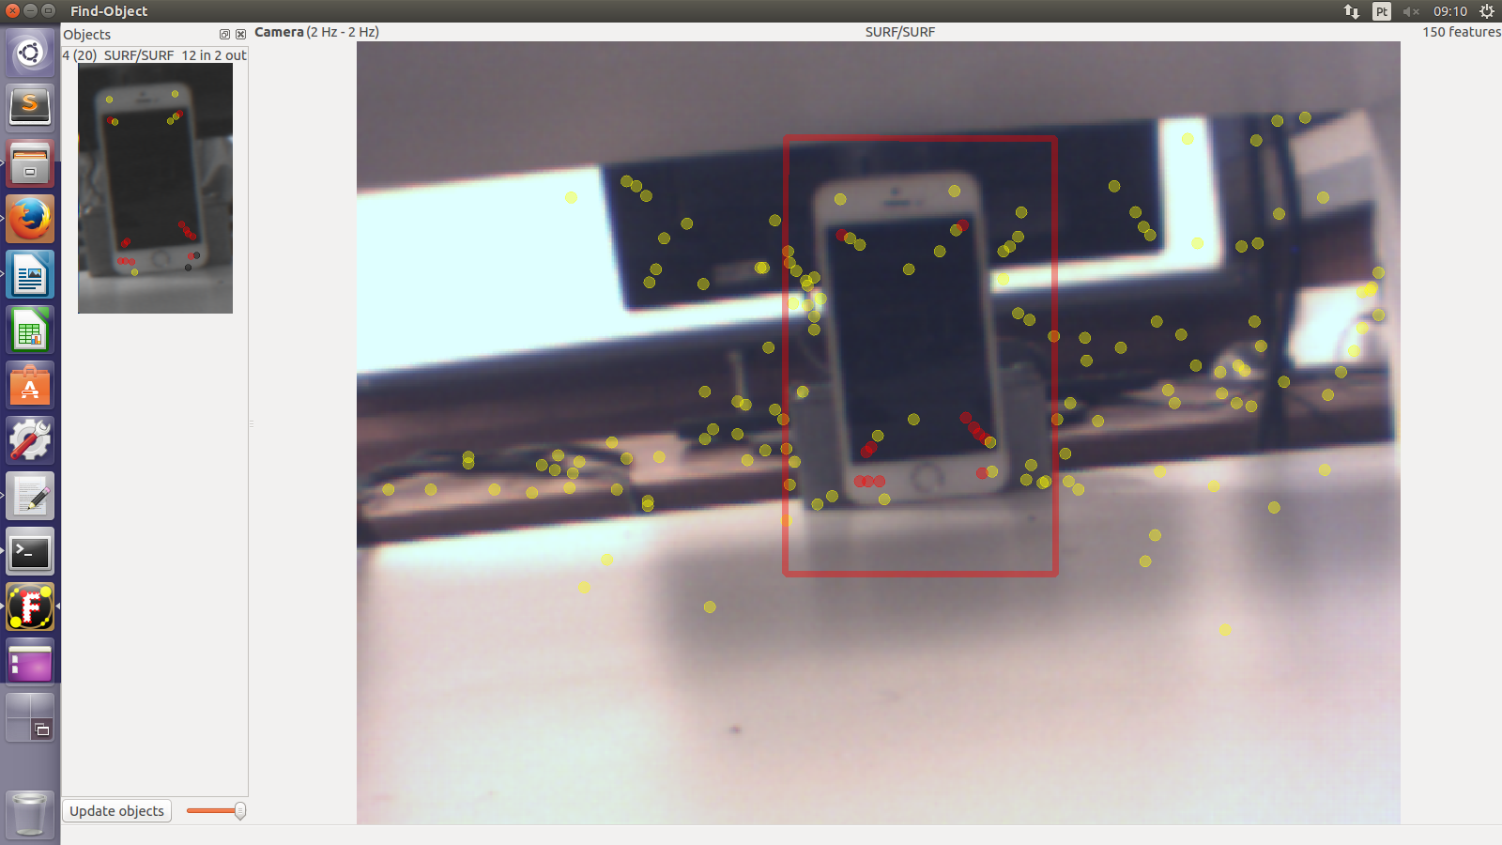
Figure 2. Find-Object is recognizing a cellphone.

