SIGN LANGUAGE TO SPEECH CONVERSION

SCOPE

Speech and Hearing disabled people use sign language to communicate with other people. However, it is possible only for those who have undergone special training to understand the language. The objective of the project is to develop a system that helps a speech disabled person to communicate with others by efficiently converting sign language to speech.

This comprises of two modules as follows. First module involves detection of sign language gestures. This will use Image processing and computer vision techniques combined with machine learning/deep learning approach to predict the gesture. Second module involves concatenating the predicted gestures and converting it to speech.

RELATED WORK

Existing systems use Long term Convolutional Neural Network(LRCN) to interpret the signs and a text to speech system to speak the interpreted sign. There are also systems that use 3D Convolutional network where he convolutions would be applied in three dimensions, with the first two dimensions being the image and the third dimension being time.

Some systems, instead of being trained using a CNN on individual frames from a video stream, use optical flow representations which represent the pattern of apparent motion between two consecutive frames. Models trained on video stream representing the motion between frames is said to produce a better accuracy. In such cases, Deep Learning is applied to video streams.

Teachable Machine, is a system that was developed using kNN. The image in this case is first passed through a small neural network called SqueezeNet. The output from the penultimate layer of this network is then fed into the kNN which classifies it by finding its label.

One of the existing systems, uses TensorFlow.js as it can be interfaced well with the text-to-Speech APIs that modern browsers support. Also, creating dataset for training would be made faster and easier.

WORK PROGRESS

Finished Work:

- Kaggle’s sign language dataset for alphabets was made use. Image data was deconstructed and given in the form of pixel information. A script was written to re-construct the pixels into image. A total of 27454 images were reconstructed.

- The images were segregated into class according to their class labels. Their were a total of 24 classes.

- A CNN architecture was used to train the model. The architecture consists of 2 convolution layers, 2 max pooling layers, 1 flatten layer and 2 dense layers.
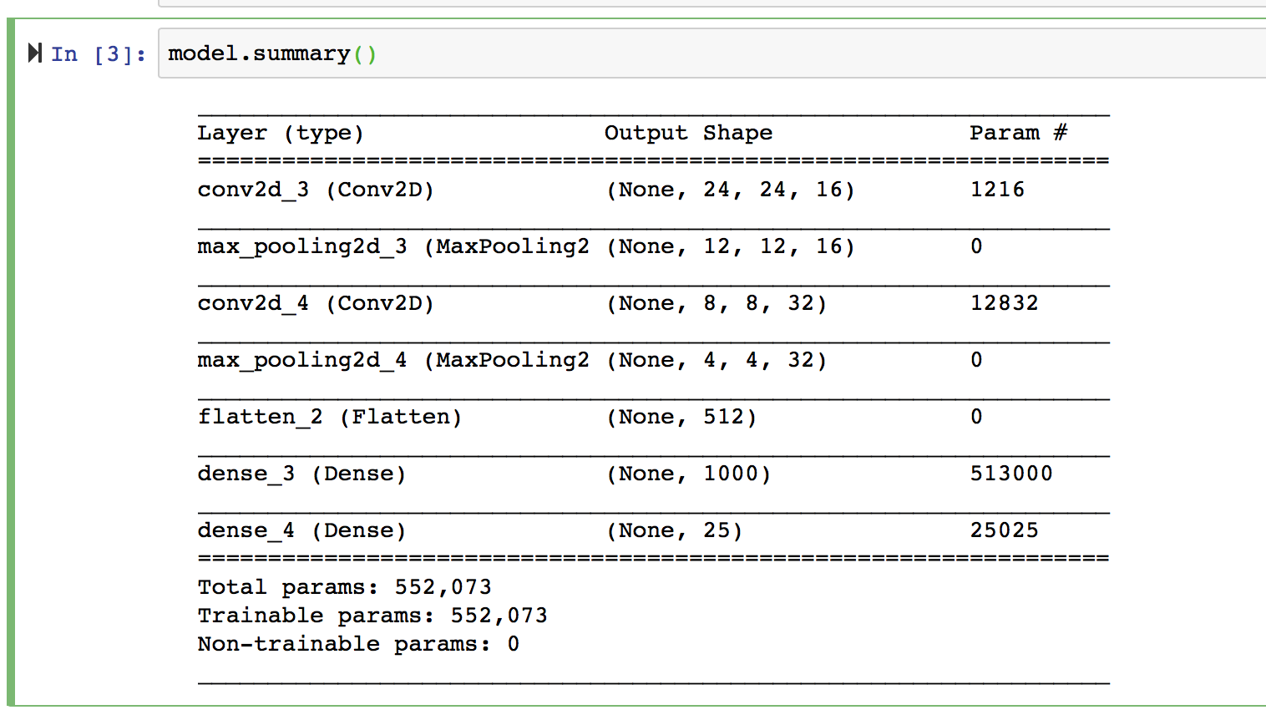

- This model was used to predict on frames captured from a live stream. Results were as follows. A specified portion of the frame denoted by the blue border was used to read the gestures. Input gesture was fed to the neural network as the test image. Predicted result of the label was displayed on the side.

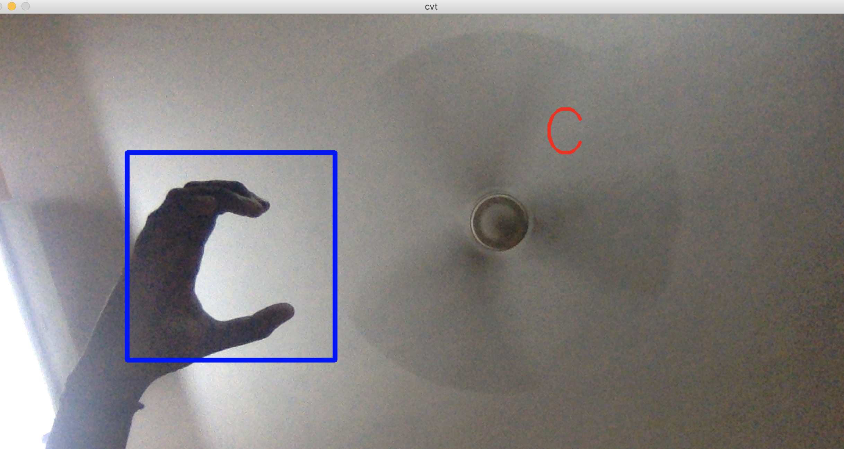

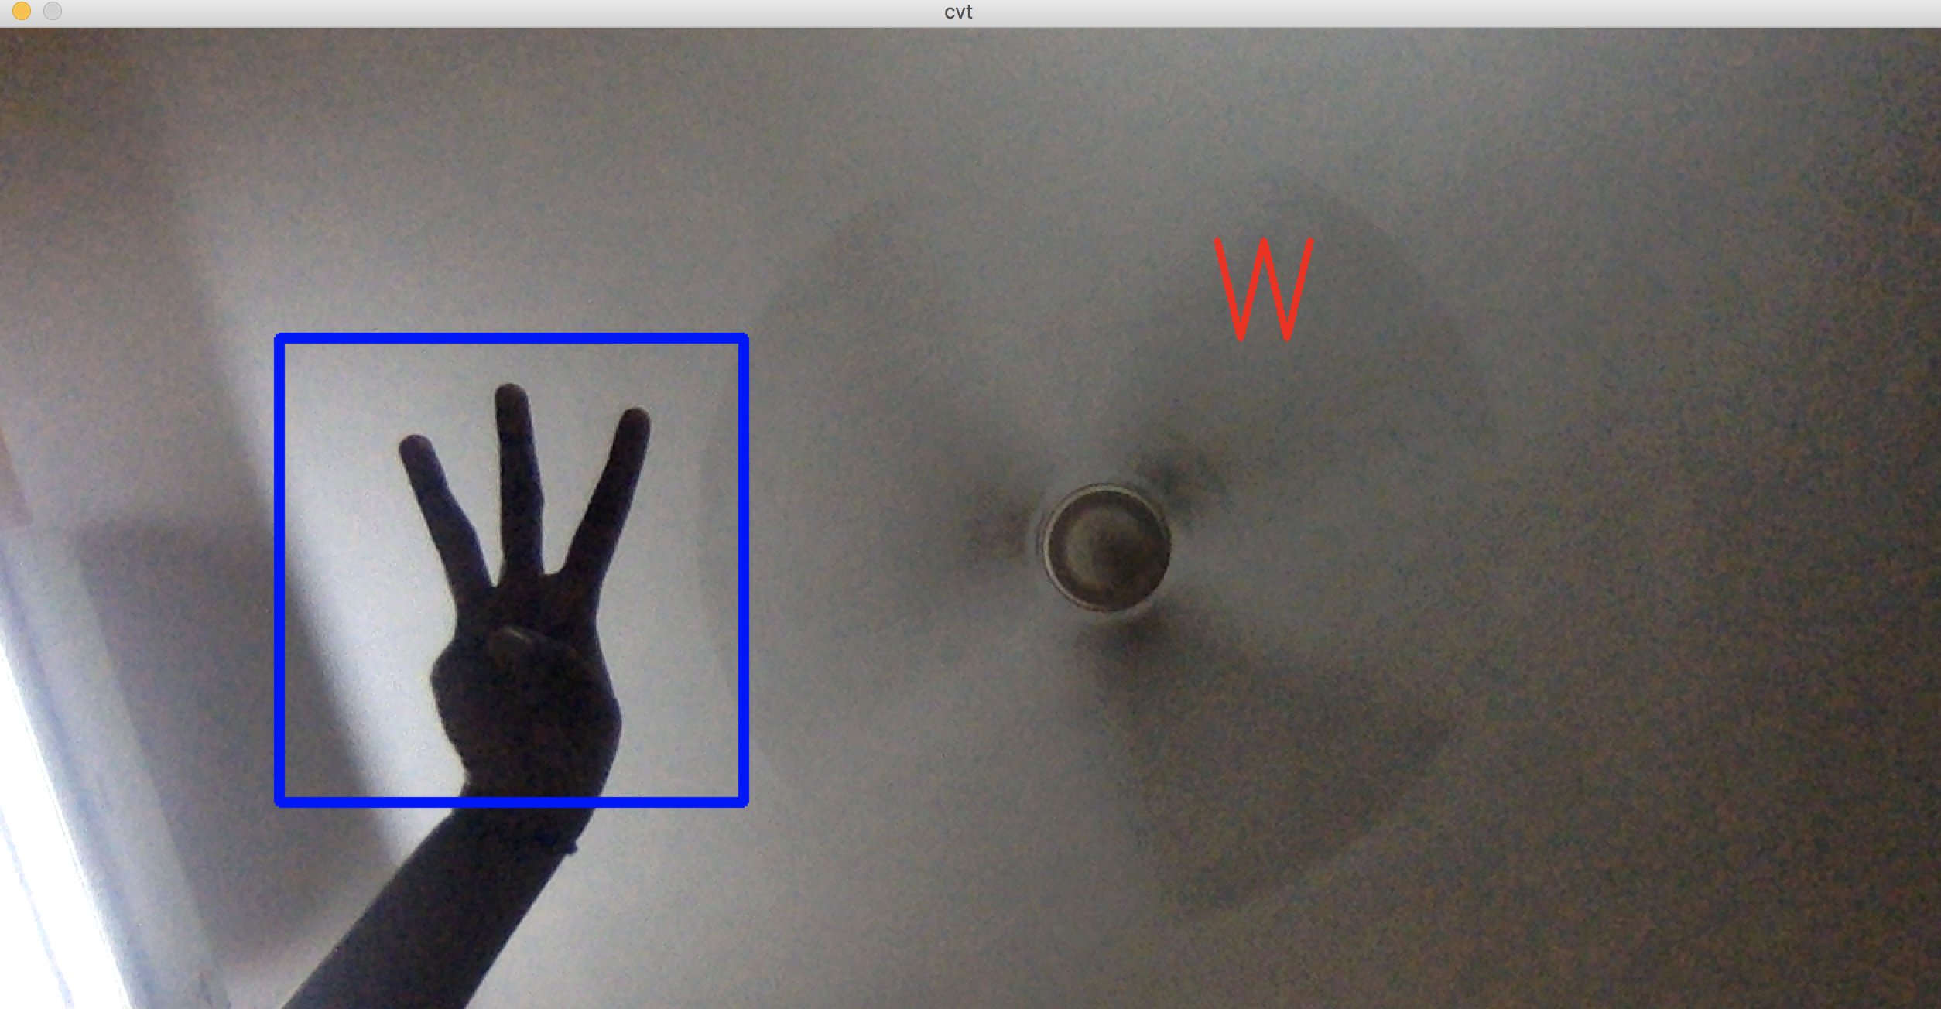

Future Work:

- Hand detection has to be incorporated so that the region of interest can be found in a dynamic way.

- Generative Adversial Network(GAN) technique can be used to generate artificial data to enlarge the dataset.

- Training data can be fed to a model with more number of layers and the accuracy measures can be compared.

