USER MANUAL

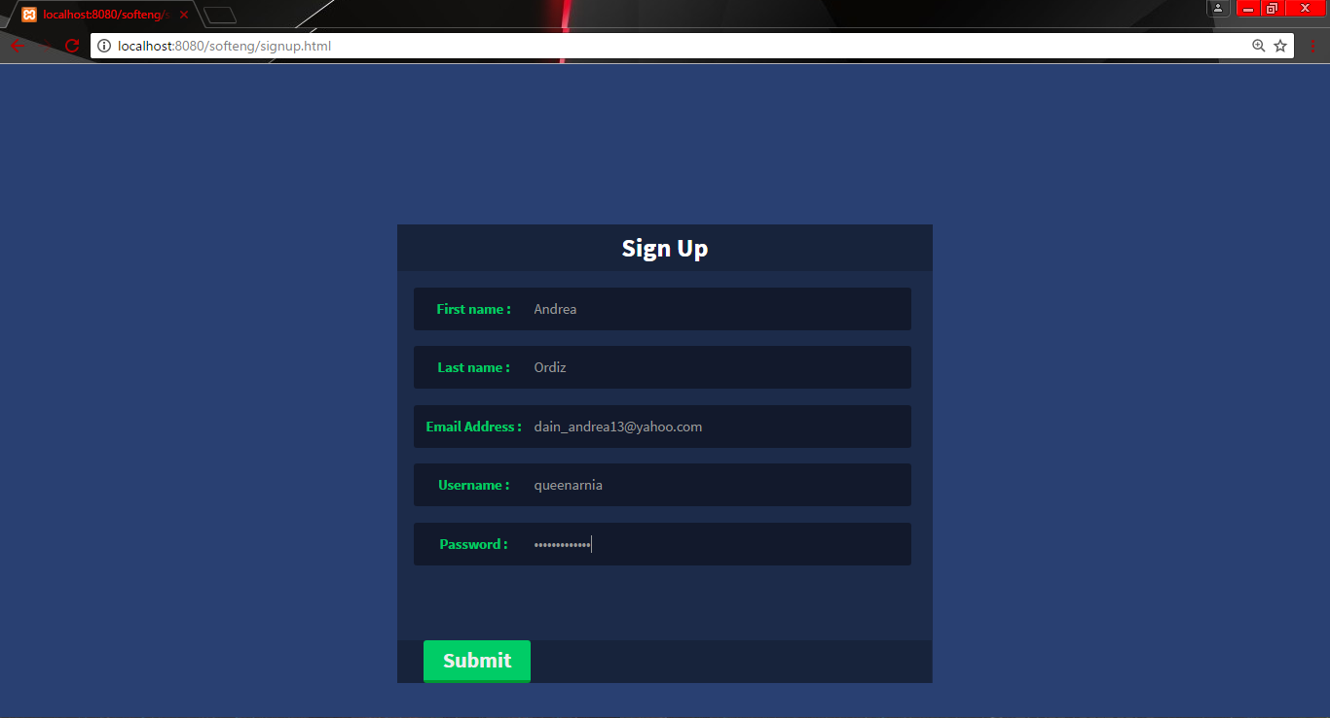

1

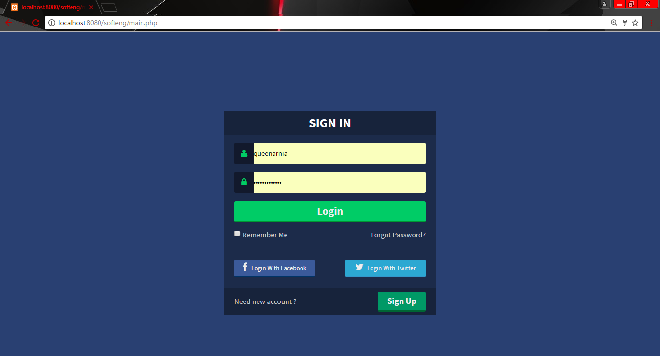

2

3



4

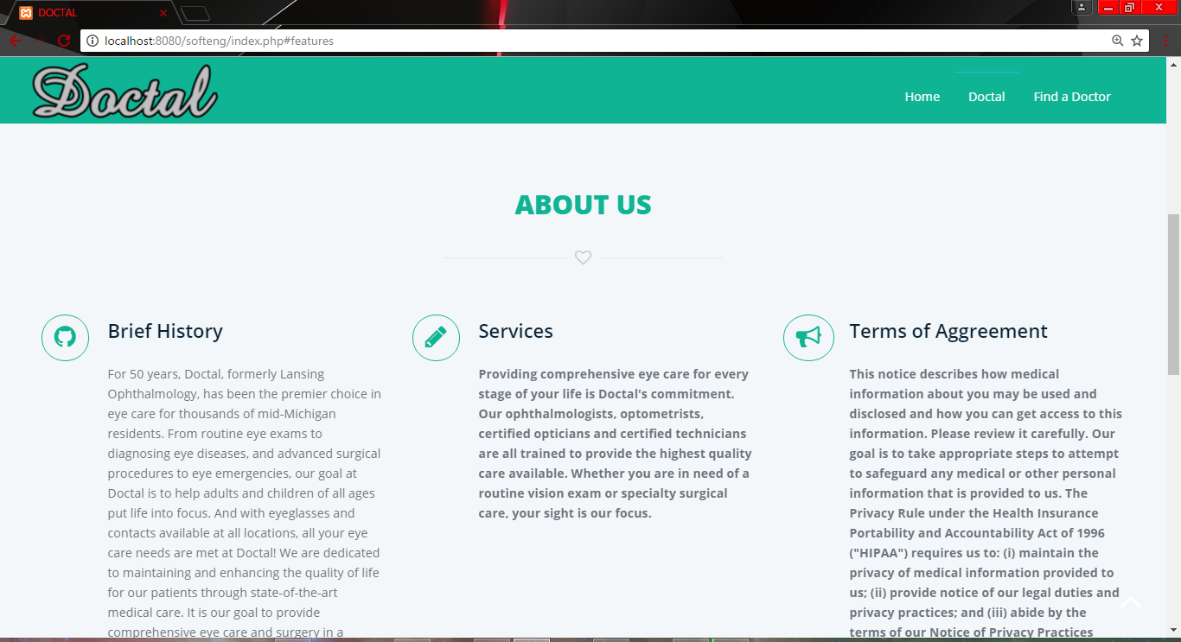

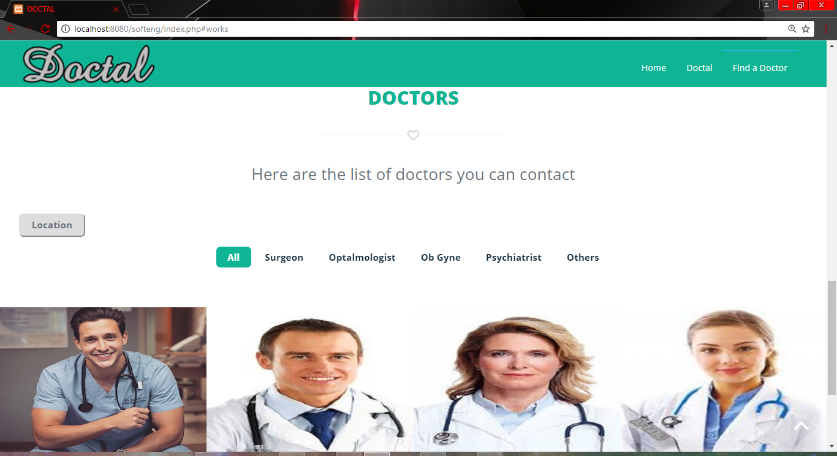

5

Doctor’s Profile

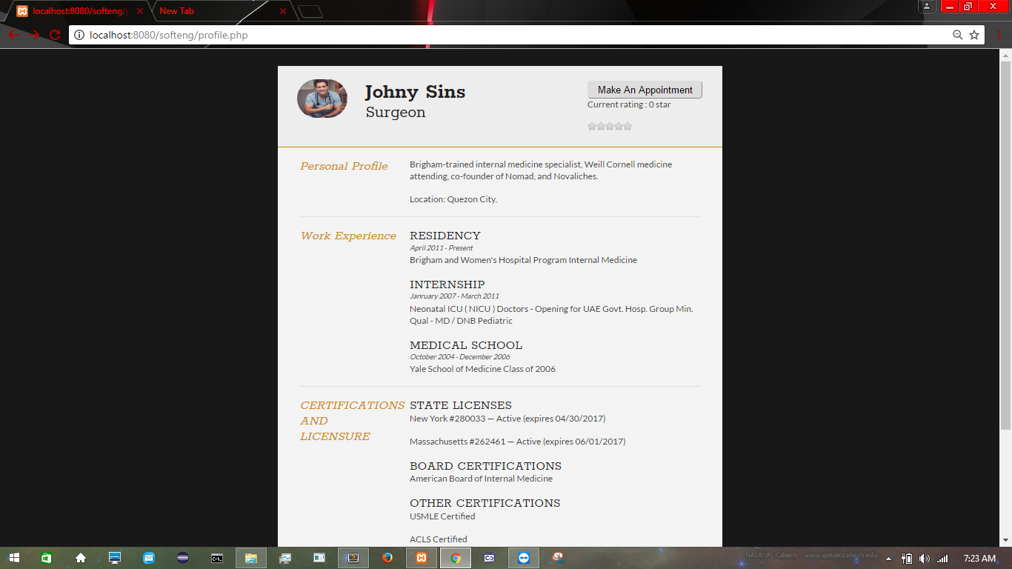

6

Make an Appointment

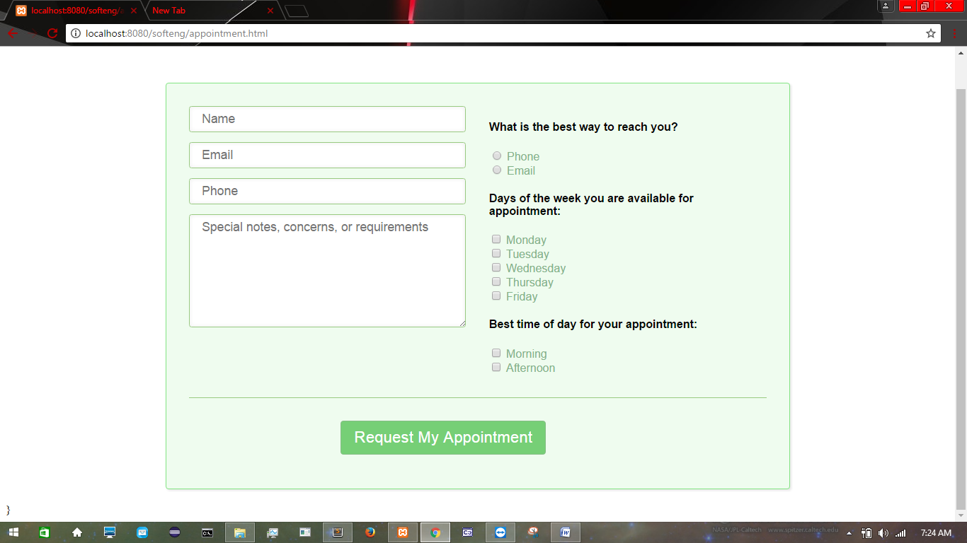

7

1. **Sign Up** - User will fill up the form that will be submitted.

2. **Login** - User will use the username and password created to access the webpage.

3. **Home** - Views the home page.

4. **Doctal** - Information about the webpage.

5. **Find a doctor** - Display the information about the doctors (Specialization, Location, certifications)

6. **Make an appointment** -Display the form to be filled up.

7**. Request my Appointment** - Sends the information of the user.

**TEST SCRIPT**

|  |  |  |  |  |  |
| --- | --- | --- | --- | --- | --- |
| **Scenarios** | **Sub Levels** | **Complexity** | **Date of Execution** | **Status** | **Defect Description** |
| Log In Page | Log In | Medium | 03/04/2017 | Passed |  |
| Main Menu | Search for a Doctor | Medium | 03/28/2017 | Passed |  |
| Sub Menu | Choose a Doctor | Complex | 04/01/2017 | Not yet executed |  |
|  | Make an appointment | Complex | 04/01/2017 | Not yet executed |  |