**Objective 1**: Use your Bootstrap and CSS skills to beautify the HTML page inside CSS folder [ 20 Marks]

**Objective 2**: Find all SQL statements inside “PHP Source Code” folder and subfolder add a function programmatically. [ 50 Marks]

Example:

Step 1: In this below document you can see a SQL query on line number 17.

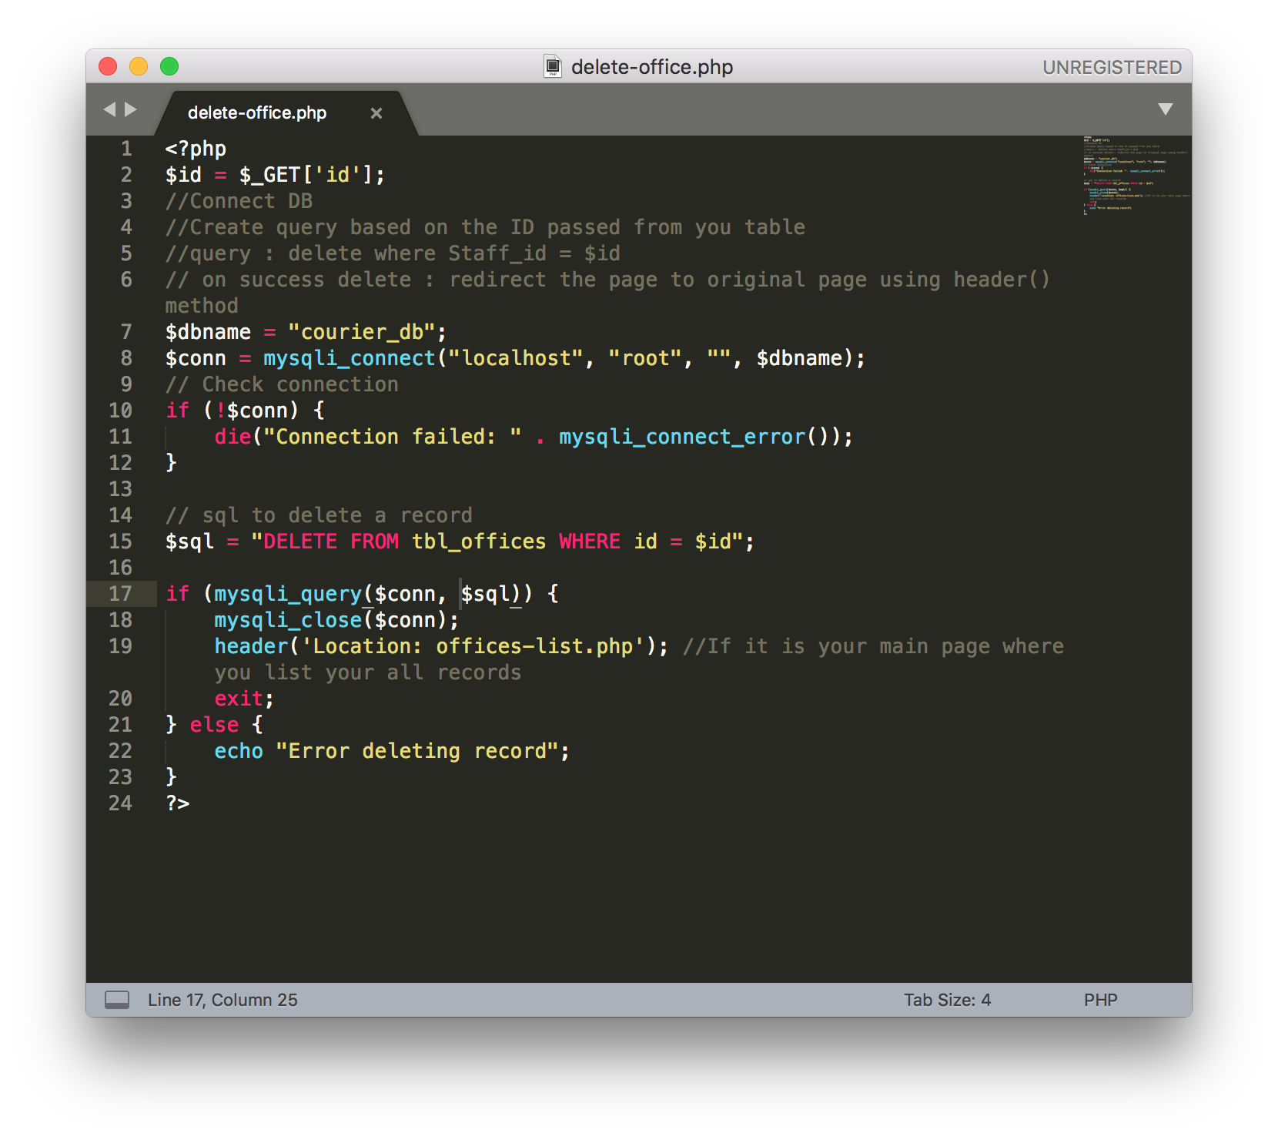

Step 2: You need to add a test_func(); function programmatically just like the image below (Please note, we may change the variable name from SQL to any other).

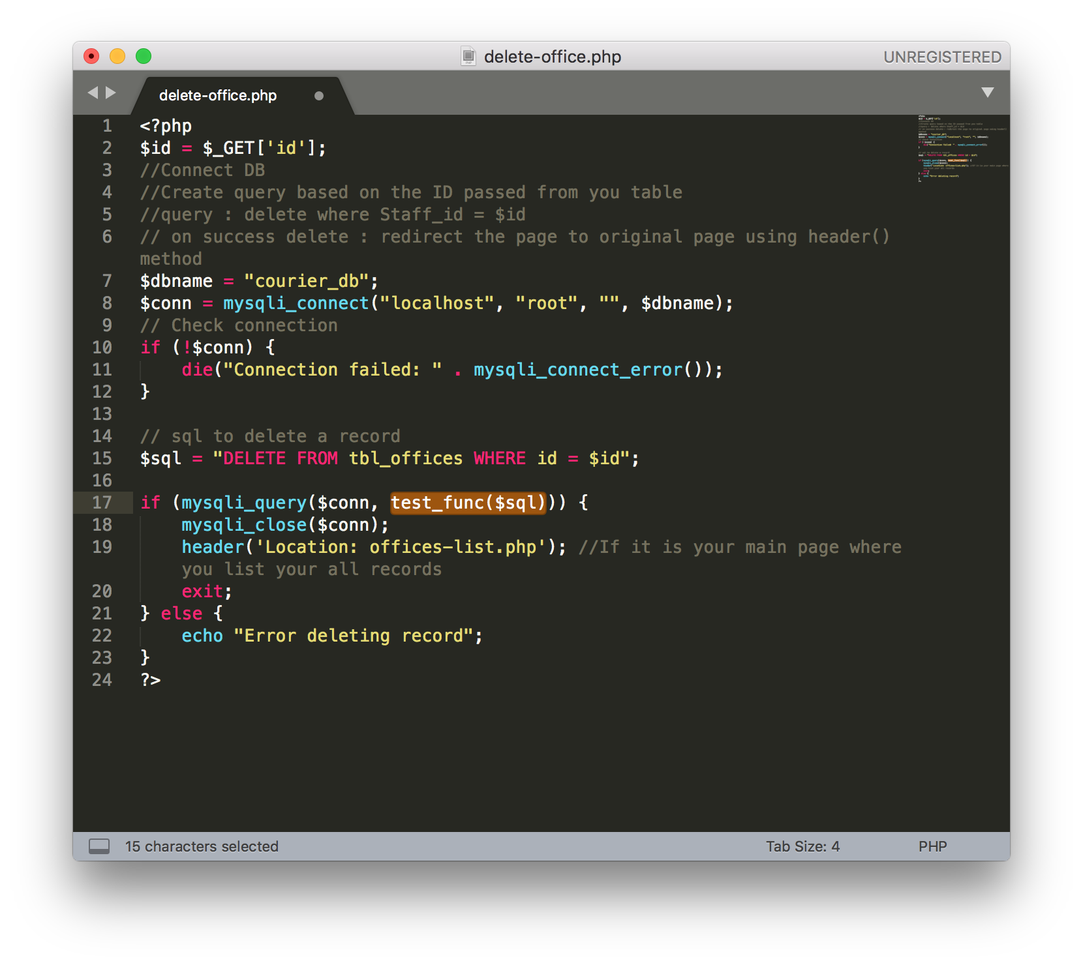

Step 3: Your script should scan for subfolders too for possible SQL statements (No language barrier).

**Objective 3**: Parse JSON in JavaScript and PHP and display a table using Bootstrap table [10 marks]. Create separate PHP and JS file.

**Objective 4**: Connect PHP and Mongo DB in Linux and prepare a Documentation. [ 10 Marks]

**Objective 5**: Create a PHP programme to display start-up programs from your system (code for your current OS). [10 Marks]