Article
Ridge Regression

The purpose of regression is to minimize a loss function, the residual sum of squares (RSS) being one commonly used. The problem of overfitting described in Chapter 2 §Accessing a model – Overfitting can be addressed by adding a penalty term to the loss function. The penalty term is an element of the larger concept of regularization.

L_{n} roughness penalty
Regularization consists of adding a penalty function J(w) to the loss function (or RSS in the case of a regressive classifier) in order to prevent the model parameters (or weights) from reaching high values. A model that fits a training set very well tends to have many features variable with relatively large weights. This process is known as shrinkage. Practically, shrinkage consists of adding a function with model parameters as an argument to the loss function.
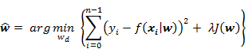
8742OS_Sample_01_1stDraft.png
The penalty function is completely independent from the training set {x,y}. The penalty term is usually expressed as a power to function of the norm of the model parameters (or weights) w_{d}. For a model of D dimension the generic Lp-norm is defined as
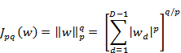
8742OS_Sample_02_1stDraft.png
Notation:
Regularization applies to parameters or weights associated to an observations. In order to be consistent with our notation w₀ being the intercept value, the regularization applies to the parameters w₁ …w_{d}.
The two most commonly used penalty functions for regularization are L₁ and L₂.
Regularization in machine learning:
The regularization technique is not specific to the linear or logistic regression. Any algorithm that minimizes the residual sum of squares, such as support vector machine or feed-forward neural network, can be regularized by adding a roughness penalty function to the RSS.
The L₁ regularization applied to the linear regression is known as the Lasso regularization. The Ridge regression is a linear regression that uses the L₂ regularization penalty.
You may wonder which regularization makes sense for a given training set. In a nutshell L₂ and L₁ regularization differs in terms of computation efficiency, estimation and features selection [Machine Learning: A Probabilistic Perspective §13.1 L₁ Regularization basics 6:10] [Feature selection, L₁ vs. L₂ regularization, and rotational invariance 6:11]
- Model estimation: L₁ generates a sparser estimation of the regression parameters than L₂. For large non-sparse dataset, L₂ has a smaller estimation error than L₁
- Feature selection: L₁ is more effective in reducing the regression weights for features with high value than L₂.Therefore L₁ a reliable features selection tool.
- Overfitting: Both L₁ and L₂ reduce the impact of overfitting. However, L₁ has a significant advantage in overcoming overfitting (or excessive complexity of a model) for the same reason it is more appropriate for selecting features.
- Computation: L₂ is conducive to a more efficient computation model. The summation of the loss function and L₂ penalty w² is a continuous and differentiable function for which the first and second derivative can be computed (convex minimization). The L₁ term is the summation of |w_{i}| and therefore not differentiable.
Terminology:
The ridge regression is sometimes called the penalized least squares regression. The L₂ regularization is also known as the weight decay.
Let us implement the ridge regression, and then evaluate the impact of the L₂-norm penalty factor.

Ridge Regression
The ridge regression is a multivariate linear regression with a L₂ norm penalty term.
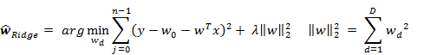
8742OS_Sample_03_1stDraft.png
The computation of the ridge regression parameters requires the resolution of the system of linear equations similar to the linear regression.
Matrix representation of ridge regression closed form
8742OS_Sample_04_1stDraft.png
I is the identity matrix and using the QR decomposition
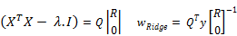
8742OS_Sample_05_1stDraft.png

Implementation
The implementation of the ridge regression add L₂ regularization term to the multiple linear regression computation of the Apache Commons Math Library.
The methods of RidgeRegression, have the same signature as its Ordinary Least Squares counterpart. However, the class has to inherit the abstract base class AbstractMultipleLinearRegression in the Apache Commons Math and override the generation of the QR decomposition to include the penalty term
class RidgeRegression[T <% Double](val xt: XTSeries[Array[T]],
val y: DblVector,
val lambda: Double) {
extends AbstractMultipleLinearRegression
with PipeOperator[Array[T], Double] {
private var qr: QRDecomposition = null
private[this] val model: Option[RegressionModel] = …
…
}
Besides the input time series xt and the labels y, the ridge regression requires the lambda factor of the L₂ penalty term. The instantiation of the class train the model. The steps to create the ridge regression models are to
- Extract the Q and R matrices for the input values, newXSampleData (1)
- Compute the weights using the calculateBeta defined in the base class (2)
- Return the tuple regression weights calculateBeta and the residuals calculateResiduals
private val model: Option[(DblVector, Double)] = {
this.newXSampleData(xt.toDblMatrix) //1
newYSampleData(y)
val _rss = calculateResiduals.toArray.map(x => x*x).sum
val wRss = (calculateBeta.toArray, _rss) //2
Some(RegressionModel(wRss._1, wRss._2))
}
The QR decomposition in the base class AbstractMultipleLinearRegression does not include the penalty term (3); the identity matrix with lambda factor in the diagonal has to be added to the matrix to be decomposed (4).
override protected def newXSampleData(x: DblMatrix): Unit = {
super.newXSampleData(x) //3
val xtx: RealMatrix = getX
val nFeatures = xt(0).size
Range(0, nFeatures).foreach(i => xtx.setEntry(i,i,xtx.getEntry(i,i) + lambda)) //4
qr = new QRDecomposition(xtx)
}
The regression weights are computed by resolving the system of linear equations using substitution on the Q.R matrices. It overrides the calculateBeta from the base class.
override protected def calculateBeta: RealVector =
qr.getSolver().solve(getY())

Test case
The objective of the test case is to identify the impact of the L₂ penalization on the RSS value then compare the predicted values with original values.
Let us consider the first test case related to the regression on the daily price variation of the Copper ETF (symbol: CU) using the stock daily volatility and volume as feature. The implementation of the extraction of observations is identical as with the least squares regression.
val src = DataSource(path, true, true, 1)
val price = src |> YahooFinancials.adjClose
val volatility = src |> YahooFinancials.volatility
val volume = src |> YahooFinancials.volume //1

val _price = price.get.toArray
val deltaPrice = XTSeries[Double](_price
.drop(1)
.zip(_price.take(_price.size -1))
.map( z => z._1 - z._2)) //2
val data = volatility.get
.zip(volume.get)
.map(z => Array[Double](z._1, z._2)) //3
val features = XTSeries[DblVector](data.take(data.size-1))
val regression = new RidgeRegression[Double](features, deltaPrice, lambda) //4

regression.rss match {
case Some(rss) => Display.show(rss, logger)
….
The observed data, ETF daily price, and the features (volatility and volume) are extracted from the source src (1). The daily price change deltaPrice is computed using a combination of Scala take and drop methods (2). The features vector is created by zipping volatility and volume (3). The model is created by instantiating the RidgeRegression class (4). The RSS value, rss, is finally displayed (5).
The RSS value, rss is plotted for different values of lambda <= 1.0
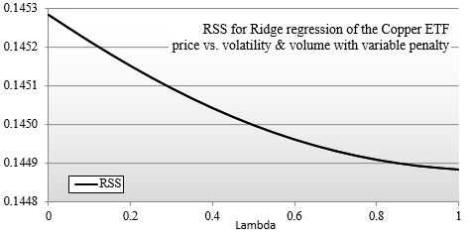
Graph of RSS versus Lambda for Copper ETF
8742OS_Sample_06_1stDraft.png
The residual sum of squares decreased as λ increases. The curve seems reaching for a minimum around λ=1. The case of λ = 0 correspond to the least squares regression.
Next let us plot the RSS value for λ varying between 1 and 100
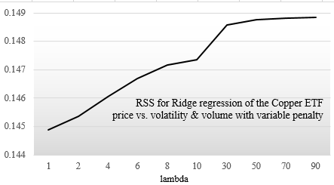
Graph RSS versus large value Lambda for Copper ETF
8742OS_Sample_07_1stDraft.png
This time around RSS increases with λ before reaching a maximum for λ > 60. This behavior is consistent with other findings [Model selection and assessment 6:12]. As λ increases, the over-fitting gets more expensive and therefore the RSS value increases.
The regression weights can by simply output as follows
regression.weights.get
Let’s plot the predicted price variation of the Copper ETF using the ridge regression with different value of lambda (λ).
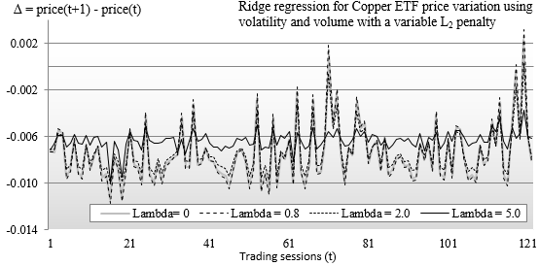
Graph of Ridge regression on Copper ETF price variation with variable Lambda
8742OS_Sample_08_1stDraft.png
The original price variation of the Copper ETF Δ = price(t+1)-price(t) is plotted as λ =0. The predicted values for λ = 0.8 is very similar to the original data. The predicted values for λ = 0.8 follows the pattern of the original data with reduction of large variations (peaks and troves). The predicted values for λ = 5 corresponds to a smoothed dataset. The pattern of the original data is preserved but the magnitude of the price variation is significantly reduced.
The reader is invited to apply the more elaborate K-fold validation routine and compute precision, recall and F₁ measure to confirm the findings.

Summary
The ridge regression is a powerful alternative to the more common least squares regression because it reduces the risk of overfitting. Contrary to the Naïve Bayes classifiers, it does not require conditional independence of the model features

