This application demonstrates asynchronous background processing using Flask, Celery, Redis, and MySQL. Flask handles API requests, while Celery runs background tasks independently. Redis is used as the message broker, and MySQL stores task data.

1.Celery Setup
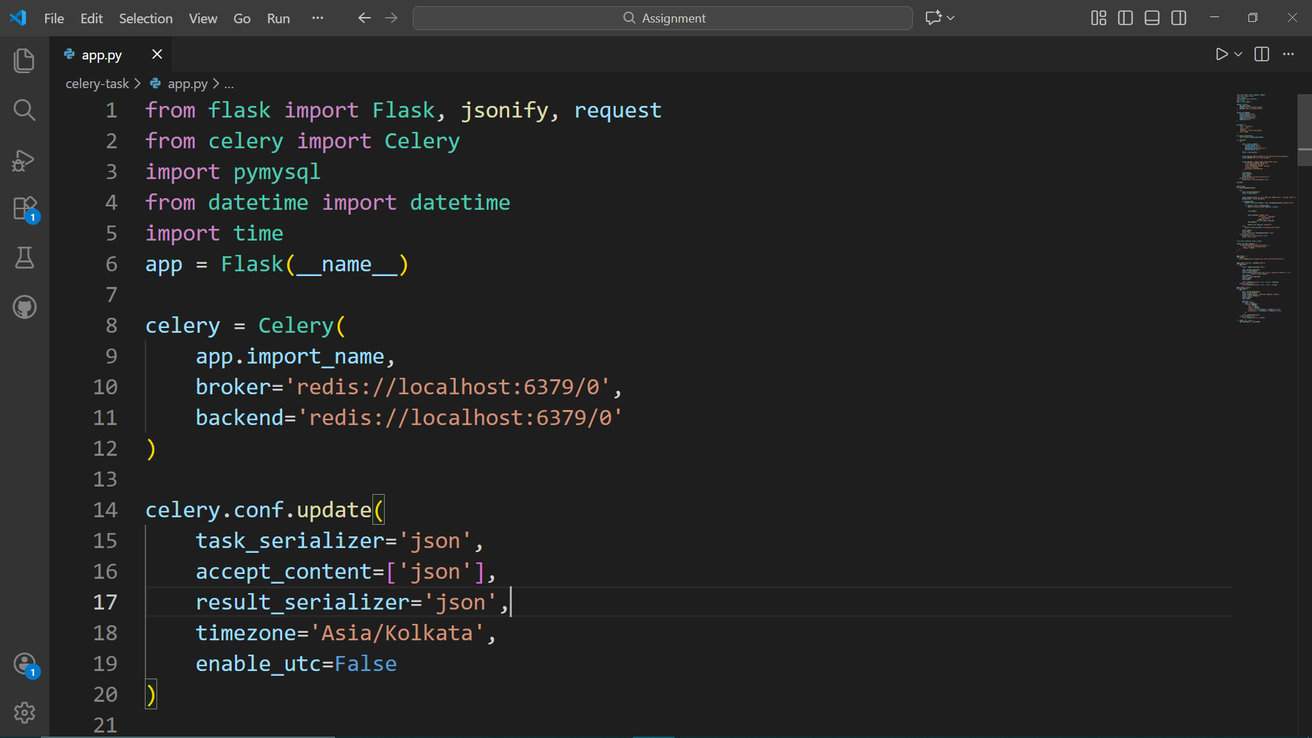Celery is configured with Redis as both the broker and result backend. JSON serialization is used for lightweight communication. The timezone is set to Asia/Kolkata to ensure consistent scheduling and logging.

2.Database Initialization
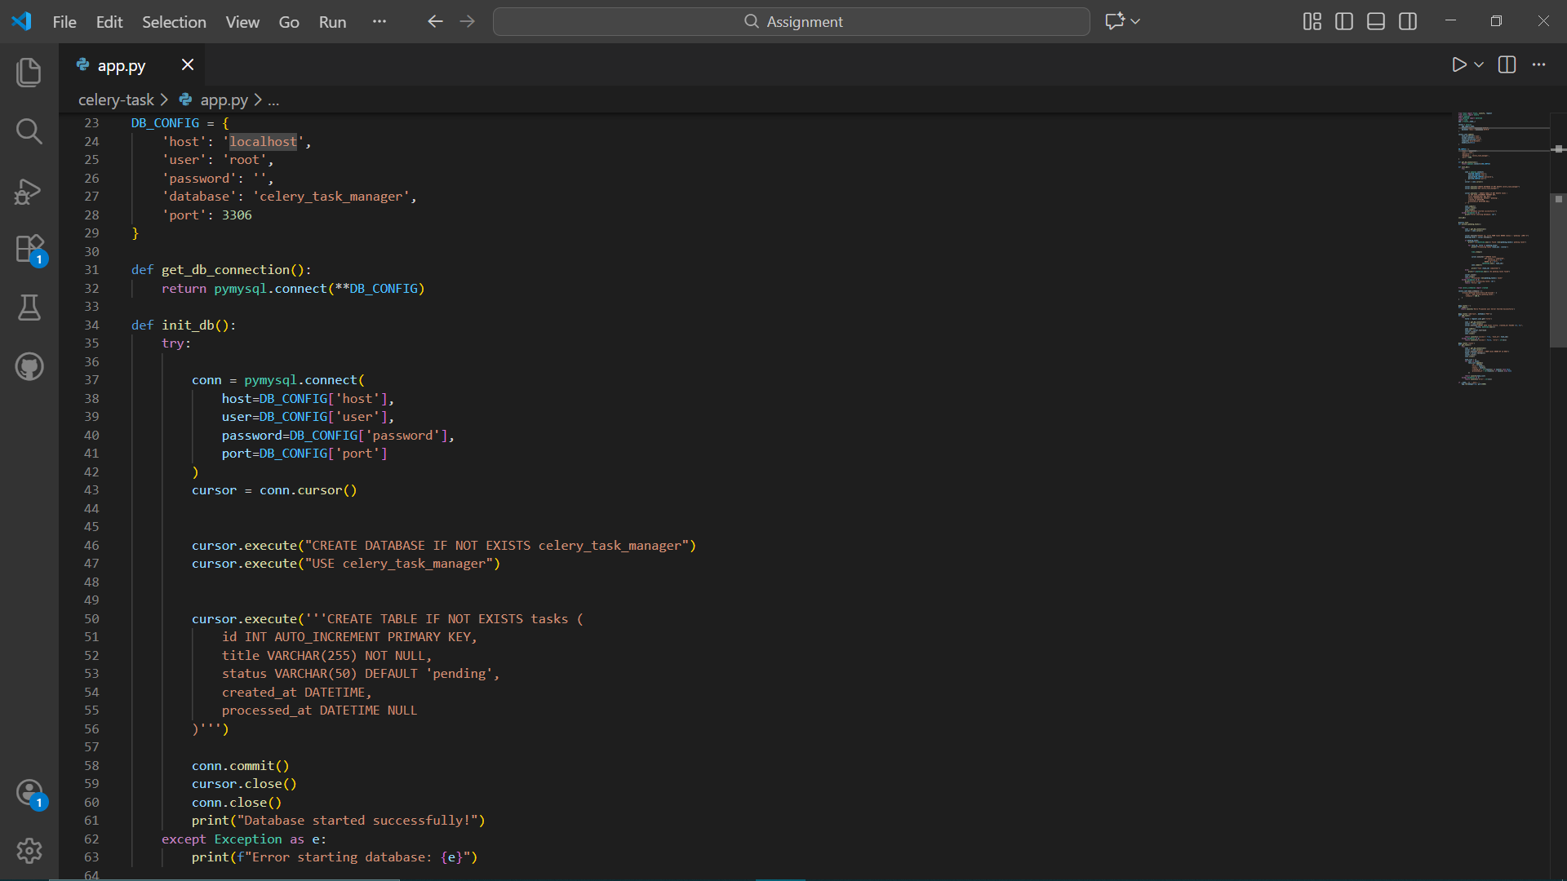On startup, the application creates the database and a tasks table if they do not exist. The table stores task titles, status, creation time, and processing time, allowing the system to run without manual database setup.

3.Background Task Logic
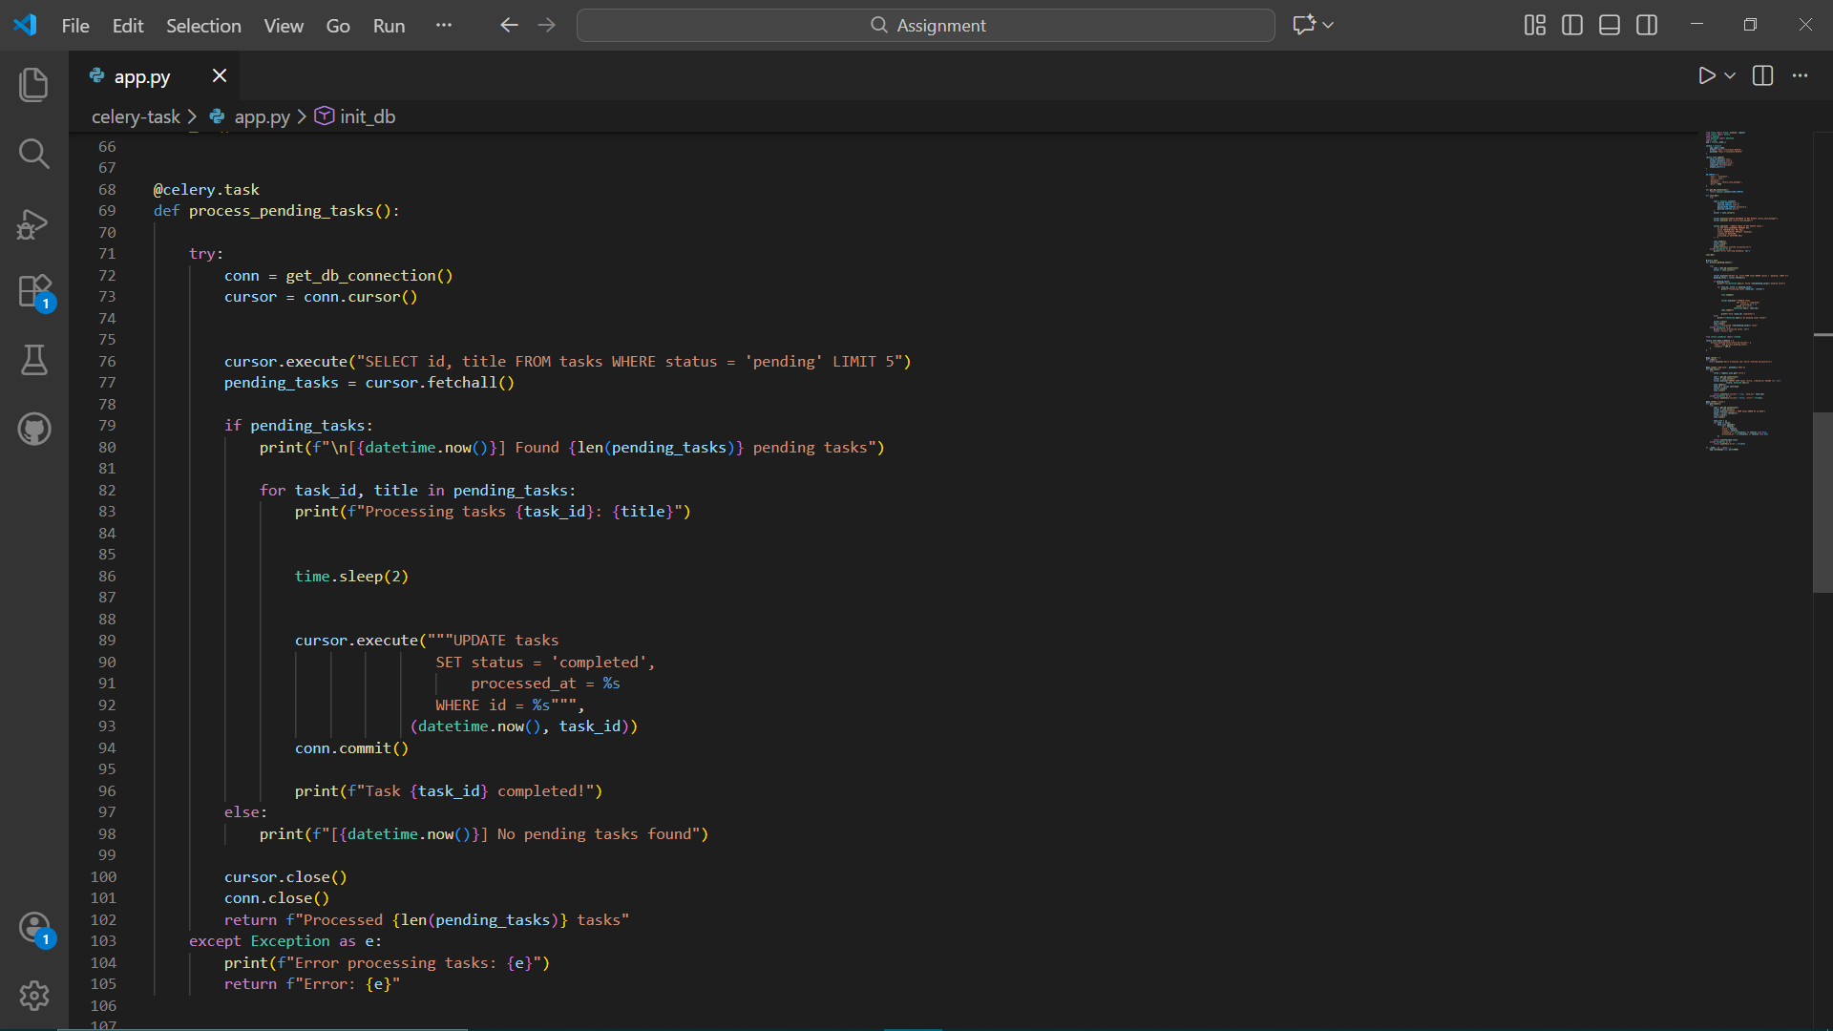The Celery task periodically queries the database for pending tasks. When tasks are found, they are processed one by one and marked as completed with a timestamp. If no tasks are available, the worker logs the status and waits for the next cycle.

4.Periodic Scheduling
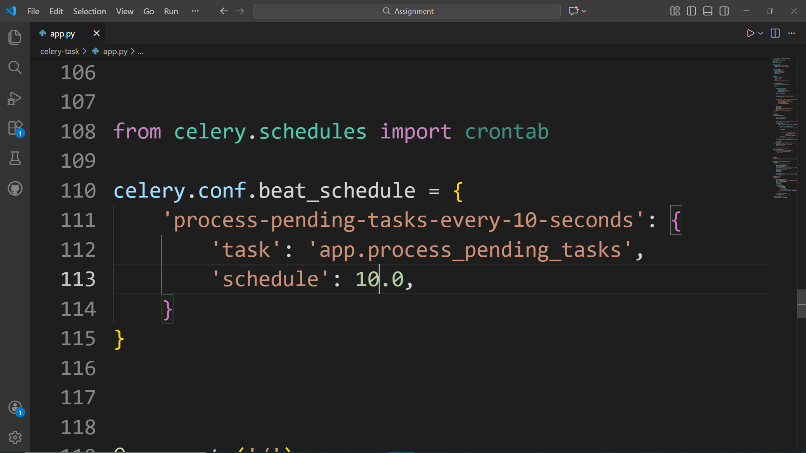Celery Beat schedules the background task to run every fixed interval 10 seconds. This scheduling is time-based and independent of when tasks are created, ensuring predictable background execution.

5.Flask API Endpoints
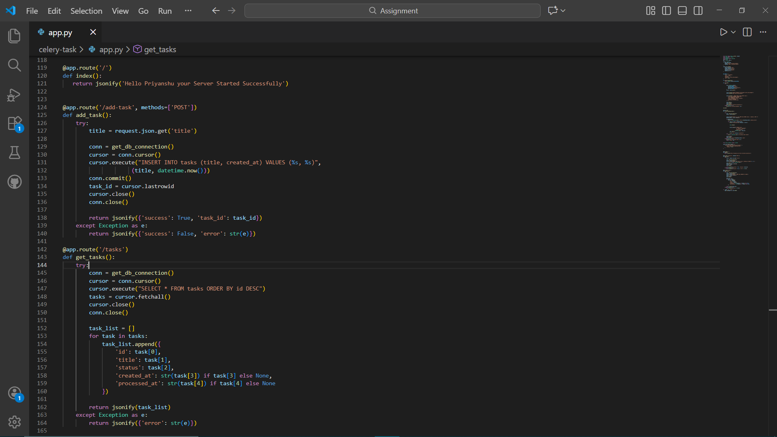The Flask server provides endpoints to add new tasks and retrieve all tasks. These endpoints interact with the database directly while background processing happens asynchronously.

6.Starting the Application
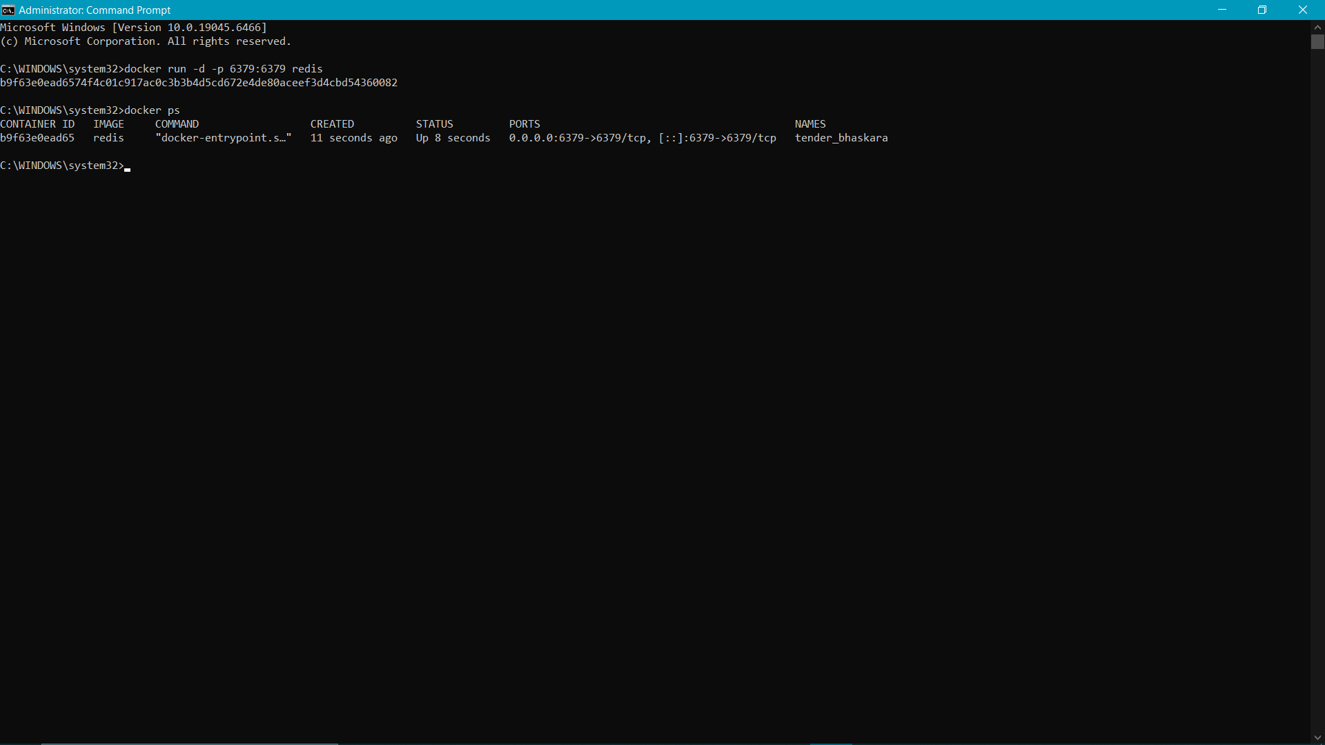Starting the redis server in CMD using docker on port 6379

7.Checking With Docker Engine
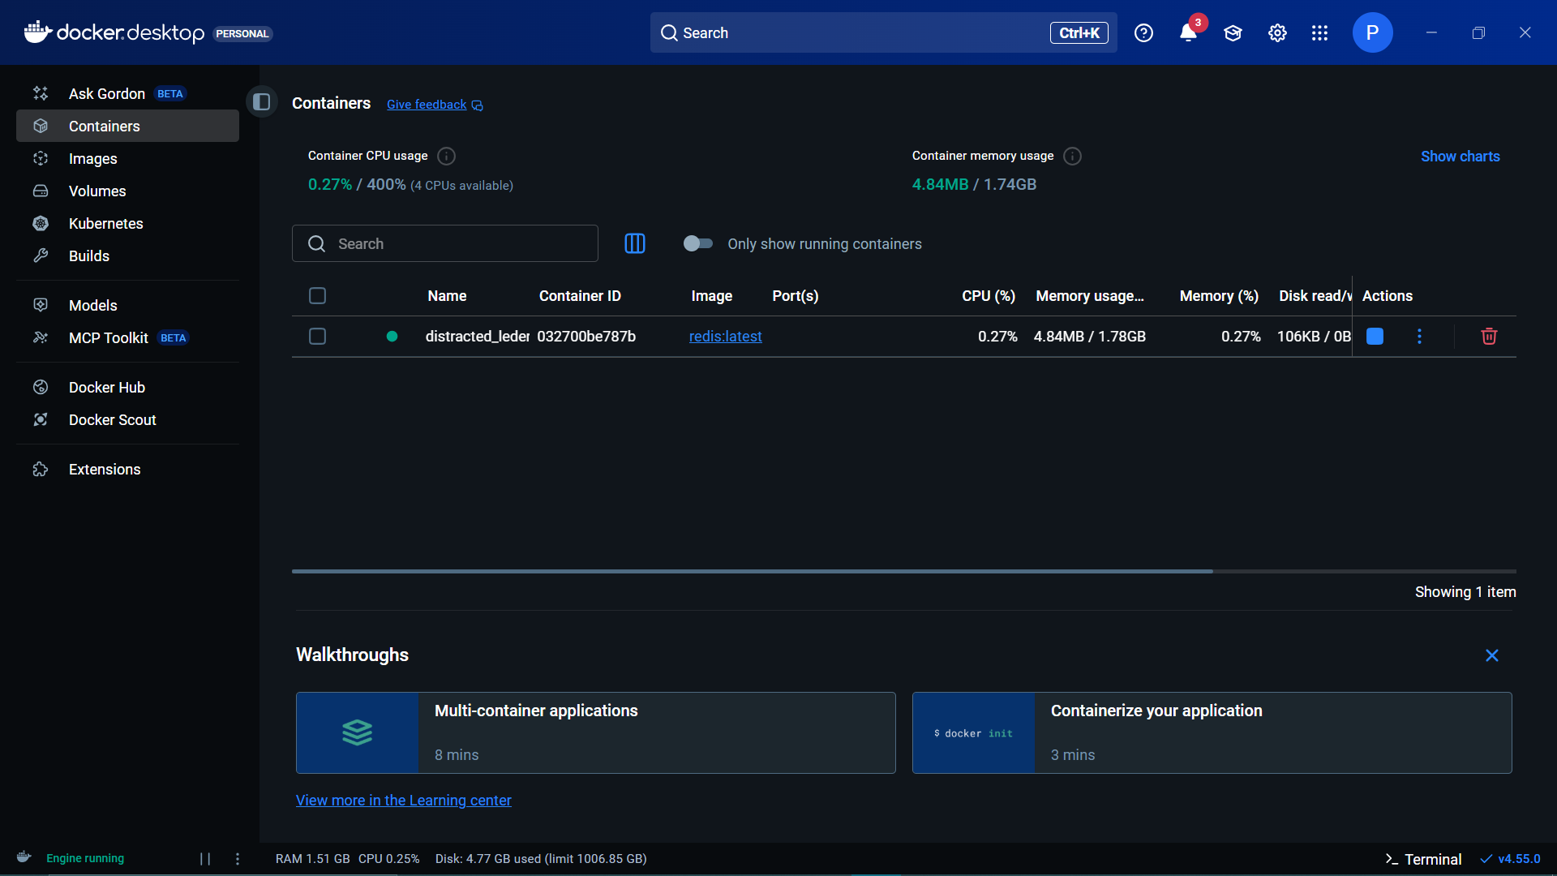Checking for the running images to make sure redis is running

8.Starting the app.py
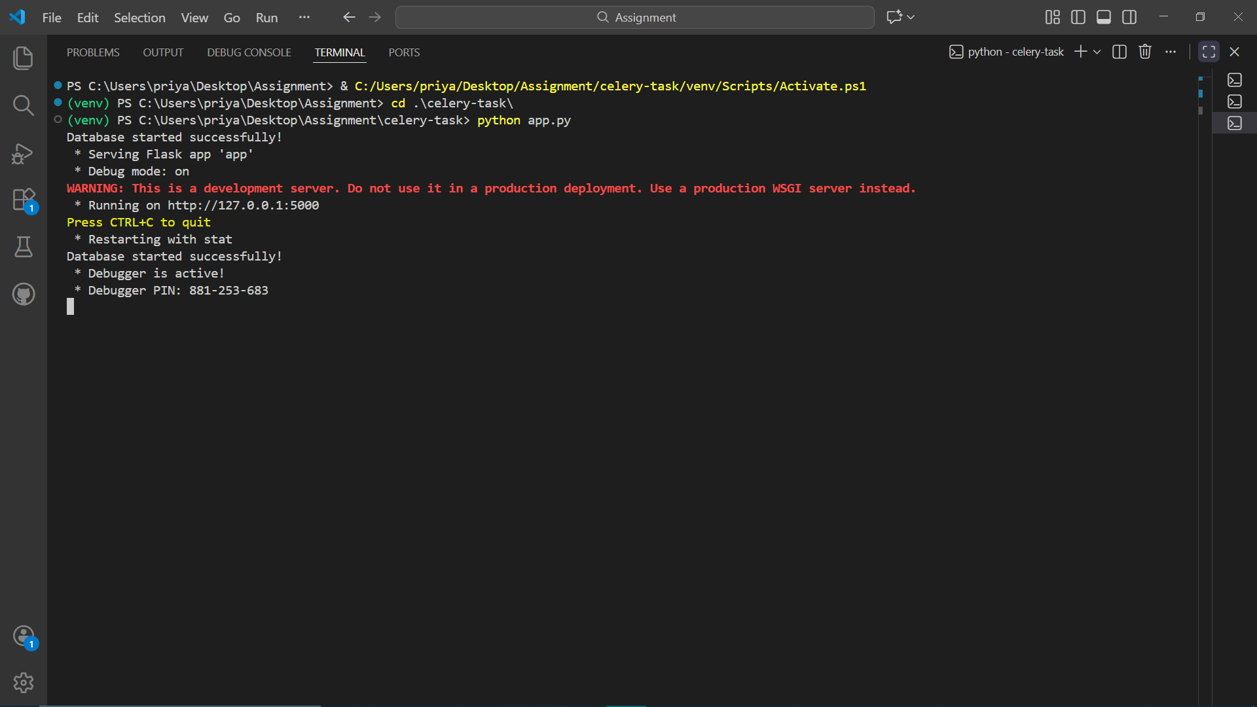The app starts running on the port 5000 as we start the application with python app.py

9.Starting celery worker
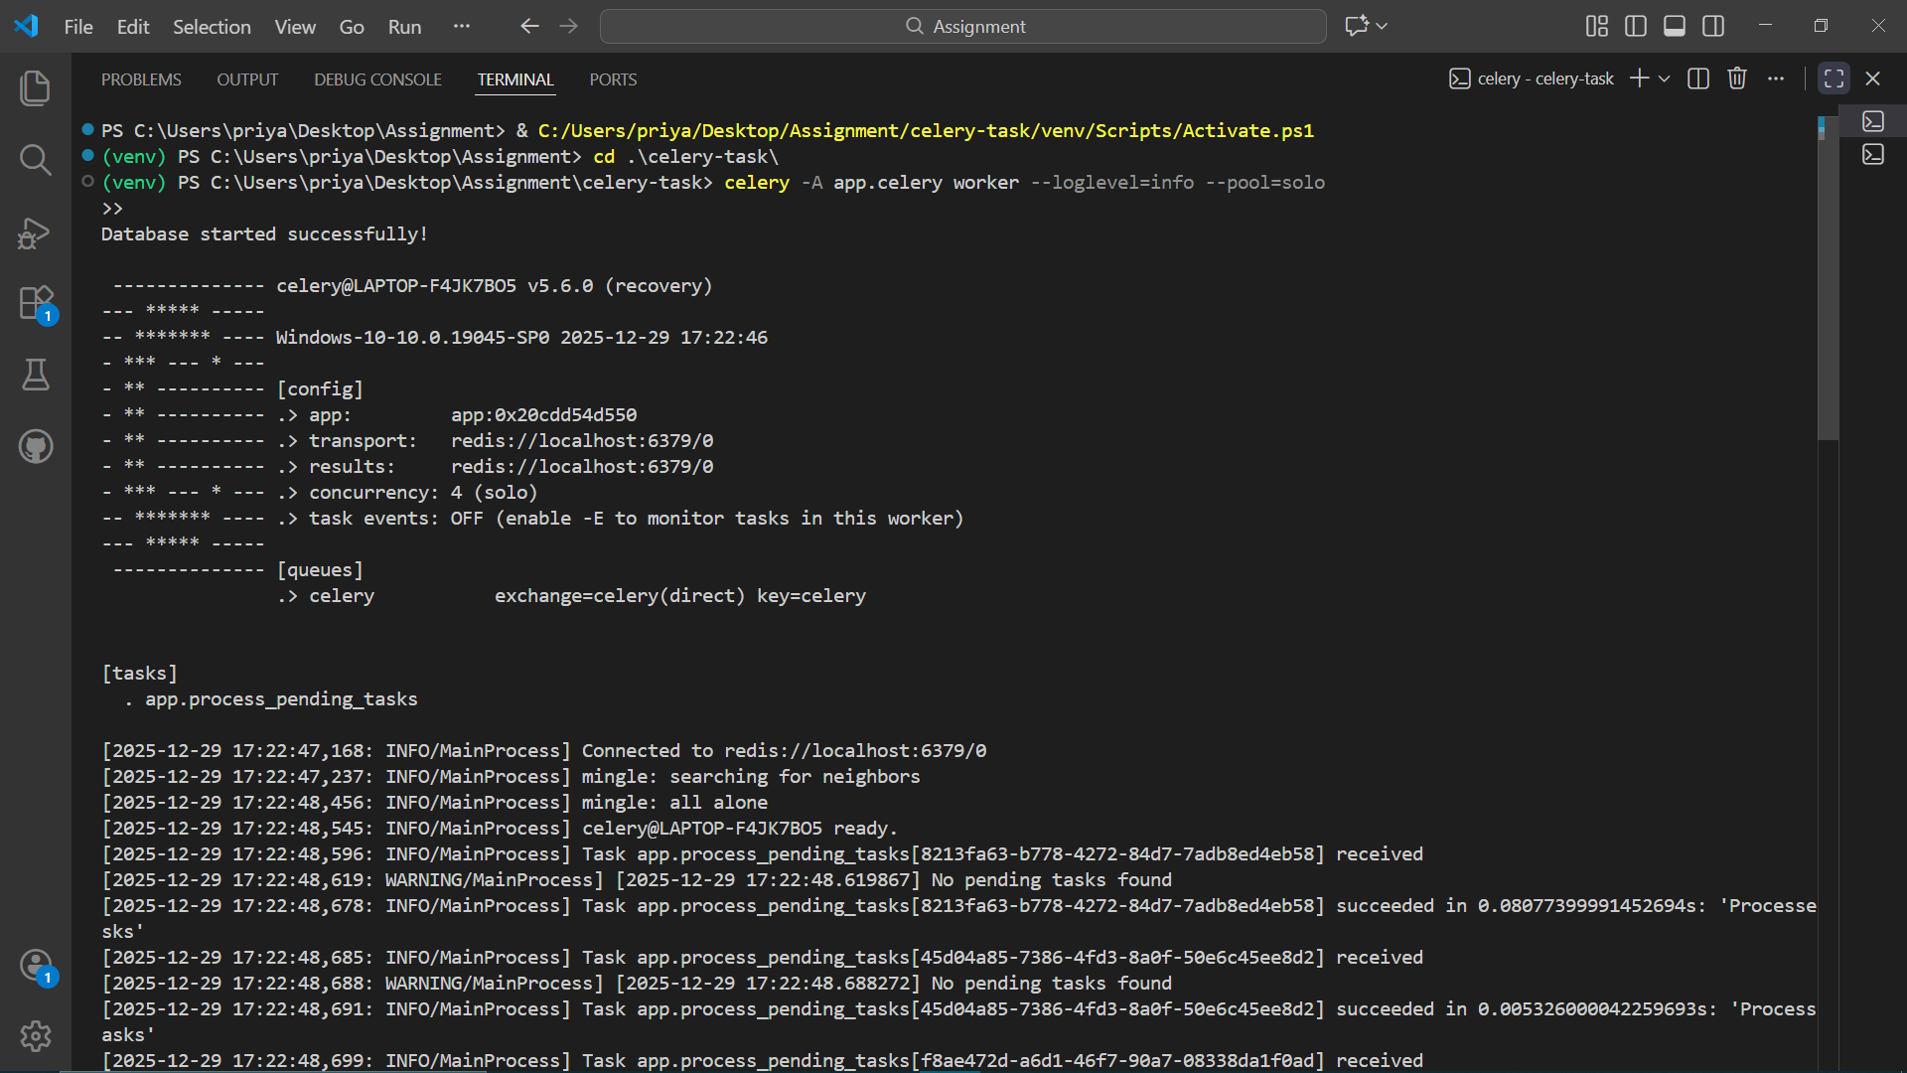We start the celery worker in app.py using celery -A app.celery worker --loglevel=info --pool=solo
10. Celery Beat
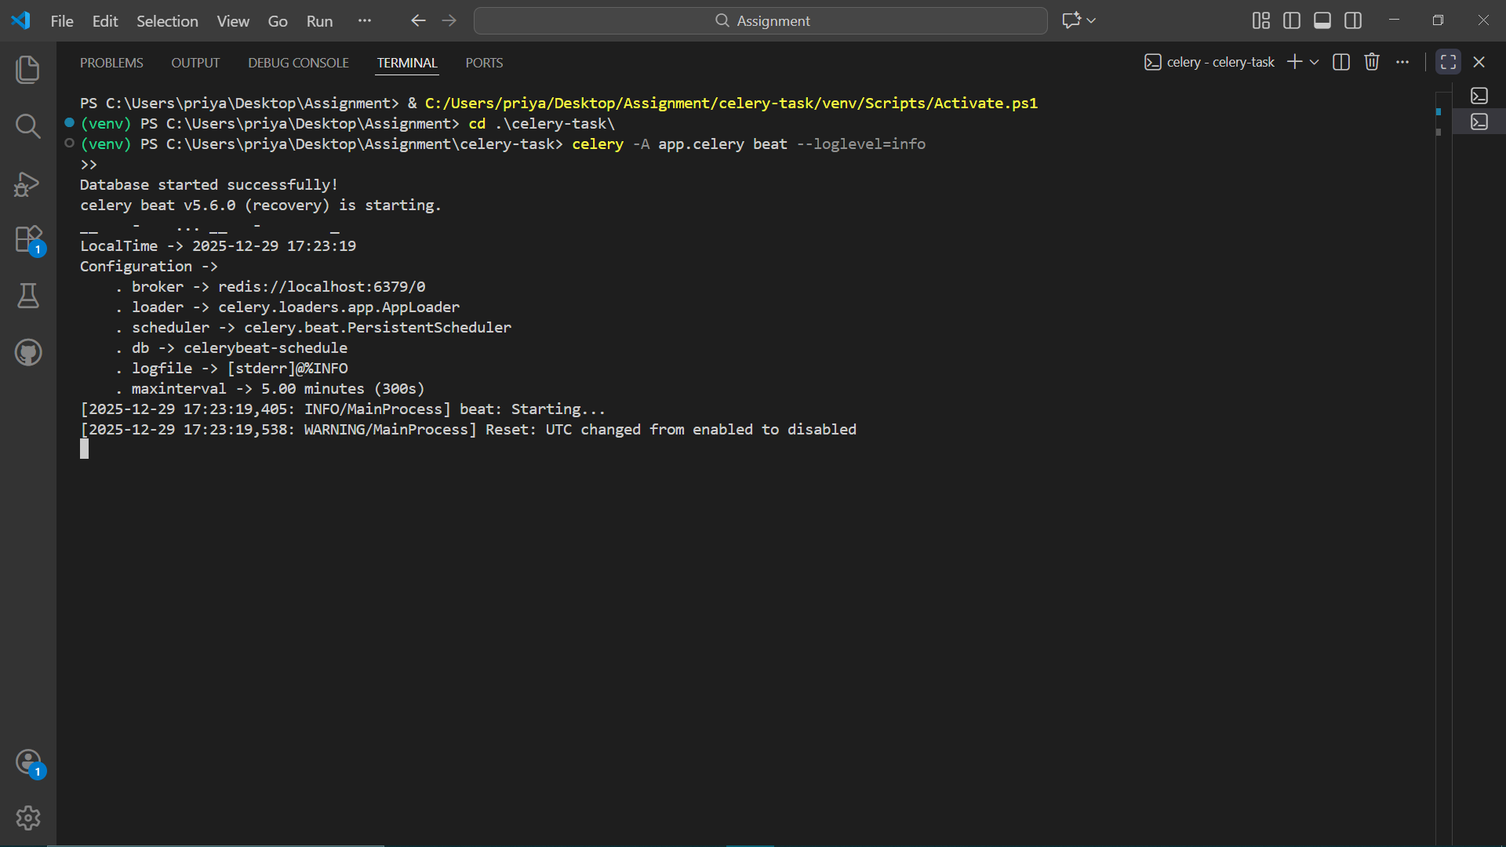We start the celery beat using celery -A app.celery beat --loglevel=info

11.Starting the app on postman
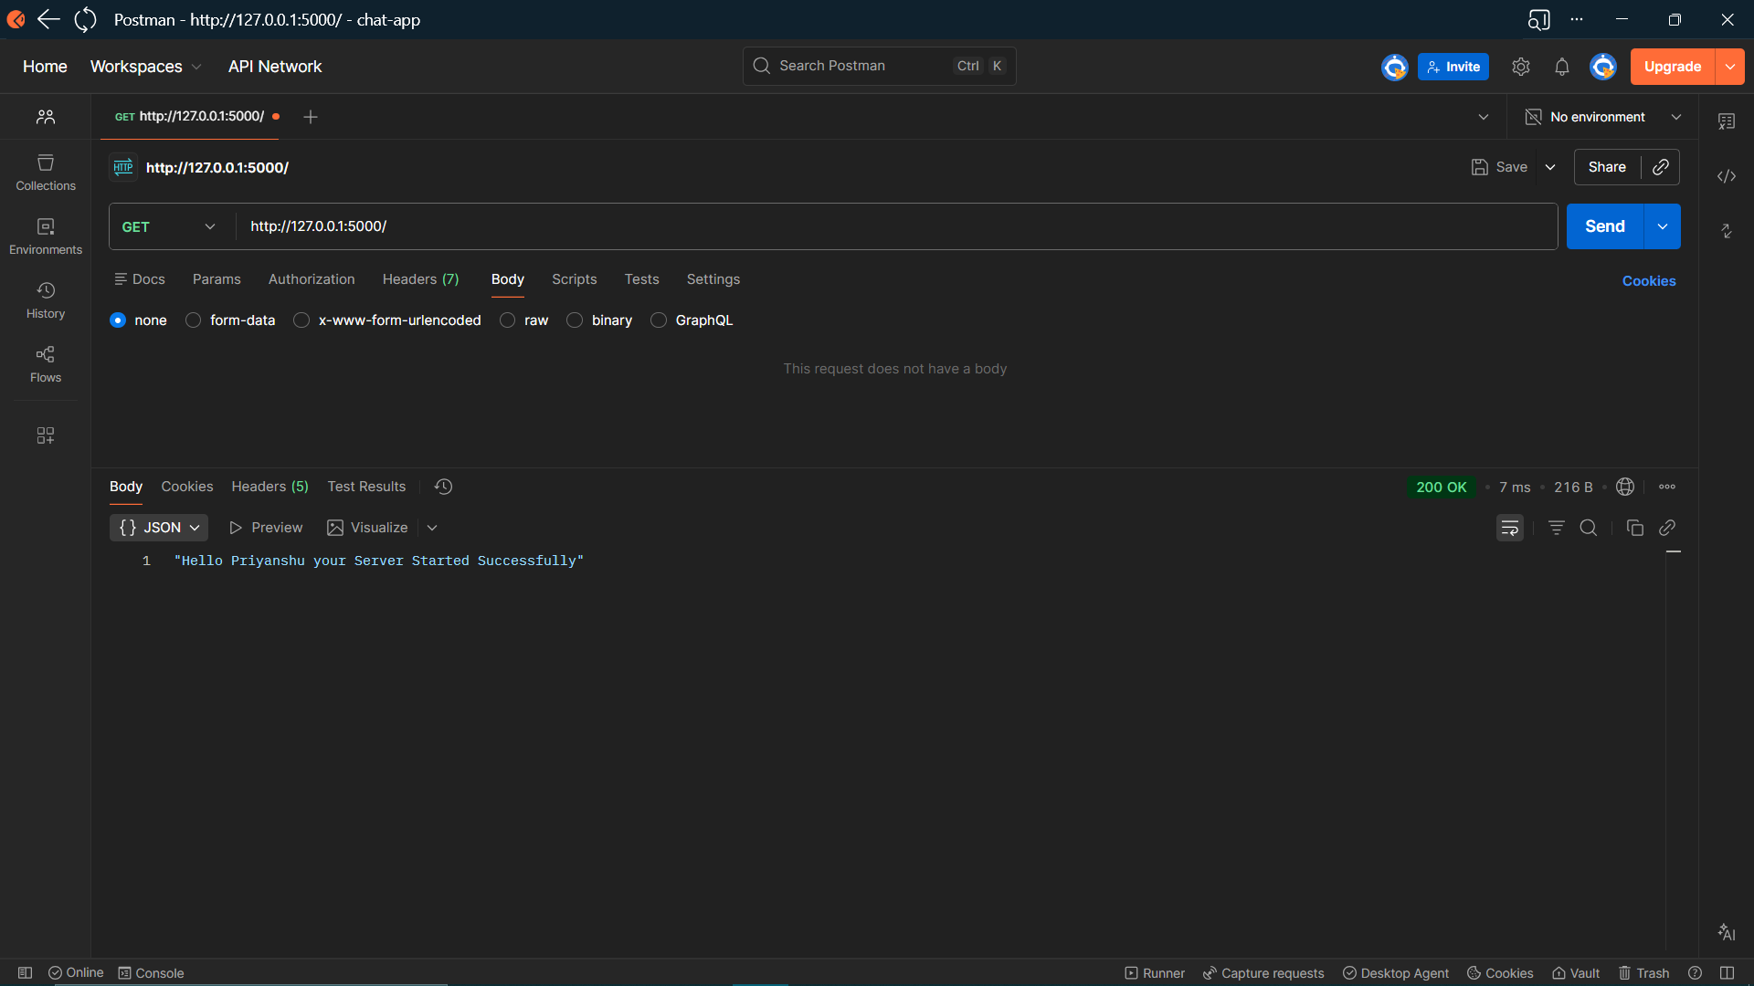We start the application and server is Successfully Started at the (‘/’) route

12.Adding task to the DB
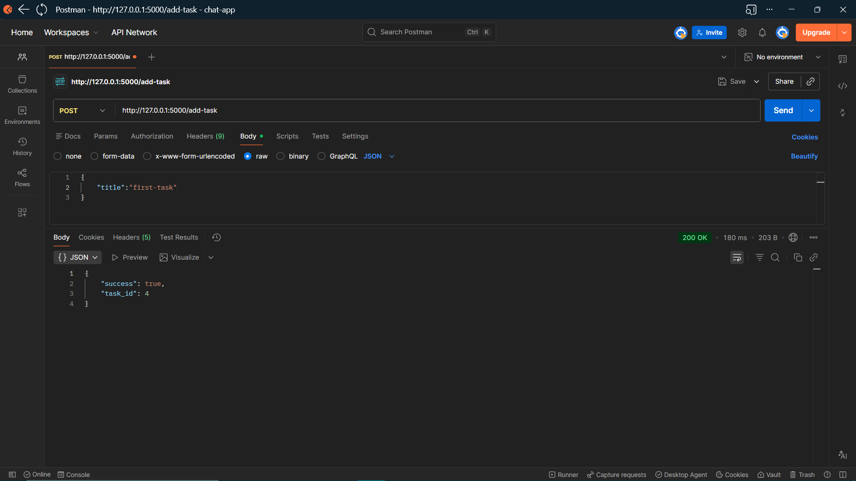We add tasks to the db for celery to start fetching tasks with title as input at the (‘/add-task’) route

13.DB check at php-myadmin (XAMPP software)
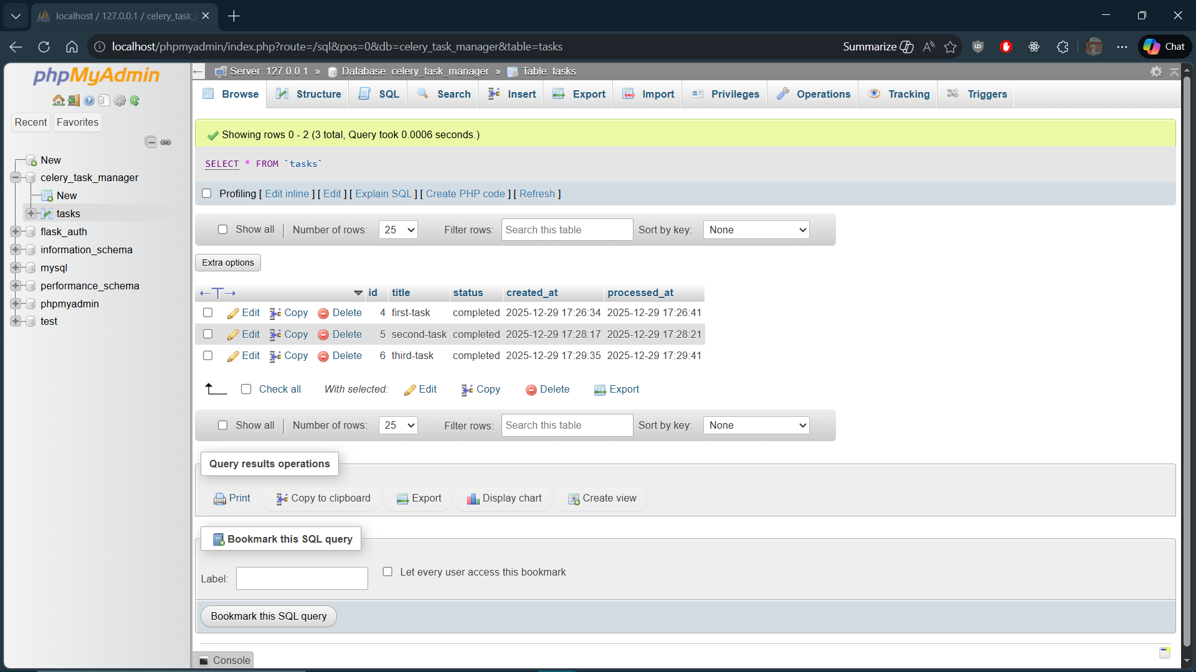We check if our entry is added to database by checking at the my-php-admin server

14.Check for tasks
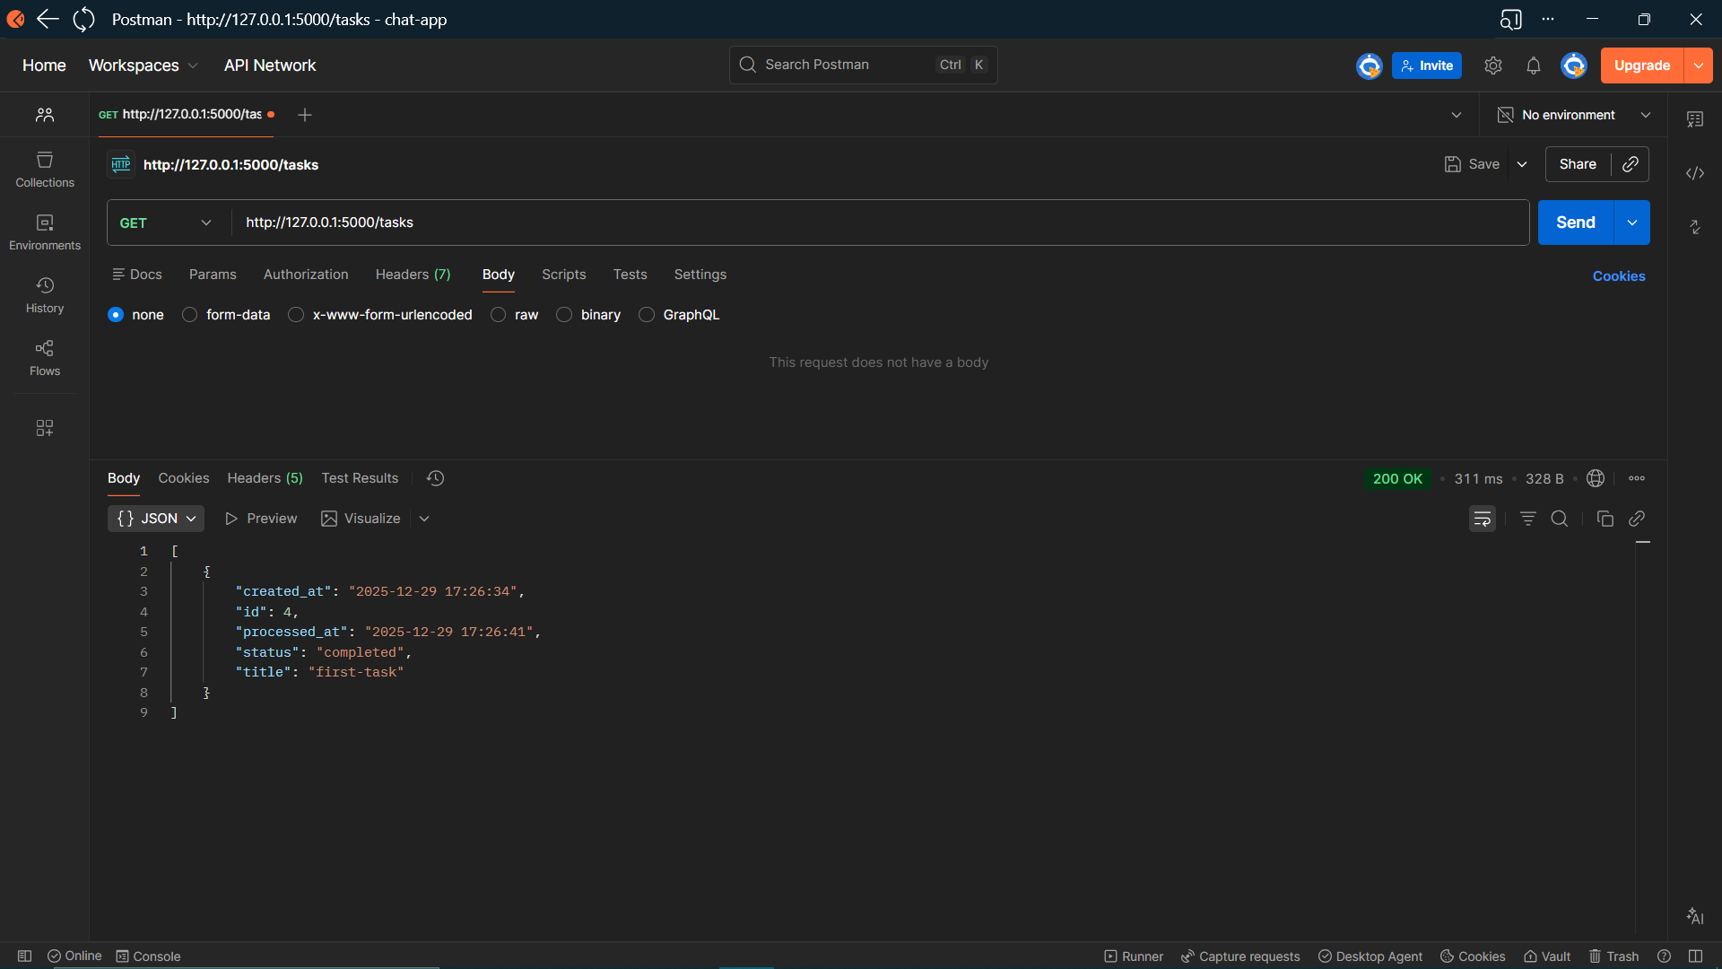
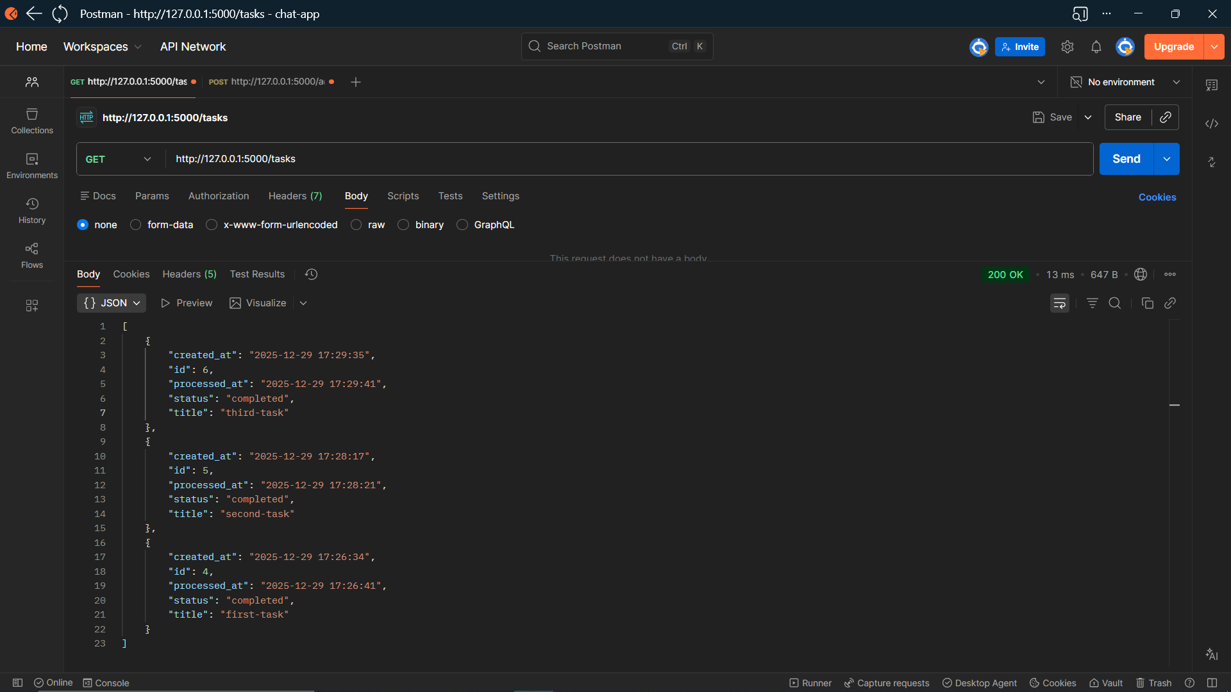We check for tasks at the (‘/tasks’) route to check all pending/completed tasks and we can see the status in response

15.Execution Flow:
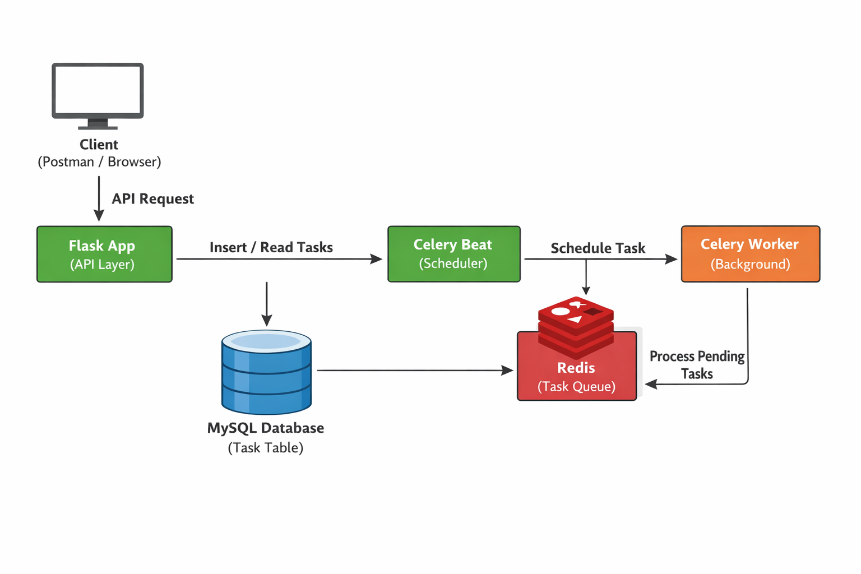Flask handles user requests, Redis manages task messaging, and Celery workers process tasks in the background. This separation ensures non-blocking execution and scalability

