RAG Week 2 Project: SEC 10-K Filings
Nov 11, 2026 · @Surya Garimella

The Primer: Your one-liner
An assistant that answers a financial analyst's questions about Apple's FY2025 and FY2026 10-K filings from the filings themselves, and counts as good when the right figure is in the top three retrieved passages.

At a glance
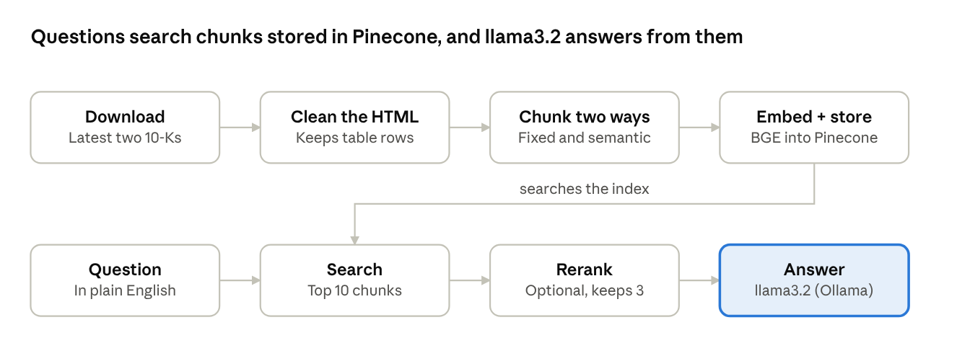
pipeline · 8 stages, 2 chunk sets
Filings are cleaned and cut into fixed and semantic chunks, each stored in its own Pinecone namespace; a question searches one namespace, optionally reranks, and llama3.2 answers from the top three chunks.

Use case
A financial analyst asks plain-English questions about Apple's annual reports, such as net sales by product, earnings per share or supply-chain risk, and gets an answer built from the filing's own passages. It runs as a notebook pipeline (Colab or local Jupyter) that retrieves the best passages from a Pinecone index and hands them to an LLM.

Corpus
Two Apple Inc. annual reports (Form 10-K), fiscal 2025 and fiscal 2026, in English, from SEC EDGAR, which is the source of truth. Each arrives as a full-submission.txt bundle that holds the main HTML filing plus exhibits and XBRL data; the accessions are 0000320193-25-000079 and 0000320193-26-000026.

Ingestion + cleaning
sec-edgar-downloader fetches Apple's last two 10-Ks, and a loader reads each file with LangChain's TextLoader. A clean_edgar_text function then makes the HTML readable before any chunking:
- Keeps only the 10-K document inside the bundle and drops exhibits and images.
- Removes the hidden XBRL header, <script> and <style> blocks.
- Turns paragraph, row and line-break tags into newlines so tables keep one row per line.
- Strips the remaining tags first and decodes entities (&amp;, &#160;) afterwards, then collapses extra whitespace.
- Tags every document with ticker, form, accession and source for later filtering.

Ingestion + freshness
Refresh is manual: re-running Step 1 downloads the latest two 10-Ks, and Steps 6 to 10 rebuild the chunks and overwrite the Pinecone vectors. No schedule or freshness SLA is defined; since Apple files one 10-K a year, one refresh after each new filing would keep the index current.

Chunking + embedding
The project builds two chunk sets from the same text so they can be compared, and embeds both with BAAI/bge-base-en-v1.5 (768 dimensions, normalized). That model is free, runs locally on the Colab GPU and reads up to 512 tokens.
 | Fixed-size | Semantic
Splitter | RecursiveCharacterTextSplitter | SemanticChunker (percentile)
Size | 512 characters, 64 overlap | Variable; threshold 65
Extra step | Drops chunks under 100 characters or under 40% letters | Chunks over 8,000 characters are re-split with 100 overlap
Splits at | Paragraph, line, then word | Where meaning changes between sentences
The semantic threshold started at 95, which produced 142 chunks against 1,142 fixed ones, so it was lowered to 65 for smaller, more focused chunks. The 8,000-character cap keeps each chunk under Pinecone's 40 KB metadata limit.

Retrieve
Retrieval is dense-only (no keyword or hybrid search) against a Pinecone serverless index named financial-rag (AWS us-east-1, 768 dimensions, cosine). The fixed and semantic chunks sit in separate namespaces, fixed and semantic, and a metadata filter on the accession number limits a search to one filing.
- Top-k: fetch 10 candidates and show the best 3.
- Optional rerank: a BAAI/bge-reranker-base cross-encoder re-scores the 10 candidates and keeps the top 3.
- Answering: llama3.2 (3B) through Ollama, temperature 0 and an 8,192-token context. The prompt tells it to answer only from the retrieved text, cite exact figures, and say "I don't know" otherwise.

Pipeline walkthrough
The notebook runs in 19 numbered steps, in this order. Steps 0 to 5 are setup, 6 to 11 build the index, and 12 to 19 search, answer and evaluate.
Step | What it does | Key detail
0 | Installs packages and Ollama | %pip install, then the Ollama server and llama3.2
1 | Downloads the SEC filings | limit=2 latest 10-Ks for AAPL
2 | Connects to the LLM | ChatOllama, temperature 0, 8,192-token context
3 | Loads the API keys | From .env, or a hidden prompt on Colab
4 | Loads the embedding model | bge-base-en-v1.5, GPU if available
5 | Connects to Pinecone, creates the index | financial-rag, 768 dimensions, cosine
6 | Reads and cleans the filings | clean_edgar_text; adds ticker, form, accession
7 | Builds fixed-size chunks | 512 characters, 64 overlap, noise filter
8 | Embeds and uploads fixed chunks | Namespace fixed; namespace cleared first
9 | Builds semantic chunks | Percentile threshold 65
10 | Embeds and uploads semantic chunks | Namespace semantic; 8,000-character cap
11 | Connects to both vector stores | One PineconeVectorStore per namespace
12 | Loads the test questions | Numbers questions and narrative questions
13 | Searches without reranking | Similarity search with scores; optional accession filter
14 | Adds the reranker | bge-reranker-base cross-encoder
15 | Compares with and without reranking | Top 3 for each question, semantic store
16 | Asks the LLM | Prompt template chain; answers only from retrieved text
17 | Evaluates the setups | Retrieved, correct, grounded and seconds per setup
19 | Builds a question-and-answer page | Gradio: question box, rerank tick box, fixed or semantic

Evaluation and comparison
Four setups are compared on the same questions: fixed or semantic chunks, each with and without the reranker. Step 17 runs every question through all four and scores each run on:
- Retrieved: the correct figure appears in one of the top 3 chunks.
- Answer correct: the correct figure appears in the LLM's answer.
- Grounded: every number in the answer also appears in the retrieved chunks, a free check for invented figures.
- Seconds: average time per question.
The scored set currently holds three fiscal 2026 questions: iPhone net sales ($254,098 million), Services net sales ($123,301 million) and total net sales ($478,834 million). A separate ten-question set with ground-truth answers (fiscal 2024 figures) is defined in the notebook but not yet wired into the scoring loop. Add 10 to 20 questions before drawing conclusions, since three is too few for stable percentages.
Results from the Step 17 run, as the share of the three questions each setup passed (top 3 chunks, llama3.2 answering):
Setup | Retrieved | Answer correct | Grounded | Avg seconds
Semantic, no rerank | 0.67 | 0.67 | 1.00 | 0.47
Semantic, rerank | 1.00 | 1.00 | 1.00 | 0.83
Fixed, no rerank | 0.33 | 0.33 | 1.00 | 0.43
Fixed, rerank | 1.00 | 1.00 | 1.00 | 0.50

Findings, limitations and next steps
Retrieval usually finds the right section of the filing but not always the single chunk that holds the number. These observations come from the test questions:
Step 17 results (3 questions, so a first signal, not a ranking):
- Reranking helped most: fixed chunks went from 0.33 to 1.00 and semantic chunks from 0.67 to 1.00 on both retrieved and answer correct.
- Semantic beat fixed without reranking: the right figure was in the top 3 for 2 of 3 questions, against 1 of 3.
- Reranking cost little time: 0.43 to 0.50 seconds per question for fixed chunks and 0.47 to 0.83 for semantic.
- All 3 wrong answers came from runs without the reranker, where the figure was not in the top 3: two said "I don't know" and one answered "$93,943 million" for Services instead of $123,301 million.
- Grounded stayed at 1.00 everywhere, even for that wrong $93,943 million, so the check catches invented numbers but not a real number taken from the wrong place.
- Net sales: the top result was the net sales by country table (score 0.787), which holds the 2026 total of $478,834 million.
- Earnings per share: the top semantic chunk (0.811) was the start of the EPS note, ending before the EPS rows, so the figures sat in the next chunk.
- iPhone net sales: the reranker ranked a distribution-channel paragraph (0.997) just above the table that holds iPhone's $254,098 million (0.994). Rerankers trained on prose tend to favor sentences that repeat the question's words.
- Repeated text: results from the 2025 and 2026 filings were near-identical paragraphs, because a 10-K repeats most of its text each year. This is not chunk overlap; the accession filter selects one year.
- Chunk counts: at threshold 95 the semantic splitter produced 142 chunks against 1,142 fixed ones, which is why the threshold was lowered to 65.
Limitations
- Only two filings and three scored questions, so the numbers are not stable yet.
- The 3B model can misread tables, and scoring by exact string misses answers written in another format, such as "$254.1 billion".
- Semantic chunks can exceed the embedding model's 512-token limit, in which case only the start of the chunk is embedded.
- Search is dense only, and refresh is manual.
Next steps
- Grow the scored set to 10 to 20 questions with answers taken from the filing.
- Try bge-reranker-v2-m3, or keep five results instead of three.
- Fetch the neighbouring chunks of each hit so tables stay with their headings.
- Add keyword search for exact terms, and an LLM judge such as RAGAS if a judge model is available.

