  - Ryan Grigg
CIS Capstone
Project Management Software

  - Project Management Software Review: OpenProject

Introduction
Open Project is a widely used project management (PM) software solution designed to support organizations in planning, executing, and monitoring projects efficiently. This report provides an in-depth overview of Open Project’s features, resources for effective use, and an objective evaluation of its strengths and weaknesses. The intent is to assist project managers and IT staff in assessing the software’s suitability for their project management needs.

Screenshots of the Installation:
There are three versions of this software: Cloud-based (paid version), Linux (official, free) and Windows (unofficial, free). I have chosen to use the Linux version on Ubuntu x64. I used this script to set up and install OpenProject:
#!/bin/bash

echo "=========================================="
echo " OpenProject Docker Install Script"
echo " For Ubuntu 24.04 LTS"
echo "=========================================="

# Update system
echo "[1/6] Updating system packages..."
sudo apt update && sudo apt upgrade -y

# Install Docker
echo "[2/6] Installing Docker..."
sudo apt install -y docker.io

# Enable and start Docker
sudo systemctl enable docker
sudo systemctl start docker

# Install Docker Compose
echo "[3/6] Installing Docker Compose..."
sudo apt install -y docker-compose

# Create OpenProject directory
echo "[4/6] Creating OpenProject directory..."
mkdir -p ~/openproject
cd ~/openproject

# Create docker-compose.yml
echo "[5/6] Creating docker-compose.yml..."
cat << 'EOF' > docker-compose.yml
version: '3.7'

services:
openproject:
image: openproject/community:latest
container_name: openproject
restart: always
ports:
- "8080:80"
environment:
- SECRET_KEY_BASE=supersecretkey
volumes:
- pgdata:/var/lib/postgresql/12/main
- opdata:/var/db/openproject

volumes:
pgdata:
opdata:
EOF

# Start OpenProject
echo "[6/6] Starting OpenProject with Docker Compose..."
sudo docker-compose up -d

echo "=========================================="
echo " OpenProject is now running via Docker!"
echo
echo " Access it in your browser using:"
echo " http://<your-vm-ip>:8080"
echo
echo " To find your IP, run: ip a"
echo "=========================================="
- 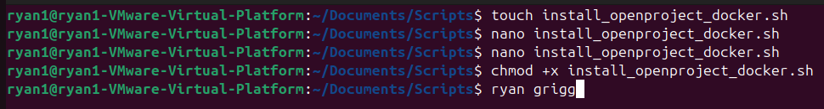
- Ran the code: sudo docker compose up -d 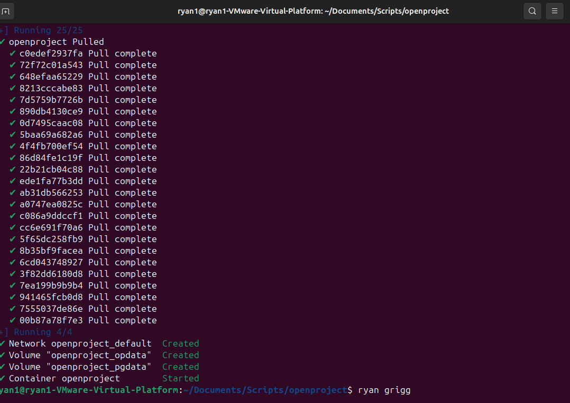
- Had to modify the docker yaml:
cat << 'EOF' > docker-compose.yml
services:
db:
image: postgres:13
environment:
POSTGRES_USER: openproject
POSTGRES_PASSWORD: openproject
POSTGRES_DB: openproject
volumes:
- pgdata:/var/lib/postgresql/data

memcached:
image: memcached:1.6

openproject:
image: openproject/community:13
depends_on:
- db
- memcached
ports:
- "8080:80"
environment:
DATABASE_URL: postgres://openproject:openproject@db/openproject
OPENPROJECT_CACHE__MEMCACHE__SERVER: memcached:11211
SECRET_KEY_BASE: supersecretkey
volumes:
- opdata:/var/openproject/assets

volumes:
pgdata:
opdata:
EOF
- Restarted the docker: 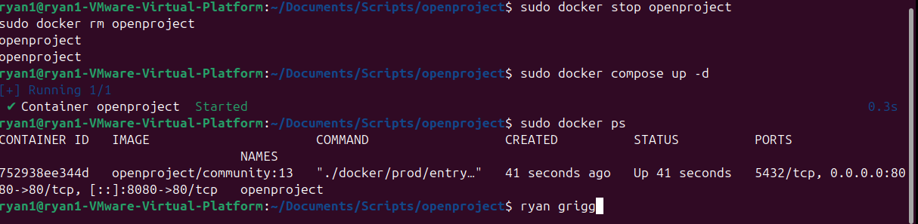
- Open Project Running on Browser.

Installed Features of Open Project
Open Project offers a robust suite of features to facilitate comprehensive project management. Key installed features include:
- Task Management: Create, assign, and prioritize tasks with clear deadlines and responsible team members.
- Gantt Charts: Visualize project timelines and dependencies for effective scheduling.
- Time Tracking: Log hours spent on each task, enabling accurate progress monitoring and reporting.
- Progress Reporting: Generate clear reports on project status, milestones, and team performance.
- Collaboration Tools: Share documents, communicate via integrated messaging, and maintain project notes.
- Weekly Updates: Automate and customize weekly project updates for stakeholders.

Screenshots of Key Features
Below are representative screenshots illustrating Open Project’s interface and core functionalities:
- Task Management: 
- Gantt Charts: 
- Time Tracking: 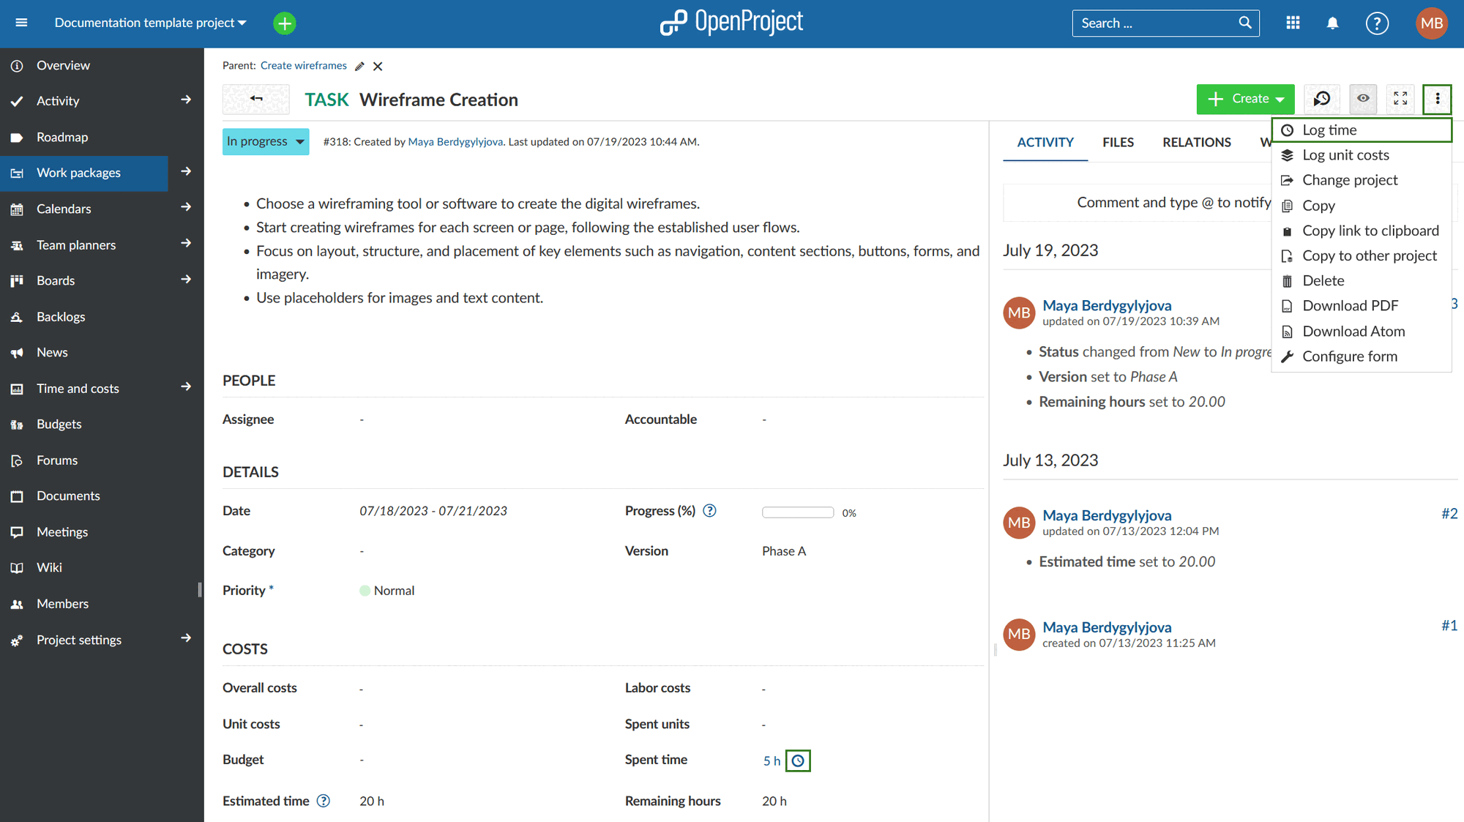
- Progress Reporting: 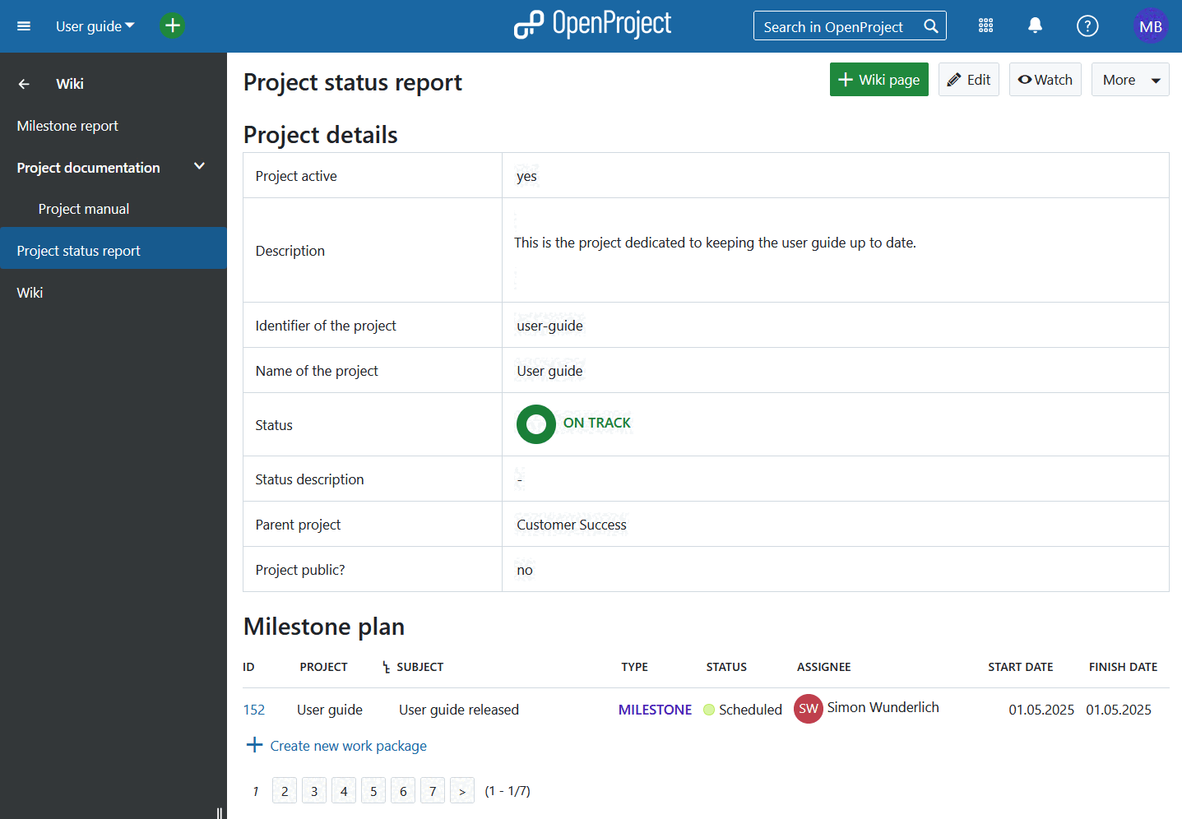
- Collaboration Tools: 
- Weekly Updates: 

Resources for Using Open Project

OpenProject Official Tutorials: https://www.openproject.org/docs/

OpenProject YouTube Channel: https://www.youtube.com/c/OpenProject

Beginner’s Guide to OpenProject (YouTube): https://www.youtube.com/watch?v=JtW7xZ4dZ3E

OpenProject Time Tracking Tutorial: https://www.youtube.com/watch?v=8pGxE2YtJxE

OpenProject Agile Boards Overview: https://www.youtube.com/watch?v=5Q0Nqz8N5iE

Evaluation of Open Project

Positives
- Open Project provides a comprehensive set of tools for managing tasks, resources, and timelines, making it suitable for projects of varying complexity.
- The software’s open-source nature allows for extensive customization and integration with other tools.
- Clear reporting features support decision-making and stakeholder communication.

Negatives
- The interface, while powerful, can be overwhelming for new users without prior PM software experience.
- Some advanced features and plugins may require additional configuration or technical expertise.
- Performance can vary depending on server setup and user load, especially in self-hosted environments.

Ability to Produce Clear Progress Reports
Open Project excels in generating detailed progress reports. Users can customize report templates to highlight project milestones, completed tasks, and outstanding issues. Reports can be exported and shared with stakeholders, ensuring transparency and accountability throughout the project lifecycle.

Task Tracking and Reporting Features
Open Project enables users to track tasks by specific dates and hours, supporting accurate work allocation and resource management. Each task can be assigned deadlines, estimated effort, and actual hours worked, which are then aggregated into weekly progress reports. These reports can be scheduled for automatic distribution, ensuring all team members and stakeholders receive timely updates.

Notes on Performance: Successes and Challenges
- Successes: Teams have reported improved coordination and visibility into project status, thanks to real-time dashboards and collaborative tools. The ability to centralize documentation and communication has streamlined project workflows.
- Challenges: Adapting to the software’s interface may require additional training. Some users have noted that advanced customization options can be complex, and occasional technical support is needed for optimal utilization.

Conclusion and Recommendations
Open Project is a feature-rich PM solution suitable for organizations seeking flexibility, transparency, and robust tracking capabilities. While it may present a learning curve for some users, the wealth of available resources and community support can ease adoption. It is recommended for teams that value open-source adaptability and require strong reporting and collaboration tools.

