**Lab 3: Finite State Machine Design**

***Digital Design and Computer Architecture: RISC-V Edition (Harris & Harris, Elsevier © 2021)***

**Objective**

The purpose of this lab is to learn to design a finite state machine using **structural** SystemVerilog, debug it in simulation with a self-checking testbench, and download it onto an FPGA board.

**1. Thunderbird Turn Signal**

Your goal for this lab is to design a finite state machine in SystemVerilog to control the taillights of a 1965 Ford Thunderbird[1]. There are three lights on each side that operate in sequence to indicate the direction of a turn. Figure 1 shows the tail lights and Figure 2 shows the flashing sequence for (a) left turns and (b) right turns.

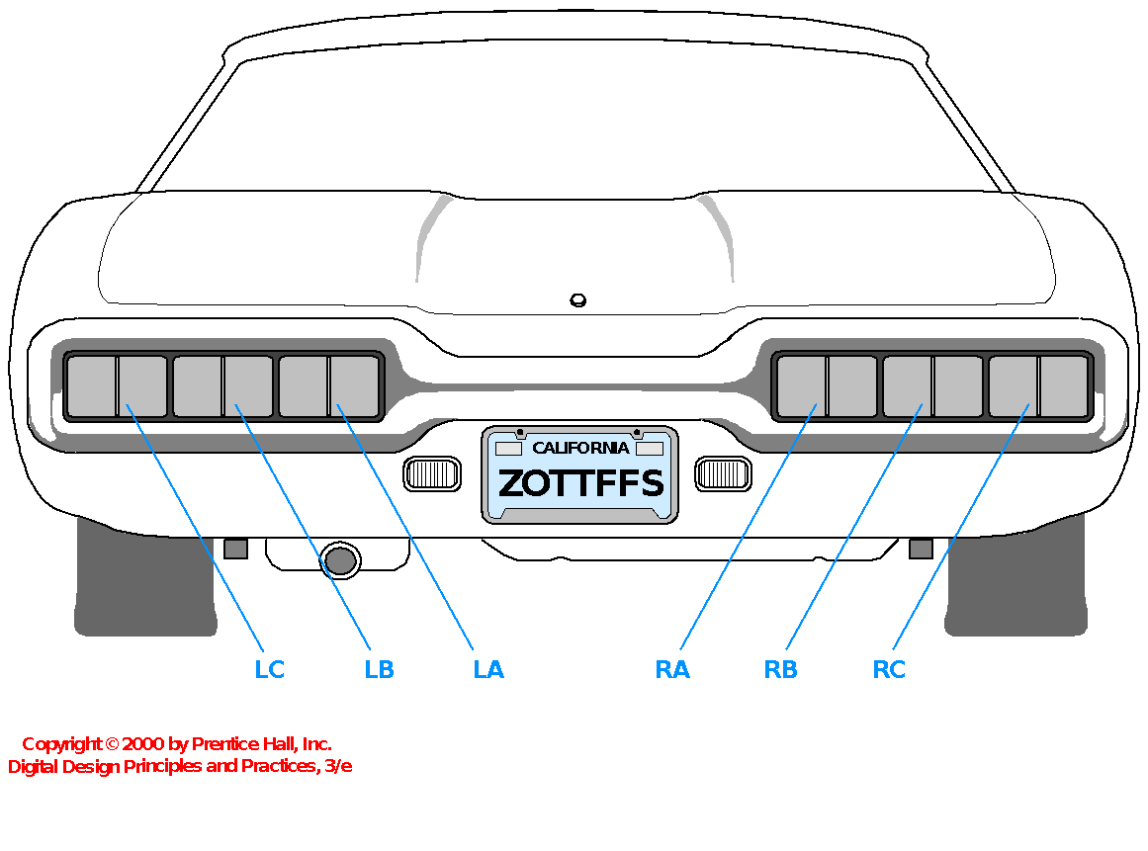

**Figure 1. Thunderbird Tail Lights**

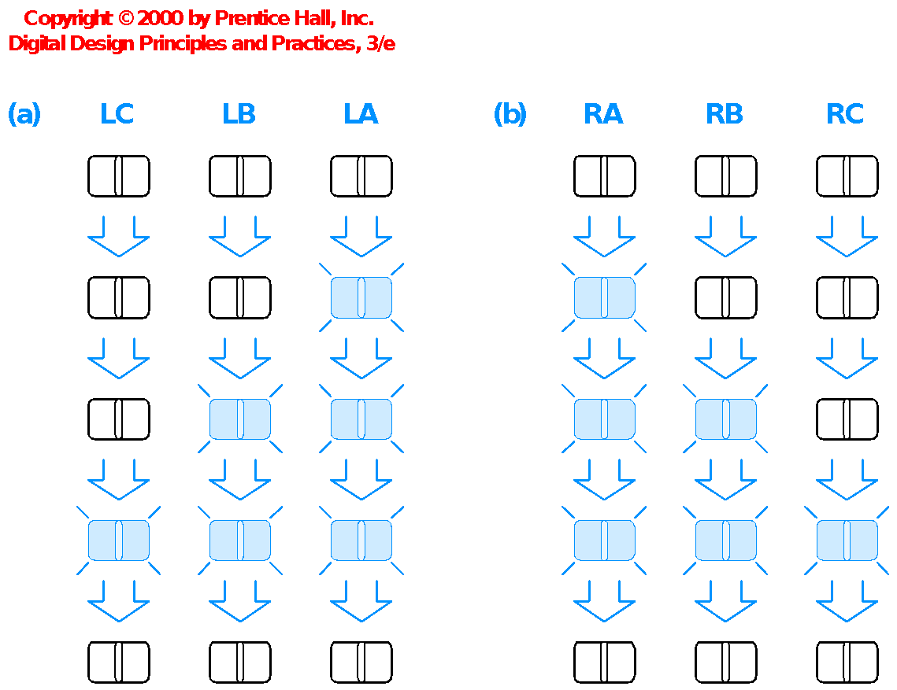

**Figure 2. Flashing Sequence (shaded lights are illuminated)**

The FSM should have two inputs, left and right, that trigger the flashing sequence on the cycle after they are asserted. At most one of the inputs will be asserted at any time. The FSM should have six outputs, LA, LB, LC, RA, RB, and RC. Once the sequence starts, it should continue even if the input is deasserted. When the sequence completes, it should go back to all lights off for a cycle before another sequence may begin. See the Thunderbird test vector file later in this lab for an example of the expected behavior.

* Draw a state transition diagram for your FSM. Be careful to exactly follow the specification above because you will have to repeat all of the subsequent steps if your diagram is incorrect.
* Choose state encodings and write Boolean equations for the next state and output logic. The difficulty of this task is strongly influenced by the state encoding you choose.
* Sketch the circuit.
* Write **structural SystemVerilog** code for your FSM. Your structural SystemVerilog should consist of logic gates and flip-flops, not always blocks or Boolean equations or other higher-level constructs. You’ll need to write at least one behavioral Verilog module to define a resettable or settable flip-flop; use the flip-flop code from the book. Your FSM should have the following module declaration:

module lab3_xx(input logic clk,

input logic reset,

input logic left, right,

output logic la, lb, lc, ra, rb, rc);

where xx are your initials. You may assume that **clk** runs at the desired speed (e.g. about 1 Hz).

* Simulate your FSM with the following self-checking testbench and vectors. Study the testbench and observe how it applies inputs and checks the outputs. Debug any discrepancies.

You’ll probably have errors at first. Get used to interpreting the messages from ModelSim and correct any mistakes. In fact, it’s good if you have bugs in this lab because it’s easier to learn debugging now than later when you are working with a larger system!

module testbench();

logic clk, reset;

logic left, right, la, lb, lc, ra, rb, rc;

logic [5:0] expected;

logic [31:0] vectornum, errors;

logic [7:0] testvectors[10000:0];

// instantiate device under test

lab3_xx dut(clk, reset, left, right, la, lb, lc, ra, rb, rc);

// generate clock

always

begin

clk=1; #5; clk=0; #5;

end

// at start of test, load vectors and pulse reset

initial

begin

$readmemb("thunderbird.tv", testvectors);

vectornum = 0; errors = 0; reset = 1; #22; reset = 0;

end

// apply test vectors on rising edge of clk

always @(posedge clk)

begin

#1; {left, right, expected} = testvectors[vectornum];

end

// check results on falling edge of clk

always @(negedge clk)

if (~reset) begin // skip during reset

if ({la, lb, lc, ra, rb, rc} !== expected) begin // check result

$display("Error: inputs = %b", {left, right});

$display(" outputs = %b %b %b %b %b %b (%b expected)",

la, lb, lc, ra, rb, rc, expected);

errors = errors + 1;

end

vectornum = vectornum + 1;

if (testvectors[vectornum] === 8'bx) begin

$display("%d tests completed with %d errors", vectornum, errors);

$stop;

end

end

endmodule

// thunderbird.tv

// left right _ la lb lc ra rb rc

00_000000

10_000000

10_100000

10_110000

10_111000

10_000000

10_100000

00_110000

01_111000

01_000000

01_000100

00_000110

00_000111

00_000000

* Synthesize your FSM. Look at the **RTL Viewer**. Does it match your expectations?
* Assign pins. Use slide switches[2] for reset, left, and right, a pushbutton switch for clk, and LEDs for the six outputs. Resynthesize with the pin assignments.
* Look at the compilation report in the **Quartus Flow Summary**. Find the number of registers and pins the design uses. Does that match expectations?
* Under **Analysis & Synthesis**, look at the resource utilization summary. Check that the number of register and I/O pins matches your expectations.
* Test your design.

Note that the switches sometimes experience a phenomenon called *bounce*, in which the mechanical contacts bounce as the switch is opening or closing, creating multiple rapid rising and falling pulses rather than a single clock edge. If your lights seem to skip through multiple states at a time, it is probably because of switch bounce on the clock switch. With a bit of practice, you can learn to push the switch in a way that bounces less, but the slide switches have such severe bounce that you will be frustrated if you use a slide switch for clk. It is also possible to build a circuit to “debounce” a switch, but that is beyond the scope of this lab. Fix any other problems that you observe.

**What to Turn In**

1. Please indicate how many hours you spent on this lab. This will be helpful for calibrating the workload for next time the course is taught.
2. State transition diagram
3. State encoding and Boolean equations for next state and output
4. Sketch of circuit
5. Structural SystemVerilog code
6. Simulation waveforms showing the FSM inputs and outputs. Did it pass the self-checking testbench?
7. RTL Viewer schematics. Do they match your expectations?
8. Did the tail lights function correctly on the DE2 Board?

Please indicate any bugs you found in this lab manual, or any suggestions you would have to improve the lab.

1. This lab is derived from an example by John Wakerly from the 3rd Edition of Digital Design.
2. It is also possible to use the KEY3:0 pushbutton, but beware that these are 1 when not pressed and 0 when pressed.