**Lab 6: Music Keyboard**

***Digital Design and Computer Architecture: RISC-V Edition (Harris & Harris, Elsevier © 2021)***

**Objective**

The purpose of this lab is to independently design a nontrivial digital system. Specifically, you will design a 4-key music keyboard that plays notes onto an amplified speaker.

**1. Connecting the Speaker**

Connect an amplified speaker to the GPIO0 headers using one of the custom connectors in the lab that has a speaker jack on one end and two female headers on the other.

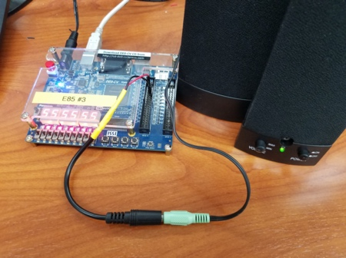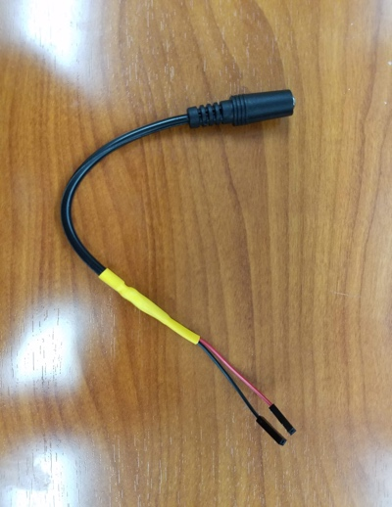

* Plug the red or orange header into pin D0 (upper left corner, FPGA PIN_N16) and the black or gray header into ground (6th row, right side). Make sure the speaker is plugged in and powered on.

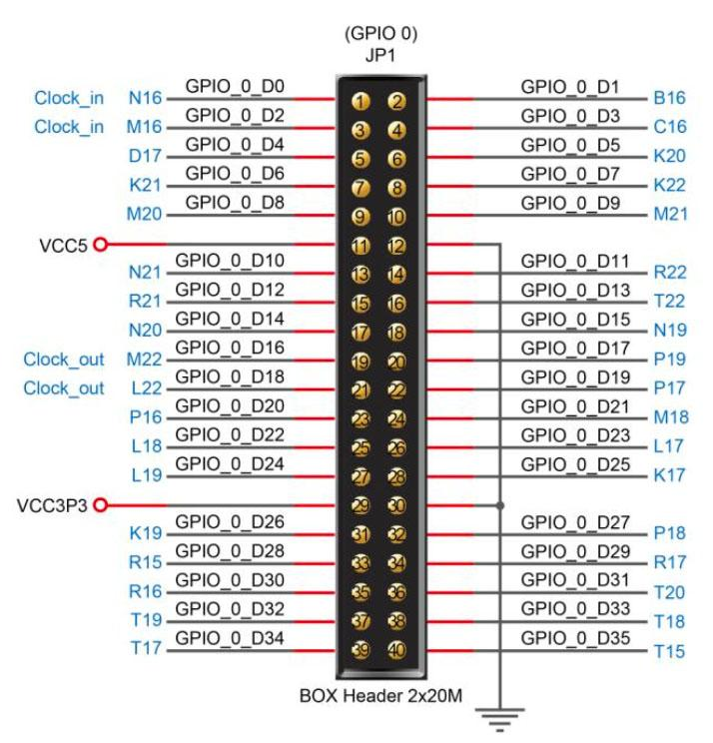

**Figure 1: GPIO Conn. From DE0-CV User Manual**

**2. Generating Tones**

Design a digital system with four inputs from KEY3:0 and one output to GPIO D0. When a key is pressed, a square wave of the corresponding frequency as given below should be generated. Set the output frequencies within 1% of the desired frequencies.

To generate tones, you may want to use one of the DE0 board’s clock signals. The board has buffered 50 MHz clock signals connected to PIN_M9, PIN_H13, PIN_E10, and PIN_V15. If you are using a reset signal, you can assign reset to a toggle switch, e.g., SW0, PIN_U13.

Remember that the keys are wired active low, i.e. they produce a 1 when not pressed and a 0 when pressed.

* Sketch a schematic at the level of registers, adders, multiplexers, and gates.
* Write behavioral SystemVerilog to implement your design.
* Program it onto the DE0-CV board and test it.
* Optional: Measure the output frequency for each key pressed with an oscilloscope.
* Fill out the following table. If more than one key is pressed, you can choose what should happen.

|  |  |  |  |
| --- | --- | --- | --- |
| **Key** | **Note** | **Desired Frequency (Hz)** | **Actual Frequency (Hz)** |
| KEY3 | C | 261.6 |  |
| KEY2 | E | 329.6 |  |
| KEY1 | G | 392 |  |
| KEY0 | A | 440 |  |

**3. A Happy Song (if you enjoy the Bubonic Plague)**

* Play a tune by tapping the following keys.

1120 12 1120 12 12 12 11 3

Can you name the tune?

**4. Extra Credit**

* Invent another song for your keyboard or modify the hardware to create another interesting feature, such as the ability to add more notes, change octaves, play more than one note at a time, or play a tune automatically.
* Test your invention.

**What to Turn In**

1. Please indicate how many hours you spent on this lab. This will be helpful for calibrating the workload for next time the course is taught.
2. Schematic
3. Behavioral SystemVerilog code
4. Table of actual output frequencies

|  |  |  |  |
| --- | --- | --- | --- |
| **Key** | **Note** | **Desired Frequency (Hz)** | **Actual Frequency (Hz)** |
| KEY3 | C | 261.6 |  |
| KEY2 | E | 329.6 |  |
| KEY1 | G | 392 |  |
| KEY0 | A | 440 |  |

1. Does your system play music? Can you name the tune? (it’s ok if you don’t recognize it)
2. Extra credit, if applicable

Please indicate any bugs you found in this lab manual, or any suggestions you would have to improve the lab.