toolStripButton2
справкаToolStripMenuItem
toolStripButton4
toolStripButton3
расчетToolStripMenuItem
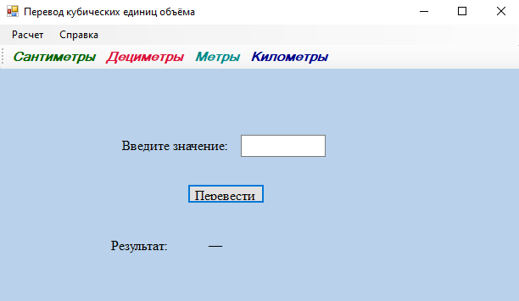
Label4
Label5
Button2
Label6
toolStripButton1
textBox1

