Ночной светильник

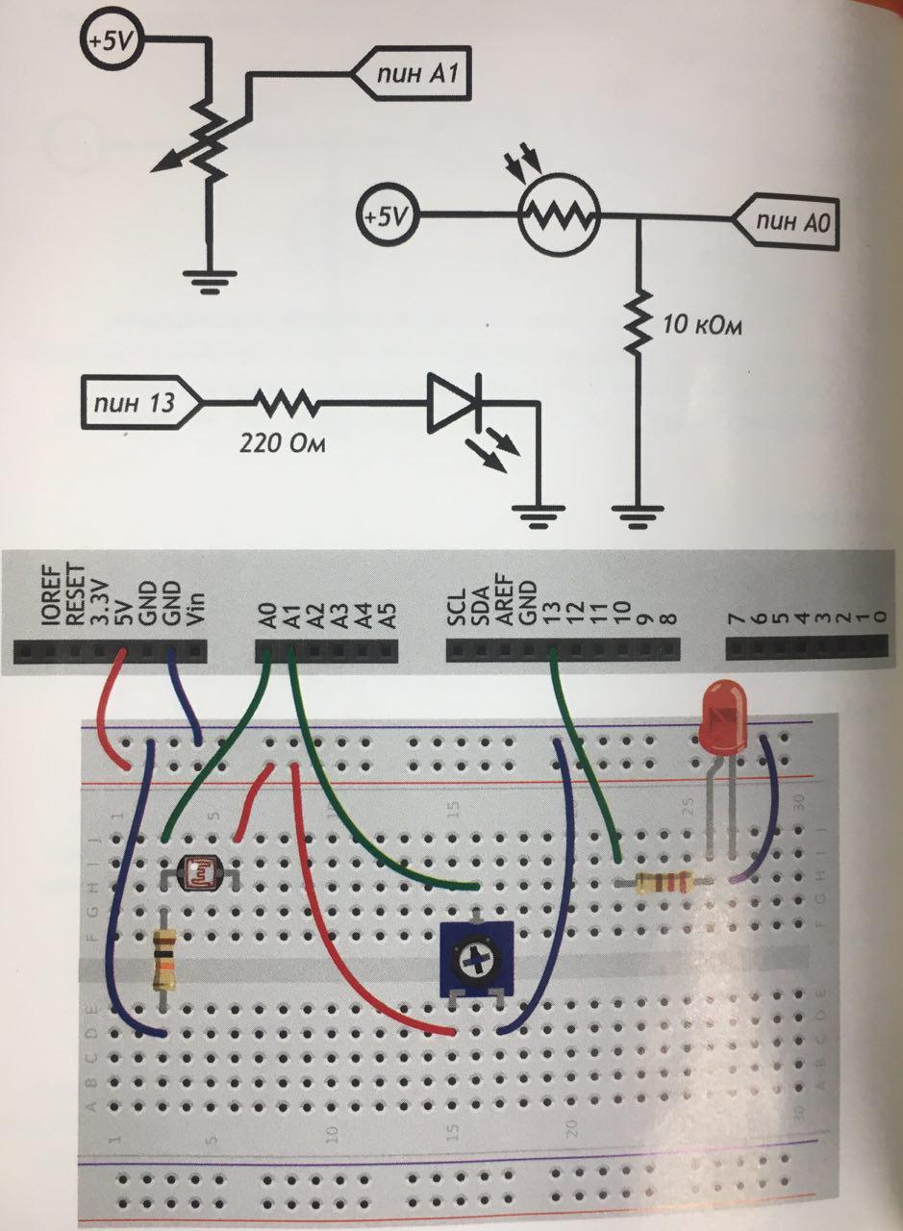

Маячок

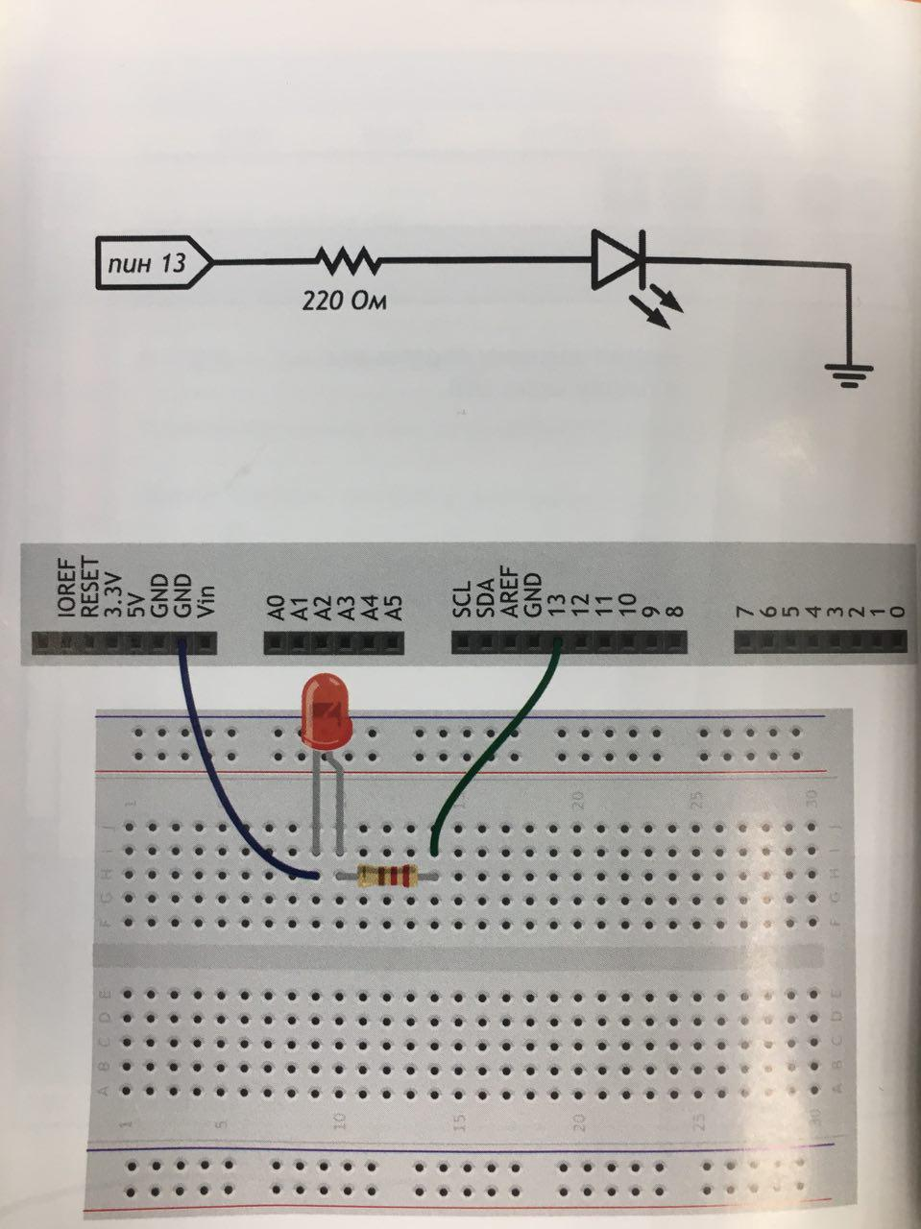

Тестер батареек

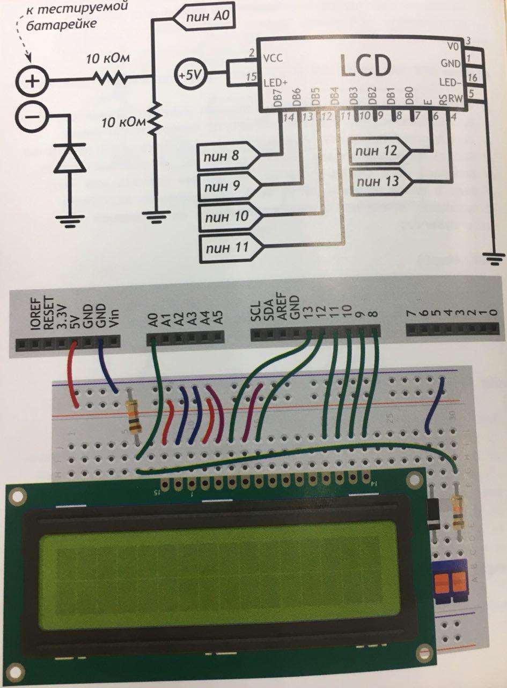

\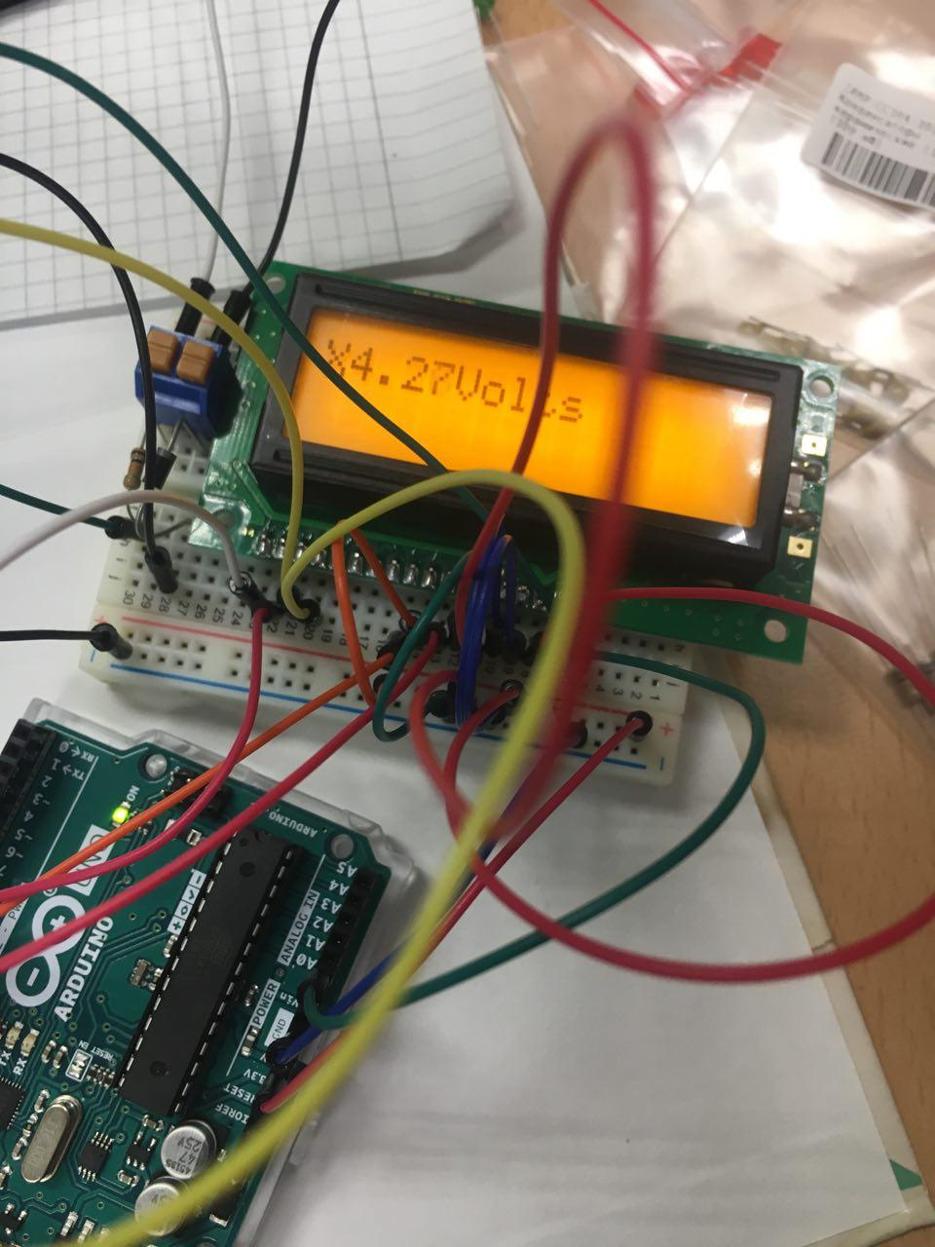

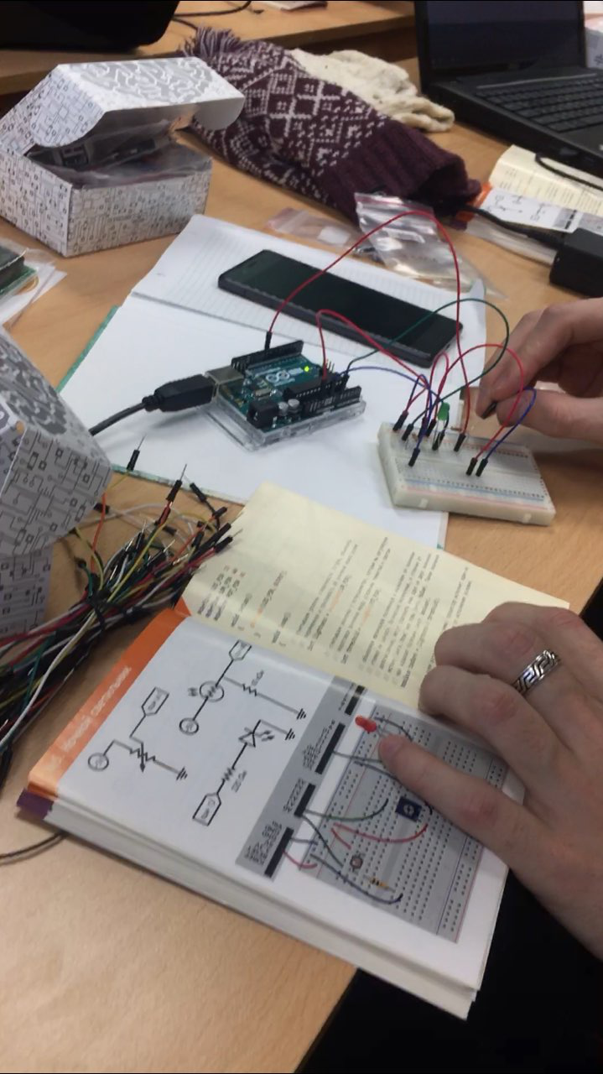

Приложение

**Тестер батареек**

#include <LiquidCrystal.h>

#define DIODE_DROP 0.7

LiquidCrystal lcd(13,12,11,10,9,8);

void setup() {

// put your setup code here, to run once:

lcd.begin(16,2);

lcd.print("Battary ");

}

void loop() {

// put your main code here, to run repeatedly:

float voltage = analogRead(A0) / 1024.0 * 10.0;

if (voltage > 0.1)

voltage +=DIODE_DROP;

lcd.setCursor(1,0);

lcd.print(voltage, 2);

lcd.print("Volts");

}

**Маячок**

#define LED_PIN 9

void setup() {

// put your setup code here, to run once:

pinMode(LED_PIN, OUTPUT);

}

void loop() {

// put your main code here, to run repeatedly:

analogWrite(LED_PIN, 85);

delay(250);

analogWrite(LED_PIN, 170);

delay(250);

digitalWrite(LED_PIN, 255);

delay(250);

}

void setup() {

// put your setup code here, to run once:

pinMode(13, OUTPUT);

}

void loop() {

// put your main code here, to run repeatedly:

digitalWrite(13, HIGH);

delay(100);

digitalWrite(13, LOW);

delay(900);

}

**Ночной светильник**

#define LED_PIN 13

#define LDR_PIN A0

#define POT_PIN A1

void setup() {

// put your setup code here, to run once:

pinMode(LED_PIN, OUTPUT);

}

void loop() {

// put your main code here, to run repeatedly:

int lightness = analogRead(LDR_PIN);

int threshold = analogRead(POT_PIN);

boolean tooDark =(lightness < threshold);

if (tooDark)

{

digitalWrite(LED_PIN, HIGH);

}

else

{

digitalWrite(LED_PIN, LOW);

}

}