SkillSwap
A Peer-to-Peer Knowledge Exchange Platform Proposal
Amrit Bhattarai
Coventry ID: 15372312
Batch: 36

Softwarica College of IT and E-Commerce
Coventry University

ST6002CEM: Mobile Application Development
Module Leader: Kiran Rana

Submission Date: : 4/29/2026

Abstract
SkillSwap is a mobile application created to tackle the problem of limited access to and prohibitive cost of skill acquisition due to the rapidly changing nature of our world. It is a peer-to-peer skill exchange tool where users have the opportunity to learn and teach skills among themselves without any financial transactions involved in the process, thus creating a collaborative learning environment. The primary audience of SkillSwap includes mainly young learners; students, young professionals, freelancers, and lifelong learners who would like to expand their knowledge and skill sets while helping others do the same by sharing their experience and knowledge. Such functions of the app as personal accounts of the users allowing them to specify their teachable and needed skills, intelligent matching technology, request processing, in-application chatting, monitoring the progress made, and rating/reviewing functionality all serve as means of ensuring a high level of productivity and engagement of users in learning. The architecture used in SkillSwap is the MVVM (Model-View-ViewModel) pattern, which ensures that there will be a clear separation of concerns, easy maintainability of the app, and excellent performance of the application on both web and mobile platforms via a unified backend API.

Table of Contents
Introduction 4
Project Introduction 4
Justification of the Project 4
Background of the Project 5
Problem Statement 5
Description of the Project 6
Features of the Project 7
Aims and Objectives 8
Aims 8
Objectives 8
MVVM Design Pattern 9
Configuration Management 11
GitHub Repository Link 11
GitHub Repository Screenshot 11
Prototyping 12
High-Fidelity Prototypes 13
Conclusion 15
References 16

Introduction

Project Introduction
SkillSwap is a mobile app that lets users exchange skills with each other without any money changing hands. It connects people who want to share their knowledge with those who are eager to learn new skills. This creates a community where learning is collaborative and mutual. The app is developed using flutter. (Amazon Web Services, n.d.)
The project aims to build a functional Android app where users can create profiles, list skills they can teach and skills they want to learn, find appropriate matches, send requests for exchanges, chat with partners, track their progress, and rate each other after completing exchanges. The project focuses on essential features such as user authentication, profile management, skill matching, handling requests, in-app chat, a rating system, and AI-based recommendations.

Justification of the Project
The development of SkillSwap is highly justified due to the persistent barriers in skill development; high costs of traditional online courses and the lack of truly reciprocal, personalized learning experiences. Many aspiring learners, especially students, young professionals, and freelancers in developing regions, cannot afford paid platforms like Udemy, Skillshare, Coursera, or one-on-one tutoring services. Existing solutions are mostly one-directional, requiring monetary payment and offering limited peer-to-peer interaction.
SkillSwap fills this critical gap by introducing a free, peer-to-peer skill exchange model where users teach what they know and learn what they need in return. This addresses a clear user need for affordable, flexible, and community-driven learning while tapping into the growing demand for sharing economy models in education. With the neighborhood skill-swap and bartering platforms market showing strong growth, SkillSwap promotes inclusive skill development, encourages knowledge sharing, and builds meaningful local and global connections without financial barriers. (Skill Exchange Platform, n.d.)

Background of the Project
In today's competitive world, it's important to learn new things, but sites like Coursera, Udemy, and Skillshare that teach you things are often too expensive and only teach you one thing. Many students, young professionals, and freelancers, especially in developing countries, cannot afford paid courses and lack access to personalized, reciprocal learning.
SkillSwap fills this gap by providing a free platform for people to exchange skills with each other. Users can teach others what they know and learn new skills in return. This project is worth developing because it removes financial barriers, encourages community-driven knowledge sharing, and meets the need for flexible, mutual skill development. It also meets the growing need for affordable and collaborative learning solutions.

Problem Statement
Accessing high-quality skill-building opportunities is a major obstacle for students, early career professionals and workers, and freelancers, especially those who come from developing countries. Most online platforms are subscription based or one-time fee based (and therefore very expensive) thus limiting access to a wide variety of learners wanting to obtain needed skills. Many individuals wish to learn new skills but simply cannot afford to use these online platforms, while others that have useful skills have very few ways to teach and gain recognition without investing money into it.
This issue is represented by the high number of individuals dropping out of paid courses as well as the low number of individuals in low and middle income countries participating in formal online education. The predominant barrier to participation in online education is a financial barrier being placed upon learners; therefore prohibiting an otherwise motivated learner from receiving in demand skills resulting in limited opportunities for advancement personally and professionally.

Description of the Project
SkillSwap is a cross-platform mobile application built on Flutter which allows users to trade skills among themselves for free through a Peer-to-Peer exchange model. SkillSwap takes away the expensive cost of developing new skills by providing users with a listing of what skills they would like to learn and what skills they are able to teach; additionally, SkillSwap matches users with other users who are trying to learn a skill from someone else.
After creating your profile and adding your skills, you can search through other SkillSwap users to find other users who are interested in exchanging skills. Once matched with a user for skill exchange, users can request permission to exchange skills, communicate via the chat function to set up an exchange session, and finally complete the exchange. After completing the skill exchange, users have the ability to rate one another's performance.
SkillSwap facilitates this entire process by maintaining user profile information, skill information, skills exchange requests, chat messages, and skill exchange ratings. By promoting reciprocal learning and eliminating any barrier resulting from material, economic resources (money), SkillSwap enables users of all income brackets to learn, develop, and refine new skills in an interactive and supportive community environment.

Features of the Project
Minimum Viable Product features:
- User registration / Profile Management : allows user registration; user can create a profile to display their own skills as a teacher and as a learner enabling ease of onboarding and visibility of their profile by others.
- Skill Listing and Intelligent Matchmaking : match users by listing their skills and can receive recommendations for partners by finding them based upon what skills the potential partner has available to offer (thus enabling users' ability to connect with the users with the required skills).
- Skill Exchange Request system : allows users to send and manage skill exchange requests to one another to initiate a mutual exchange between users.
- In-app chat : allows users to coordinate with one another in real time so that they can ensure a session can be coordinated. This should help to reduce issues with coordinating sessions between matched partners.
- Rating / Review System : after a session has occurred, partners rate each other. This should help build trust between partners and ensure quality both in the partners and in the skills exchanged.
Stretch Goals (Extended Features)
- Advanced Search and Filters
- Exchange Progress Tracking
- Notifications and reminders

Aims and Objectives

Aims
This project aims to create a mobile app built on Flutter for multiple platforms that allows people to share skills in a peer-to-peer system where no money changes hands. This will help students, young professionals, and freelancers develop skills more collaboratively, affordably, and easily.

Objectives
The project has following objectives:
- Design & build an Android mobile application using Flutter where users can create a profile with skills they would like to exchange or learn by the end of the project.
- Implement a skill matching system that allows users to search, view and send requests to potential partner(s) to complete a skill exchange.
- Implement a chat feature that allows users to communicate and coordinate an exchange once matched.
- Build a rating/review system so that users can give feedback and rate their partner after completing an exchange.
- Ensure the application uses the MVVM architecture with a clean code structure and integrates with the back-end API for data management.
- Test and validate the entire exchange process (matching through rating) by functional testing on Android devices before the project is submitted for approval.

MVVM Design Pattern
Modern mobile application development often employs the Model-View-ViewModel (MVVM) architecture pattern since it separates user interface and visual presentation from business logic and data layer/management. With this structure, the code is organized better because MVVM is composed of three unique layers (Model: Business Logic/ Data layer; View: User Interface (UI); ViewModel: Acts as bridge between Model and View). (Sharma, 2023)
The Model in the MVVM architecture pattern is responsible for containing the data layer and business logic. As such, the Model layer is responsible for interacting with data sources and performing tasks like calling an application's API for data, performing any database operations required, and applying any core business rules.
The View is responsible for presenting the user interface (UI) to the user, as well as providing functionality for capturing user input. The ViewModel serves as an intermediary layer between the View and the Model; therefore, the ViewModel contains all of the presentation logic associated with displaying data in the view and interpreting and processing user input as it relates to the data layer as well as exposing (observable) data from the Model layer that the View can bind to.
The SkillSwap project would greatly benefit from using MVVM architecture because it provides the best separation of concerns inherently creates a modular, testable, maintainable codebase. Flutter's use of MVVM provides excellent tools for state management and reactive data binding, which will greatly enhance the responsiveness of the UI for real-time features such as chat and skill matching. The clear separation of layers will also allow for independent development and testing of each layer, thus reducing the number of defects, as well as making enhancements and scaling simpler in the future.

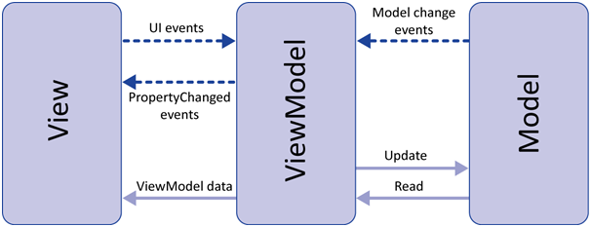
Figure 1: MVVM Architecture for SkillSwap

Configuration Management

GitHub Repository Link
https://github.com/Softwarica-College-of-IT-E-Commerce/final-assignment-36a-pro5598.git

GitHub Repository Screenshot
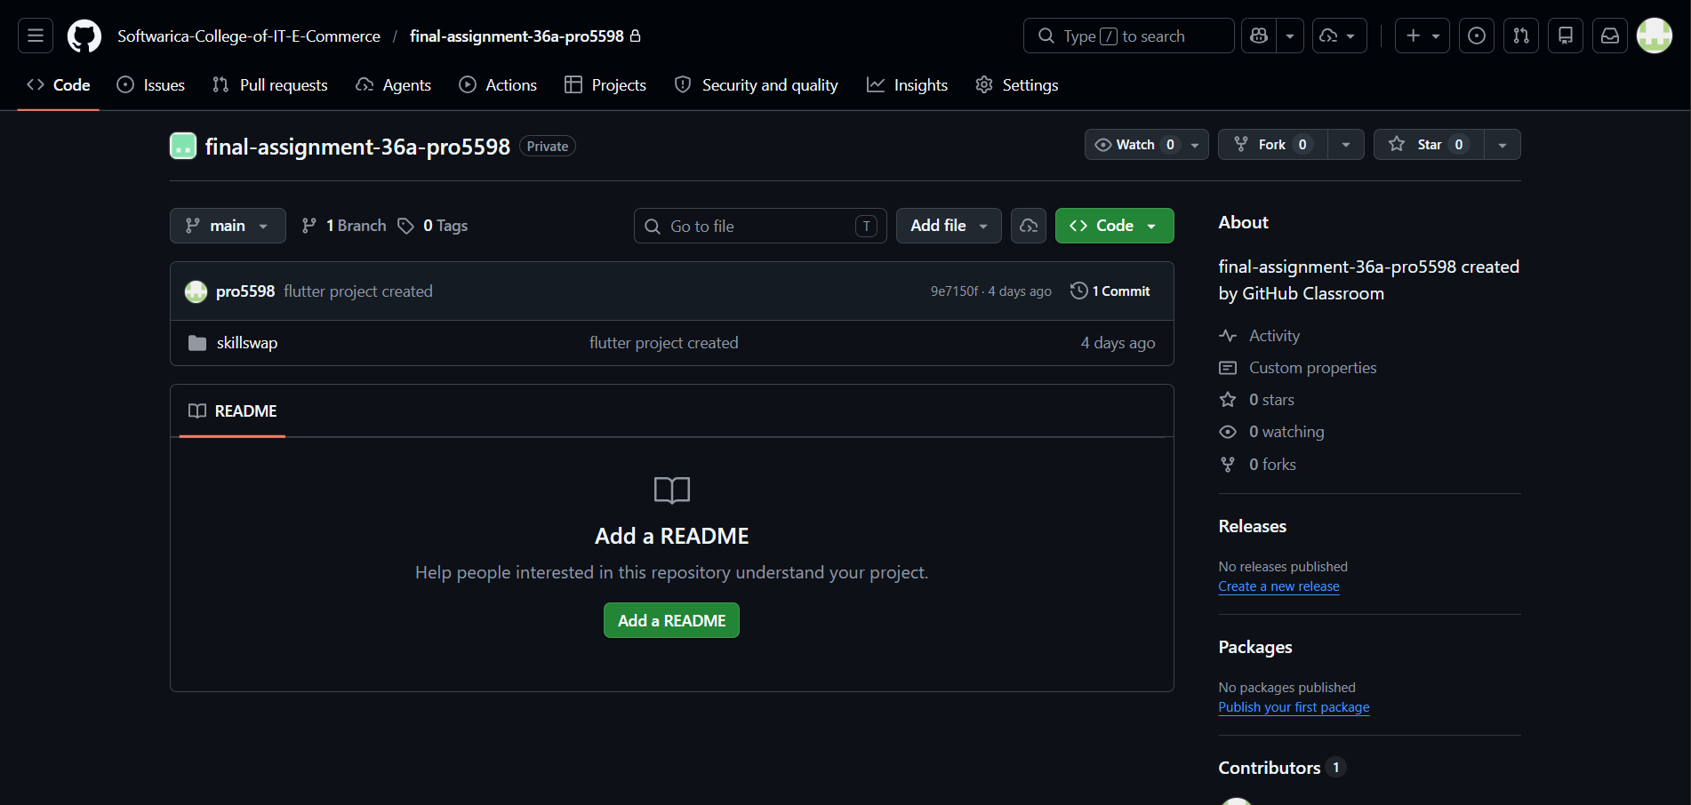
Figure 2: Github Repository Overview

Prototyping
Through use of Figma, one of the most widely used collaborative UI/UX design tools available today; The prototype design process was able to produce prototypes that could assist in visualizing how users would ultimately interact with the UI and UX components of the application prior to beginning the actual development of the application itself.
The prototypes are made up of many key application screens including; user registration, profile creation, skill listing, matching page, request management, in-app chat and rating system. By building these prototypes it allowed us to validate the primary user journey and enhance the overall flow of the application early on in its lifecycles.
As a result, by developing prototypes that are rich in interactivity and created in Figma, all design-related decisions that were made during the design process directly supported the project goals and core features by developing intuitive navigation mechanisms, providing users with clear interaction paradigms, and providing a consistent user experience across all components of the application. Additionally, this process allowed for identifying usability issues early in the lifecycle of the product, align prototyping efforts and decisions with the overall MVVM architectural design approach, and ensure a smooth handoff and implementation processes throughout the actual development phase of the project. (Digital Promise, 2022)

High-Fidelity Prototypes
A high-fidelity representation of the interface was produced after the wireframe initial phase using Figma to create a prototype that illustrates how the SkillSwap application will function/look/feel. While this interactive model has turned static designs into a usable experience for users, specific details such as font styles, colours and UI elements have been accurately represented. (Cagan & Cagan, 2023)
The prototype simulates user flows such as matching algorithm display, real-time messaging and profile management. I was able to validate data flow with a MVVM architecture by experimenting with design details and transitions prior to developing the final prototype to ensure that navigation would be friendly/easy. Overall, high-fidelity development ensures a reduced level of ambiguity in design, creating a design blueprint for building the front-end and back-end Flutter application.
Figma Link:
https://www.figma.com/design/fJkBuz37jHfEzyxuL75AeX/SkillSwap-UI?node-id=0-1&t=jAqAiR4kkTw4uVJm-1

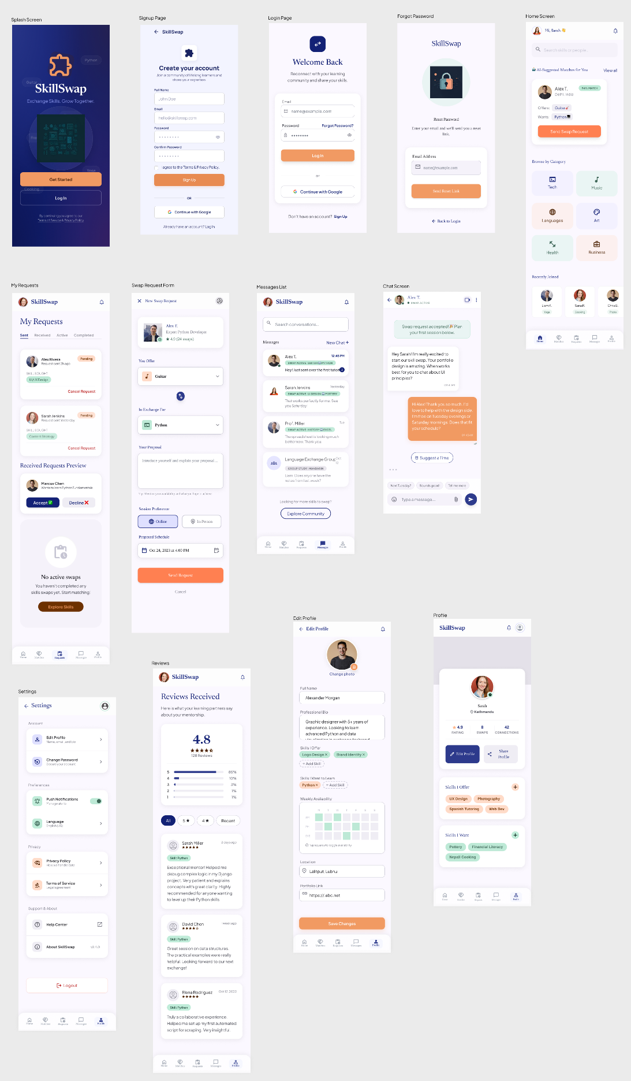
Figure 3: SkillSwap High Fidelity Prototypes

Conclusion
The SkillSwap initiative is intended to bridge a significant gap in the current education system: the cost of learning new skills. Most educational platforms charge for subscriptions to access content, whereas SkillSwap uses a peer-to-peer system that allows members to use knowledge as a form of currency. By bringing together students, freelancers, and early career professionals, SkillSwap creates a community where members can learn from one another, making the acquisition of new skills more widely available.
To deliver an effective and easily maintainable application, SkillSwap has been built using the Flutter framework and MVVM (Model-View-View Model) architecture. This approach separates the code that runs the business logic from that which is responsible for the user interface, allowing for seamless real-time features like intelligent pairing, chat between users, and other real-time services. The addition of a rating system allows users to trust the community and maintain quality within the platform
With a well-defined scope and a focus on creating a Minimum Viable Product, this project will be easily completed within the timeframe of the module. The completion of a functional Android app from the completed Figma prototype demonstrates that the core objectives of the project (match, chat, and share skills) will be validated through implementation. SkillSwap provides a viable and scalable method of providing equal opportunity and affordable access to education.

References
Amazon Web Services. (n.d.). What is Flutter? Amazon Web Services, Inc. https://aws.amazon.com/what-is/flutter/
Sharma, N. (2023, July 3). MVVM design pattern for iOS and Android -. https://codewave.com/insights/mvvm-design-pattern-for-ios-and-android/
Skill Exchange Platform. (n.d.). https://fossunited.org/hack/fosshack25/p/rbbd7rpub8
Digital Promise. (2022, May 13). What is Prototyping? – Digital Promise. https://digitalpromise.org/initiative/360-story-lab/360-production-guide/investigate/augmented-reality/pre-production/what-is-prototyping/
Cagan, M., & Cagan, M. (2023, August 18). High-Fidelity Prototypes. Silicon Valley Product Group. https://www.svpg.com/high-fidelity-prototypes/

