WaveDrom with MS Word

# Here are the steps:

1. Edit timing diagram using WaveDrom Editor: <http://wavedrom.googlecode.com/svn/trunk/editor.html>

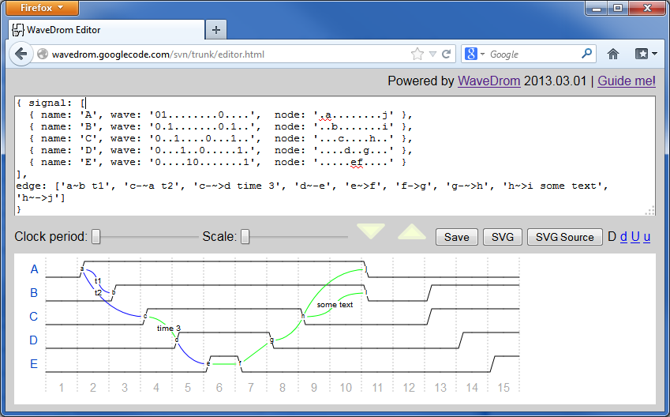

1. Press SVG button:  (new Tab will open with SVG picture)

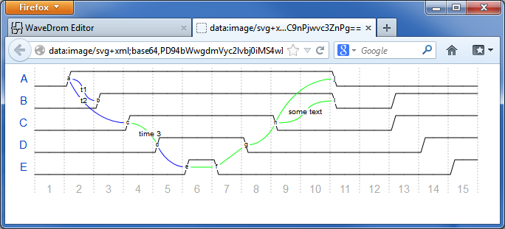

1. Ctrl+S to save the SVG with the name and in the folder of your choice:

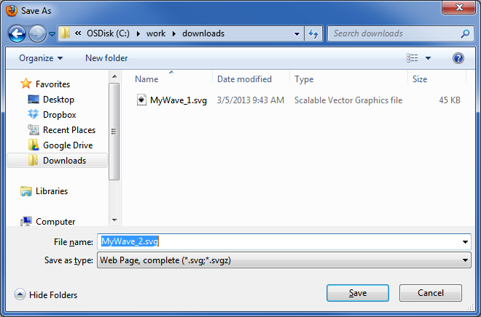

1. You can convert SVG 🡪 PNG using Inkscape vis GUI or from command line:

"c:/Program Files (x86)/Inkscape/inkscape.exe" MyWave_2.svg **--export-png**= MyWave_2.png

And Then insert as picture below:

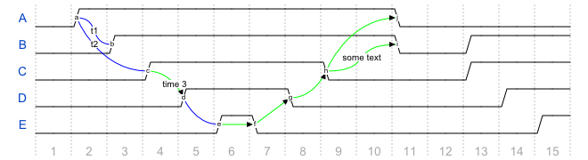

1. Or similar story for SVG 🡪 EPS (but now the vector format is preserved!)

"c:/Program Files (x86)/Inkscape/inkscape.exe" MyWave_2.svg **--export-eps**= MyWave_2.eps



Click **Show/Hide** Button image on the **Home** toolbar to see the diagram source.

{ signal: [

{ name: 'A', wave: '01........0....', node: '.a........j' },

{ name: 'B', wave: '0.1.......0.1..', node: '..b.......i' },

{ name: 'C', wave: '0..1....0...1..', node: '...c....h..' },

{ name: 'D', wave: '0...1..0.....1.', node: '....d..g...' },

{ name: 'E', wave: '0....10.......1', node: '.....ef....' }

],

edge: ['a~b t1', 'c-~a t2', 'c-~>d time 3', 'd~-e', 'e~>f',

'f->g', 'g-~>h', 'h~>i some text', 'h~->j']

}

# Place WaveDrom source code under picture

Place the source code inside the word document to provide the way for future modifications of Timing Diagrams you have created.

Make source code hidden using the following steps:

1. Select the text you want to hide.
2. On the **Format** menu, click **Font**, and then click the **Font** tab.
3. Select the **Hidden** check box.

# Simplified flow

You can use Windows **Snipping Tool** to get quick raster picture into your MS Word document.