**CHAPTER 3: THEORY OF CONSUMER BEHAVIOR**

* Utility and element of analysis
* Theories of utility
  + The cardinal theory
    - The law of diminishing marginal utility
    - Maximizing total utility
  + The ordinal theory (indifference curve approach)
    - Characteristics of indifference curve
    - Marginal rate of substitution
    - Budget line
    - Maximizing total utility

**THEORY OF CONSUMER BEHAVIOR/CHOICE**

Theory of consumer behavior or choice is used to explain:

How consumers decide on the basket of goods and services they consume

How consumers allocate a limited income to the purchase of different commodities

* Theory of consumer behavior is then helpful to:

Explain the principles underlying demand:

How changes in income and prices affect demands for commodities;

Why the demand for some goods is more sensitive to others.

To design public and private policies.

* Consumer behavior is best understood in three distinct steps:

1. **Preference:** the first step is to find a practical way to describe the reason why people/consumer might prefer one good over the other.

***Consumer preference*** is the ranking or choice behavior of a consumer based on the utility derived from the commodity consumed.

***Utility*** is the satisfaction that an individual or a consumer receives from consuming goods and services /activities they are engaged in.

Consumers rank items or group of items (market basket or bundle) according to the utility. ***Market basket*** or ***market bundle*** is a list of items with specific quantities of one or more commodities.

**Assumptions** of consumer preference ranking of bundles or items are: *completeness* (consumers list all goods & services for consumption); *transitivity* (if a consumer prefers A over B over C, then A over C); and *more is better than the less*.

1. **Budget Constraint**: Given the income and prices, the consumers’ income limits the quantities of goods they can buy.
2. **Consumer Choice:** Given preferences and limited income, consumers choose to buy combinations of goods/services that maximize their satisfaction.

Thus understanding consumers’ choice will help us understand demand – consumers’ willingness and ability to purchase a given quantity.

**3.1 Utility Theory**

* The value a consumer places on a unit of a good or service depends on the pleasure or satisfaction he/she expects to derive from having or consuming it at a point of time of making a consumption (consumer) choice.
* In economics the satisfaction or pleasure consumers derive from the consumption of consumer goods is called “utility”.
* It indicates numerical score representing the satisfaction that a consumer gets from a market basket.
* Consumers, however, cannot have everything they wish to have. Consumers’ choices are constrained by their incomes.
* Within the limits of their incomes, consumers make their consumption choices by evaluating and comparing consumer goods with regard to their “utilities.”

**Basic assumptions about a Rational Consumer:**

* ***Rationality***: Consumers maximize their respective utility;
* ***Ranking preferences***: Consumers prefer more of a good (thing) to less of it;
* Facing choices X and Y, a consumer would either prefer; X to Y or Y to X, or would be indifferent between them;
* ***Transitivity:*** If a consumer prefers X to Y and Y to Z, we conclude he/she prefers X to Z;
* ***Diminishing marginal utility:*** As more and more of a good is consumed, ceteris paribus, beyond a certain point the utility of each additional unit starts to fall.

**3.1.1 Measurement of Utility: *Cardinality***

**How?** Measuring utility in “utils” (**Cardinal Approach**):

* Assumes that we can assign values for utility, (Jevons, Walras, and Marshall).

E.g.: derive 100 utils from eating a slice of pizza, 10 utils from eating banana

Abebe derives 10 utils from having one banana but only 5 utils from having a bread.

* Under certain assumptions, utility measurement in absolute terms is possible ***(Cardinalists)***. ⇒ utility is additively separable & summed to give the total.

**Total Utility Vs Marginal Utility**

* Marginal utility (MU) is the utility a consumer derives from the last unit of a consumer good she or he consumes (during a given consumption period), ceteris paribus;
* *Additional* *satisfaction* that an individual derives from consuming an *additional unit* of a good or service.
* Total utility (TU) is the utility a consumer derives from the consumption of all of the units of a good or a combination of goods over a given consumption period, ceteris paribus;

⇒ the overall level of satisfaction derived from consuming a good or service.

*Total utility = Sum of marginal utilities*

**Total and Marginal Utility for Bread**



**The Law of Diminishing MU (in Brief )**

* Over a given consumption period, the more of a good a consumer has, or has consumed, the less an additional unit, MU, it contributes to his or her overall satisfaction (TU);
* Alternatively, we could say: over a given consumption period, as more and more of a good is consumed by a consumer, beyond a certain point, the MU of additional units begins to fall.

⇒ Consuming successive units of a product over a period gives less and less marginal utilities.

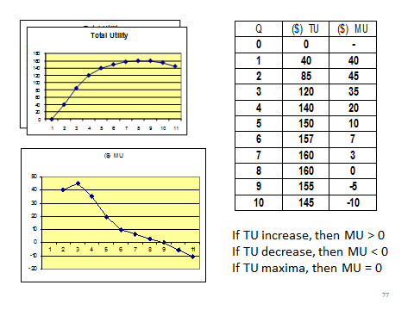

**Utility Maximizing Rule**

* When choosing, confronted with a range of goods and prices, a consumer may not choose the item which has the greatest utility because price and income are important factors; the relevant question is not which item has most utility but which has the most utility per unit of price;
* The consumer’s money income should be allocated so that the last dollar (birr) spent on each product yields the same (equal) amount of extra (marginal) utility;
* A rational consumer would buy an additional unit of a good as long as the perceived dollar (birr) value of the utility of one additional unit of that good [say, its marginal dollar utility] is greater than its market price.

***a)* Utility Maximization: *Single Good Rule***

* In the single commodity case, a consumer is at equilibrium when he/she maximizes his/her utility from the consumption level of a good for a given price;
* He/she is faced with the choice of either spending income on the purchase of the commodity or retaining(saving) his her income;
* **Decision Criteria:** the equilibrium quantity of consumption is at the equality of the additional utility (MU) of the commodity and the marginal utility of money (MUm = which is constant).
* **E.g.** Suppose that the price of commodity X in the above hypothetical utility table is, *Px = 7*; and then, the equilibrium is achieved when *MUx = Px = 7, OR MUx/Px = 1*.

***b)* Two or More commodity (general) Case**

* In reality, a consumer consumes a larger no of goods; MU schedules of various goods thus may not be the same; some yield higher utility and some lower, while MU of some goods decreases rapidly than that of others as consumption rises.
* A rational utility maximizing consumer consumes commodities in the order of their utilities; he/she picks up the commodity yielding the highest utility followed by the commodity which yields the second highest, and so on.
* Given *Px = Py*, the consumer will choose to consume that combination of X & Y at which *MUx = MUy*; but when *Px ≠ Py*, the consumer switches his/her expenditures from one good to the other in accordance with their MU until MU/P of the two goods are equal.

Mathematically: The Two-Good Rule

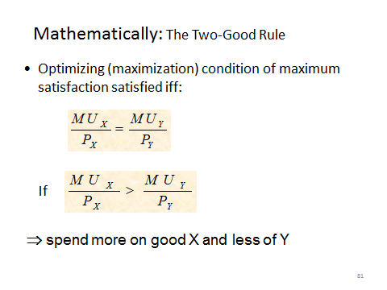

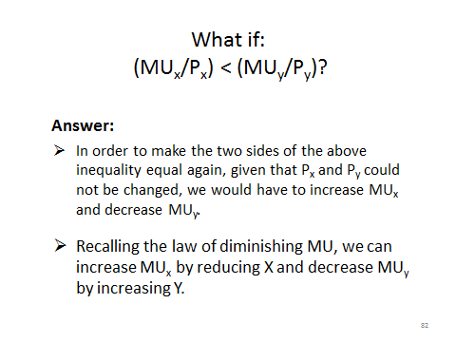

**Example:** the table below shows combination of two goods, good *X* and good *Y*, between which a consumer is indifferent.

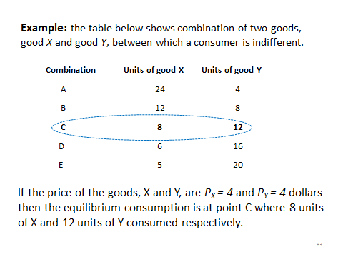

**Some simplifying assumptions:**

* Consumer’s objective: to maximize his/her utility subject to income constraint;
* Two goods (X, Y);
* Prices *Px*, *Py* are fixed; thus
  + Consumer’s income (M) or *Budget equation* is given by

*Px•Qx* **+** *Py•Qy = I*

**Utility Maximization under Income constraint**

* Consumers’ spending on consumer goods is constrained by their incomes:

*Income = PxQx + PyQy + PwQw + …. + PzQz*

* While the consumer tries to equalize MUx/Px , MUy/Py, MUw/Pw, ... and MUz/Pz , to maximize his/her utility, his/her total spending cannot exceed the income.

**Example:** with an income of birr 86, Abebe is trying to decide how much ice cream and how much pizza he should buy for a given price of ice cream 6 and that of pizza 10 unit of money.

Abeb’s income = 6 * 6 + 5*10 = 86

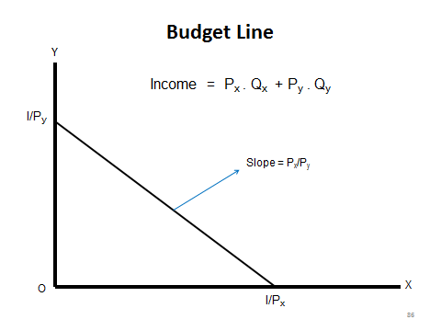

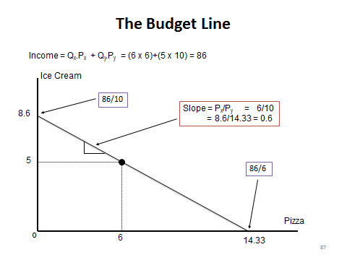

**Critiques of the Cardinalists’ Approach to Consumer Preference and Choice:**

1. The assumption of cardinal utility is very doubtful;
2. The assumption of constant utility of money is also unrealistic;
3. Diminishing Marginal Utility (DMU): -The psychological axiom of DMU has been established from introspection that it does not work in all cases and does not take in to account the changes in tastes and preferences.

- it is accepted without empirical verification.

1. Cardinal approach also considers that ‘the effect of price changes on demand curve is exclusively price effect’ is unrealistic since price effect may include income and substitution effect;

* Despite these criticisms it constitutes the development of the economic understandings: ***to the understanding of the law of demand***, ***consumer surplus & value paradoxes***, and ***elasticity***.

**3.2.Measuring Utility by Comparison: Ordinal/Indifference Curve/ Approach**

* Measurement and interpersonal comparison of utility is impossible but ranking of all market baskets in order;
* Does not assign values, instead works with a ranking of preferences.

***E.g.*** *Abebe prefers a bread to a slice of pizza and a slice of pizza to a banana.*

* Often consumers are able to be more precise in expressing their preferences.

**For example***, we could say: - Abebe is willing to trade a burger for 4 pizza but he will give up only 2 bananas for a slice of pizza.*

* + We can infer that to Abebe, a burger has twice as much utility as a slice of pizza, and a slice of pizza has twice as much utility as a banana.
* Utility is not measured in absolute magnitude, but ranking is enough;
* Preferences of market baskets are ranked b/c consumers are rational (preference ranking - Indifference curve analysis);
* **Indifference Curve (IC)** is a curve showing all combinations of market baskets (bundles) each representing different combinations of goods & services that provide or yield the consumer the same Utility or level of satisfaction so that the consumer is indifferent in between each combinations;
* The assumption is that the consumer can make a complete ranking of his/her preferences.

**Assumptions of Ordinal Utility Theory:**

1. Consumer rationality;
2. Ordinal utility and completeness of preferences
3. Transitivity and consistency of choice
4. Total utility of the consumer depends on the quantities of the commodities consumed (more is better than the less); then utility *U = f(q1, q2, q3 …, qn)*;
5. The axiom of ***diminishing marginal rate of substitution*** (MRS): preferences are ranked in terms of indifference curve (IC); IC is convex to the origin (MRS diminishes), and MRS measures the slope of an IC.

**Indifference curve *(IC)***

* An indifference curve is a line drawn in a two-dimensional space showing different combinations of two goods from which the consumer draws the same amount of utility and therefore he/she is “indifferent” about.

**Budget line (BL)**

* A budget line is a line drawn in a two-dimensional space representing a certain level of income with which the consumer can purchase various combinations of two goods at given prices.
* Given these IC and BL, a consumer make a choice of combinations of goods/services that maximize its utility.

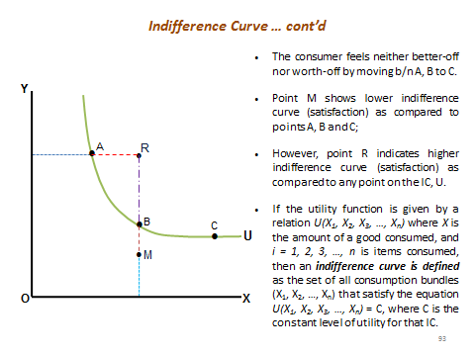

**Marginal Rate of Substitution (MRS):**

* It shows the rate at which consumers are wiling to substitute one commodity for the other in the consumption pattern and maintain the same level of utility(the same indifference curve).
* The rate at which the consumer substitutes one good for the other so as to remain equally satisfied is the slop of the indifference curve. It is known as the marginal rate of substitution. When two goods are in trade-off:

→ *Marginal rate of substitution of A for B*

* MRS diminishes as more and more of a good is used in place of the other.

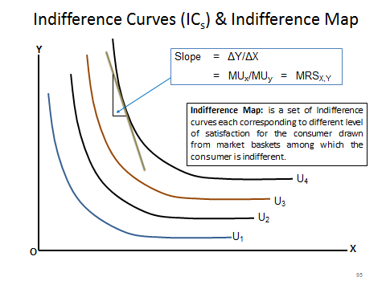

**Properties of Indifference curves:**

1. Indifference curves for two “goods” are generally negatively sloped;
2. The slope of an IC reflects the degree of substitutability of two goods for one another;
3. Indifference curves are generally convex to the origin, reflecting the principle of diminishing marginal rate of substitution;
4. Indifference curves never cross (intersect each other);
5. The further an IC lies from the origin the higher level(s) of utility it denotes.

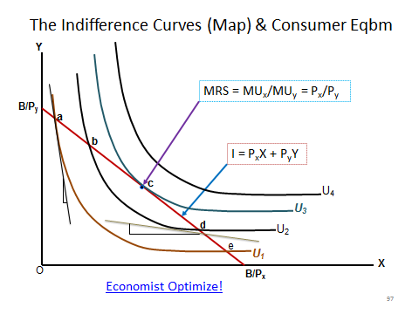

**Digression:**

* The superiority of the Ordinalist over the Cardinalist approach:
  + Cardinalists: equilibrium is reached ( or consumer maximize utility) when the rule of equi-marginal utility is satisfied, *i.e.*
  + Does the Ordinalist approach satisfy this rule?
  + **YES:** The Ordinalist approach to utility maximization also satisfy without going through the restrictive and doubtful assumptions of Cardinal utility.