# What is SnowBall?

SnowBall is a small application that enables you to transfer terabytes of data inside and outside of the AWS environment.

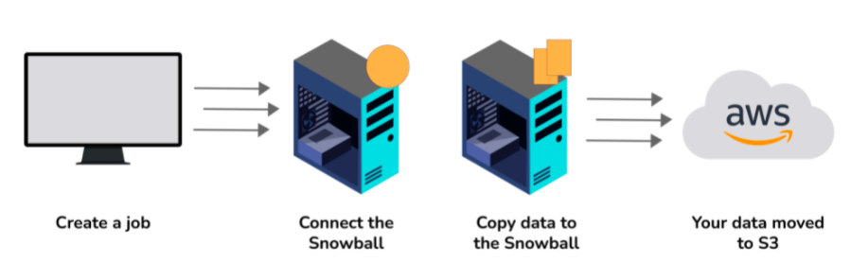

# What is CloudWatch?

CloudWatch helps you to monitor AWS environments like EC2, RDS Instances, and CPU utilization. It also triggers alarms depending on various metrics.

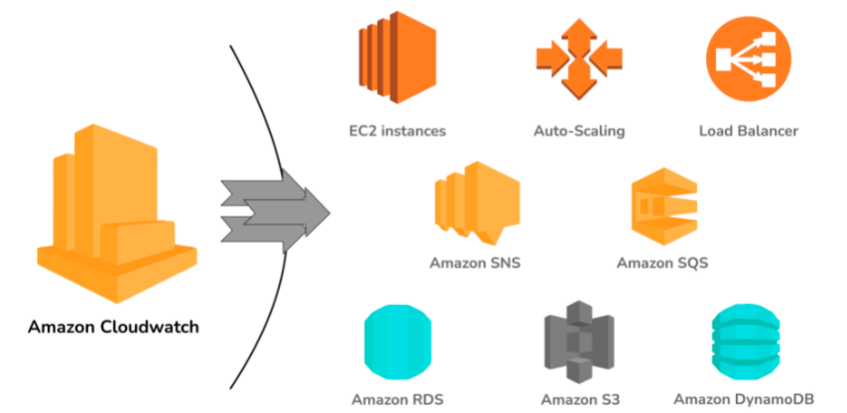

# What is Elastic Transcoder?

Elastic Transcoder is an AWS Service Tool that helps you in changing a video’s format and resolution to support various devices like tablets, smartphones, and laptops of different resolutions.

# What do you understand by VPC?

VPC stands for Virtual Private Cloud. It allows you to customize your networking configuration. VPC is a network that is logically isolated from other networks in the cloud. It allows you to have your private IP Address range, internet gateways, subnets, and security groups.

# DNS and Load Balancer Services come under which type of Cloud Service?

DNS and Load Balancer are a part of IaaS-Storage Cloud Service.

# What are the Storage Classes available in Amazon S3?

Storage Classes available with Amazon S3 are:

* Amazon S3 Standard
* Amazon S3 Standard-Infrequent Access
* Amazon S3 Reduced Redundancy Storage
* Amazon Glacier

# Explain what T2 instances are?

T2 Instances are designed to provide moderate baseline performance and the capability to burst to higher performance as required by the workload.

# What are Key-Pairs in AWS?

Key-Pairs are secure login information for your Virtual Machines. To connect to the instances, you can use Key-Pairs which contain a Public Key and a Private Key.

# How many Subnets can you have per VPC?

You can have 200 Subnets per VPC.

# List different types of Cloud Services.

Different types of Cloud Services are:

* Software as a Service (SaaS)
* Data as a Service (DaaS)
* Platform as a Service (PaaS)
* Infrastructure as a Service (IaaS)

# How does Amazon Route 53 provide high availability and low latency?

Amazon Route 53 uses the following to provide high availability and low latency:

* **Globally Distributed Servers -** Amazon is a global service and consequently has DNS Servers globally. Any customer creating a query from any part of the world gets to reach a DNS Server local to them that provides low latency.
* **Dependency -** Route 53 provides a high level of dependability required by critical applications.
* **Optimal Locations -** Route 53 serves the requests from the nearest data center to the client sending the request. AWS has data-centers across the world. The data can be cached on different data-centers located in different regions of the world depending on the requirements and the configuration chosen. Route 53 enables any server in any data-center which has the required data to respond. This way, it enables the nearest server to serve the client request, thus reducing the time taken to serve.

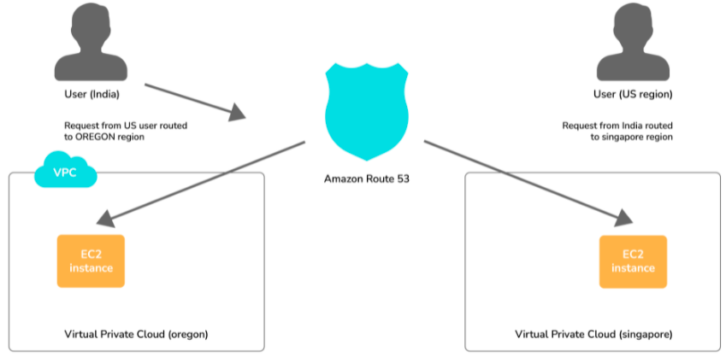

# What does AMI include?

An AMI includes the following things:

* A template for the root volume for the instance.
* Launch permissions to decide which AWS accounts can avail the AMI to launch instances.
* A block device mapping that determines the volumes to attach to the instance when it is launched.

# What are the different types of Instances?

Following are the types of instances:

* Compute Optimized
* Memory-Optimized
* Storage Optimized
* Accelerated Computing
* General Purpose

# What is the relation between the Availability Zone and Region?

An AWS Availability Zone is a physical location where an Amazon data center is located. On the other hand, an AWS Region is a collection or group of Availability Zones or Data Centers.

This setup helps your services to be more available as you can place your VMs in different data centers within an AWS Region. If one of the data centers fails in a Region, the client requests still get served from the other data centers located in the same Region. This arrangement, thus, helps your service to be available even if a Data Center goes down.

# How do you monitor Amazon VPC?

You can monitor Amazon VPC using:

* CloudWatch
* VPC Flow Logs

# What are the different types of EC2 instances based on their costs?

The three types of EC2 instances based on the costs are:

**On-Demand Instance -** These instances are prepared as and when needed. Whenever you feel the need for a new EC2 instance, you can go ahead and create an on-demand instance. It is cheap for the short-time but not when taken for the long term.

**Spot Instance -** These types of instances can be bought through the bidding model. These are comparatively cheaper than On-Demand Instances. (this is a good option if you are flexible about when your applications can run and if your applications can be interrupted.)

**Reserved Instance -** On AWS, you can create instances that you can reserve for a year or so. These types of instances are especially useful when you know in advance that you will be needing an instance for the long term. In such cases, you can create a reserved instance and save heavily on costs.

# What do you understand by stopping and terminating an EC2 Instance?

Stopping an EC2 instance means to shut it down as you would normally do on your Personal Computer. This will not delete any volumes attached to the instance and the instance can be started again when needed.

On the other hand, terminating an instance is equivalent to deleting an instance. All the volumes attached to the instance get deleted and it is not possible to restart the instance if needed at a later point in time.

# What are the consistency models for modern DBs offered by AWS?

**Eventual Consistency -** It means that the data will be consistent eventually, but may not be immediate. This will serve the client requests faster, but chances are that some of the initial read requests may read the stale data. This type of consistency is preferred in systems where data need not be real-time. For example, if you don’t see the recent tweets on Twitter or recent posts on Facebook for a couple of seconds, it is acceptable.

**Strong Consistency -** It provides an immediate consistency where the data will be consistent across all the DB Servers immediately. Accordingly. This model may take some time to make the data consistent and subsequently start serving the requests again. However, in this model, it is guaranteed that all the responses will always have consistent data.

# What is Geo-Targeting in CloudFront?

Geo-Targeting enables the creation of customized content based on the geographic location of the user. This allows you to serve the content which is more relevant to a user. For example, using Geo-Targeting, you can show the news related to local body elections to a user sitting in India, which you may not want to show to a user sitting in the US. Similarly, the news related to Baseball Tournament can be more relevant to a user sitting in the US, and not so relevant for a user sitting in India.

# What are the advantages of AWS IAM?

AWS IAM enables an administrator to provide granular level access to different users and groups. Different users and user groups may need different levels of access to different resources created. With IAM, you can create roles with specific access-levels and assign the roles to the users.

It also allows you to provide access to the resources to users and applications without creating the IAM Roles, which is known as Federated Access.

# What do you understand by a Security Group?

When you create an instance in AWS, you may or may not want that instance to be accessible from the public network. Moreover, you may want that instance to be accessible from some networks and not from others.

Security Groups are a type of rule-based Virtual Firewall using which you can control access to your instances. You can create rules defining the Port Numbers, Networks, or protocols from which you want to allow access or deny access.

# Explain Connection Draining.

Connection Draining is a feature provided by AWS which enables your servers which are either going to be updated or removed, to serve the current requests.

If Connection Draining is enabled, the Load Balancer will allow an outgoing instance to complete the current requests for a specific period but will not send any new request to it. Without Connection Draining, an outgoing instance will immediately go off and the requests pending on that instance will error out.

# What is a Stateful and a Stateless Firewall?

A Stateful Firewall is the one that maintains the state of the rules defined. It requires you to define only inbound rules. Based on the inbound rules defined, it automatically allows the outbound traffic to flow.

On the other hand, a Stateless Firewall requires you to explicitly define rules for inbound as well as outbound traffic.

For example, if you allow inbound traffic from Port 80, a Stateful Firewall will allow outbound traffic to Port 80, but a Stateless Firewall will not do so.

# What is a Power User Access in AWS?

An Administrator User will be similar to the owner of the AWS Resources. He can create, delete, modify or view the resources and also grant permissions to other users for the AWS Resources.

A Power User Access provides Administrator Access without the capability to manage the users and permissions. In other words, a user with Power User Access can create, delete, modify or see the resources, but he cannot grant permissions to other users.

# What are Recovery Time Objective and Recovery Point Objective in AWS?

**Recovery Time Objective -** It is the maximum acceptable delay between the interruption of service and restoration of service. This translates to an acceptable time window when the service can be unavailable.

**Recover Point Objective -** It is the maximum acceptable amount of time since the last data restore point. It translates to the acceptable amount of data loss which lies between the last recovery point and the interruption of service.

# What is the use of lifecycle hooks is Autoscaling?

Lifecycle hooks are used for Auto-scaling to put an additional wait time to a scale-in or a scale-out event.