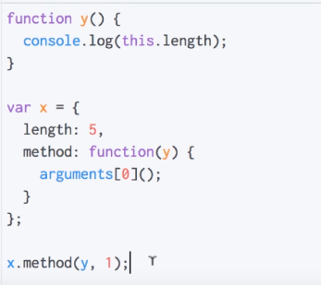

Answer=2

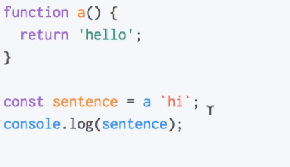

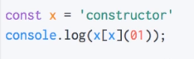

Answer=1

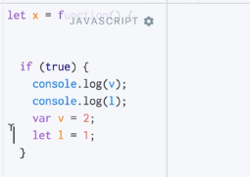

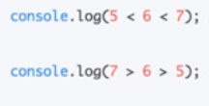

Answer=true and false

======================

typeof : a JavaScript unary operator used to return a string that represents the primitive type of a variable, don’t forget that typeof null will return “object”, and for the majority of object types (Array, Date, and others) will return also “object”.

instanceof : is another JavaScript operator that check in all the prototypes chain the constructor it returns true if it’s found and false if not.

var arr = ["a", "b", "c"];

typeof arr; // return "object"

arr instanceof Array // true