# 1. What are query methods?

Query methods are methods that find information from the database and are declared on the repository interface.

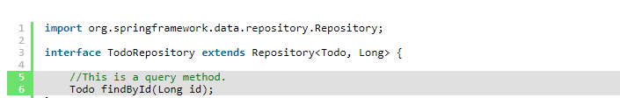

# 2. What kind of return values can we use?

A query method can return only one result or more than one result.

Also, we can create a query method that is invoked asynchronously.

One Result

* *Basic type*. Our query method will return the found basic type or *null*.
* *Entity*. Our query method will return an entity object or *null*.
* Java 8 *Optional<T>*. Our query method will return an *Optional* that contains the found object or an empty *Optional*.

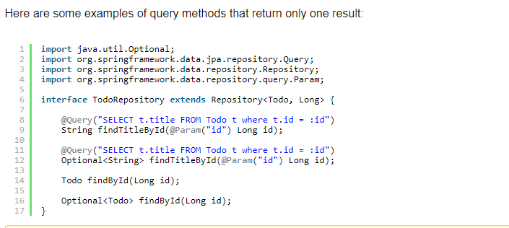

More than One Result

* *List<T>*. Our query method will return a list that contains the query results or an empty list.
* *Stream<T>*. Our query method will return a *Stream* that can be used to access the query results or an empty *Stream*.

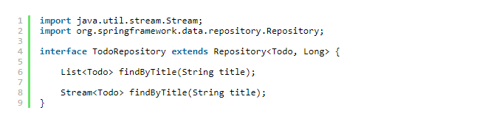

@Async annotation and return a Future<T> object. Here are some examples of query methods that are executed asynchronously:

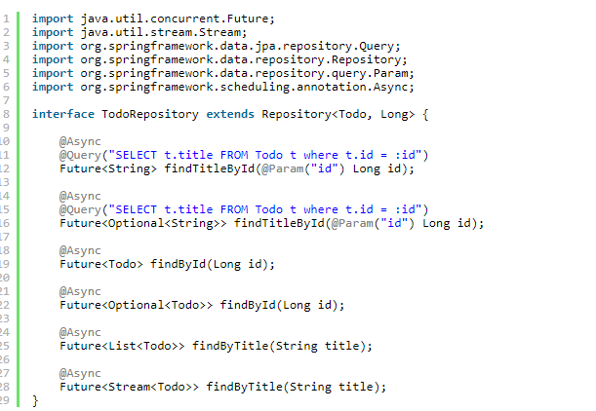

# 3. How can we pass parameters to our query methods?

Spring Data JPA supports both position based parameter binding and named parameters.

 position based parameter



named parameters

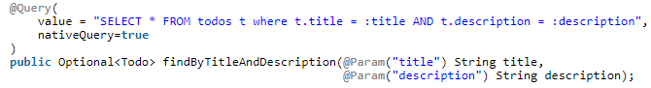

# 4. How many Query lookup strategies

CREATE

CREATE attempts to construct a store-specific query from the query method name. The general approach is to remove a given set of well-known prefixes from the method name and parse the rest of the method. Read more about query construction in [the section called “Query creation”](https://docs.spring.io/spring-data/data-commons/docs/1.6.1.RELEASE/reference/html/repositories.html#repositories.query-methods.query-creation).

USE_DECLARED_QUERY

USE_DECLARED_QUERY tries to find a declared query and will throw an exception in case it can't find one. The query can be defined by an @Query annotation somewhere or declared by other means(named or native). If the repository infrastructure does not find a declared query for the method at bootstrap time, it fails.

CREATE_IF_NOT_FOUND (default)

CREATE_IF_NOT_FOUND combines CREATE and USE_DECLARED_QUERY. It looks up a declared query first, and if no declared query is found, it creates a custom method name-based query. This is the default lookup strategy and thus will be used if you do not configure anything explicitly. It allows quick query definition by method names but also custom-tuning of these queries by introducing declared queries as needed.

# 5. [What is difference between CrudRepository and JpaRepository interfaces in Spring Data](https://stackoverflow.com/questions/14014086/what-is-difference-between-crudrepository-and-jparepository-interfaces-in-spring)

