PM_Lambda_Functions guide
You should be able to load the PM_Lambda_functions.xlam file as either an add-in or as an ordinary Excel file.
Loading the file will add a tab named “PM Lambda Functions” to the Ribbon, with a single button labeled Define HDR and Metalog
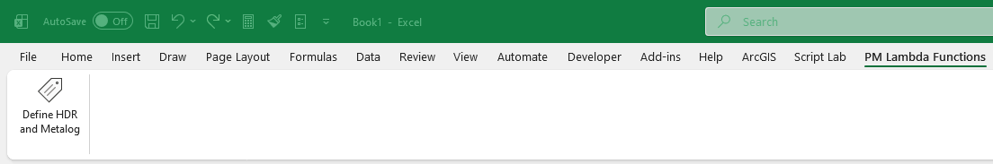Pressing the button will add Lambda functions defining the HDR PRNG and Metalog functions to the currently open Excel file. You can see the lambda functions in the Formulas | Name Manager dialog:
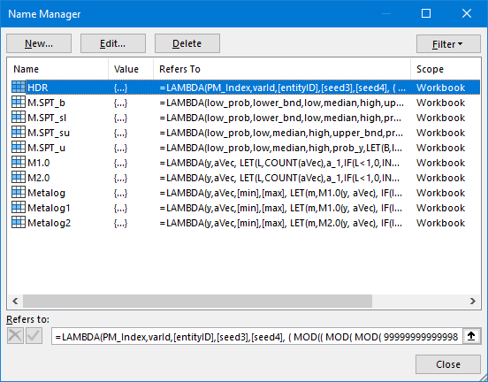

HDR takes 5 arguments, which should all be non-negative integers: PM_Index, varID, (optional) entityID, (optional) seed3, (optional) seed4

M.SPT_b is the bounded SPT metalog function. It takes the arguments low_prob, low_bnd, low, median, high, upper_bnd, prob_y.
low_prob is the chance of the result being less than or equal to the value of low. It should be between 0 and 1.
low_bnd is the smallest value that will be returned.
upper_bnd is the largest value that will be returned.
prob_y is a uniform (pseudo-) random value between 0 and 1, such as would be returned by =RAND() or =HDR( PM_Index, 31415 )

M.SPT_sl is the SPT metalog with lower bounds only. It is like M.SPT_b but no upper bound is specified.
M.SPT_su is the SPT metalog with upper bounds only. It is like M.SPT_b but no lower bound is specified.
M.SPT_u is the unbounded SPT metalog; it is like M.SPT_b but no upper or lower bounds are specified.

M1.0 is the version 1 unbounded full metalog function. It takes the arguments y and aVec.
y is a random value between 0 and 1. aVec is a vector of from 1 to 16 “a-coefficients” that specify the distribution returned by the Metalog. It may be a row or a column.
M2.0 is the version 2 unbounded full metalog function. It takes the same arguments as M1.0.
Metalog and Metalog1 add optional lower and upper bounds to the M1.0 function. They take the arguments y and aVec, which are the same as M1.0, and add the optional lower bound min and upper bound max.
I included Metalog() for backward compatibility; for consistency I would recommend using Metalog1(), but it is indentical to Metalog().
Metalog2 adds optional lower and upper bounds to the M2.0 function. It takes the arguments y and aVec, which are the same as M1.0, and adds the optional lower bound min and upper bound max.

