2dCam

2dCam lets you conveniently use a shape layers as cameras.

**Installation**

Copy the **2dcam.jsx** file to the ScriptUI folder in your After Effects installation:

Windows: Support Files/Scripts/ScriptUI Panels

macOS: Scripts/ScriptUI Panels

**Usage**

To open the 2dCam panel, go to the "Window" menu and click on **2dCam.jsx**.

**# Create a 2dCam**

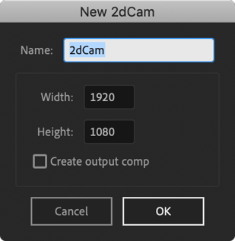

Click on the **camera icon**, and you'll see the options for creating a 2dCam.

Change the camera's **Width** and **Height** to your liking, and check the **Create output comp** box if you'd like to create the camera's output composition now, rather than later. Usually, you'll keep the **Prefix** as default.

**Alt-click** the camera icon in the 2dCam panel to have the **Create output comp** checkbox enabled by default.

**# Using a 2dCam**

You can freely change the 2dCam's Transform properties, although changing the opacity doesn't do anything.

**# Create an Output**

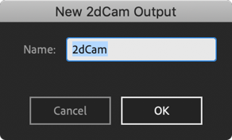Click on the **screen icon** to create an output composition with an output layer. You'll have to type in the prefix you chose for your 2dCam if you didn't go with the default one.

**Alt-click** the screen icon to apply 2dCam's output to the currently selected layers. This way, you can also update an output layer's prefix.

**# Multiple 2dCams**

To have multiple 2dCams for one output, simply duplicate your 2dCam or create a new one and name it something like **2dCam 2**. The 2dCam output composition will show the top-most, currently visible 2dCam that starts with the prefix you chose in your output comp.

To have multiple different 2dCam outputs, you would need to choose different prefixes for your 2dCams. For instance, you could have 2dCams named **Cam A**, **Cam B** and **2dCam Zoom** and then create two output compositions with prefixes **Cam** and **2dCam**.

**# Renaming**

The 2dCams themselves can be renamed like normal layers. To update a prefix, however, you need to re-apply the 2dCam output. Select the output layer, alt-click the screen icon and choose your new prefix.

**# Changing Output Composition Size**

To change a 2dCam's size, change **Contents > Rectangle > Size** property. Afterwards, change your output composition to match that new size.