**NUMBER PLATE RECOGNITION**

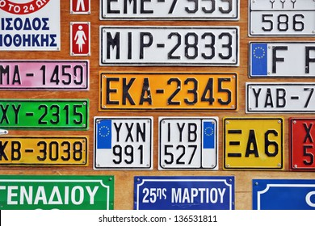

Number plate recognition is an image processing technology which uses number plate to identify the vehicle. It is known that accidents and many illegal activities are increasing day by day. Most of these activities are taking place in vehicles.

**Prerequisites:**

* **OpenCV**: OpenCV is a library of programming functions mainly aimed at real-time computer vision plus its open-source.
* **IDE:** We are using Jupyter here.
* **Keras**: Easy to use and widely supported, Keras makes deep learning about as simple as deep learning can be.

#### **Character detection:**

Another YOLOv3 model is used to detect the character in the preprocessed image which has been trained by annotating the segmented images.

#### **Character Classification:**

Finally the LeNet architecture is used to classify the letter and numbers in the image.

### DATASET:

We have taken random 4 number plates from online resources and images are manually annotated.

[Weights reference](https://amritauniv-my.sharepoint.com/:f:/g/personal/amenu4aie20168_am_students_amrita_edu/Ek1oIFq3RCdBmfSrPOFMMXIBWkXNyf6RxRcx6HfQJh1V-g?e=LKUfRD)