4931_Grace College of Engineering




DEPARTMENT OF ARTIFICIAL INTELLIGENCE AND DATA SCIENCE
B.Tech-Artificial Intelligence and Data Science

Anna University Regulation: 2021

AD3351-DESIGN AND ANALYSIS OF ALGORITHMS

II Year/ III Semester

LAB MANUAL

Prepared By, Mrs.P.Joy Suganthy Bai, AP/CSE

AD3351_DAA

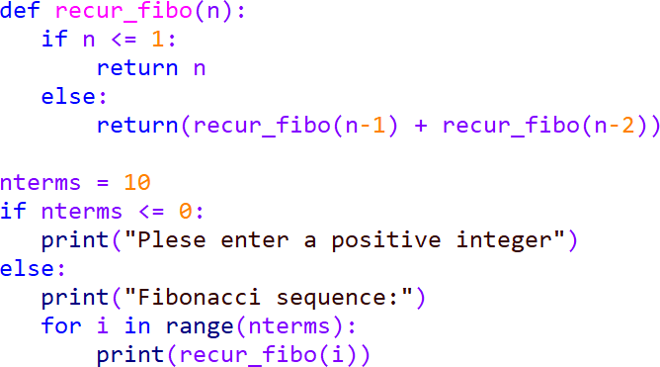


EX NO:1a IMPLEMENTATION OF RECURSIVE ALGORITHM

AIM:
Aim is to write a program in C to implement the implementation of recursive algorithm.

ALGORITHM:

- START.
- Input the non-negative integer 'n'
- If (n==o || n==1) return n; else. return fib(n-1)+fib(n-2);
- Print, n^{th} Fibonacci number.
- END.

PROGRAM:

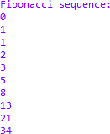

EX NO:1a IMPLEMENTATION OF RECURSIVE ALGORITHM OUTPUT:


RESULT:
Thus the program implemented Successfully.

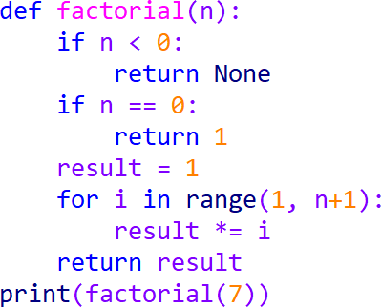


EX NO:1b IMPLEMENTATION OF NON RECURSIVE ALGORITHM

AIM:
Aim is to write a program in C to implement the implementation of non recursive
algorithm.

ALGORITHM:
Step 1: Take the first two numbers of the series and the number of terms to be printed from the user.
Step 2. Print the first two numbers.
Step 3. Use a while loop to find the sum of the first two numbers and then proceed the fibonacci series.
Step 4. Print the fibonacci series till n-2 is greater than 0. Step 5. Exit.

PROGRAM:



EX NO:1b IMPLEMENTATION OF NON RECURSIVE ALGORITHM OUTPUT:
5040

RESULT:
Thus the program implemented Successfully.

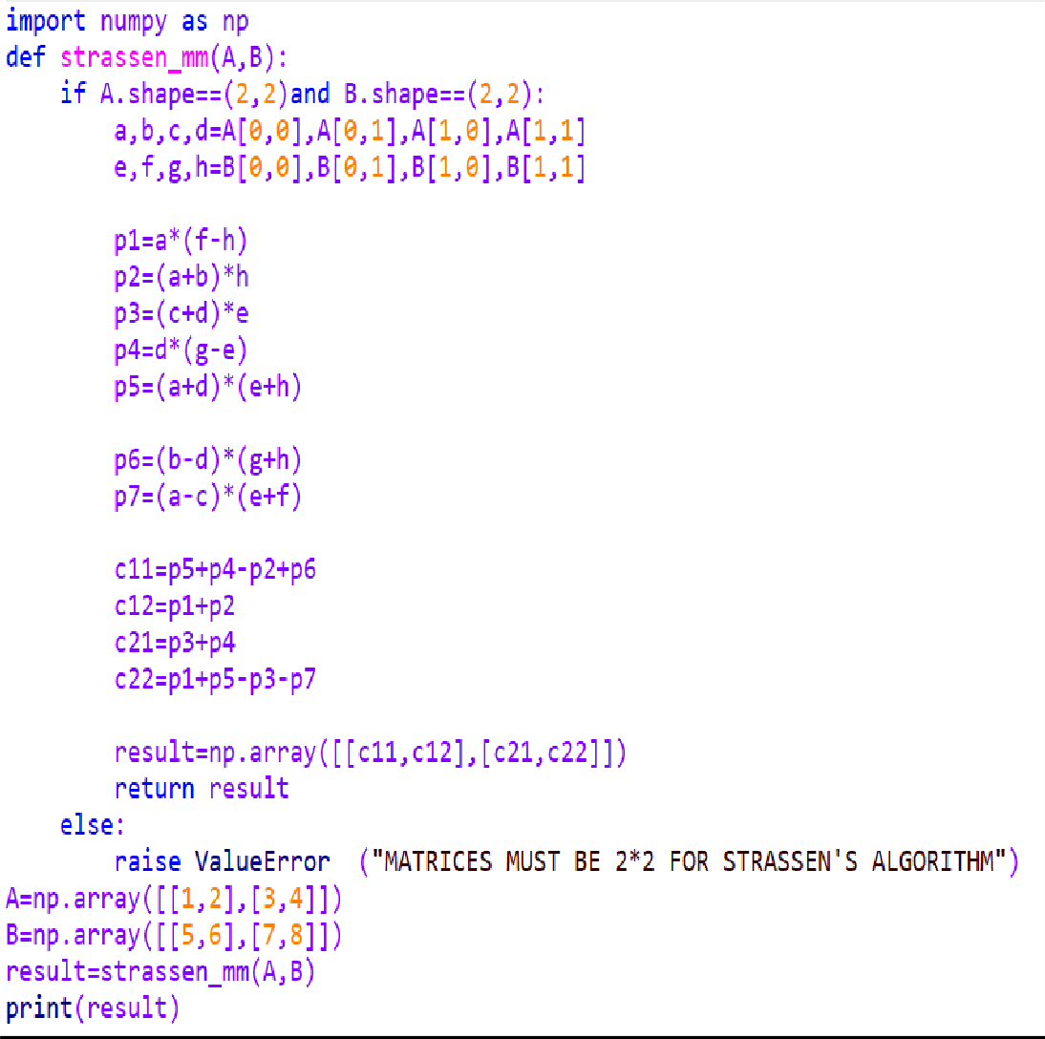

EX NO:2 DIVIDE AND CONQUER – STRASSEN’S MATRIX
. MULTIPLICATION

AIM:
Aim is to write a program in C to implement the Divide and Conquer by strassen’s matrix
multiplication algorithm.

ALGORITHM:
Step 1:Start with two input matrices, A and B, of size n x n that you want to multiply.
Step 2: If the size of the matrices (n) is 1, then multiply the corresponding elements and return the result as a 1x1 matrix.

Step 3: Divide each of the input matrices A and B into four equal-sized submatrices. Each matrix can be divided into four quadrants:
Step 4: Calculate seven products recursively using the following formulas:
Step 5: Compute the four submatrices of the result matrix C using the calculated products
Step 6: Combine the four submatrices C11, C12, C21, and C22 to form the final result matrix C.

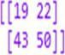

EX NO:2 DIVIDE AND CONQUER – STRASSEN’S MATRIX OUTPUT:


RESULT:
Thus the program implemented Successfully.

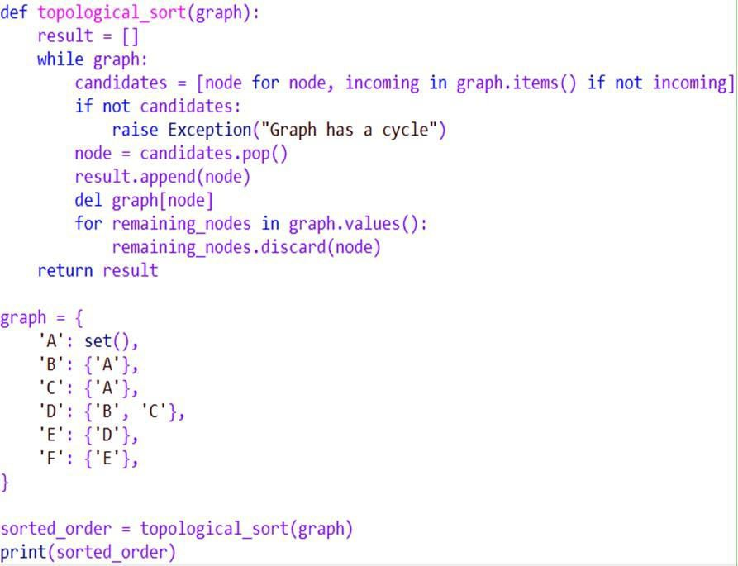


EX NO:3 DECREASE AND CONQUER – TOPOLOGICAL SORTING

AIM:
Aim is to write a program in C to implement the Decrease and Conquer by topological
sorting algorithm.

ALGORITHM:
- Step 1: Find a vertex with in-degree 0 (a vertex with no incoming edges).
- Step 2: Remove the selected vertex and its outgoing edges from the graph.
- Step 3: Repeat Steps 1 and 2 until all vertices are processed.
- Step 4: If there are still vertices left in the graph after Step 3, the graph contains a cycle (it's not a DAG).
- Step 5: The order in which vertices are removed in Steps 2 forms a topological ordering.
PROGRAM:



EX NO:3 DECREASE AND CONQUER – TOPOLOGICAL SORTING OUTPUT:

RESULT:
Thus the program implemented Successfully

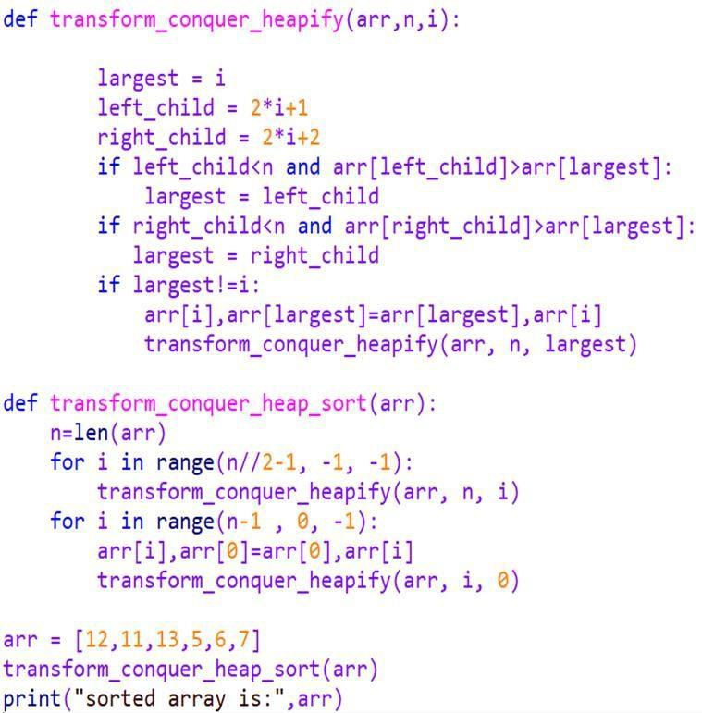


EX NO:4 TRANSFORM AND CONQUER – HEAP SORT

AIM:
Aim is to write a program in C to implement the Divide and Conquer by strassen’s matrix
multiplication algorithm.

ALGORITHM:
Step 1: Build a max heap from the input array.
Step 2: Extract the maximum element (root) from the heap and put it at the end of the array
Step 3: Heapify the remaining elements to maintain the max heap property.
Step 4: Repeat steps 2 and 3 until the heap size is reduced to 1.

PROGRAM:

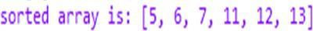


EX NO:4 TRANSFORM AND CONQUER – HEAP SORT OUTPUT:

RESULT:
Thus the program implemented Successfully

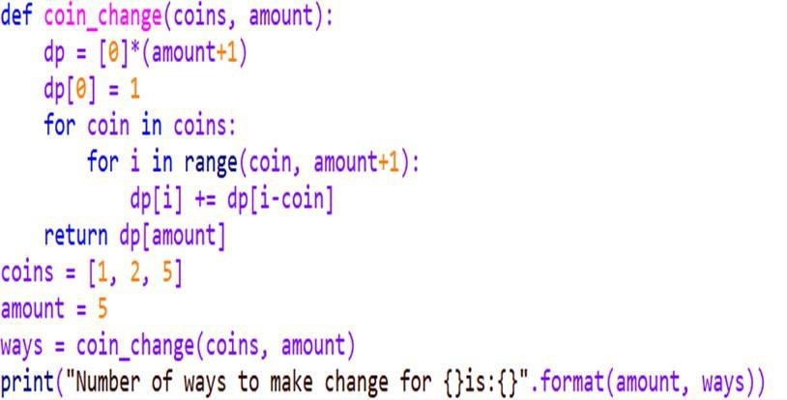

EX NO:5a DYNAMIC PROGRAMMING – COIN CHANGE PROBLEM

AIM:
Aim is to write a program in C to implement the dynamic programming by coin change
problem.

ALGORITHM:

- Create a table with dimensions (number of coins + 1) x (target amount + 1).
dp
- Initialize the first column of the table with 0 (representing the number of ways to make change for 0).
- Initialize the first row of the table with 1 (representing the number of ways to make change for any amount using 0 coins).
- For each cell in the table, calculate the value based on the recurrence relation:
dp[i][j]

The final result is stored in the bottom-right cell of the table

PROGRAM:



EX NO:5a DYNAMIC PROGRAMMING – COIN CHANGE PROBLEM OUTPUT:

RESULT:
Thus the program implemented Successfully

EX NO:5b DYNAMMIC PROGRAMMING – WARSHALL’S AND

FLOYD’S ALGORITHM

AIM:
Aim is to write a program in C to implement the dynamic programming by warshall and
Floyd’s algorithm.

ALGORITHM:

Initialization:
  - Start with the given adjacency matrix, let's call it
  - Create another matrix, let's call it
transitive_closure
.
graph

Main Loop:

.
, initialized as a copy of the
graph

  - For each intermediate vertex
h pair of vertices |  |  | and | j | :
Update | transitive_closure[i][j]
transitive_closure[i][j]
transitive_closure[k][j]

    - For eac
•

Final Result:
from 1 to the number of vertices:

i
k
to 1 if either is 1 or both
transitive_closure[i][k]
are 1.

and

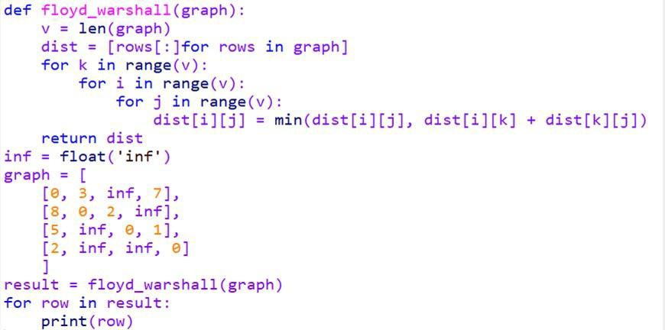
  - The graph
transitive_closure

PROGRAM:
matrix now represents the transitive closure of the original

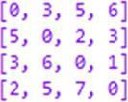


EX NO:5b DYNAMMIC PROGRAMMING – WARSHALL’S AND OUTPUT:

RESULT:

Thus the program implemented Successfully.

EX NO:5c DYNAMMIC PROGRAMMING – KNAPSACK PROBLEM

AIM:
Aim is to write a program in C to implement the dynamic programming by knapsack

problem.

ALGORITHM:
Initialize the table:

Create a 2D table (array)
W

of size (n+1) x (W+1), where
dp
dp[i][j]

is the
n

number of items and
is the maximum capacity of the knapsack. Each cell
in the

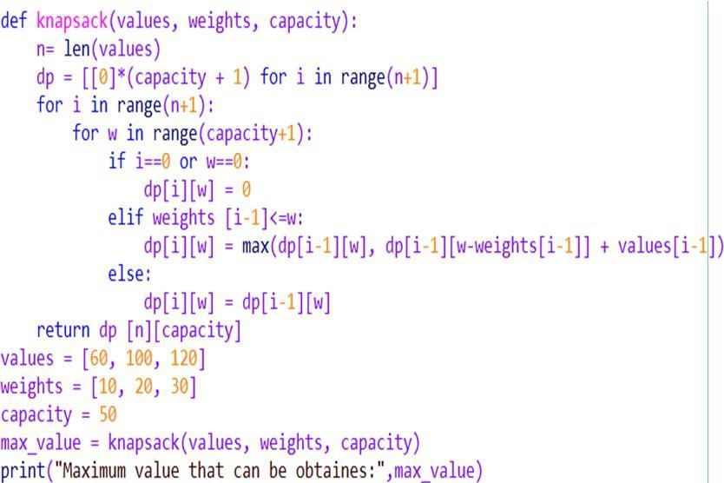
table represents the maximum value that can be obtained with the first i items and a knapsack capacity of j.
Fill in the table:

- For each item i and each capacity j, calculate the maximum value that can be obtained considering whether or not to include the current item in the knapsack.
•  • | wt[i-1]
 | val[i-1]
Final result:

is the weight of the i-th item. is the value of the i-th item.
- The maximum value that can be obtained is stored in dp[n][W], where is
n
the total number of items and is the maximum capacity of the knapsack.
W

PROGRAM:



EX NO:5c DYNAMMIC PROGRAMMING – KNAPSACK PROBLEM

OUTPUT:

RESULT:
Thus the program implemented successfully.
\

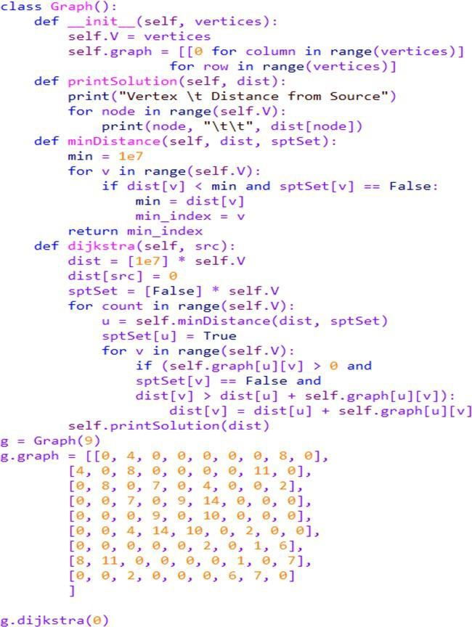

EX NO:6a GREEDY TECHNIQUE - DIJKSTRA’S ALGORITHM AIM:
Aim is to write a program in C to implement the greedy technique by Dijkstra’s algorithm

ALGORITHM:
- Set the distance from the source vertex to itself as 0 and the distance to all other vertices as infinity. Create a priority queue or a min-heap and add all vertices with their distances as the key.
Select Vertex:
Initialize:
- Extract the vertex with the smallest distance from the priority queue.
- For the selected vertex, update the distances to its neighboring vertices if the newly calculated distance is smaller than the current known distance. This step is what makes Dijkstra's algorithm greedy.
Update Distances:
Repeat:
- Repeat steps 2 and 3 until all vertices have been processed or the destination vertex is reached.
Result:

- The distances stored in the algorithm's data structure now represent the shortest path distances from the source vertex to all other vertices.

PROGRAM:

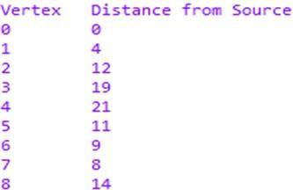

EX NO:6a GREEDY TECHNIQUE - DIJKSTRA’S ALGORITHM OUTPUT:


RESULT:

Thus the program implemented successfully.

EX NO:6b GREEDY TECHNIQUE - HUFFMAN TREES AND CODES

AIM:

codes

Aim is to write a program in C to implement the greedy technique by Huffman trees and

ALGORITHM:

Frequency Count:
  - Count the frequency of each character in the input text or dataset.
Create Nodes:
  - Create a leaf node for each unique character, and associate the frequency of that character with the node.
Priority Queue:


  - Place all the leaf nodes into a priority queue (min-heap), where the priority is based on the frequency of the characters. The node with the lowest frequency has the highest priority.
Build Huffman Tree:

  - While there is more than one node in the priority queue:
    - Remove the two nodes with the lowest frequency from the priority queue. These nodes will become the left and right children of a new internal node.
    - Create a new internal node with a frequency equal to the sum of the frequencies of the two nodes removed in the previous step.
    - Insert the new internal node back into the priority queue.
Result:
  - The final node remaining in the priority queue is the root of the Huffman tree.
Assign Codes:
  - Traverse the Huffman tree from the root. Assign a binary '0' to each left branch and a '1' to each right branch.
  - The Huffman codes for the characters are the binary sequences obtained by traversing from the root to the leaves.
Generate Huffman Codes:

  - For each character, the Huffman code is the binary sequence obtained by concatenating the binary values associated with each branch from the root to the leaf corresponding to that character.

PROGRAM:

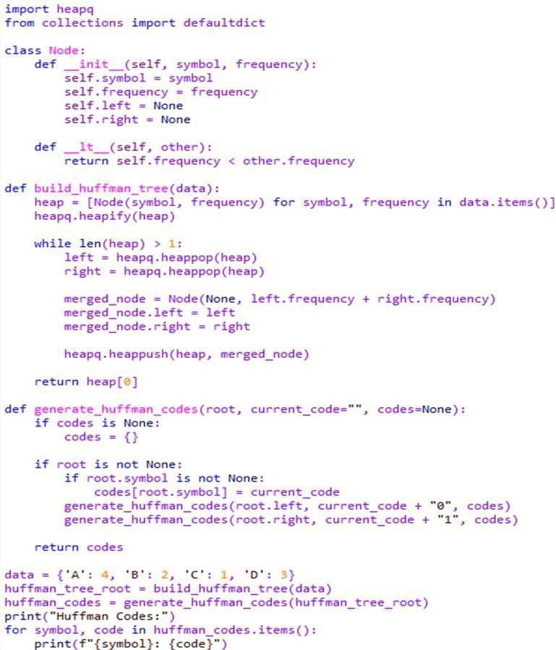
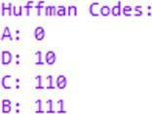


EX NO:6b GREEDY TECHNIQUE - HUFFMAN TREES AND CODES

OUTPUT:

RESULT:
Thus the program implemented Successfully.

EX NO:7 ITERATIVE IMPROVEMENT – SIMPLEX METHOD

AIM:
Aim is to write a program in C to implement iterative improvement by simplex method.

ALGORITHM:
Formulate the Linear Programming Problem:

  - Identify the decision variables.
  - Formulate the objective function to be maximized or minimized.
  - Write down the linear equality and inequality constraints.
Convert the Problem to Standard Form:

  - Express any inequalities as equalities by introducing slack or surplus variables.

  - Make sure all variables are non-negative.
Initialize the Simplex Tableau:

  - Set up an initial simplex tableau with the coefficients of the objective function and the constraints.
Select the Pivot Column:

  - Identify the column with the most negative coefficient in the bottom row (excluding the rightmost column).
Select the Pivot Row:

  - For the chosen pivot column, calculate the ratios of the right-hand side values to the corresponding coefficients in the pivot column. Select the row with the smallest non-negative ratio as the pivot row.
Pivot Operation:

  - Use elementary row operations to make the pivot element (intersection of the pivot row and pivot column) equal to 1 and all other elements in the pivot column equal to 0. This operation updates the tableau.
Update the Tableau:

  - Update the tableau by applying the pivot operation to the rest of the rows to make the pivot column a unit vector.
Repeat Steps 4-7:

  - Continue the iterations until there are no more negative coefficients in the bottom row of the tableau.
Read the Solution:

  - The values in the rightmost column represent the solution to the linear programming problem.
Check Optimality:
  - If all coefficients in the bottom row are non-negative, the solution is optimal. Otherwise, go back to steps 4-9.
Post-Optimal Analysis (if needed):

  - If there are multiple optimal solutions or if sensitivity analysis is required, perform additional analysis based on the specific problem requirements.

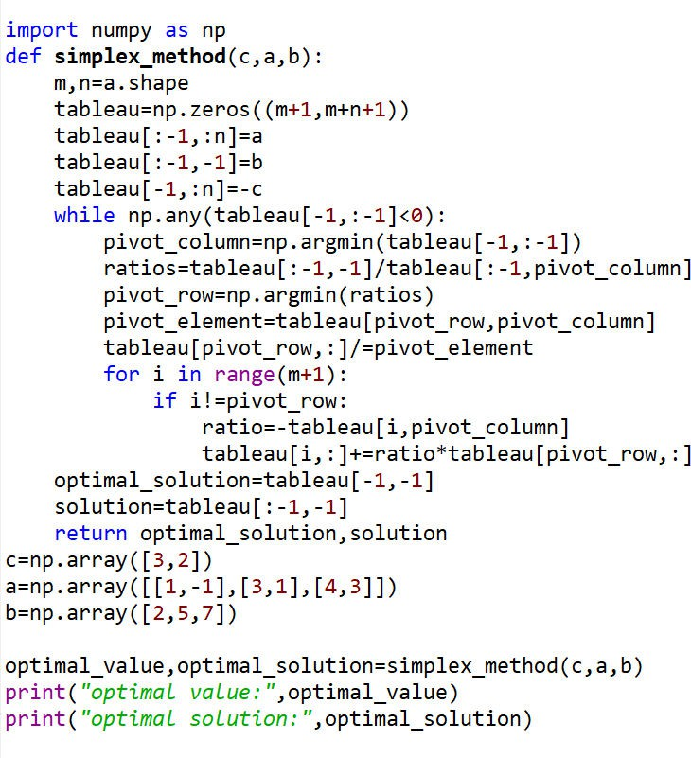
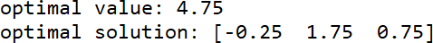


EX NO:7 ITERATIVE IMPROVEMENT – SIMPLEX METHOD PROGRAM:

OUTPUT:

RESULT:

Thus the program implemented successfully.

EX NO:8a BACKTRACKING – N QUEEN PROBLEM AIM:
Aim is to write a program in C to implement backtracking technique by N-Queens Problem..

ALGORITHM:

- Create an N×N chessboard and initialize it. This can be done using a 2D array or any suitable data structure. Initially, all cells may be empty.
Define the Backtracking Function:
Initialize the Chessboard:
- Create a recursive backtracking function that will attempt to place queens on the chessboard. The function should explore different possibilities while respecting the constraints of the problem.
Base Case:
- Define a base case for the recursion. In the context of N-Queens, the base case is often when all queens are placed successfully on the board.
Recursive Step:

- In the recursive function, try placing a queen in each row, one by one. Check if placing the queen in the current position violates any constraints. If not, proceed to the next row and continue the process.
Constraint Checking:
- At each step, check whether the placement of the queen violates any constraints (i.e., check if it attacks any other queen in the same row, column, or diagonal). If the placement is valid, proceed; otherwise, backtrack and try a different position.
Backtrack:
- If you reach a point where it's impossible to place a queen without violating constraints, backtrack to the previous step and explore other possibilities.

PROGRAM:

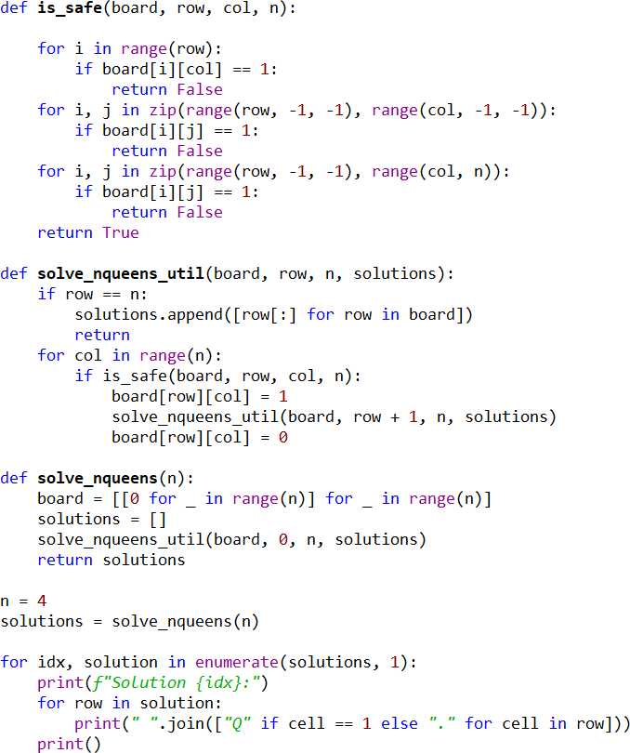
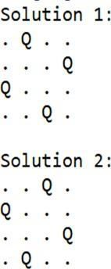


EX NO:8a BACKTRACKING – N QUEEN PROBLEM

OUTPUT:

RESULT:

Thus the program implemented successfully.

EX NO:8b BACKTRACKING – SUBSET SUM PROBLEM

AIM:
Aim is to write a program in C to implement backtracking technique Subset sum Problem..

ALGORITHM:
- In the recursive function, consider two cases:
  - Include the current element in the subset and reduce the target sum by the value of the current element.
  - Exclude the current element from the subset and move on to the next element.
Backtracking:

  - If the current combination does not lead to a solution, undo the choice (backtrack) and explore other possibilities.

PROGRAM:
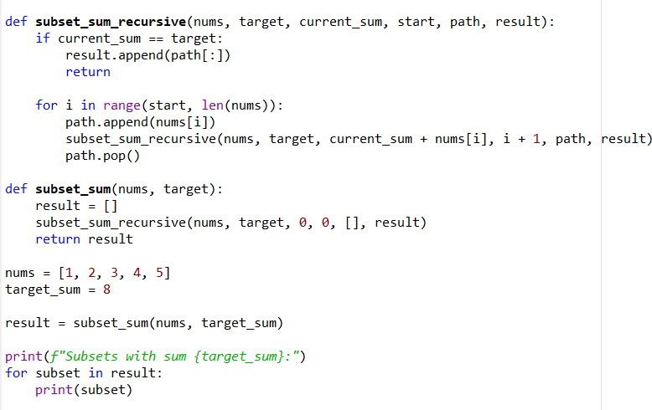

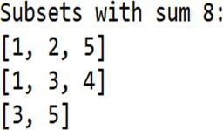


EX NO:8b BACKTRACKING – SUBSET SUM PROBLEM OUTPUT:

RESULT:

Thus the program implemented successfully.

EX NO:9a BRANCH AND BOUND - ASSIGNMENT PROBLEM

AIM:
Aim is to write a program in C to implement branch and Bound by assignment Problem..

ALGORITHM:

Initialize:
  - Create an initial solution or assignment.
  - Initialize the lower bound to a very large value (for minimization problems) or a very small value (for maximization problems).
Create a Priority Queue:

  - Use a priority queue (min-heap for minimization, max-heap for maximization) to store partial solutions or subproblems.

  - The priority is determined by the lower bound of each subproblem.
While the Priority Queue is not Empty:
  - Dequeue the subproblem with the lowest bound from the priority queue.
  - If the subproblem is feasible:
    - Update the lower bound if the solution is better than the current best solution.
    - Enqueue the subproblems obtained by branching (creating new assignments).
Branching:

  - Choose a variable to branch on. This involves creating two new subproblems: one where the selected variable is assigned to one value and another where it is assigned to another value.
  - Update the partial solution and calculate the lower bounds for both subproblems.

PROGRAM:

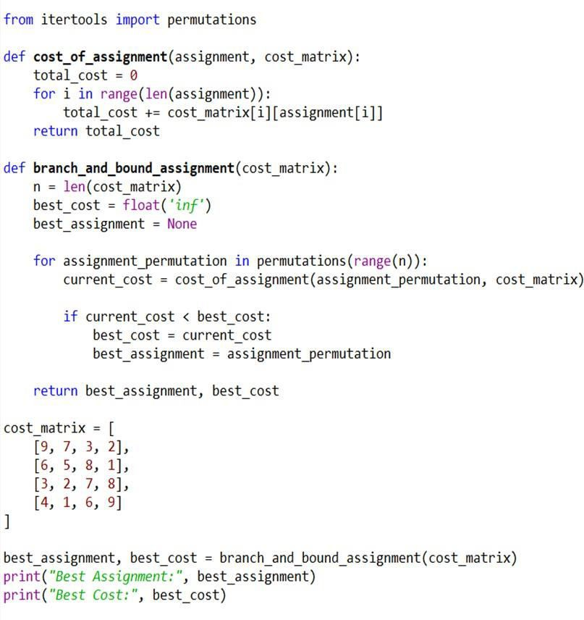
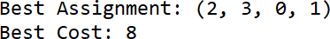


EX NO:9a BRANCH AND BOUND - ASSIGNMENT PROBLEM

OUTPUT:

RESULT:

Thus the program implemented successfully.

EX NO:9b BRANCH AND BOUND - TRAVELLING SALESMAN

PROBLEM
AIM:
Aim is to write a program in C to implement branch and Bound by assignment Problem..

ALGORITHM:

Initialization:
  - Create an initial node in the search tree, representing the initial state of the problem (e.g., the starting city). Initialize the lower bound with an initial estimate.
Branching:

  - Divide the problem into subproblems (branches) by making decisions. For TSP, this involves selecting the next city to visit. Create child nodes for each possible decision and add them to the search tree.
Bounding:

  - Compute a lower bound for each node in the search tree. This is an estimate of the minimum possible cost of any solution that can be obtained by expanding that node. Prune (discard) branches that are guaranteed to lead to a solution that is worse than the current best solution.

PROGRAM:

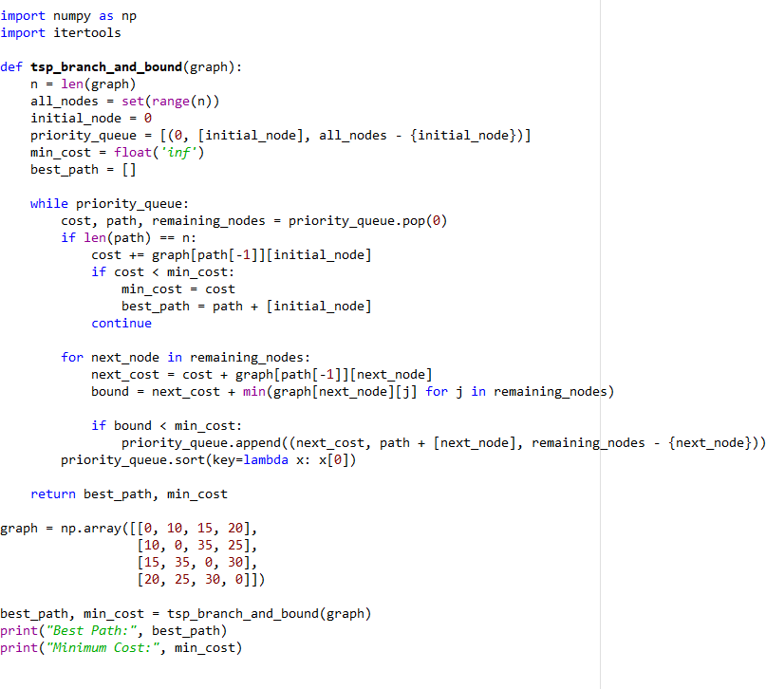
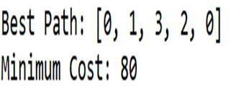


EX NO:9b BRANCH AND BOUND - TRAVELLING SALESMAN

OUTPUT:

RESULT:

Thus the program implemented successfully.



