stAngles

In the Euclidean 2D plane we can associate an Angle to every vector in the following way:
Vector: v = (v₁, v₂) → Angle: φ = atan (v₂/v₁)
The unit vector for this direction can then be written as
u_{v} = (cos φ , sin φ)

In the Minkowskian (1,1)D plane we can also associate an stAngle to every vector in an analogous way:
Vector: v = (v₁, v₀) → stAngle: φ = atanh [ (v₀/v₁) ^{stType} ]
where atanh is the inverse hyperbolic tangent function, and
using v² = v₁² -v₀²
if v² = 0 → stType = 0 , otherwise stType = v² / abs(v² )
The resulting values for stType are:
stTipe = +1 for spacelike vectors (v₁ > v₀)
stTipe = +1 for timelike vectors (v₁ < v₀)
stTipe = 0 for lightlike vectors (v₁ = v₀)

The stUnitVector in the minkowskian case can be written as
u_{v} = (cosh φ , sinh φ) for spacelike vectors (stType = +1)
u_{v} = (sinh φ , cosh φ) for timelike vectors (stType = -1)
u_{v} is nonexistent for lightlike vectors (stType = 0)

Geometric interpretation of Angles as Areas

Euclidean Plane
-The Angle (in rads) is the measure of the Arc Length of a Unit Circle.
-The Angle is also the double of the Area enclosed by a Unit Circle Sector.
For example, the Angle of a whole circle is 2π, which is the length of its unit circumference, 2π·r, and two times the area of the unit circle: A = π·r² (r = 1)

Minkowski Spacetime
-The stAngle is the measure of the Arc stLength of a Unit stCircle.
-The stAngle is also the double of the Area enclosed by a Unit stCircle Sector.

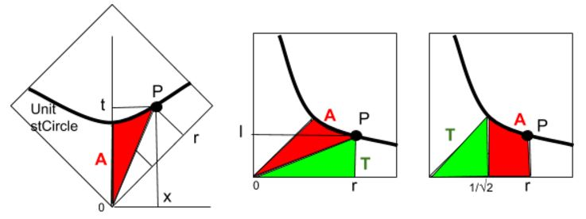
In the figure, point P(x,t) on a Unit stCircle (left) marks a stCircular Sector (red) whose Area is A.
Rotating the figure 45º , the equation of the stCircle, in the new coordinates (r,l) , is: r·l = ½ .
It is easy to check at the right figures that the area of both green triangles has the same value (T = r·l/2 = ¼ ).
The Area A, thus, is equal to the integral of the hyperbolic curve between the values 1/√2 and r.
Integrating the equation l = ½ r⁻¹ yields A =∫ldr = ½ ∫r⁻¹dr = ½ ln r
Between 1/√2 and r, we get A = ½ [ln r - ln(1/√2)] = ½ ln (r√2) .
Applying φ = 2A, we have φ = ln (r√2)

Getting back to the original coordinates, r = 1/√2 (x+y), so
φ = ln (x+y)

To see that this is in accordance with the usual definition, we transform this expression to get x+t = e^{φ}

Recalling that x = sinh φ = ½ (e^{φ} - e^{-φ} ) and
t = cosh φ = ½ (e^{φ} + e^{-φ} )
x + t = sinh φ + cosh φ = e^{φ}

