**PURBANCHAL UNIVERSITY**



**DEPARTMENT OF COMPUTER ENGINEERING**

**KHWOPA ENGINEERING COLLEGE  
LIBALI-2, BHAKTAPUR**

**FINAL PROJECT REPORT**

**ON**

**Blood donation helper**

Project work submitted in partial fulfilment of requirements for the award of the degree of Bachelor of Engineering in Computer Engineering (Fourth Semester)

**Submitted By:**

Roshish Parajuli (750333)

**Submitted to:**

Er. Milan Chikanbanjar

March, 2021

**DEPARTMENT OF COMPUTER ENGINEERING**

**KHWOPA ENGINEERING COLLEGE  
LIBALI-2, BHAKTAPUR**

**CERTIFICATE**

This is to certify that the project entitled "**Blood donation helper**" submitted by Mr Roshish Parajuli in a partial fulfillment of the requirements for the award of the Degree of Bachelor of Engineering in Computer Engineering of Purbanchal University is a bonafide work to the best of our knowledge and may be placed before the examination board for their consideration.

.

**Panel of Examiners:**

|  |  |  |  |  |
| --- | --- | --- | --- | --- |
| **Name** | | **Signature** | | **Date** |
|  | |  | |  |
|  | |  | |  |
| **External Examiner** | |  | |  |
|  | |  | |  |
|  | |  | |  |
|  | |  | |  |
|  |  | |
|  |  | |
|  |  | |
|  |  | |
|  |  | |
|  |  | |
|  |  | |

**ACKNOWLEDGEMENT**

This report is an outcome of inspiration and moral support of many people, especially our honourable teachers of Department of Computer Engineering, and I am always grateful to all of them. I want to express my sincerest gratitude to all those who have inspired us to make this report.

I would also like to thank our supervisor **Er. Milan Chikanbanjar** who helped us a lot in gathering different information, collecting data and guiding us from time to time and sharing us their valuable ideas.

Finally, I am also grateful to friends and our seniors for their supports and innovative ideas for this report.

Roshish Parajuli (750333)

**ABSTRACT**

In this project, I have developed a website for seeing who is in need of blood donation, where blood donation programs are going to be held and to know who are potential blood donors. Users can view the location of blood donation campaign in map and know the date and time of program. Donors can also share their experience through the site.

**Table of Contents**

LIST OF FIGURES

CHAPTER 1

INTRODUCTION

1.1 Background

1.2 Motivation

1.3 Statement of Problems

1.4 Objectives

1.5 Scopes and Application

CHAPTER 2

METHODOLOGY

2.1 Generic Model

2.2 Generic model

2.4 Algorithm

2.5 Flowchart

2.6 Tools and Platforms

CHAPTER 3

RESULTS AND DISCUSSION

3.1 Overview

3.2 Analysis of Result

CHAPTER 4

CONCLUSION AND RECOMMENDATION

4.1 Conclusion

4.2 Future Enhancement

REFERENCES

# 

# CHAPTER 1

**INTRODUCTION**

* 1. Background

**“Blood donation helper”** is a site where people can see who is in need of blood donation, where blood donation programs are going to be held and to know who are potential blood donors. Users can view the location of blood donation campaign in map and know the date and time of program. Donors can also share their experience through the site.

This project will demonstrate all the basic syntaxes, commands, functions, etc of html, css, javascript , php and mysql.

* 1. Motivation

This project is simple website design project. I was encouraged to make this website because it is very hard to find blood in time if someone needs it urgently. Although people donate bloods they are sent to different hospitals and are not easily accessible to the needy ones. So I wanted to make this site so that there can be communication directly between donors and needy people. Furthermore, this site helps to give credit to the donors and organizers.

* 1. Statement of Problems

I couldn’t find many sites for this purpose. I found a site of red cross and I analyzed the site and found some things which could be improved.

There was no feature for selection for the seat reservation.

* There is no way to figure out who the donors are.
* The donors cannot know who they are donating for.
* The donors can only know when red cross hosts a blood donation program but other programs will be unknown.
* When someone needs blood there is no way to ask.
  1. Objectives

The main objective of this project is to properly utilize the features and commands of the scripting languages like html, css, javascript, php and mysql for database design.

* 1. Scopes and Application

This project can be applicable in countries like Nepal where other major blood donation organizations are not mostly active. It creates an easier way to solve blood related deaths and people can find blood easily instead of sharing a post in thousands of facebook groups, sending one message to this site will be more effective. With a few modifications the project can be hosted into the web for use.

# 

# CHAPTER 2

# METHODOLOGY

**2.1 Generic Model:**

**users**

**login**

**Send message**

🚺

Menu view urgent needs

Contact Us

About Us

Donors

Login/Signup

Events

**Fig 3.1:Generic Model**

2.3 Second Level DFD:

*DFD For Login*

**Insert email/password**

**Check for Account**

2.4 Use Case Diagrams

Admin:

The Administrator can see the messages through the database.

User:

Users can view the content of the site and send message to the admin.

🚺

**User**

2.5Database Design

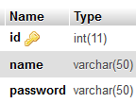

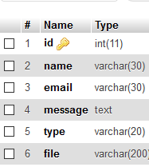 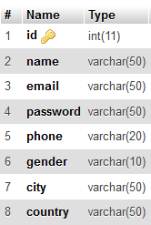

2.6 Tools and Platform

During the development of the project, the tools and platforms that I used for coding and testing the project are:

1. Sublime Text

2. Wamp Server



# CHAPTER 3

# RESULTS AND DISCUSSION

3.1 Overview

I have completed the project “Blood donation helper” using HTML, CSS, JS and php languages. This project consists of a home page in which urgent blood needs are displayed and the home page contains a menu which leads to donors, events blogs, login/signup options.

This project is developed as per the requirements specified for passing in the fourth semester and is well designed for the proper utilization of the knowledge relating the scripting language like javascript and php applicating with mySQL for proper information storage.

3.2 Analysis of Result

The results can be as seen below:

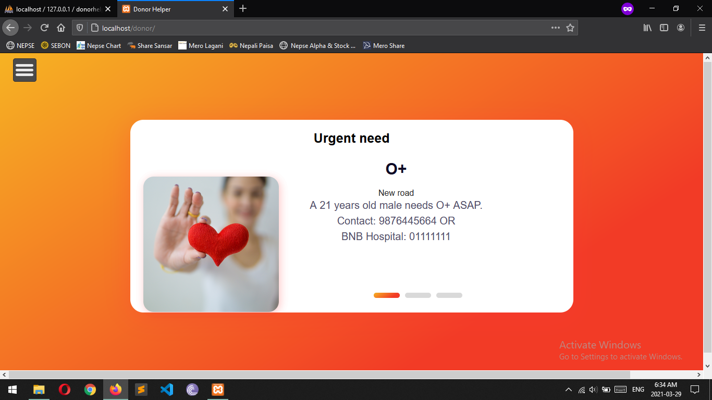

Fig: index page

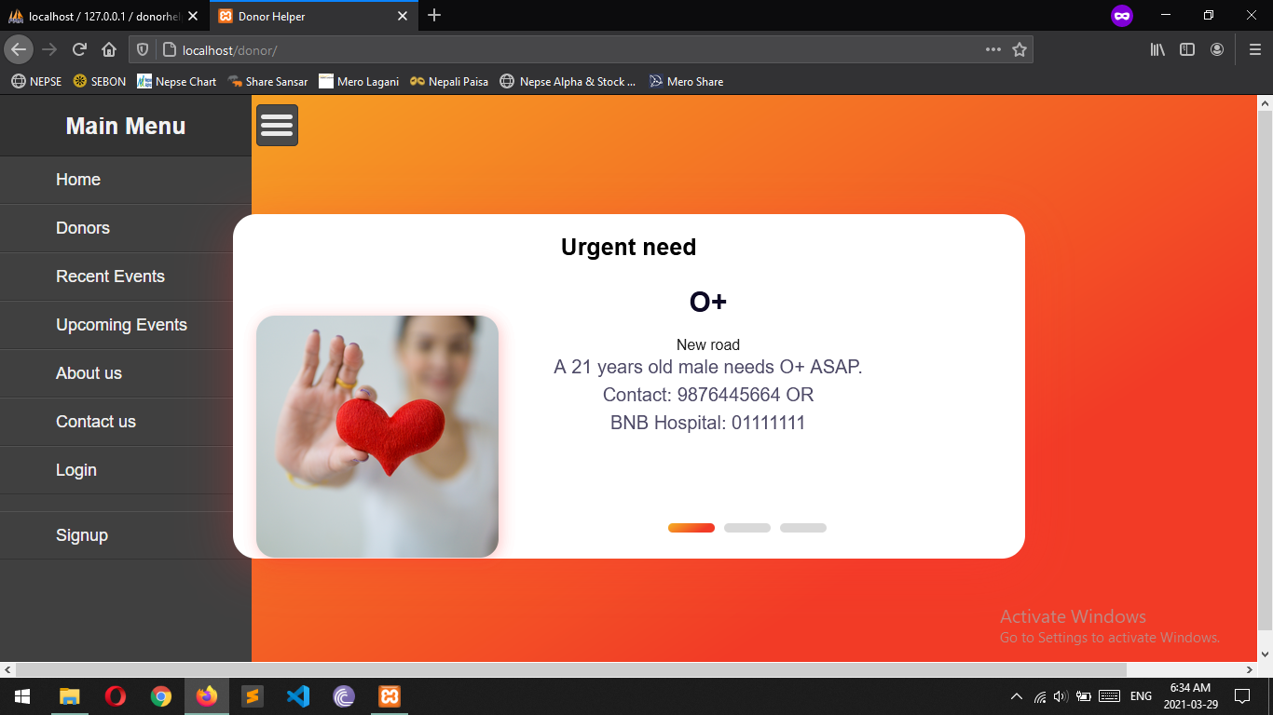

Fig: index page with menu

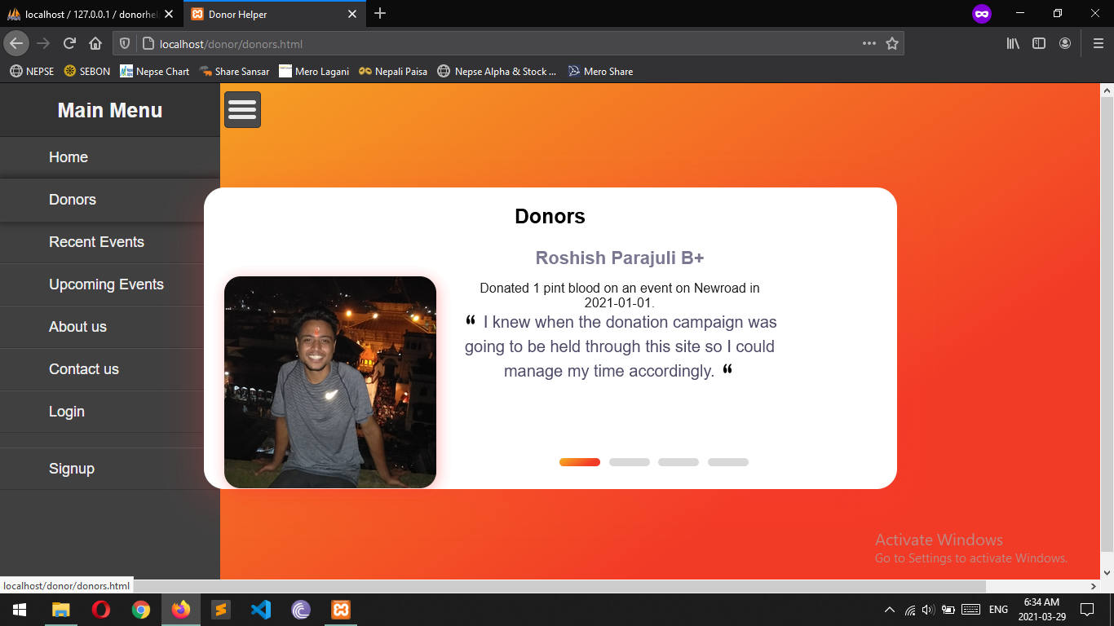

Fig: Donors blog page

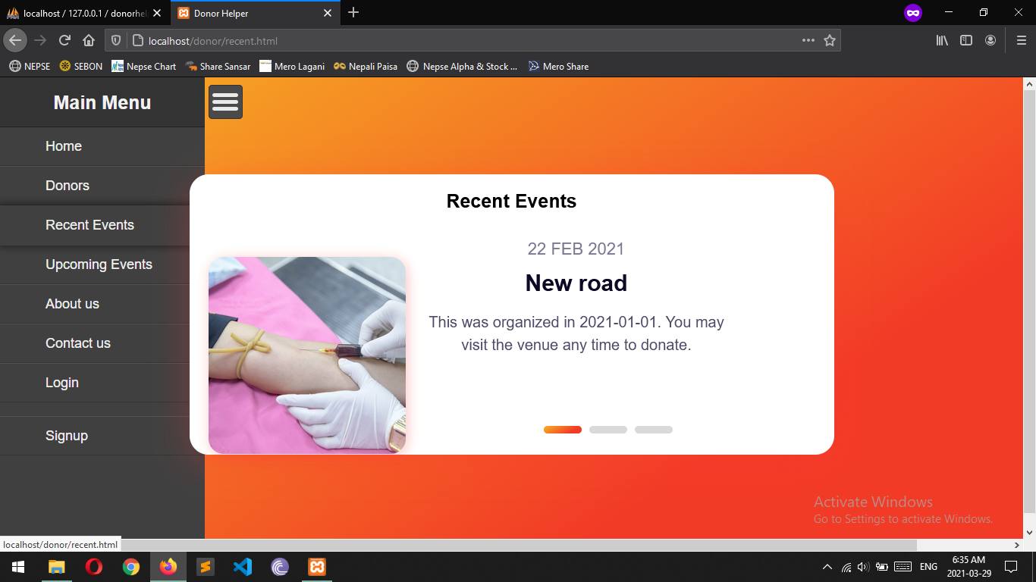

Fig: Recent events blog page

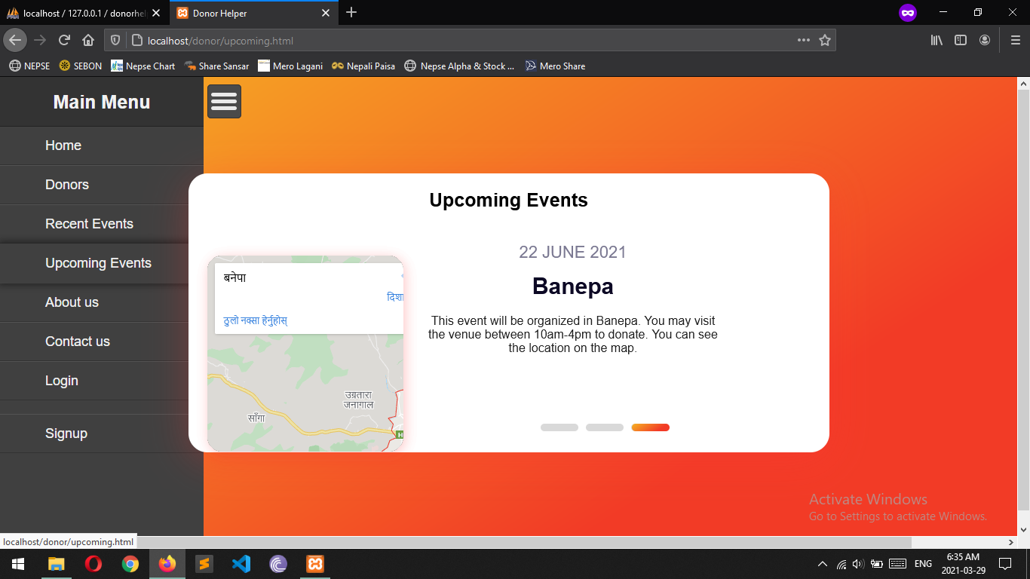

Fig: Upcoming Events

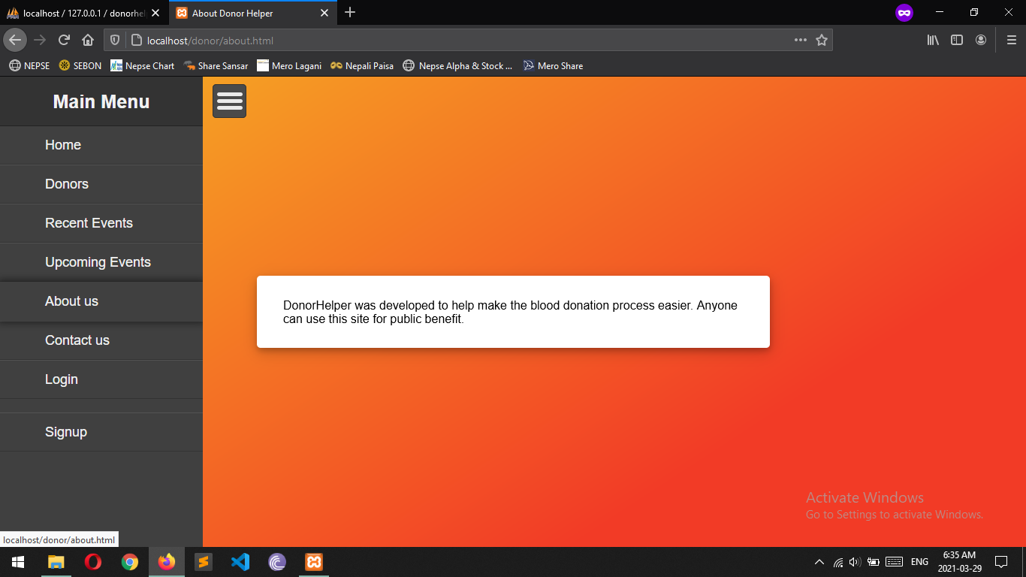

Fig: About Page

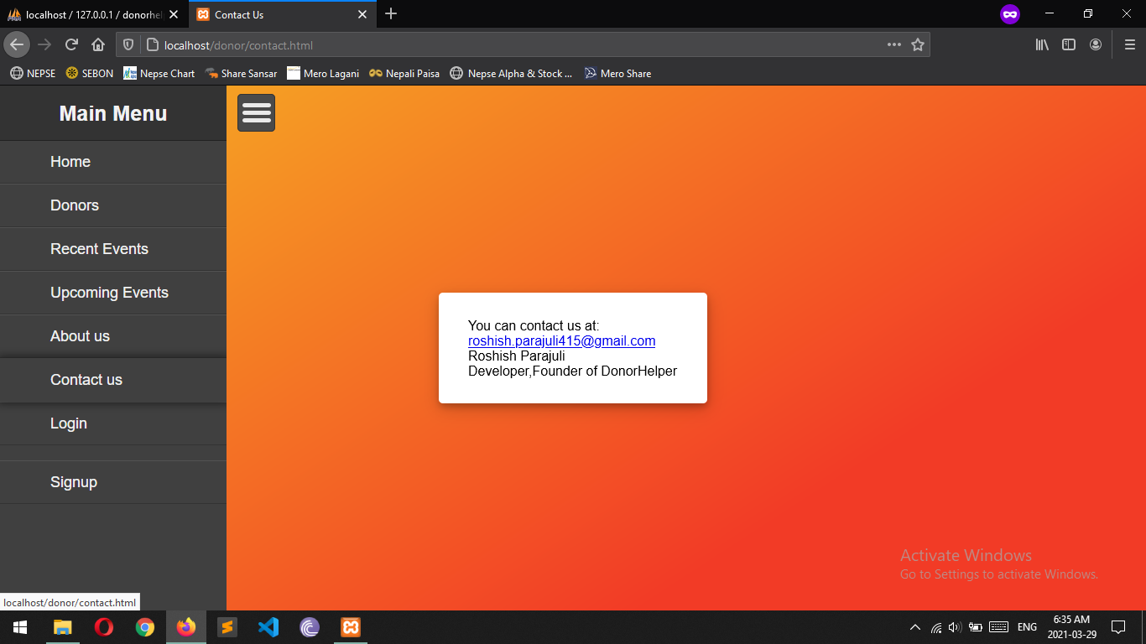

Fig: Contact Page

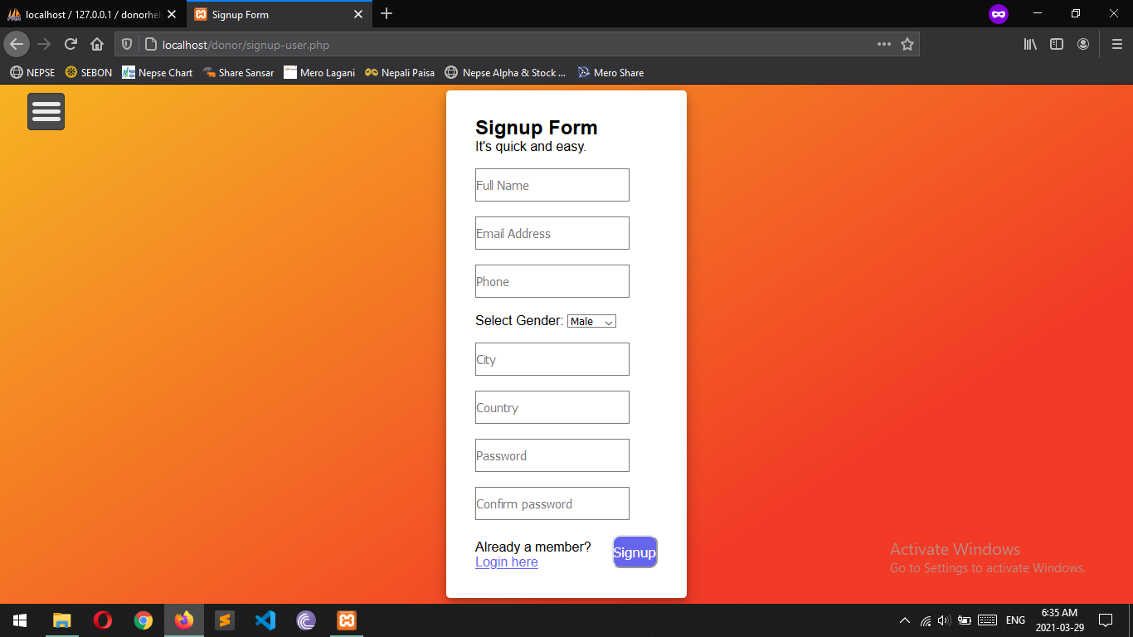

Fig: Signup Page

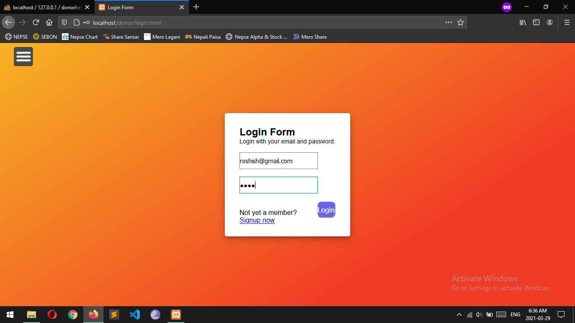

Fig: Login Page

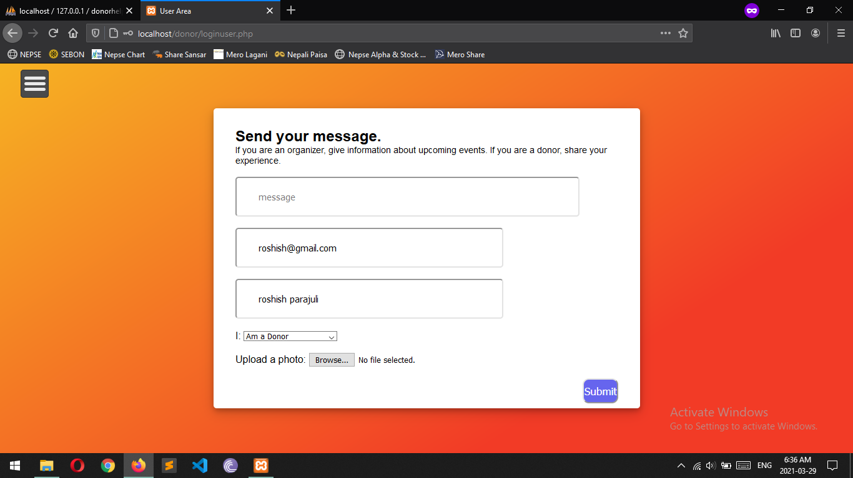

Fig: Send message page after login

# 

# CONCLUSION AND RECOMMENDATION

4.1 Conclusion

Hence, after completion of the project I got familiar with the basic scripting languages and its features. As a whole, this project has been good experience for me. I have gained knowledge about the various aspects of web design and database connectivity. At the same time I have developed a better understanding of mySQL database language.

Since the project is completed but there are still lots of room for improvement.

4.2 Future Enhancement

This project is done with some basic knowledge and some research of scripting languages. Since I am a beginner and I didn’t have much time so there may be some flaws in the developed project. So, there are still improvements that can be done in our project.

1. The user interface can be improved.
2. The site can be made dynamic.
3. More options like fundraiser can be added.

# REFERENCES

1. https://www.w3schools.com/sql