This documentation guide addresses the technical integration of a RunCam FPV Camera with a Network Card (WiFi Dongle) for digital FPV transmission and RunCam WifiLink, likely via the OpenIPC or RubyFPV ecosystem.

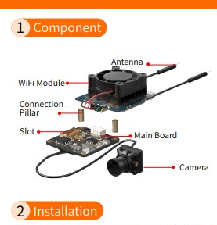

1. Video Signal Interface (Digital)
In this specific setup, the "Interface" is actually a two-part bridge:
- Camera to Main Board
- Main Board to WiFi Dongle
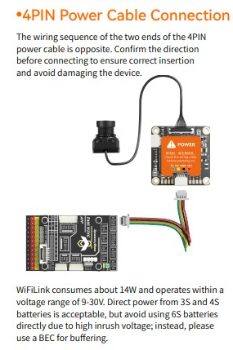

Operating Voltage & Current Draw
Digital transmission requires high current stability. Voltage ripple should be kept below 100mV.
- Operating Voltage: 9V – 30V (Optimized for 3S/4S LiPo).
- Typical Current (Idle): 450mA @ 12V.
- Typical Current (Streaming): 1.2A @ 12V.
- Max Peak Current: 2.5A @ 12V (During high-bitrate scene changes or extreme range transmission).

2. WiFi Channel & Frequency Configuration
The system uses the 5.8 GHz band. It is highly configurable via a text file on the SD card.
- Default Frequency: 5.8 GHz.
- Supported Power: Up to 29dBm (approx. 800mW) on FCC settings.
- Channel Selection: Recommended to use Channel 149 (5745 MHz) to 165 (5825 MHz) to stay clear of standard WiFi routers.
- Codec: H.265 is preferred for digital FPV as it offers better quality at lower bitrates, reducing latency.
- Ground Station: ground station WiFi dongle must be put into Monitor Mode.Need the gs.key file (automatically generated on the camera's SD card) to decrypt the video stream on your ground station device.

3. Antenna Placement (LoRa Interference Check)
Since the rover also carries a LoRa link:
- WiFi Antenna: 5.8 GHz (Circular Polarized or "Mushroom" antennas are best for multi-path rejection).
- LoRa Antenna: 433/868/915 MHz (Linear Monopole/Dipole).
- Interference Rule: WiFi 5.8 GHz is a harmonic of some lower frequencies. Keep the WiFi antenna at least 20cm away from the LoRa antenna. If you experience "telemetry lost" when the video starts, the WiFi dongle is likely "swamping" the LoRa receiver.

4.Specification
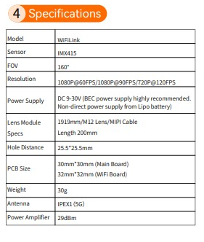
5. Mounting Strategy (Remote Cable-Mount)
The WiFiLink 2 is modular. You can "remote-mount" components to balance the rover or move the RF source.
- Camera Mount: The sensor (19x19mm) can be mounted up to 130mm away from the main board using the provided MIPI cable.
- Board Mount: The main PCB (32x 32mm) should be mounted on 25.5mm stacks.
- Thermal Note: The board must have its cooling fan active. If the green/blue lights flash alternately, the board has exceeded 90°C and will throttle or shut down.
- WiFi Dongle: Can be remote-mounted using a 4-wire shielded cable to place the antenna in the most optimal RF location.

6.Ground Station Configuration
To receive the signal on the ground station side, you need:
- Hardware: A high-power WiFi dongle (typically RTL8812AU or MT7612U chipsets).
- Software:
  - Android: FPVue or PixelPilot.
  - PC: Use the FPV4Win tool.
GS Key Management: Always keep a backup of the gs.key on a secondary device. If you lose this file from the SD card, you will lose the ability to decrypt the video stream on your Ground Station.

7.Communication Protocol
- Internal (Cam to Board): MIPI CSI-2 (4-Lane).
- External (Board to GS): UDP/RTSP over WiFi (Monitor Mode).
- Telemetry: MAVLink via UART (compatible with ArduPilot/PX4).
- Control: I2C is used internally for sensor configuration; it is not exposed for user control.

6. Testing Procedure (Bench Test Checklist)
- Continuity Check: Verify no shorts between VCC and GND before applying power.
- Voltage Check: Confirm the BEC/PDB outputs 12V stable under load.
- LED Status: Red Solid (Power), Blue Flashing (System Boot), Green Solid (WiFi Link Active).
- Ping Test: Connect GS to WiFi and ping the camera IP (Default: 192.168.1.10).
- Latency Check: Measure glass-to-glass latency (Target < 80ms

8. Board Placement & Thermal Rules
- Thermal: The SoC generates significant heat. The board must be mounted with at least 5mm of clearance underneath for airflow.
- Proximity: Keep the WiFiLink board at least 50mm away from the GPS module and 150mm away from the LoRa receiver.
- Mounting: Use M2 nylon standoffs to prevent shorting against carbon fiber or metal rover frames.
PCB Trace Width Recommendations
For the JST_GH_1x04_P1.25mm connector, the power traces must be sized to handle peak current without significant voltage drop or heat buildup.
- VCC & GND Traces: Use a trace width of at least 1.0 mm (40 mils) for internal or external layers if using standard 1oz copper. This safely handles the 2.5A peak current while keeping temperature rise under 10°C.
- UART Data Traces (TX/RX): These carry minimal current and can be thin, typically 0.2 mm (8 mils), but keep them away from high-power traces to avoid EMI.
- Polygon Pours: Whenever possible, use a Ground Plane on the layer directly beneath the WiFiLink to provide a short return path for high-frequency noise.

79 Firmware & Code Notes
- OS: Linux-based OpenIPC.
- Library: Uses WFB-ng (WiFi Broadcast next generation) for the transmission layer.
- HAL: The hardware abstraction layer is proprietary to the SigmaStar SoC, but can be modified via /etc/config/ files via SSH.
- Root Access: ssh root@192.168.1.10 (Default password is often 12345 or runcam).
10. Recommended Schematic Circuit
When integrating this into your rover's power distribution board (PDB):
- Decoupling: Place a 470µF 35V Low-ESR Capacitor across the DC input to filter motor noise.
- Protection: Add a TVS Diode (e.g., SMBJ24A) to protect against voltage spikes from the rover's motors.
- Symbol Name: JST_GH_1x04_P1.25mm

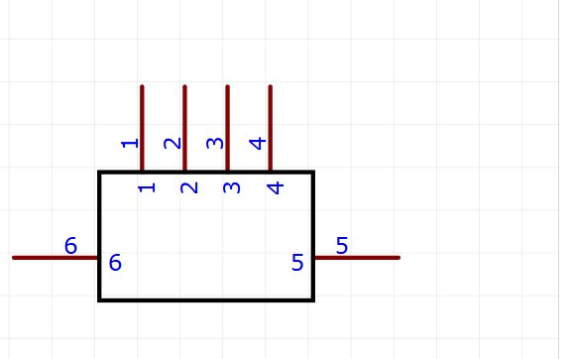
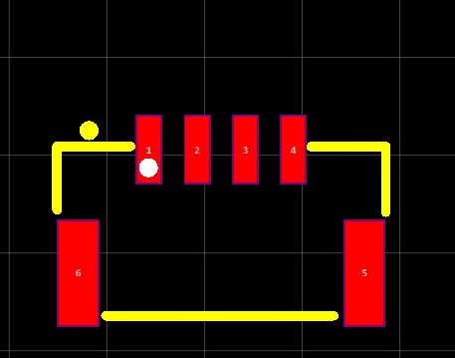
General Description and Purpose
The JST_GH_1x04 is a 4-pin, 1.25mm pitch wire-to-board connector symbol used to define the primary electrical interface for the WiFiLink system. In professional electronics design, this symbol serves three critical purposes for your rover build:
- Power Delivery Integration: It provides the schematic connection point for the 9V–30V DC input, ensuring the high-current requirements (up to 2.5A peak) are routed through traces capable of handling the load.
- Telemetry Communication Bridge: The symbol maps the UART TX and RX lines, allowing you to establish a MAVLink communication protocol between the WiFiLink board and the rover's flight controller or main processor

Pin | Function | Description
1 | VCC | Main Power Input
2 | GND | Common System Ground
3 | TX | Data output to Flight Controller (Telemetry)
4 | RX | Data input from Flight Controller (Control)
5 & 6 | Shielding | which should be soldered to a grounded plane for physical stability and additional noise shielding

