E220-400T22D adopts a new generation of LoRa spread spectrum technology and a wireless serial port module (UART) designed based on the LLCC68 chip scheme. It has a variety of transmission methods, works in the (410.125～493.125MHz) frequency band (default 433.125MHz), TTL level output, compatible with 3.3V and 5V IO port voltage.
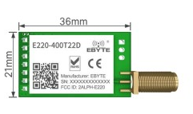
Pinout Description
The module generally includes the following pins, starting from the antenna end:
Pin Name | Description
M0 | Mode selection pin 0 (Used with M1 for sleep/wake/power-saving modes)
M1 | Mode selection pin 1 (Used with M0)
RXD | TTL UART Serial Input (Connects to MCU TX)
TXD | TTL UART Serial Output (Connects to MCU RX)
AUX | Auxiliary indication (Indicates module state, wakes up external MCU)
VCC | Power Supply (Typically 3.3V - 5.2V)
GND | Ground (0V)
Key Features
- Operating Frequency: 433-532MHz band
- Interface: UART (Serial)
- Distance: Long-range (LoRa technology)
- Antenna: SMA or solder pin for external antenna (essential for range)
- Operating Temperature: -40~+85 ℃
Performance:
- Output Power: +22dBm
- Maximum Receiving Sensitivity: -135dBm (BW=125, SF=12)
- Open space visible distance up to 8km (for reference only, actual distance may vary)

EASYEDA SCHEMATIC/DIAGRAM
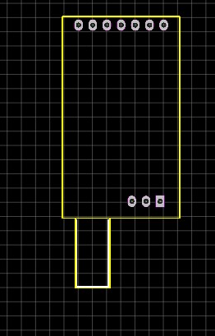 FootPrint
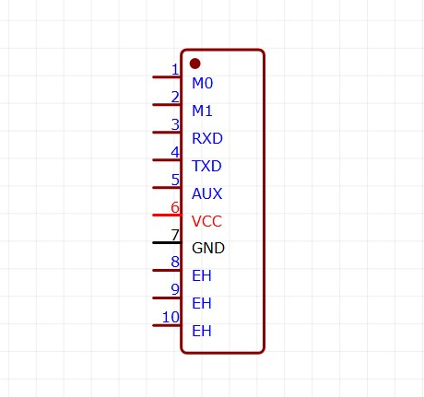

Hardware Design Layout Suggestions
The E220-400T22D module operates in the 433-532M frequency band and uses an external antenna. The antenna's VSWR and efficiency depend on the module's placement. Minimize factors affecting wireless transmit and receive signals. Pay attention to the following points:

Avoid using metal for the product casing surrounding the E220-400T22D. If using a partial metal casing, keep the module's antenna section as far away from the metal as possible. Internal metal connections or screws should also be kept away from the module's antenna section.
The module's antenna section should be placed near the edge of the carrier board PCB or directly exposed, and should not be placed in the middle of the board.
It is recommended to use insulating material for isolation at the module mounting position on the baseboard, such as a complete silk screen (TopOverLay) at this location

Recommended Circuit

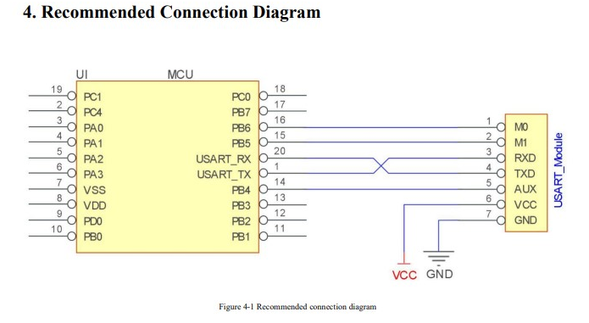

Precautions
- Power Check: Ensure the module is receiving stable power within the specified voltage range (3.3V-5.5V).
- Antenna Connection: Verify that the antenna is securely connected before powering on the module. An unconnected antenna can lead to damage.
- UART Connection: Double-check your RXD and TXD connections to your microcontroller or computer. Ensure baud rates match.
- AT Command Syntax: Confirm that the AT commands sent are correctly formatted and terminated. Refer to the technical manual for exact syntax.
- Frequency Band: Ensure both transmitting and receiving modules are configured to the same frequency band.
- Communication Range: Consider environmental factors (obstacles, interference) that might affect the actual communication range. The stated 8km range is for open, unobstructed environments.
- Module Operating Mode: Verify that the M0 and M1 pins are configured correctly for the desired operating mode (e.g., transparent, fixed-point).
TX power setting and link budget calculation
TX Power Settings
The maximum transmit power for these "22D" series modules is typically +22 dBm (160mW).
- Adjustment Range: Usually configurable from 0 dBm to +22 dBm in steps.
- Power Consumption: Higher TX power significantly increases current draw during transmission. For example, at +22 dBm, the module may draw over 100mA, whereas lower settings like +10 dBm draw much less.
- Regulatory Limits: In many regions, the 433 MHz ISM band has strict effective radiated power (ERP) limits (often 10mW or 14 dBm) and duty cycle restrictions. Ensure your settings comply with local laws
Link Budget Calculation
The link budget is the sum of all gains and losses in your communication system. It determines the maximum path loss your signal can survive before it becomes unreadable

Received Power(dBm)=P_{TX}+G_{TX}-L_{TX}-FSPL+G_{RX}-L_{RX}
P_{TX}(TX Power): Your setting (e.g., +22 dBm).
G_{TX}/G_{RX}(Antenna Gain): Typical rubber ducky antennas are ~2 dBi.
L_{TX}/L_{RX}(Cable/Connector Loss): Usually ~0.5–1 dB for direct SMA connections.
FSPL (Free Space Path Loss): The loss over distance d (km) at frequency (MHz):
FSPL=20log₁₀(d) + 20log₁₀(f)+32.45
Fade Margin: Always subtract a safety margin (e.g., 10–15 dB) for obstacles and weather to ensure reliability.

Range Test Protocol
Step 1: Static Bench Test (0.5km)
- Goal: Verify the ACK Loop logic works.
- Action: Send 100 commands. If the Ground Station logs 100 ACKs, the firmware is stable.
Step 2: Line-of-Sight (LoS) Test (5km - 8km)
- Action: Have the Rover assignee move to a clear hilltop.
- Data: Record the RSSI (Signal Strength) and SNR (Signal Quality) reported by the module.
- Orientation: Test if holding the Ground Station antenna Vertical vs. Horizontal changes the signal.
Step 3: Failure Boundary Test
- Action: Move until the "Heartbeat" starts dropping.
- Goal: Confirm the Rover's Fail-Safe triggers (Motors stop) when the signal is lost.

Firmware and Code Libraries
The E220-400T22D is primarily a UART-based module, meaning most developers interact with it via serial strings rather than low-level register manipulation
1. Core Architecture
- Driver Type: Because the module includes an onboard MCU to handle the LoRa stack, you generally use HAL drivers for UART on your host controller (e.g., STM32 HAL, Arduino Serial) rather than SPI HAL drivers for the LoRa chip itself.
2. Register Maps & Configuration
The module does not expose the raw SX1262 register map over UART. Instead, it uses a Virtual Register Map accessed via AT commands.
- Configuration Storage: Settings changed via AT commands are typically stored in the LLCC68's internal Flash/EEPROM, persisting through power cycles.
- Register Access: This specific EByte module usually uses Hexadecimal Configuration Commands
3. Recommended Libraries
For most microcontrollers, you do not need a specific "LR32" library. You can use standard serial libraries:
- Arduino: SoftwareSerial or hardware Serial for basic data. For structured control, the EByte E32 Library is often partially compatible due to similar pinouts and UART logic.
- STM32: Use the STM32 HAL UART with DMA for high-speed telemetry.
4. Code Implementation Notes
- Interrupt-Driven RX: Always use an interrupt or DMA on your host MCU to read from the module. LoRa packets arrive asynchronously; if your code is "blocked" in a delay, you will miss telemetry.
- The AUX Pin: This is your hardware "Interrupt" pin.
  - High: Module is idle/ready.
  - Low: Module is busy (transmitting or receiving).
  - Code Tip: Use a falling-edge interrupt on the host MCU's AUX-connected pin to trigger a serial read.
- Data Buffering: The module typically has a 230-byte buffer. Sending more than this in one burst without checking the AUX pin status may result in data loss.

PCB Antenna Design
433 MHz Band (Global)
The 433 MHz band is available in many regions but with varying power limits and restrictions.
Key specifications:
- Center frequency: 433.92 MHz
- Bandwidth: Typically 125 kHz
- Max TX power: +22 dBm (160 mW) in EU, varies elsewhere
- Longer range potential due to lower frequency

Frequency | Full Wavelength (λ) | Quarter-Wave (λ/4) | Half-Wave (λ/2)
433 MHz | 692 mm | 173 mm | 346 mm

Use external ¼ Wave Whip Antenna
Connect to SMA Female Edge-Mount Connector

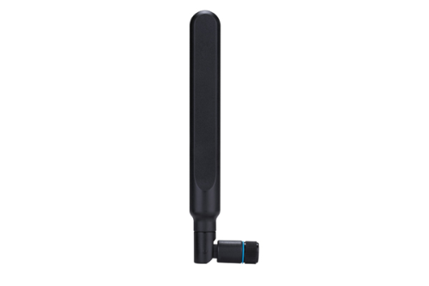
Minimum Ground Plane Dimensions
Frequency | Minimum Size | Recommended Size | Notes
433 MHz | 80 × 100 mm | 100 × 150 mm | Larger is better

Ground Plane Design Rules for LoRa
Rule 1: No copper under the antenna
The entire antenna keep-out zone must be free of copper on ALL layers. For a 868 MHz meandered monopole, this means a 45mm × 15mm (minimum) region with no ground, power, or signal traces.
Rule 2: Ground plane edge position
The edge of the ground plane nearest the antenna significantly affects performance. Keep this edge straight and perpendicular to the antenna feed direction.
Rule 3: Via stitching requirements
At sub-GHz frequencies, via spacing can be more relaxed than at 2.4 GHz, but still important:
Frequency | Maximum Via Spacing
433 MHz | 15–20 mm
Rule 4: Ground continuity
For multi-layer boards, ensure ground continuity between layers in the antenna region. Avoid routing signals through the antenna ground area on internal layers.
Feed Line Design for LoRa Frequencies
The transmission line from your LoRa module to the antenna must maintain 50Ω characteristic impedance.
Microstrip Dimensions for Sub-GHz
At lower frequencies, trace widths for 50Ω are wider than at 2.4 GHz:
PCB Thickness | Trace Width for 50Ω | Notes
0.8 mm | 1.5 mm | 4-layer boards
1.0 mm | 1.9 mm | Common 4-layer
1.6 mm | 3.0 mm | Standard 2-layer
Coplanar Waveguide (CPW) for LoRa
CPW provides better ground return and is often preferred:
PCB Thickness | Trace Width | Gap to Ground | Total Width
1.6 mm | 2.0 mm | 0.4 mm | 2.8 mm
1.6 mm | 1.5 mm | 0.3 mm | 2.1 mm
Feed Line Best Practices
- Keep feed lines short (loss increases with length)
- Avoid sharp bends; use 45° miters if necessary
- Maintain consistent width throughout
- Don’t route over split planes or near board edges
Impedance Matching for LoRa PCB Antennas
LoRa antennas often need matching networks to optimize performance across the operating band.
Pi Matching Network
The standard matching topology:
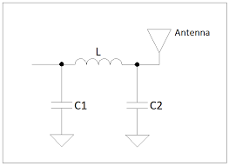
Only include a "Zero-Ohm Resistor" (jumper) or a single series capacitor (approx. 100pF) in the path to the antenna to protect against DC shorts

Packet Structure
System Architecture: The "Master-Slave" Flow
The Ground Station acts as the Master node. It initiates commands and expects confirmation, while the Rover acts as the Slave node, providing telemetry (status updates) and executing instructions.
The Logic Flow:
- Idle State: Ground Station monitors the AUX pin. If HIGH, the LoRa module is ready.
- Command Phase: Ground Station packages a "Fixed Schema" binary packet and sends it via UART.
- Validation Phase: The Rover receives the packet, verifies the CRC-16 checksum, and checks if the Target ID matches its own.
- Acknowledgment (ACK): For critical commands, the Rover sends a tiny confirmation packet back. The Ground Station waits for this; if not received within a timeout window (e.g., 500ms), it automatically retries.

2. The "Fixed Schema" Packet Logic
Instead of sending text (which is slow and bulky), we use a Binary Struct. This ensures the absolute minimum "Time-on-Air," which is critical for maintaining an 8km link without interference.
- Standardized Length: Every packet is a fixed size (e.g., 8 or 10 bytes). This prevents "buffer overflow" in the E220's 230-byte internal memory.
- Byte Alignment: Data is packed tightly using Little-Endian format to match the STM32's native processing, ensuring no data is lost during the conversion from ground to rover.

3. Data Integrity & Safety Standards
To ensure the rover doesn't behave unpredictably at long distances, we implement three specific logic layers:
- Scaling (Efficiency): We eliminate 4-byte "Floating Point" numbers. Instead, we multiply values (like Battery Voltage) by 100 to send them as 2-byte integers, cutting payload size in half.
- Idempotency (Duplicate Prevention): Every command has a unique Msg ID. If a retry causes the Rover to receive the same "Turn Left" command twice, the Rover recognizes the duplicate ID and ignores the second instruction.
- The Heartbeat (Telemetry): The Rover sends a status update every 1–2 seconds. If the Ground Station misses several heartbeats, it triggers a "Signal Lost" alarm for the operator.

4. Hardware Management (The AUX Pin)
The most important piece of logic for the E220 module is the Hardware Handshake.
- Logic: The code must "Listen" to the AUX pin before every transmission.
- Purpose: If AUX is LOW, the module is busy transmitting or receiving. Sending UART data during this time will cause data corruption or buffer loss.

Byte # | Name | Value / Example | Why it's here
0 | Target ID | 0x01 (Rover) | Tells the Rover: "This is for you".
1 | Sender ID | 0xFE (Ground) | Tells the Rover: "This is from HQ".
2 | Command | 0xA1 (Drive) | The “What to do “ Code
3 | Data A | 0xFF(Speed) | Primary variable(e.g  Throttle)
4 | Data B | 0x7F(Steer) | Secondary variable(  e.g Steering angle)
5 | Msg ID | 0-255 | An incrementing number for idepomtency
6-7 | CRC-16 | 0xABCD | The math check to ensure the data is “clean”

NOTE:
We shifted from SPI to UART because our hardware (E220-400T22D) is a System-on-a-Module. Using UART allows us to offload the complex LoRa timing to the module's internal processor, reducing the STM32's CPU load and simplifying our firmware to a basic 'Serial Bridge'. This ensures maximum stability for the 8km link without the risk of SPI timing failures.

