NAME: SOH CHAU BOON STUDENT ID: B170145B

My assignment width and height is fix.

So, just direct read yoda.raw file.

Orignal file:

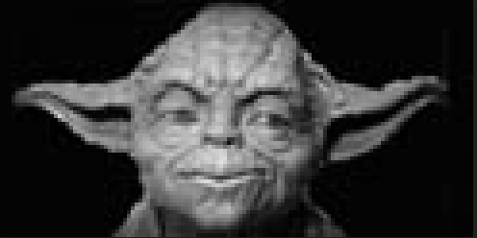

CONVOLUTION:

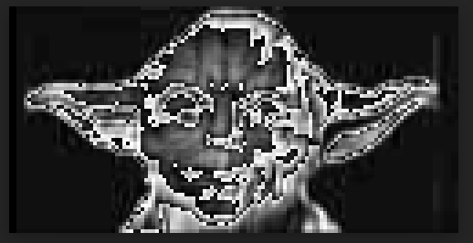

PATTERNING:

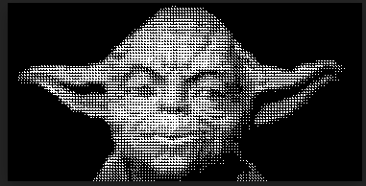

DITHERING 2X2:

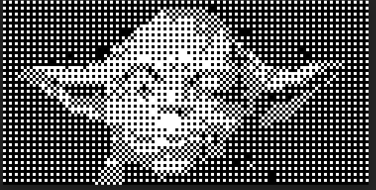

DITHERING 4X4:

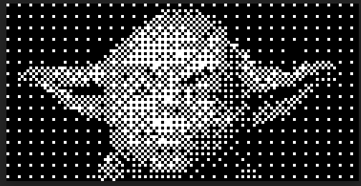

LOW PASS FILTER:

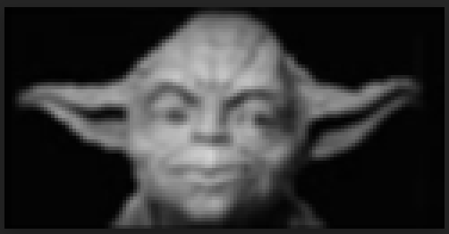

HIGH PASS FILTER:

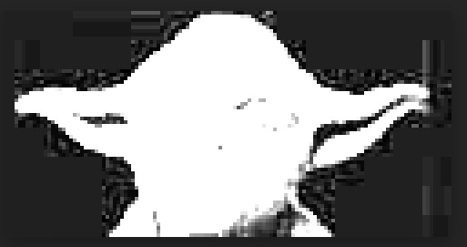

HISTOGRAM

