

|  |  |
| --- | --- |
|  |  |
| **Subject Name:** | Fundamentals Of Image Processing |
| **Subject Code:** | BTPR2053 |

**Group Project**

**By**

|  |  |  |
| --- | --- | --- |
| **Student Name:** | Ong Zhi Siang |  |
| **Student ID:** | B170216B |  |
| **Class ID:** | BOSE17-B1 |  |

|  |  |  |
| --- | --- | --- |
| **Student Name:** | Soh Chou Boon |  |
| **Student ID:** | B170145B |  |
| **Class ID:** | BOSE17-B1 |  |

|  |  |
| --- | --- |
| **Lecturer Name:** | Dr. Pang Yee Yong |
| **Submit Date:** | 14th April 2020 |

Table of Contents

1. Introduction 1

2. Detail 2

3.0 Conclusion 4

# Introduction

In our project, we can turn all raw type images into any form you want. The forms we can change are lower pass, high pass, convolution, dithering, and patterning. So the user can use it at once Turn image into various formats you want without having to always look for other resources.

# Detail

## 2.1 First Page

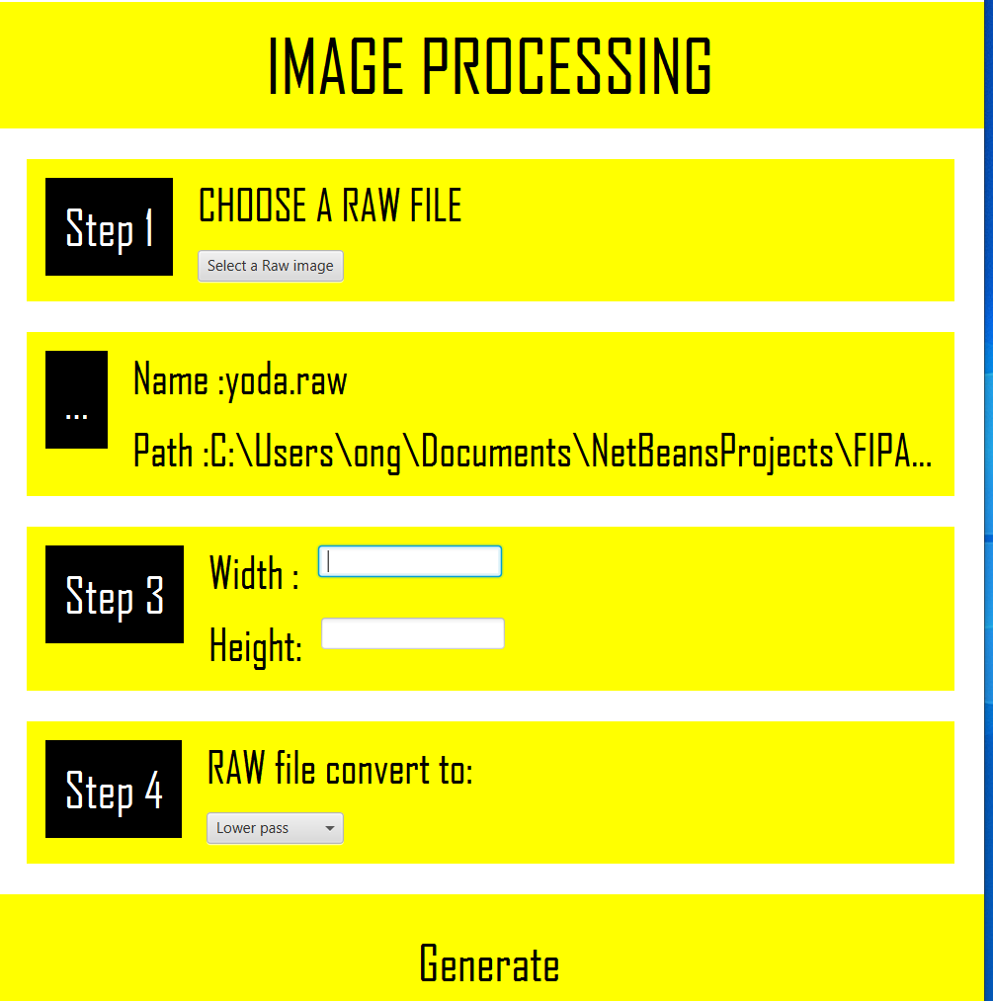

This page you can put any raw image and it will show your image name and image location.Then you can choose what you want to convert.

## 2.2 second page

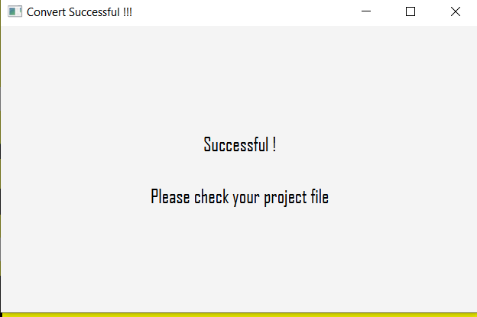

When you choose any type of convert,if successful,it will pop up a notification tell you your image is convert success and will give your a instructions.

## 2.3 last stage

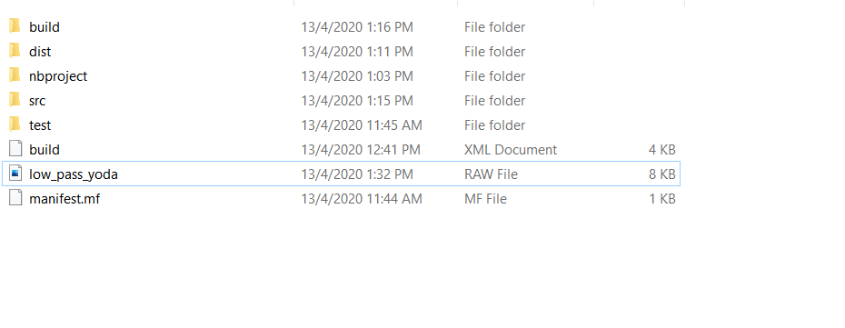

Last,you will see the convert image in your file.

# 3.0 Conclusion

In this project, I learned a lot about java, and there are many things that I only know now, such as how to read a raw type image, and make him into various types I want . Also, when writing the GUI, although the teachers used to teach us, we still forgot a lot, and we have to start from scratch.

Not only that, in this project, I also learned to work in teams, and let me know that it is impossible for a person to complete so many things.

I also want to thank my lecturer, he taught us a lot of things, otherwise this project cannot be written.