Super Directory Copy

User Manual

Table of Contents

Super Directory Copy 1
User Manual 1
Table of Contents 2
Super Directory Copy 3
Introduction 3
Using Super Directory Copy 3
Features 3
Clone 3
Tree Copy 4
Unique Files 4
All Files 4
Zeroed 4
One Level Down 4
Appendix 5
Single file copy using Super Directory Copy 5

Super Directory Copy

Introduction

Super Directory Copy is a .NET based windows utility that helps facilitate various kinds of folder and file copy operations.

Using Super Directory Copy
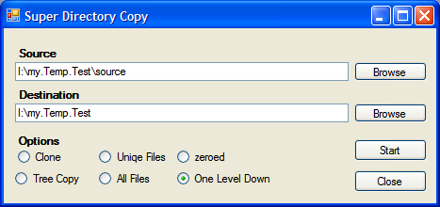
Figure 1: Super Directory Copy

- Select the source directory by using Browse button again Source Field. You may also paste your source location using ^V or by right clicking in the source field and selecting Past from the context menu.
- Select the Destination folder where you’ll like to place the copied contents.
- Select the type of operation from Options. Please refer to Features section of this manual for an explanation of the provided options.

Features

Super Directory Copy provides a multitude of copy options including the commonly known folder copy.

Clone
This is like simple folder drag & drop like copying under windows or xcopy command under DOS. It copies all the contents from Source to Destination while maintaining its directory structure and files.

Tree Copy
This feature allows the user to copy the empty directory structure from Source to Destination. The directory structure is maintained but no file is copied over to the destination.

Unique Files
This feature allows the user to copy all the files with unique names from the source tree to the destination. The destination folder contains no sub directory but only all the unique files from the source folder/subfolders. By unique files, we also mean that while copying when Super Directory Copy encounters a file with a name that has already been copied to the destination folder, it simply overwrites that.

All Files
This feature allows the user to copy all the files from the source tree to the destination. The destination folder contains no sub directory but only the files from the source folders/subfolders. While copying when Super Directory Copy encounters a file with a name that has already been copied to the destination folder, it renames the old file and then copies the newer files. The strategy for renaming the files isn’t a finished criterion yet so, you may encounter a problem while copying a folder structure that has a lot of same-named files.

Zeroed
This feature allows the user to copy all the directory structure and file names from Source to Destination. So, in that sense it is similar to Clone but the difference is that it actually copies none of the files from source. It only places zero-sized files in the destination directory with the same name as those of the corresponding files in the source tree.

One Level Down
This is a very specific option. It allows the user to copy all the folder structures from the source folder which reside at one level down i.e. the tree under each of the folder in the source folder. Say the source folder contains two folders sajha and majha. Sajha contains gamma and fiqa while majha contains ditta and fiqa. When copied using One Level Down option, the destination will contain three folders named gamma, fiqa and ditta.

Appendix

Single file copy using Super Directory Copy

You cannot specify the name of a file in Source of Destination field. The utility may copy the files from the specified source depending upon the type of the operation but it may not operate by specifying the file name as source/destination.

