# 

# AQUA-Metaverse DAO

## DAO Hacks April 2022

Hello, I am Fernando Cabal, founder of the Aqua-Metaverse platform and working on the launch of the DAO phase of our road-map.

At this phase we plan to start selling our collections of NFTs using OpenSea and we were looking for ways to kickstart the DAO launch and ensure its operation; the Hackathon gives a good overview of tools we can use to effectively manage the various aspects of launching and operating such a project.

Our NFT collections are related to Aquatic Sports and Waterfront related Art, Game assets, Avatars, and innovative technologies involving Web3 Identity and community collaborations to support the mission of the AquaMetaverse.DAO : Promote the CleanUP activities to extract plastics from Waterfronts worldwide, provide the tools and help fund the organization of each activity.

NFT creators from local zones near each CleanUP event that is organized, can submit request for minting NFT creations related to the event, the NFTs remain in display for sale on the historic pages of the event.

NFT Rewards to those who participate are sent via airdrop, email, meta, twitter, discord, and other integrations.

An historic writing on IPFS is done to immortalize of each event results.

By using picture/video geospatial metadata , and weight/volume of extracted plastics and trash we keep a global database to publish a counter that is in real-time tracking Aquametaver.dao community efforts and how much volume and Kilos of plastic we are removing.

We use analytics to extrapolate on how many years we have accelerated the recovery of the ecosystems of our planet, and we want scientific readings from Internet of Things and other sources to measure results. Be proud to be an Aquametaverse.org holder, start now!

Cheers! Fernando

# Proof o concept UNLOCK Protocol

We use the unlock protocol to create LOCKS and sell membership to our DAO and membership to our game-fi platform.

Various use cases fit perfectly with our needs when building hybrid Web2 and Web3 access portals for the Aqua-Metaverse community project and game-fi platform.

The concept of locks allows us to rapidly implement NFT membership access without the need for an advanced WEB3 knowledge or dealing with Smartcontract super heroes.

We can map these access to channel we already operate and are well equipped to run a community site and focus on the objective of the mission itself, Clean the waterfronts of planet!

Here we see all the concept we used for DAO membership, Web3 game access, Discord plugin VIP channel access. Concepts of partner NFT site access is applied using Unlock protocol Gating features.

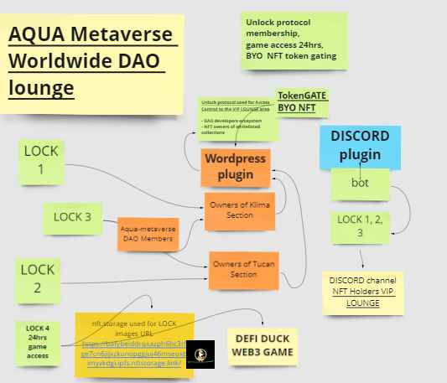

## Proof of concept

We used the Rinkeby Testnet to create some locks and deploy our proof of concept.

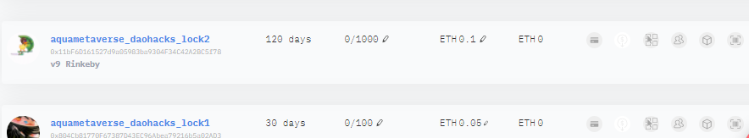

We use NFT.STORAGE to insert the images of the Unlock LOCK image

<https://bafybeiddrqxazph6hc3rfge7cn6jijxzkunopggjuj46mseuxbimyzkdgi.ipfs.nftstorage.link/>

We have tested a 24hours access to Web3 DEFI DUCK Game in dev

## Purchase addresses

We generated purchase addresses to use the for promotion of our membership on our Wordpress site by hiding some blocks of the members or the external registration page.

They each have bring to a different destination related to the type of content we have planned in the diagrams, we can separate and combine. We can create future Sub access memberships for shorter duration and embed in various ways one main membership with sub memberships.

### Purchase address aquametaverse_daohacks_lock2

<https://app.unlock-protocol.com/checkout?redirectUri=https%3A%2F%2Faquametaverse.org%2Funlock%2Faquametaverse_daohacks_lock2&paywallConfig=%7B%22locks%22%3A%7B%220x11bF6D161527d9a05983ba9304F34C42A2BC5f78%22%3A%7B%22network%22%3A4%7D%7D%2C%22pessimistic%22%3Atrue%2C%22persistentCheckout%22%3Atrue%2C%22icon%22%3A%22https%3A%2F%2Flocksmith.unlock-protocol.com%2Flock%2F0x11bF6D161527d9a05983ba9304F34C42A2BC5f78%2Ficon%22%7D>

### Purchase address aquametaversedao1 lock 1

<https://app.unlock-protocol.com/checkout?redirectUri=https%3A%2F%2Faquametaverse.org%2Funlock%2Faquametaverse_daohacks_lock1&paywallConfig=%7B%22locks%22%3A%7B%220x804Cb81770F67387D43EC96Abea79216b5a02AD3%22%3A%7B%22network%22%3A4%7D%7D%2C%22pessimistic%22%3Atrue%2C%22persistentCheckout%22%3Atrue%2C%22icon%22%3A%22https%3A%2F%2Flocksmith.unlock-protocol.com%2Flock%2F0x804Cb81770F67387D43EC96Abea79216b5a02AD3%2Ficon%22%7D>

### Purchase address aquametaversedao1 lock 2

<https://app.unlock-protocol.com/checkout?redirectUri=https%3A%2F%2Faquametaverse.org%2Funlock%2Faquametaversedao1&paywallConfig=%7B%22locks%22%3A%7B%220x0faF0c12f83766ba3116640170B68e3Cd544E147%22%3A%7B%22network%22%3A4%7D%7D%2C%22pessimistic%22%3Atrue%2C%22persistentCheckout%22%3Atrue%2C%22icon%22%3A%22https%3A%2F%2Flocksmith.unlock-protocol.com%2Flock%2F0x0faF0c12f83766ba3116640170B68e3Cd544E147%2Ficon%22%7D>

### DEFIDUCK Purchase address

<https://app.unlock-protocol.com/checkout?redirectUri=http%3A%2F%2Fdaohacks.aquametaverse.org%2Funlock%2Fdefiduck%2F&paywallConfig=%7B%22locks%22%3A%7B%220x1F17ABe76d63CfE54d9957fc48599a3a4e2d38b8%22%3A%7B%22network%22%3A4%7D%7D%2C%22pessimistic%22%3Atrue%2C%22persistentCheckout%22%3Atrue%2C%22icon%22%3A%22https%3A%2F%2Flocksmith.unlock-protocol.com%2Flock%2F0x1F17ABe76d63CfE54d9957fc48599a3a4e2d38b8%2Ficon%22%7D>

## Lock config in wordpress

We add a Block after the section of a page where we want to insert the purchase code or hide some text so it will propose the user to buy the membership access

