

CA6001- AI Algorithms Fundamentals & Application Assignment

Progressive Chess Outcome Prediction

Group member name | Matriculation Number
Gu Shucheng | G2605220E

Abstract
Stockfish can evaluate objective board strength, but its win/draw/loss (WDL) probabilities describe engine play rather than the particular human players in a game. This project asks whether human context improves three-class outcome prediction beyond direct Stockfish WDL. A public Lichess sample is cleaned to 19,113 unique games and split by game. Three in-game predictors are compared: direct WDL, a learned position-only model, and the same learner augmented with pre-match ratings and time control. Across all held-out snapshots pooled from the 10%, 25%, 50%, 75%, and 100% checkpoints, direct WDL obtains 47.6% accuracy and 43.4% macro-F1; the position-only HGB raises these to 63.4% and 52.0%; the Human-context HGB reaches 68.7% and 54.5%. The main model progresses from 52.3% accuracy before play to 89.9% at the final recorded position. The controlled comparison demonstrates that objective evaluation and human context are complementary, while retaining a compact and interpretable design.

1. Problem Background
A strategy engine is designed to evaluate positions under strong play. Human outcomes also depend on rating difference, time control, and the practical ability to convert or defend a position. Two boards with the same engine score may therefore lead to different result probabilities for different players. The study isolates this issue through a controlled ablation: the same classifier is trained first without and then with pre-match human context.

2. Task Definition
- Target: Black win, draw, or White win.
- Pre-match inputs: ratings, rated status, and time control.
- Comparison A: direct Stockfish WDL, without fitting a classifier.
- Comparison B: a position-only classifier using four engine indicators and three transparent features.
- Main model: the identical classifier plus ratings, rated status, and time control.
- Metrics: macro-F1, accuracy, and multiclass log loss, followed across retrospective game progress.
Final length and percentage progress are never model inputs. Training and validation use predetermined ply counts; percentage is used only to locate reporting positions in test games.

3. Dataset and Data Quality
The source is the public Chess Game Dataset (Lichess) on Kaggle [1]. Its 16 columns include identifiers, ratings, rated status, time control, SAN moves, opening metadata, termination status, and winner. The notebook downloads the source and prints a SHA-256 digest. Opening labels, player IDs, duration, turns, termination status, and winner are excluded from all predictors.
Table 1. Data audit and split
Item | Count | Use
Raw rows | 20,058 | Initial CSV
Duplicate game IDs | 945 | Removed before splitting
Clean games | 19,113 | All retained games
Training | 13,379 (70%) | Fit models
Validation | 2,867 (15%) | Select the pre-match candidate and inspect diagnostics
Test | 2,867 (15%) | Final estimates only
SAN parse failures | 0 | Every retained game reconstructed

The cleaned outcomes contain 8,680 Black wins, 888 draws, and 9,545 White wins. Draws are only 4.6%, so class-balanced, game-balanced sample weights are used and macro-F1 is necessary alongside accuracy. Each game contributes equal total weight regardless of its number of snapshots.
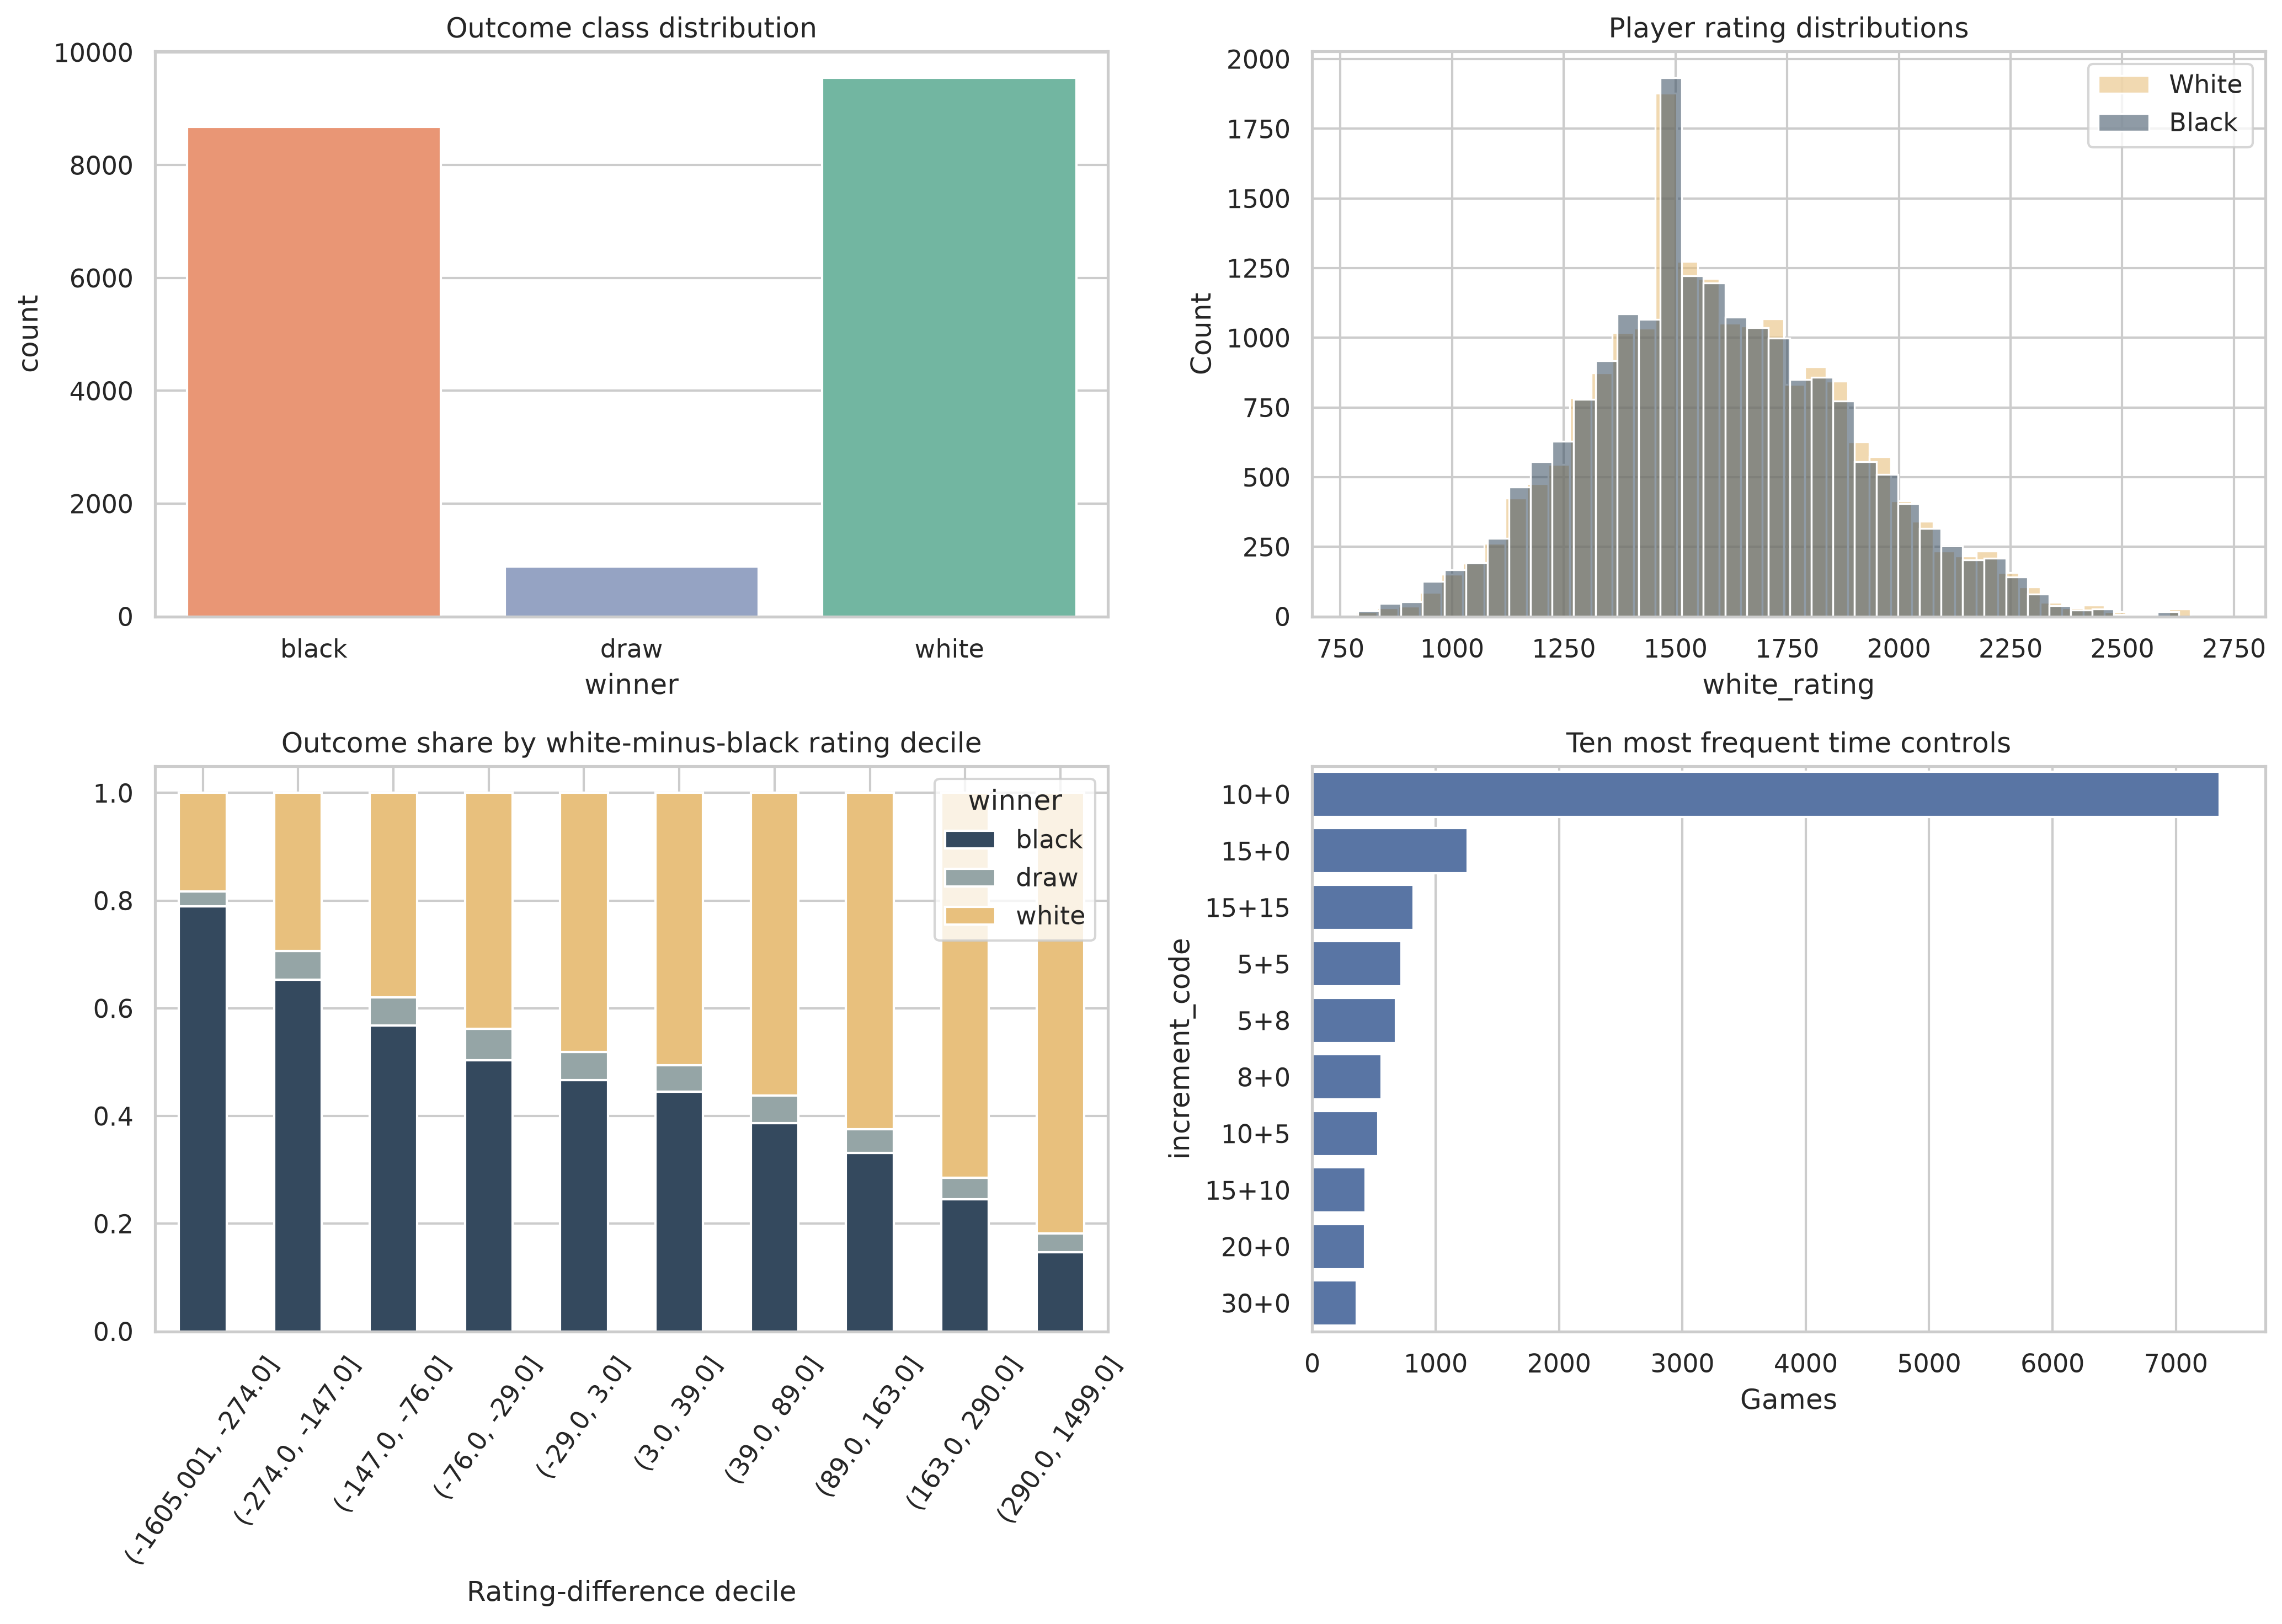
Figure 1. Outcome distribution, ratings, rating-difference outcome share, and common time controls.
Figure 1 shows that rating difference is informative but not decisive. White and Black rating distributions overlap strongly, which motivates updating the prediction from the observed board.

4. Feature Engineering

4.1 Pre-match Features
White and Black ratings, rated status, base minutes, and increment seconds are augmented with rating difference, mean, absolute gap, log base time, and an Elo-style White expectation. Difference represents directional advantage; mean captures the player pool; and gap represents mismatch. Player IDs are deliberately omitted to prevent memorisation.

4.2 Stockfish Features
Stockfish 19 analyses each snapshot with one thread and a fixed 1,000-node budget through python-chess [2,3]. All values are converted to White's perspective. Only four engine indicators are retained; search diagnostics and internal strategy terms are excluded.
Table 2. In-game features retained by design
Source | Feature | Interpretation / processing
Stockfish | score_cp | Centipawn score; missing when a forced mate score is returned
Stockfish | score_mate | Signed distance to mate; missing for ordinary centipawn positions
Stockfish | wdl_wins | White win count per 1,000 engine outcomes
Stockfish | wdl_draws | Draw count per 1,000 engine outcomes
Manual | ply | Number of half-moves observed
Manual | material_total | Total non-king material using 1/3/3/5/9 piece values
Manual | material_diff | White material minus Black material

For terminal boards where Stockfish does not emit WDL, the rule-defined terminal outcome supplies the corresponding WDL counts. The engine cache contains 146,111 unique positions and is keyed by game, ply, FEN, engine hash, and node budget. Deduplication and atomic replacement make cache generation idempotent.

4.3 Leakage-safe Progress Representation
Percentage progress is convenient for comparing games of different lengths, but it cannot be an input: calculating it requires the final number of plies, which is unknown at the current position and would leak future information. The models therefore use only ply, the number of half-moves already observed. After a test game is complete, percentage is used solely to select positions for the 10%, 25%, 50%, 75%, and 100% reporting curve. The percentage value is never supplied to a predictor.

4.4 Why These Features
The feature set is intentionally small. Stockfish supplies objective board strength, while ratings and time control describe human context. Ply and total material express game phase, and material difference provides an easily explained independent summary. This avoids a large collection of correlated engine internals and keeps feature importance interpretable.
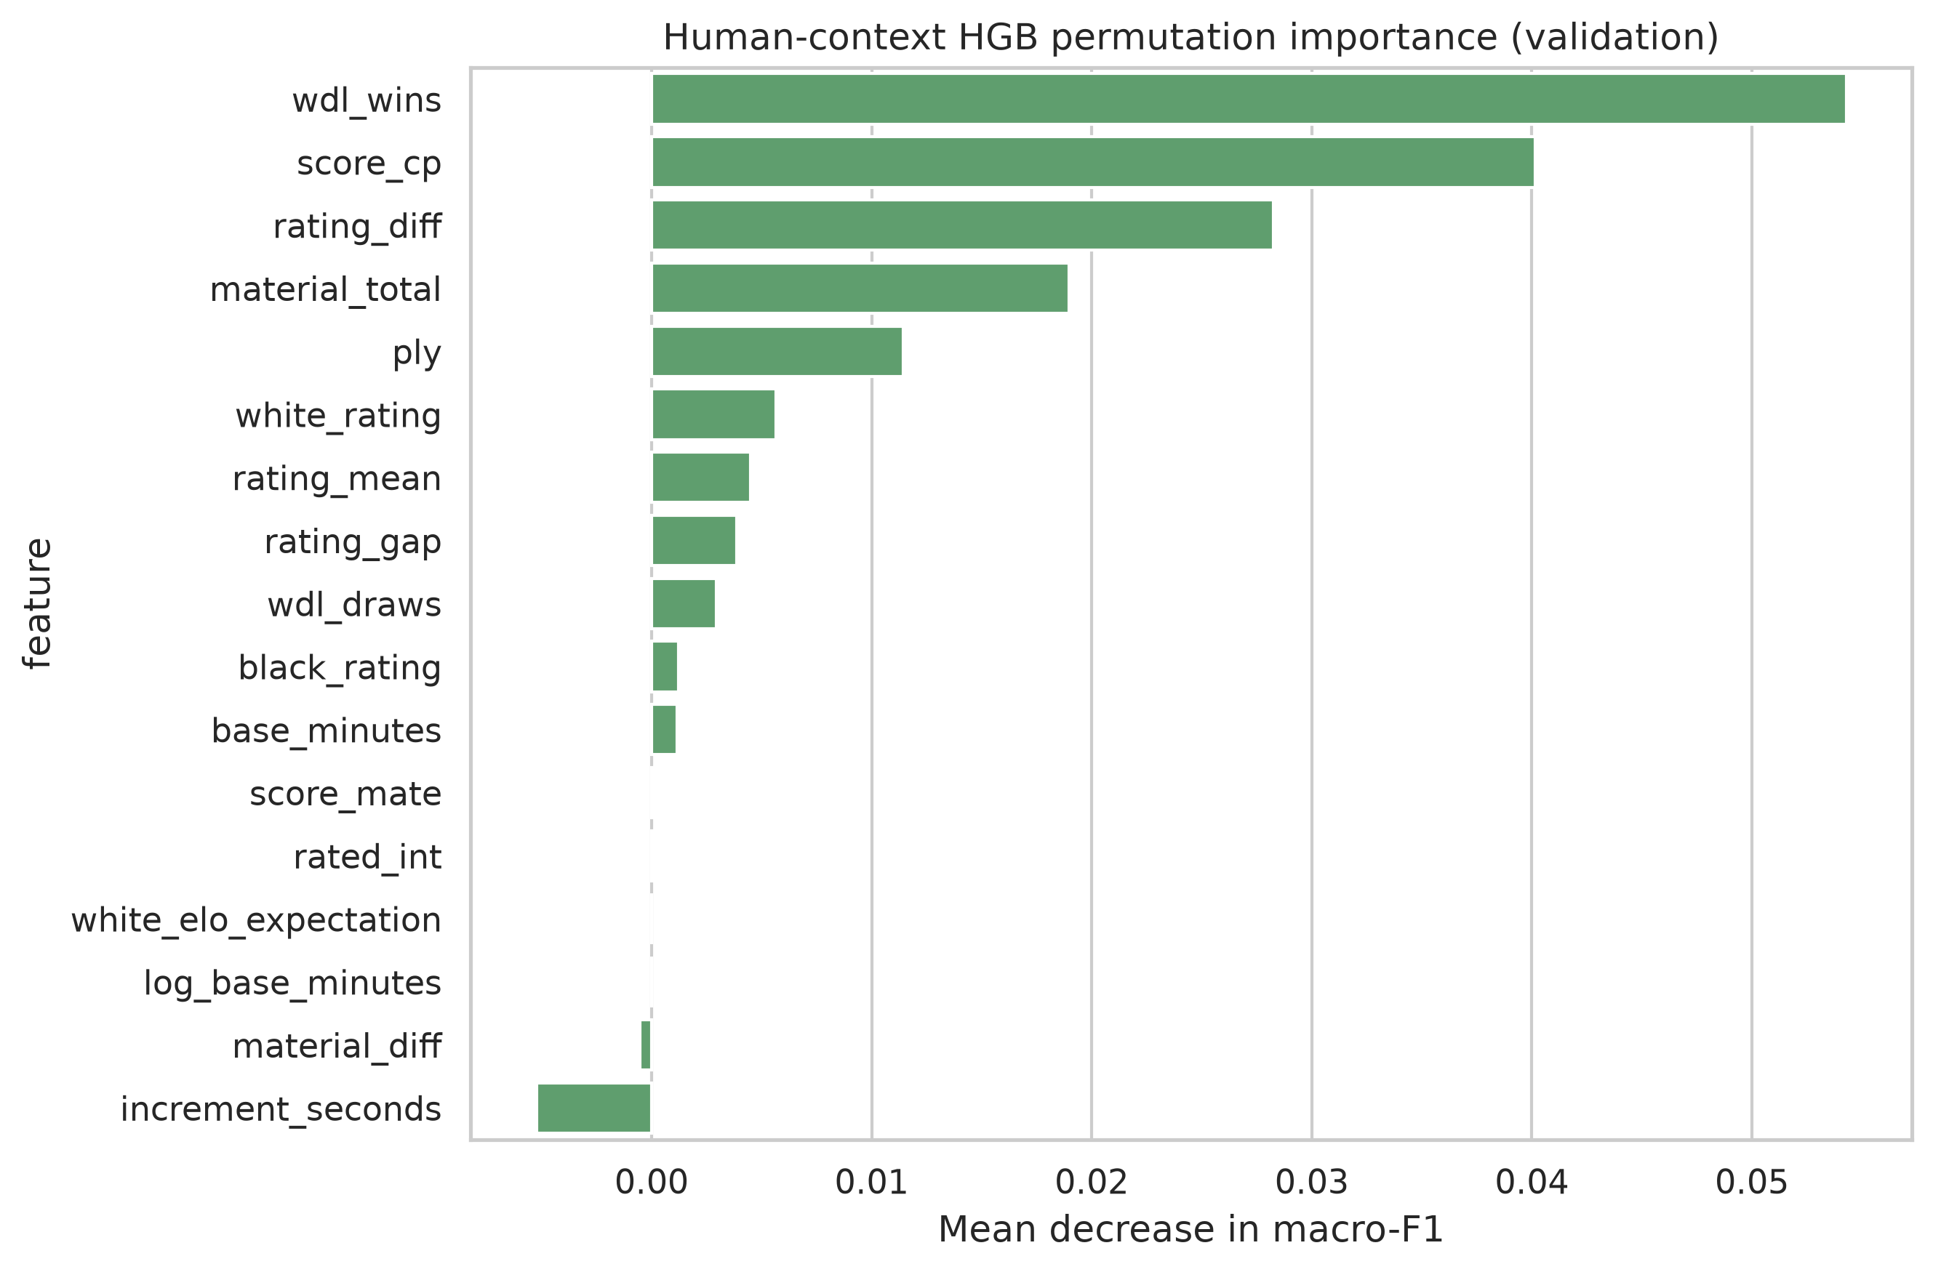
Figure 2. Permutation importance of the Human-context HGB (main).

5. Model Design

5.1 Direct Stockfish WDL
Stockfish returns White-win and draw counts per 1,000 outcomes; the implied Black-win count is 1,000 minus those two values. After normalisation, the largest probability is used directly. No game result is used to fit or calibrate this predictor. It therefore represents the pure strategy-engine view of the board.

5.2 Controlled Learned Models
Histogram gradient boosting learns nonlinear thresholds and interactions, accepts missing cp/mate values, and trains efficiently on 108,534 snapshots [4]. The position-only HGB uses the seven in-game features in Table 2. The final in-game model is also an HGB classifier, named Human-context HGB (main); it adds only the ten pre-match features. Both use learning rate 0.08, up to 240 iterations, 31 leaves, L2 regularisation, class- and game-balanced weights, and early stopping. HGB was selected because it handles nonlinear feature interactions, missing cp/mate values, and the tabular dataset efficiently. Holding the algorithm and position representation fixed isolates the contribution of context.
A separate Pre-match HGB supplies only the 0% estimate before any move exists. It is not the final in-game model and is never used after a board position becomes available.

5.3 Experimental Control
One ply is one half-move by either player. Each eligible training and validation game contributes a position after ply 4 and then plies 8, 16, 24, ..., 160; for example, ply 24 is the position after 12 full moves. Games shorter than a checkpoint simply contribute no snapshot there. Absolute ply sampling limits computation and, unlike percentage, does not require final game length.
The primary in-game comparison pools every available test snapshot selected at 10%, 25%, 50%, 75%, and 100%. Each snapshot is one observation, so the reported accuracy, macro-F1, and log loss measure overall performance across these positions. They are neither a single checkpoint nor an unweighted mean of five checkpoint scores. Checkpoint-specific metrics are reported separately. Validation uses the different fixed-ply pool and is not compared numerically with test results.
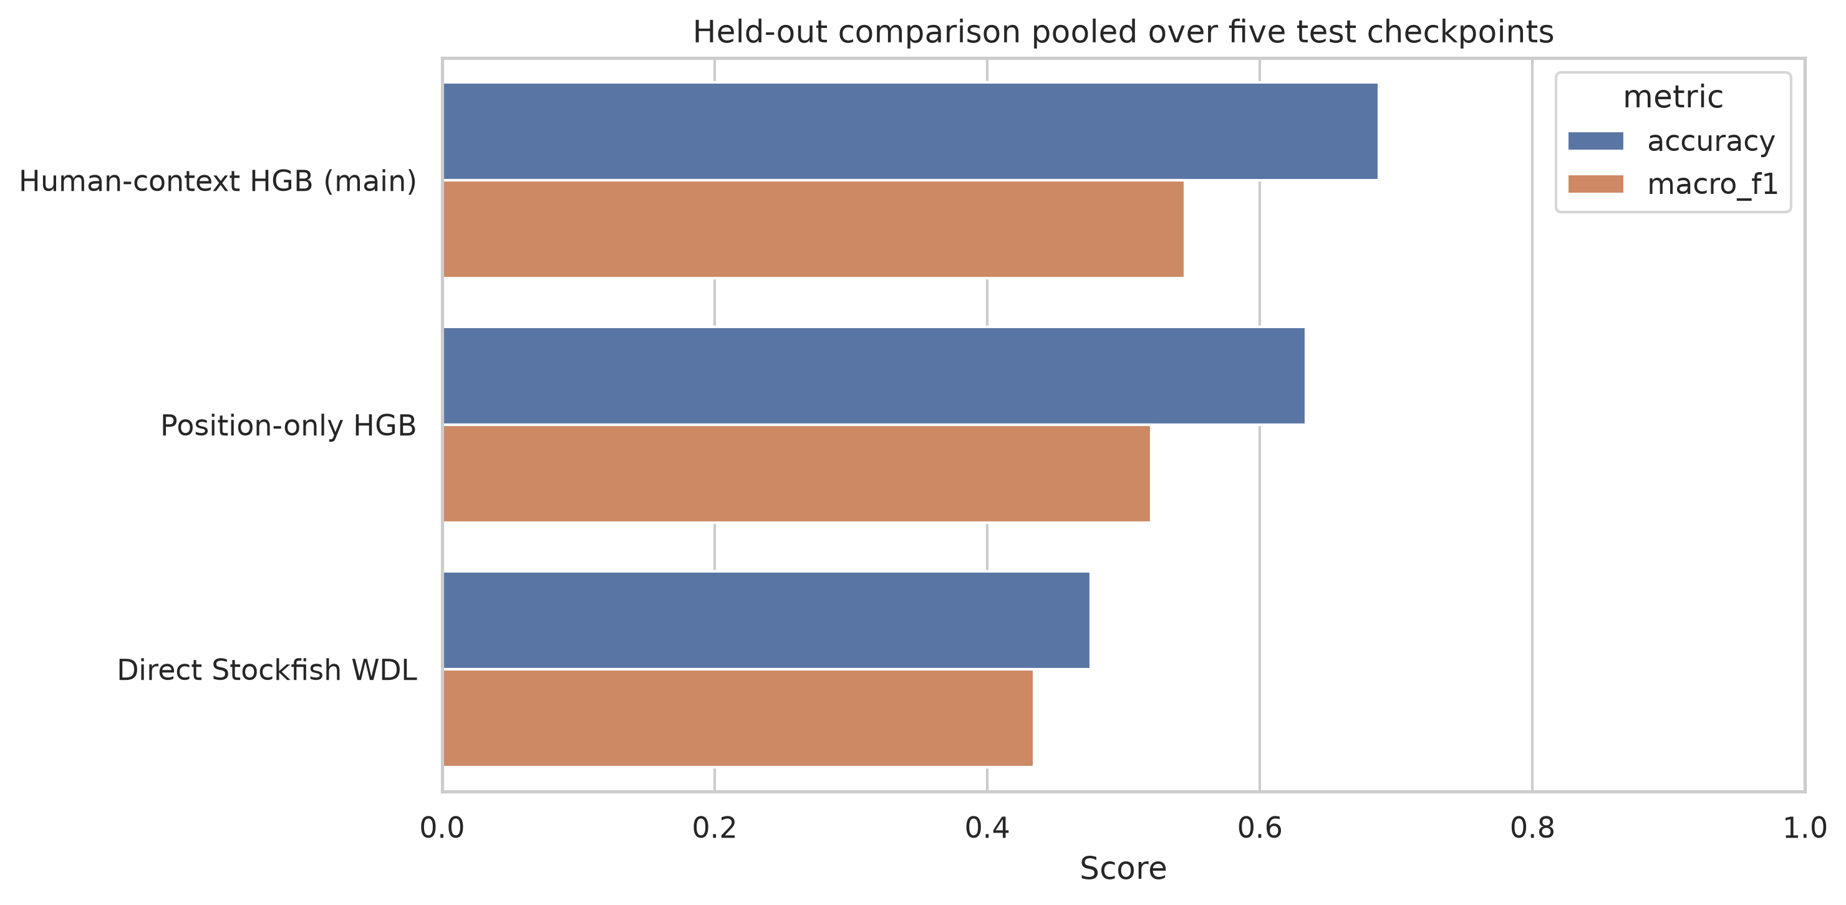
Figure 3. Validation and test comparison of the three prespecified predictors.

6. Results

6.1 Pre-match Baseline
Table 3a. Validation-only selection of the 0% pre-match model
Validation candidate | Accuracy | Macro-F1 | Log loss
Majority dummy | 0.499 | 0.222 | 0.848
Balanced logistic regression | 0.473 | 0.393 | 1.025
Pre-match HGB | 0.497 | 0.400 | 0.987

The dummy's accuracy reflects class imbalance, while its low macro-F1 reveals poor class coverage. Pre-match HGB is selected using validation macro-F1. Only after this choice is fixed is it evaluated on the held-out test games.
Table 3b. Held-out estimate for the selected 0% model only
Test model | Accuracy | Macro-F1 | Log loss
Pre-match HGB | 0.523 | 0.427 | 0.980

6.2 Controlled In-game Comparison
Table 4. Primary held-out comparison pooled over five test checkpoints
Test predictor | Accuracy | Macro-F1 | Log loss
Direct Stockfish WDL | 0.476 | 0.434 | 5.751
Position-only HGB | 0.634 | 0.520 | 0.853
Human-context HGB (main) | 0.687 | 0.545 | 0.714

Learning the mapping from position evidence to human results substantially outperforms direct engine WDL. More importantly, adding human context to the otherwise identical HGB raises test accuracy by 5.4 percentage points, macro-F1 by 2.5 points, and reduces log loss by 0.139. Figure 2 shows that WDL wins and cp remain dominant, while rating difference is also among the leading features. Objective position strength and player context therefore contribute complementary information.
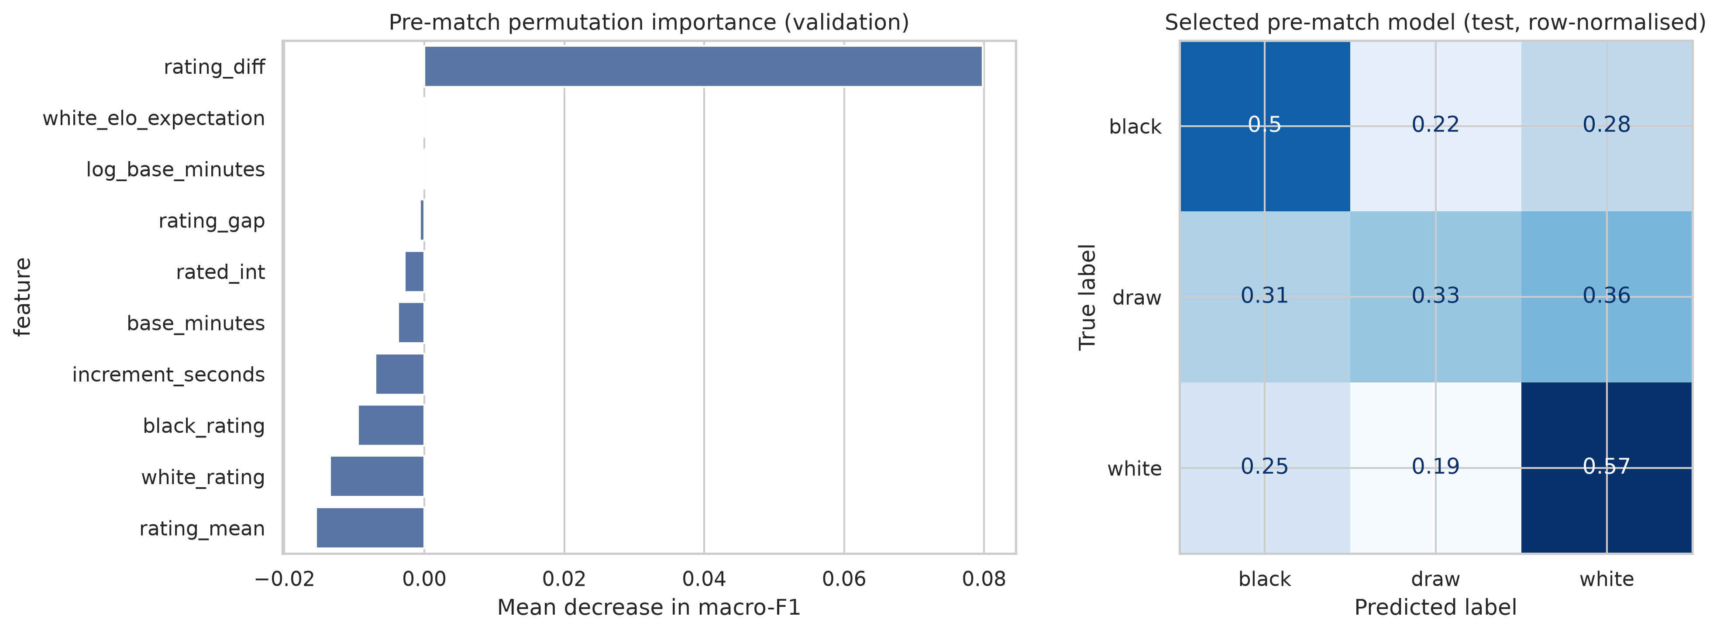
Figure 4. Pre-match HGB permutation importance and held-out test confusion matrix.

6.3 Progressive Test Performance
Table 5. Main-model performance over game progress
Progress | Accuracy | Macro-F1 | Evaluated games
0% (pre-match) | 0.523 | 0.427 | 2,867
10% | 0.584 | 0.435 | 2,803
25% | 0.588 | 0.450 | 2,830
50% | 0.649 | 0.498 | 2,849
75% | 0.714 | 0.570 | 2,830
100% | 0.899 | 0.779 | 2,867

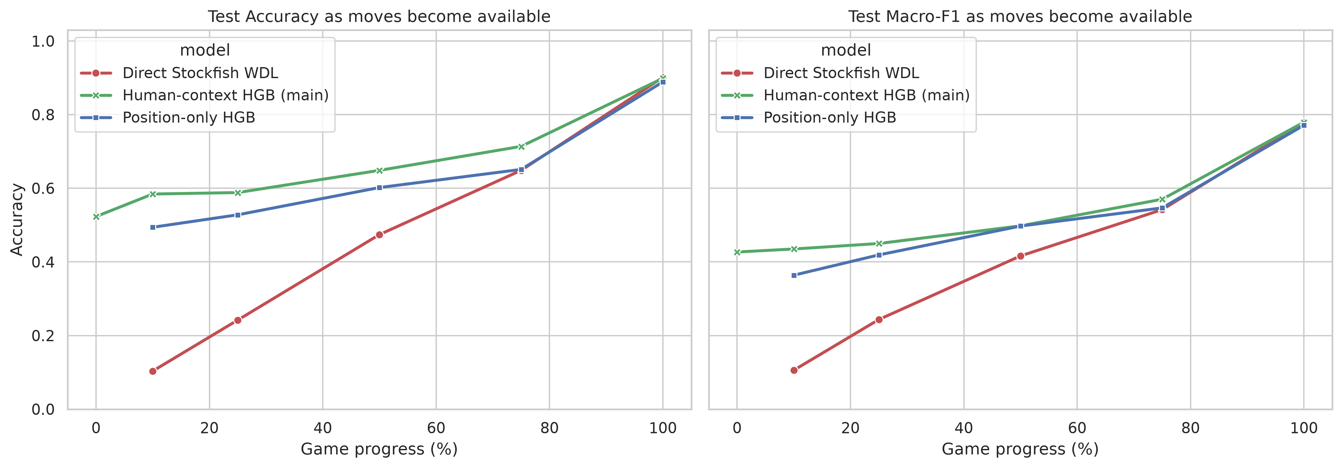
Figure 5. Held-out performance of all three predictors as moves become available.
The human-context model has the best normalised area under the 10–100% progress curve: 0.683 for accuracy and 0.541 for macro-F1, compared with 0.630/0.521 for the position-only HGB and 0.500/0.437 for direct WDL. Direct WDL performs particularly poorly early because balanced positions receive high engine draw probability, while only 4.6% of these human games are draws. At the final position it reaches 90.1% accuracy, showing that objective evidence eventually becomes decisive.
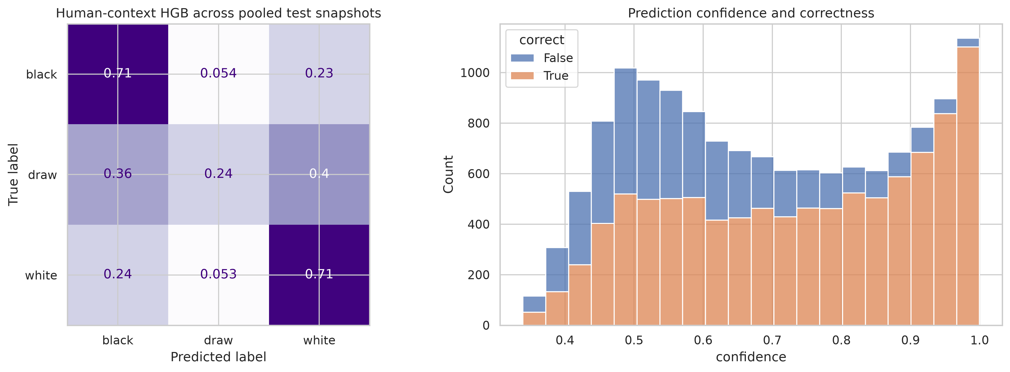
Figure 6. Human-context HGB confusion matrix and confidence across pooled test snapshots.
Across all in-game test snapshots, Black and White F1 scores are 0.708 and 0.722. Draw F1 remains lower at 0.206 because draws are rare and objective equality does not guarantee that human players will draw.

7. Discussion and Limitations
Direct WDL is not a weak chess evaluation: it answers a different question. It estimates outcomes under engine-calibrated play, where early balanced positions are often draws. The dataset instead contains short online human games with few draws. The learned position model adapts engine evidence to this outcome distribution, and the controlled context addition then captures which player is more likely to convert or resist the evaluated position.
The comparison is deliberately small: it avoids adding a second learned-model family whose performance would confound representation, optimisation, and context. The resulting ablation answers the research question directly and keeps every feature explainable.
- The 1,000-node Stockfish budget favours reproducibility and speed over maximum analysis strength.
- Stockfish WDL is based on engine play, not rating- and time-specific human behaviour.
- Per-move clocks are unavailable, which limits timeout prediction.
- Random game-level splitting does not measure temporal drift or fully unseen-player performance.
- Percentage checkpoints are retrospective reporting positions; deployed inference uses current ply.

8. Conclusion
The experiment shows that a strong strategy engine and a human-outcome predictor are not interchangeable. Direct Stockfish WDL is informative but mismatched to this human population, especially early in a game. Learning from the same position evidence improves the mapping, and adding pre-match context produces a further controlled gain of 5.4 accuracy points and 2.5 macro-F1 points. The main model rises from 52.3% accuracy before play to 89.9% at the final recorded position. A compact combination of objective board strength and human context is therefore the clearest and best-performing solution for this dataset.

9. Generative AI Use Declaration
OpenAI Codex was used to assist with structuring the analysis, drafting Python code, debugging, and language editing for the notebook, report, and README. The project authors reviewed and validated all generated content, methodological decisions, code execution, numerical results, references, and interpretations, and retain full responsibility for the submitted work. No generative-AI-produced observations, outcomes, or labels were added to the dataset.

References
[1] datasnaek. Chess Game Dataset (Lichess). Kaggle. https://www.kaggle.com/datasets/datasnaek/chess (accessed 26 October 2026).
[2] Niklas Fiekas. python-chess engine documentation. https://python-chess.readthedocs.io/en/latest/engine.html (accessed 26 October 2026).
[3] Stockfish developers. Stockfish 19 and Stockfish documentation. https://stockfishchess.org/download/ and https://official-stockfish.github.io/docs/ (accessed 26 October 2026).
[4] scikit-learn developers. HistGradientBoostingClassifier documentation. https://scikit-learn.org/stable/modules/generated/sklearn.ensemble.HistGradientBoostingClassifier.html (accessed 26 October 2026).

