Analyzing Stocks by Mining Twitter
MET CS 688
Paul J. Roche
Boston University

Table of Contents

Part 1: Mining Twitter for Stock Sentiment Analysis 1
Overview 1
a) Mining Data with the Twitter API 1
b) Creating Tweet Corpora 2
c) Preprocessing 3
d) Creating the Document-Term Matrix 4
e) Word Clouds 4
f) Sentiment Analysis 5
Discussion 7
Part 2: Extra Analysis & Stock Price Data 8
Overview 8
a) Stock Price Data for Top Losers 8
b) Stock Price Data for Top Gainers 8
c) Stock Price Data for Handpicked Stocks 9
d) Sentiment Analysis for Handpicked Stocks 13
e) Word Clouds 14
Discussion 15
References 16

Part 1: Mining Twitter for Stock Sentiment Analysis

Overview
In this project, I will perform web mining on the social media website Twitter. Twitter attempts to gather and present “what’s happening in the world and what people are talking about right now” ("About Twitter", 2018). Twitter data will be gathered using a Twitter API library named twitteR that is available for the R programming language. By using this social media platform as a data source, I hope to put my finger on the pulse of the community to gauge the social sentiment of individual stocks and ETFs (Exchange Traded Funds) that are publically traded. By performing text mining on all of the gathered Tweets, we will quantify a social sentiment score for these individual stocks, as well as groups of the top gainers and losers for a day of trading. In addition, we will track the largest publically traded S&P 500 index fund by market capitalization and repeat the same analysis in an effort to determine the overall sentiment of the market itself. We will chart these sentient scores alongside the price charts for the stocks in an effort to determine the correlation between social sentiment and stock price.

Mining Data with the Twitter API
The Twitter API is accessible via the twitteR library via CRAN in the R programming language. By installing this package and creating a Twitter developer account, one is able to obtain authentication keys to access Twitter data through the API. The API and access keys authenticate the user and enable us to search for tweets associated with each of the stocks of our choosing.

In an effort to determine the correlation between sentiment score and stock price, two sets of stocks have been picked from the top gainers and losers of the day. Three of these top gainers have the following ticker symbols: I, ARRY, and CRSP. Three of the top losers include the stocks: GWW, ACBFF, and CGC, which fell 11.95%, 7.45%, and 6.82% respectively. Only losers with small to medium market capitalizations over $1B and with trading volume over 1M were considered in order to focus on high quality stocks that might spark more of a public conversation.

In order to gather quality tweets that are focused on the subject matter of the stocks themselves, I opted to search using the $ symbol, which is often called a cashtag. This symbol is used in place of a hashtag and often used before a stock symbol to indicate that a stock is being referenced by the tweet. I chose to focus on cashtags only in this dataset because some of the ticket symbols such as “I” are ambiguous and might appear in many tweets that do not intend on referring to the Intelsat company or stock at all.

The following R code shows how the OAUTH keys were imported and the API calls were made to search for each applicable stock. The tweets were then merged into sets of 300 with 1-100 being the largest gainer, 101-200 being the second largest, and so on for both the top gainers and losers. The first tweets from each of the sets is compared from the original set of tweets to the merged replicate in order to show synchronicity.

R Code for Searching Twitter:

> # Set directory
> dir <- "C:/Users/pocke/OneDrive/Boston University/CS 688/Paul_Roche_Final_Project/"
> setwd(dir)
>
> # Import twitter API and access keys
> source("twitter_keys.r")
> #Setup authorization for API
> setup_twitter_oauth(t.api.key,t.api.secret,t.access.key,t.access.secret)
[1] "Using direct authentication"
>
> # Compile tweets from top gainers and losers
> #Top Losers
> gwwTweets<-searchTwitter('$GWW ',n=100,lang = 'en')
> acbffTweets<-searchTwitter('$ACBFF ',n=100,lang = 'en')
> cgcTweets<-searchTwitter('$CGC ',n=100,lang = 'en')
> #Combined Losers
> loserTweets<-c(gwwTweets,acbffTweets,cgcTweets)
> #Top Gainers
> iTweets<-searchTwitter('$I ',n=100,lang = 'en')
> arryTweets<-searchTwitter('$ARRY ',n=100,lang = 'en')
> crspTweets<-searchTwitter('$CRSP ',n=100,lang = 'en')
> #Combined Gainers
> gainerTweets<-c(iTweets,arryTweets,crspTweets)
>
> # Check first tweets
> #Gainers
> gwwTweets[[1]]
[1] "MareaInformativ: Northern Trust Corp Has $367.37 Million Position in W W Grainger Inc $GWW https://t.co/xZ9TvVMk8W"
> loserTweets[[1]]
[1] "MareaInformativ: Northern Trust Corp Has $367.37 Million Position in W W Grainger Inc $GWW https://t.co/xZ9TvVMk8W"
> acbffTweets[[1]]
[1] "PhillySpecialSB: RT @AlanWeedspan: $EHVVF nice volume today. Given the two-month downtrend to this point and bag holders, this is performing pretty much as…"
> loserTweets[[101]]
[1] "PhillySpecialSB: RT @AlanWeedspan: $EHVVF nice volume today. Given the two-month downtrend to this point and bag holders, this is performing pretty much as…"
> cgcTweets[[1]]
[1] "weedstreet420: HISTORY BEING MADE! The first legal gram was just sold in Newfoundland a few seconds ago by Bruce Linton himself… https://t.co/1q8RItqV9S"
> loserTweets[[201]]
[1] "weedstreet420: HISTORY BEING MADE! The first legal gram was just sold in Newfoundland a few seconds ago by Bruce Linton himself… https://t.co/1q8RItqV9S"
> #Losers
> iTweets[[1]]
[1] "optionjesus: RT @investitute: $I call buyers double their money \nhttps://t.co/pr3VRFGXT1"
> gainerTweets[[1]]
[1] "optionjesus: RT @investitute: $I call buyers double their money \nhttps://t.co/pr3VRFGXT1"
> arryTweets[[1]]
[1] "1MinuteStock: Not sure what to do with $ARRY? Explore our #fundamental pros and cons. https://t.co/Cj651YupMH"
> gainerTweets[[101]]
[1] "1MinuteStock: Not sure what to do with $ARRY? Explore our #fundamental pros and cons. https://t.co/Cj651YupMH"
> crspTweets[[1]]
[1] "OTSociety: Uridine Depletion and Chemical Modification Increase Cas9 mRNA Activity and Reduce Immunogenicity without HPLC Puri… https://t.co/BX4rudNo3D"
> gainerTweets[[201]]
[1] "OTSociety: Uridine Depletion and Chemical Modification Increase Cas9 mRNA Activity and Reduce Immunogenicity without HPLC Puri… https://t.co/BX4rudNo3D"

Creating Tweet Corpora
In order to create two separate data corpora, I created a simple yet powerful function that parses the tweets gathered from the Twitter API and outputs a corpus. This function includes a process to strip the username from the tweet text as well. Both sets of tweets are parsed through this function and two corpora are created by the R code below

R Code to Create Corpora:

> #Simple function that removes usernames and creates corpus for tweets
> createCorpus <- function (x) {Corpus(VectorSource(lapply(x, function(t) {t$getText()})))}
>
> # Eliminate usernames and text mine for each stock by using the createCorpus function
> data.corpus1<-createCorpus(loserTweets)
> data.corpus2<-createCorpus(gainerTweets)
>
> # Inspect each corpus
> inspect(data.corpus1[1])
<<SimpleCorpus>>
Metadata: corpus specific: 1, document level (indexed): 0
Content: documents: 1

[1] Northern Trust Corp Has $367.37 Million Position in W W Grainger Inc $GWW https://t.co/xZ9TvVMk8W
> inspect(data.corpus2[101])
<<SimpleCorpus>>
Metadata: corpus specific: 1, document level (indexed): 0
Content: documents: 1

[1] Not sure what to do with $ARRY? Explore our #fundamental pros and cons. https://t.co/Cj651YupMH
> data.corpus1 #Losers
<<SimpleCorpus>>
Metadata: corpus specific: 1, document level (indexed): 0
Content: documents: 300
> data.corpus2 #Gainers
<<SimpleCorpus>>
Metadata: corpus specific: 1, document level (indexed): 0
Content: documents: 300
>
> #Save corpus objects
> save(data.corpus1, file = "losersCorpuses.RData")
> save(data.corpus2, file = "gainersCorpuses.RData")

Preprocessing
To standardize the format and contents of each corpus, preprocessing must be performed. Many tweets contain links to websites and other web content. One process that is done to standardize the tweets is to remove URLs from them. Using a short find and replace function, we are able to remove most of the types of web addresses that would be often seen within tweets. Emojis and non-standard characters are often used within tweets. In order to remove these, we will use a conversion function to convert all text to UTF-8, which will help standardize the text. All characters are forced to be lowercase and all punctuation and stop words are removed. Stop words are common words that are often short like “the” or “be” that do not provide much insight into the sentiment or content of the text. The following code shows how all of these preprocessing steps are built into a function and then used to preprocess the tweet corpora data.

R Code for Preprocessing the Corpora:

> # Function that takes corpus and returns preprocessed corpus
> preprocessCorpus <- function (corpus) {
+ # Remove url from tweets
+ removeURL <- function (x) { gsub(" ?(f|ht)tp(s?)://(.*)", "", gsub(" ?(f|ht)tp(s?)://\\S+ ", "", x)) }
+ # Preprocessing
+ corpus <- tm_map(corpus,content_transformer(removeURL)) # Remove URLs
+ corpus <- tm_map(corpus,removePunctuation) # Remove Punctuation
+ corpus <- tm_map(corpus, content_transformer(tolower)) # Lowercase
+ corpus <- tm_map(corpus, removeWords, stopwords("english")) # Remove stopwords
+ corpus <- tm_map(corpus, function(x) iconv(enc2utf8(x), sub = "byte")) # Remove emojis
+ }
>
> # Perform preprocessing
> data.corpus1<-preprocessCorpus(data.corpus1)
> data.corpus2<-preprocessCorpus(data.corpus2)

Creating the Document-Term Matrix
A document-term matrix is an important data type in text mining. This is an essential element that is needed in order to create word clouds and perform sentiment score calculations. The R code for this is simple and can be seen below.

R Code for Document-Term Matrix:

> # Create term document matrix for two sets of data: top gainers and top losers
> # Create Document Term Matrix with word length >= 3 and >= 2 reps
> # Document term matrix
> dtm1 <- DocumentTermMatrix(data.corpus1, control=list(wordLengths=c(3,Inf), bounds=list(global=c(2,Inf)) ) )
> dtm2 <- DocumentTermMatrix(data.corpus2, control=list(wordLengths=c(3,Inf), bounds=list(global=c(2,Inf)) ) )

Word Clouds
Word clouds provide insight into the frequency and content of a large amount of text. In this case, the tweets for the largest daily stock gainers and losers are used to compile word cloud visualizations. We can see in the visualizations words such as cannabis and its synonyms seem to stand out next two the symbols for the top three losing stocks. For the gainers, the word cloud seems to contain many words that describe biopharma or biotech companies. This may be in part because the largest gainer CRISPR Therapeutics, is a biotech company itself. Overall, I find that word clouds are not only pleasing to the eye but contain valuable information about a text dataset.

Top Daily Losers:
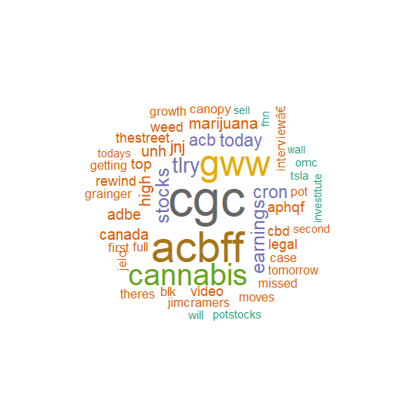
Top Daily Gainers:

R Code for Word Clouds:
> # Word Cloud
> wordcloud(names(losers.top), freq = unname(losers.top),colors=brewer.pal(8, "Dark2"),
+ random.order = FALSE)
> wordcloud(names(gainers.top), freq = unname(gainers.top),colors=brewer.pal(8, "Dark2"),
+ random.order = FALSE)

Sentiment Analysis
The sentiment of each tweet was determined and used to calculate a score for the overall sentiment of a set of text. This sentiment analysis was performed on the set of three top gaining stocks for the day as well as three top daily losing stocks, calculated by percent change between open and close. The sentiment score is calculated using a function that counts the number of positive and negative matches with a two different text lexicons that contain positive and negative words. The sum of negative matches is subtracted from the sum of positive matches in order to determine the score. Using this method, tweets with many negative words may outweigh tweets with only one positive word. This form of sentiment analysis may have some flaws, but it seems to be an accurate way of gleaning information from a large amount of text.

The sentiment analysis proves that the gainers had a high social sentiment score, while the losers had a negative social sentiment score. These finding support our expectations that negative tweets will be made during the time when a stock is plummeting and positive tweets will be made when a particular stock is soaring. This type of analysis shows a correlation between social sentiment and stock price, but it does not prove causation. It would be interesting to look deeper into the timelines of these tweets and stock movements to determine if social sentiment is a leading indicator of price.
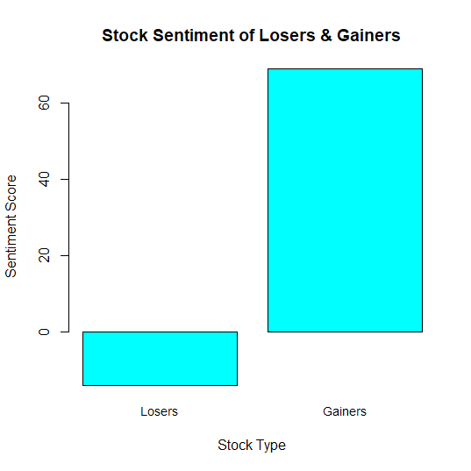
R Code for Sentiment Scores:

> # Calculate Sentiment Score:
> # Lexicons
> pos.words = scan('positive-words.txt',what='character',comment.char=';')
Error in file(file, "r") : cannot open the connection
In addition: Warning message:
In file(file, "r") :
cannot open file 'positive-words.txt': No such file or directory
> neg.words = scan('negative-words.txt', what='character', comment.char=';')
Error in file(file, "r") : cannot open the connection
In addition: Warning message:
In file(file, "r") :
cannot open file 'negative-words.txt': No such file or directory
> #### Sentiment Analysis
> #### Sentiment Analysis
> sentiment <- function(text, pos.words, neg.words) {
+ text <- gsub('[[:punct:]]', '', text)
+ text <- gsub('[[:cntrl:]]', '', text)
+ text <- gsub('\\d+', '', text)
+ text <- tolower(text)
+ # split the text into a vector of words
+ words <- strsplit(text, '\\s+')
+ words <- unlist(words)
+ # find which words are positive
+ pos.matches <- match(words, pos.words)
+ pos.matches <- !is.na(pos.matches)
+ # find which words are negative
+ neg.matches <- match(words, neg.words)
+ neg.matches <- !is.na(neg.matches)
+ # calculate the sentiment score
+ score <- sum(pos.matches) - sum(neg.matches)
+ # cat (" Positive: ", words[pos.matches], "\n")
+ # cat (" Negative: ", words[neg.matches], "\n")
+ return (score)
+ }
>
> losers.sent<-sentiment(lapply(loserTweets, function(t) {t$getText()}),pos.words,neg.words)
> gainers.sent<-sentiment(lapply(gainerTweets, function(t) {t$getText()}),pos.words,neg.words)
> barplot(c(losers.sent,gainers.sent), names.arg = c("Losers","Gainers"), xlab="Stock Type",
+ ylab="Sentiment Score",col="cyan",main="Stock Sentiment of Losers & Gainers",cex.names = 0.9)

Conclusion
Overall, I found Twitter mining to be a useful tool in determining social sentiment for a particular topic, including stocks. The word clouds that can be obtained from mining tweets give a good overview of the contents of a particular topic and enable you to put your finger on the pulse of the public. By combining and standardizing the text in hundreds of tweets, we are able to quiet the noise in the data. The words and text that shines through this noisy baseline has been proven to be relevant to the topic that is being searched. This can be a useful tool in the stock market, where any sort of edge on competition can translate into profits.

Part 2: Extra Analysis & Stock Price Data

Overview
As a bonus, I’ve gathered price information for the stocks from part 1 and plotted the charts for the top losers and gainers. In order to gather this price information and display it in candlestick graphs, I used a package called quantmod. This package is used to “specify, build, trade, and analyse quantitative financial trading strategies” (Ryan & Ulrich). By using this package to chart the previous two weeks of price data, you are able to see the volatility among many of these large gainers and losers. It appears that these stocks may be in the process of capitulating and this is why their prices are swinging back and forth so rapidly.

I’ve also hand-selected an extra six stocks as well as an ETF that tracks the S&P 500 index fund in order to perform a full analysis on a weeks worth of tweets and price data. These large capitalization stocks were not picked due to large swings in price. This additional data was gathered in an effort to explore how the price of ordinary stocks might also be correlated with social sentiment scores.

Stock Price Data for Top Losers
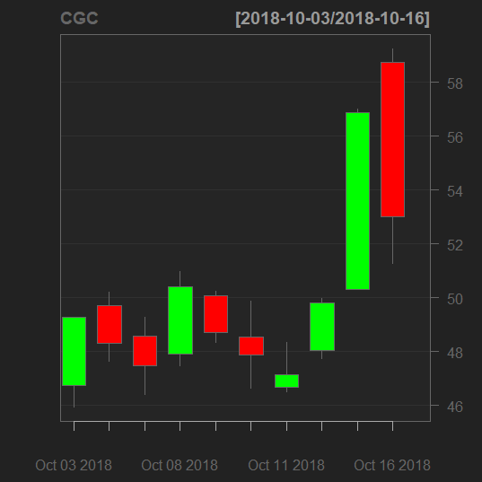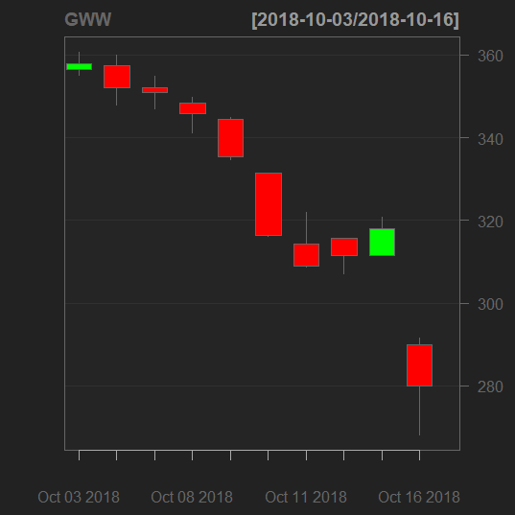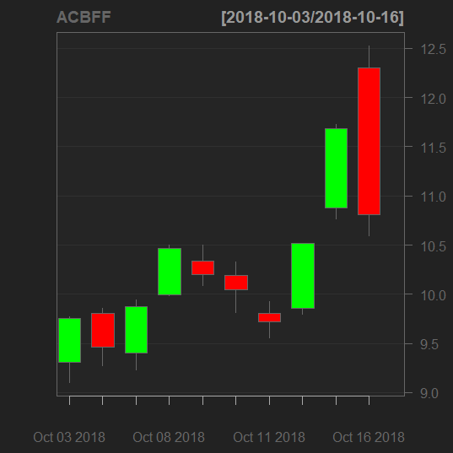

Stock Price Data for Top Gainers
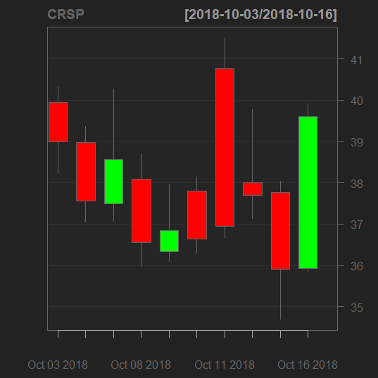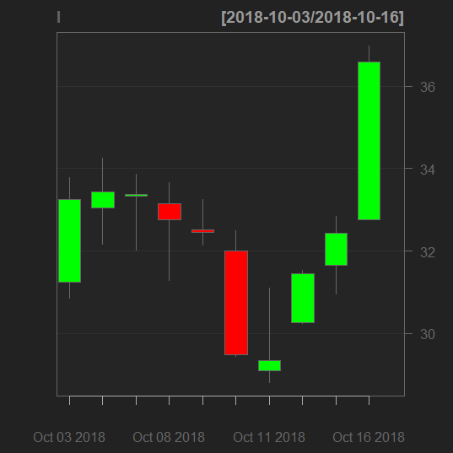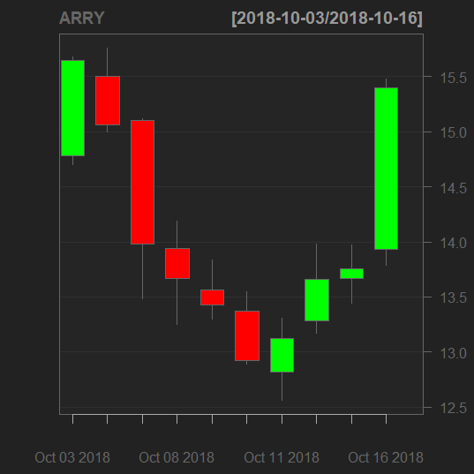

Stock Price Data for Handpicked Stocks
These stocks were selected to show the price movements during one week and how those movements might relate to a sentiment score that is also calculated using a full week of tweets from the same period. These charts should be viewed alongside the sentiment scores calculated in part D below.

> chartSeries(AAPL,type = "candlesticks",subset = '2018-10-08::2018-10-12',up.col = "green",dn.col = "red",TA=NULL)

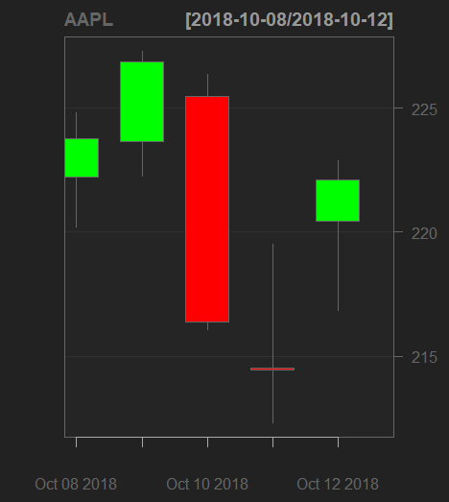

> chartSeries(GM,type = "candlesticks",subset = '2018-10-08::2018-10-12',
+ up.col = "green",dn.col = "red",TA=NULL)
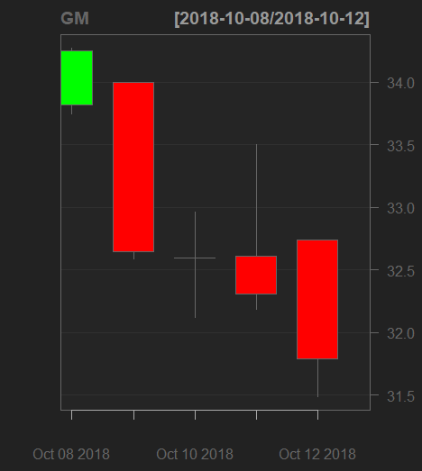

> chartSeries(GOOG,type = "candlesticks",subset = '2018-10-08::2018-10-12',
+ up.col = "green",dn.col = "red",TA=NULL)
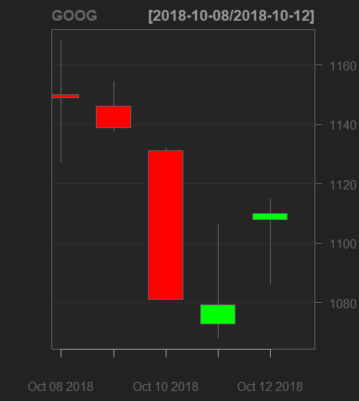

> chartSeries(JNJ,type = "candlesticks",subset = '2018-10-08::2018-10-12',
+ up.col = "green",dn.col = "red",TA=NULL)
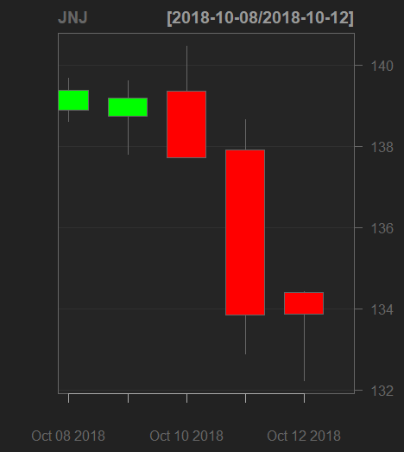

> chartSeries(CVIA,type = "candlesticks",subset = '2018-10-08::2018-10-12',
+ up.col = "green",dn.col = "red",TA=NULL)
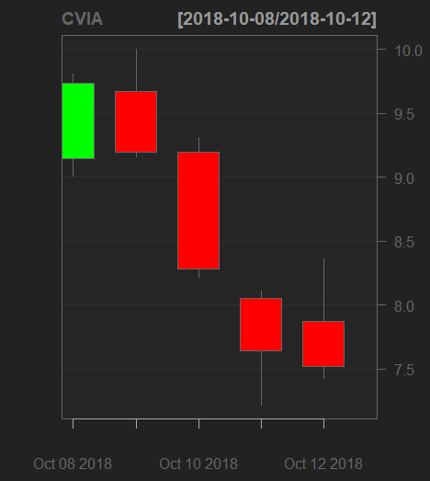
> chartSeries(AU,type = "candlesticks",subset = '2018-10-08::2018-10-12',
+ up.col = "green",dn.col = "red",TA=NULL)
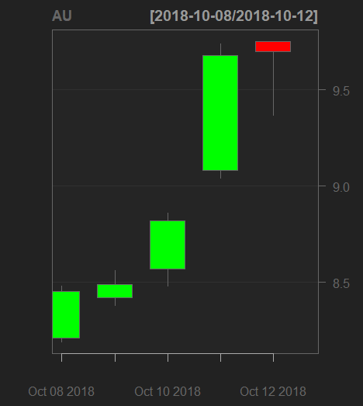

> chartSeries(SPY,type = "candlesticks",subset = '2018-10-08::2018-10-12',
+ up.col = "green",dn.col = "red",TA=NULL)

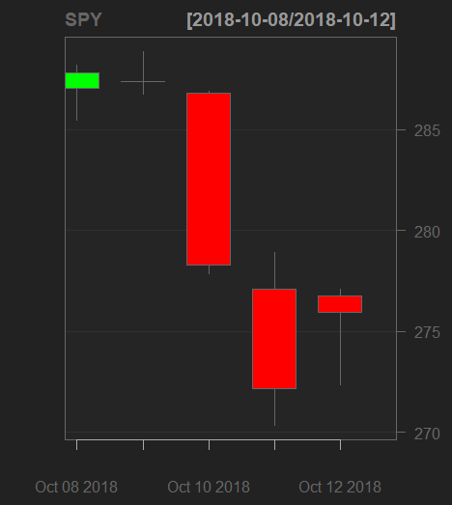

Stock Charting with googleVis
The googleVis package allows us to create charts that are interactive and can be viewed within a browser. The closing price data for each of the top gainers and losers is gathered and merged in order to create an all in one display for the user to explore the charts of these stocks over the past two weeks. This interactive chart helps to provide insight into how the price movements change from day to day. It is evident in these charts that there is plenty of volatility in stocks that end up on the daily movers and shakers lists.

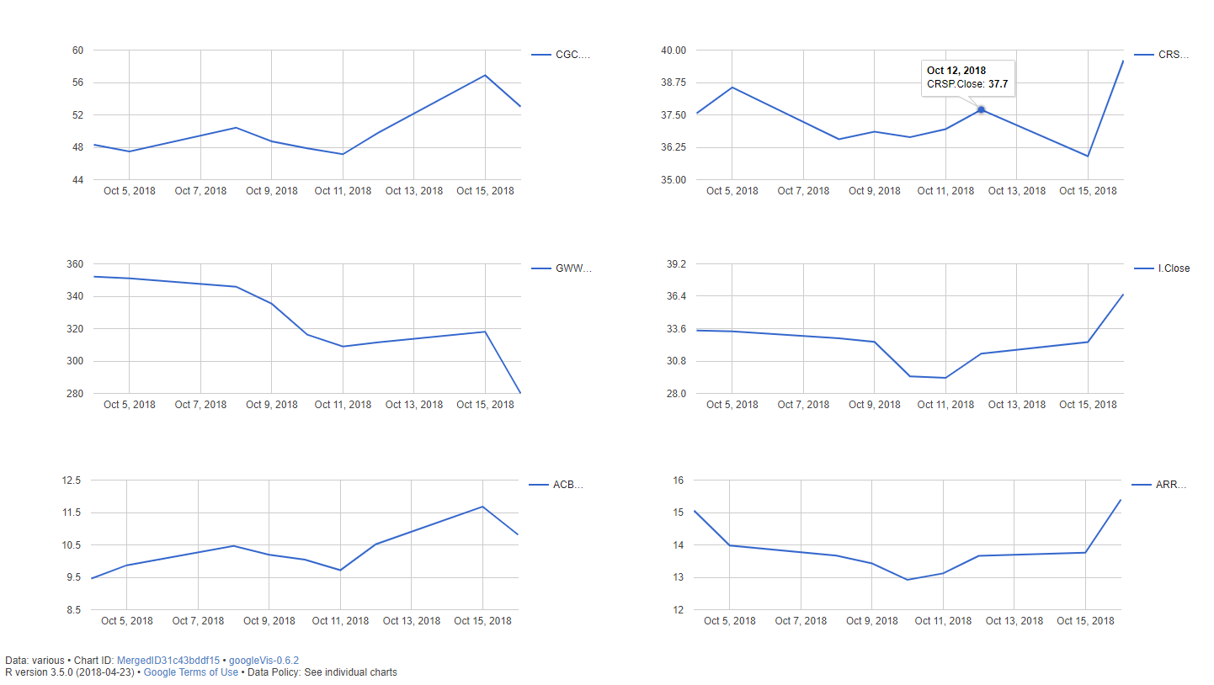

Sentiment Analysis for Handpicked Stocks
The following sentiment score is calculated from the number of positive and negative words within a weeks’ worth of tweets. The sentiment score shows that there were a large number of negative tweets about Google in the past week. This correlates with the stock chart shown above, which shows Google stock dropping almost 5% in a single trading day, without recovering much over the subsequent two days. This negative day of trading may have resulted in many negative tweets about the stock or the negative social sentiment may have caused the price movement. With the data here, it is impossible to say which of the two is actually the case.

> sentiment(aaplTweets.text,pos.words,neg.words)
[1] 99
> sentiment(gmTweets.text,pos.words,neg.words)
[1] 70
> sentiment(googlTweets.text,pos.words,neg.words)
[1] -159
> sentiment(jnjTweets.text,pos.words,neg.words)
[1] 75
> sentiment(cviaTweets.text,pos.words,neg.words)
[1] -2
> sentiment(auTweets.text,pos.words,neg.words)
[1] 151
> sentiment(spyTweets.text,pos.words,neg.words)
[1] 3

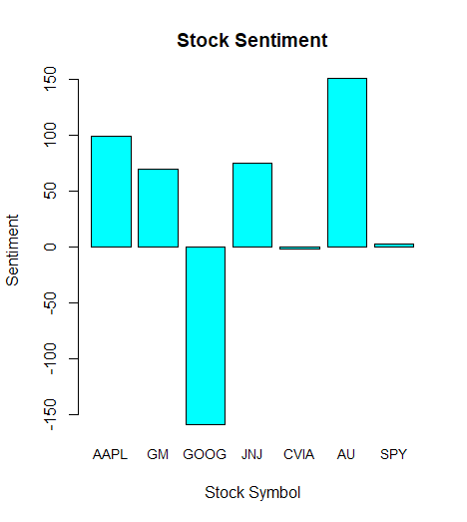

Word Clouds
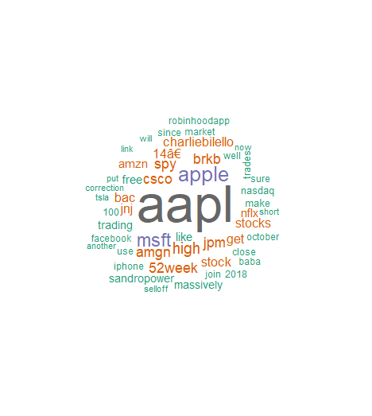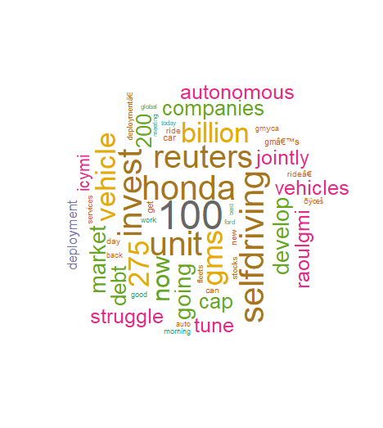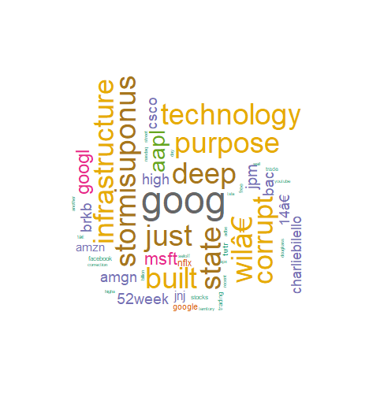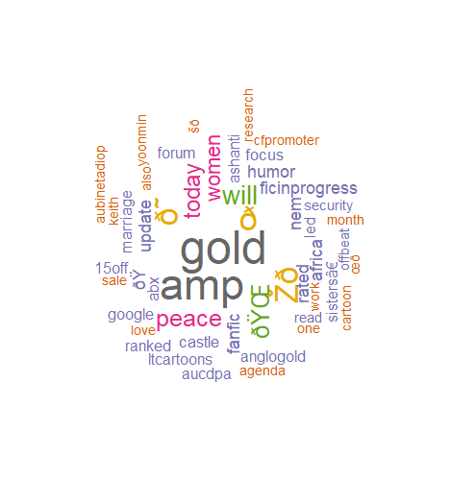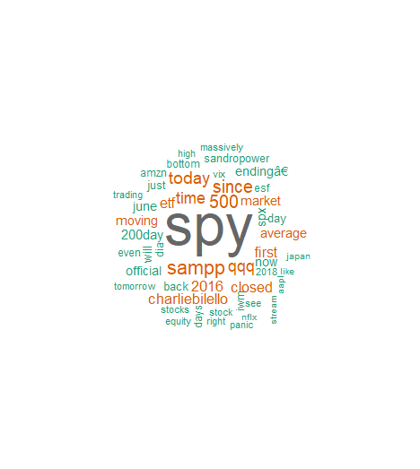

Conclusion
The most important ticker that I wanted to analyze in this project was SPY. This is because it is one of the most traded and largest capitalization ETFs in the market today. The word cloud for SPY appears quite normal and contains words that are both positive and negative. The social sentiment score reflects this, giving SPY a score of just 3, which is essentially flat, compared to some of the other highly positive and negative scores we have gathered. The S&P 500 index fund SPY fell considerably through this 5 day period. This shows me that sentiment scores are just part of a larger picture. Also, the sentiment scores do not have to be negative to indicate negative price movements.

The social sentiment scores of CVIA and AU were chosen because they were the largest losers and gainers over the entire 5 day period of trading. When examining the social sentiment scores, CVIA just barely had a negative sentiment, which is almost neutral. This is not quite what you would expect for a stock that is losing so much value. AU on the other hand, had a very positive sentiment score, which correlates with a large increase in stock price.

Based upon the data gathered in this project, I believe that social sentiment scores and price are partially correlated in some way. It appears that most of the time a positive or low/negative sentiment score appears on social media, the stock price associated with those tweets seem to move in the same direction. By using social sentiment analysis along with other trading strategies, one might be able to find an edge or at least some footing to stand on when making stock trades. It seems obvious that by using R and the Twitter API, it may be possible to build a model that aids in market analysis, whether or not social sentiment turns out to be a leading indicator to stock price.

References

Ryan, J. A. (n.d.). Quantitative Financial Modelling & Trading Framework for R. Retrieved from
http://www.quantmod.com/examples/intro/

Ryan, J. A., & Ulrich, J. M. (n.d.). Quantitative Financial Modelling Framework [R package quantmod
version 0.4-13]. Retrieved from https://cran.r-project.org/web/packages/quantmod/index.html

About Twitter. (n.d.). Retrieved October 16, 2018, from https://about.twitter.com/en_us.html

Working with data in a data frame. (n.d.). Retrieved from
https://monashbioinformaticsplatform.github.io/r-intro/data_frames.html

