Lab 3 Exercise 1
Implement a C concurrent program that generates a process tree of height n. Each process at the odd level of the tree (1, 3, 5, etc.) must generate 1 process, and terminate. Each process at an even level of the tree (2, 4, 6, etc.) must generate two processes, and terminate.
Therefore, the initial process (at level 1) must generate a single process, which is at level 2 must generate 2 processes. Each of these two processes generated (at level 3) must generate one process, and so on so forth. The processes on the last level of the tree (the leaves) must print their PID.
The program receives the value of n from the command line. Example with n=5
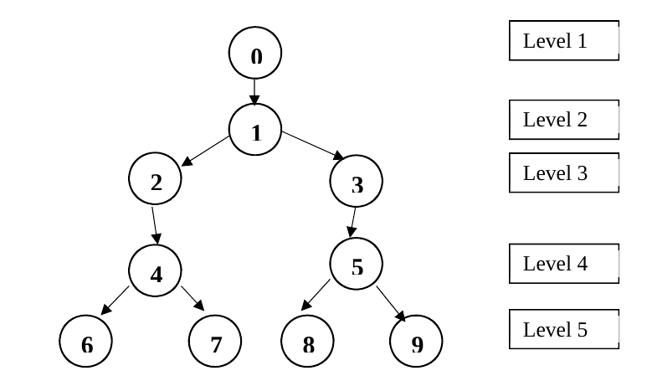
> process_tree 5
Process 2204
Process 2206
Process 2208
Process 2211

