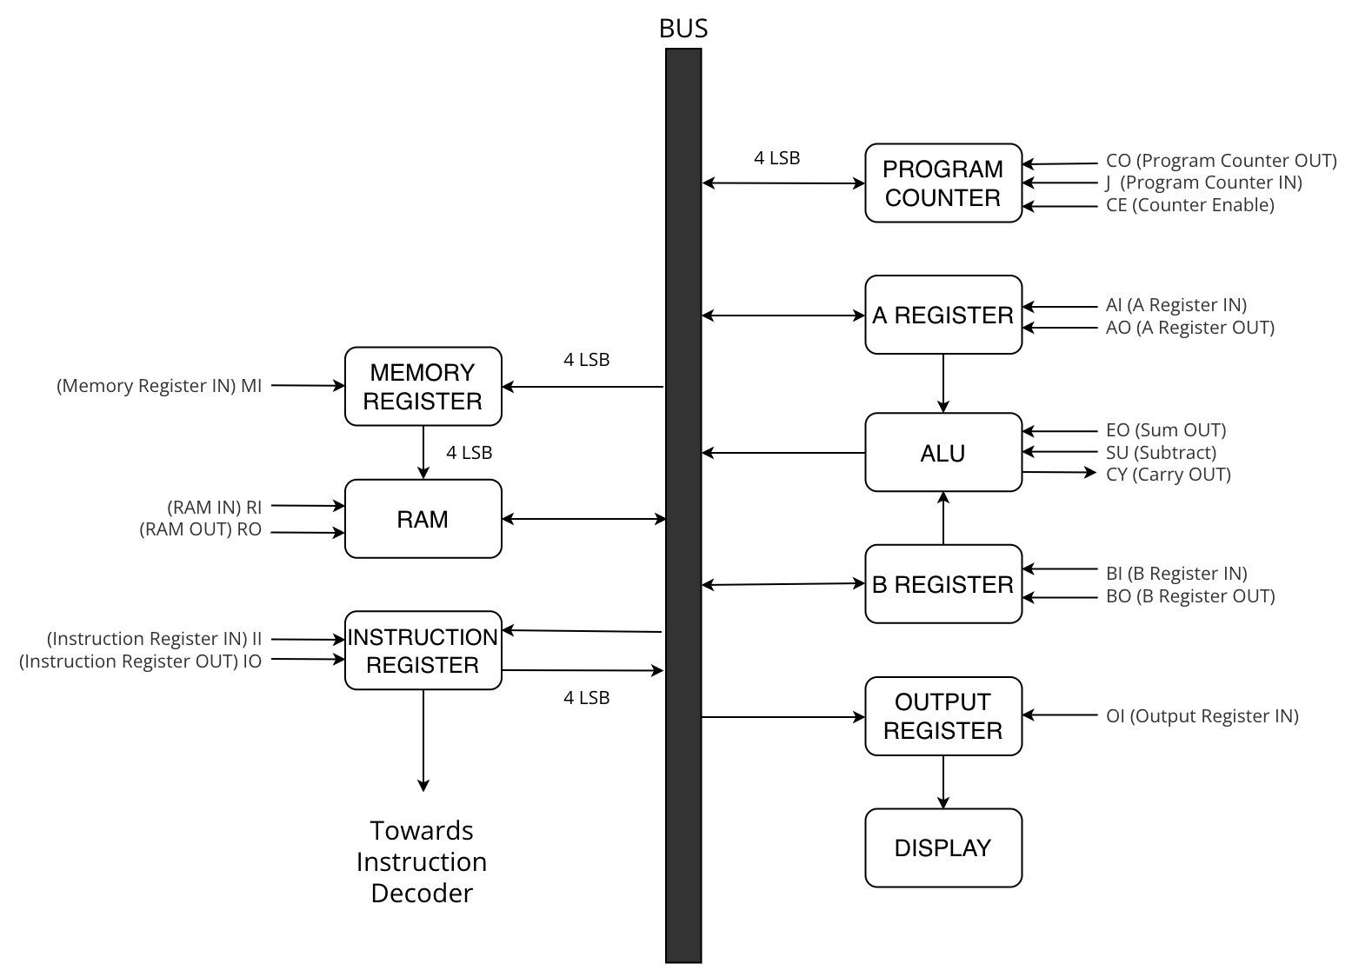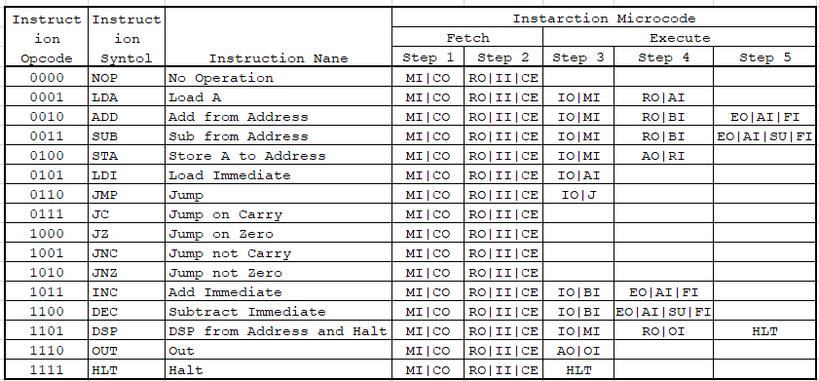

|  |  |
| --- | --- |
| HLT | Halt clock |
| MI | Memory address register in |
| RI | RAM data in |
| RO | RAM data out |
| IO | Instruction register out |
| II | Instruction register in |
| AI | A register in |
| AO | A register out |
| EO | ALU out |
| SU | ALU subtract |
| BI | B register in |
| OI | Output register in |
| CE | Program counter enable |
| CO | Program counter out |
| J | Jump (program counter in) |
| FI | Flags in |