Job poster Web app

* First of all pull the git repo from the given link
* Install node modules and python dependencies for react and fast api
* I made two routes in the backend which were not present in the design one was the keep track record of job and other was see workers.
* Click on the + button

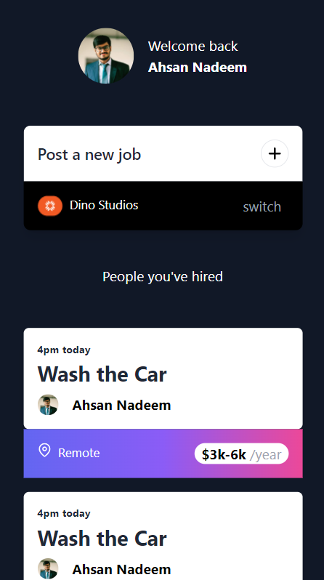

There will be two options

If you want to schedule a job for later click on schedule otherwise on post when you post or schedule job from here they will be saved in the mongoDB and will appear on the service worker tab:

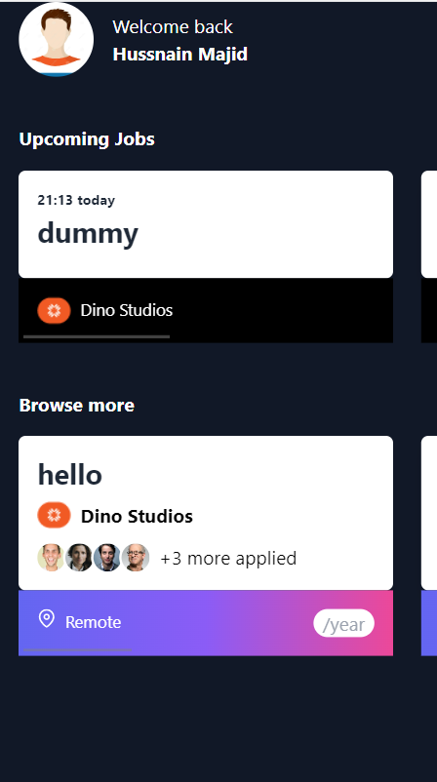

Scheduled jobs will appear above And post jobs will appear below.The design is responsive as per demand. There are two routes in react

**/: Job poster**

**/serviceworker: Service worker**

