PVS Roadmap Planner
FR10 — National PVS Roadmap
Design Review, Ideal Reference Screens & Developer Handoff

Prepared for: Development Team
Date: 2026-08-04
Source: mockups-pink-eight.vercel.app
Ideal Screens: 7 included (Screens 1, 2, 8, 9, 10, 11 + budget correction)
Status: Review — Action Required

Table of Contents

Executive Summary
This document reviews the 7 mockup screens for the FR10 National PVS Roadmap feature and provides corrected ideal reference screens for the developer to duplicate. It identifies critical gaps, provides severity-rated issue tables, and includes 6 ideal screen mockups embedded as images with accompanying HTML files for interactive reference.
Budget correction: The original mockups show per-activity dollar amounts ($150K, $180K) on every card. FR10 does not ask for this. Per-mission budgets are operational detail belonging to the Mission Workflow. Budget projections in FR10 are programme-level analytics only (annual totals, breakdowns by mission type, cohort projections). Individual activity cards should NOT show dollar amounts. Budget data belongs exclusively in the executive summary panel and cohort analytics, derived from historical averages by mission type.
Quarterly → Annual: The 20-column quarterly grid must change to a 5-column annual grid. FR10 says "five-year activity roadmap" with "annual budgets" — the planning unit is the year. This eliminates triple-sticky CSS issues, simplifies drag-snap, and makes mobile trivial.

Screen 1 — Timeline Layout

Issues
# | Issue | Severity
1 | 20-column quarterly grid contradicts FR10's annual planning model | Critical
2 | Per-activity budget amounts on timeline bars have no basis in FR10 | Critical
3 | No scroll affordance — no gradient, shadow, or scrollbar hint | Critical
4 | Legend bar mixes structural elements with filterable mission types | Major
5 | Breadcrumb and header duplicate country, region, date range | Major
6 | Zoom controls show no current percentage | Major
7 | No confidence degradation visual for Year 4–5 vs Year 1 | Major
8 | Budget heatmap has no numeric labels | Major
9 | "Interactive" label is meaningless | Minor

Ideal Screen 1 — Annual Timeline (No Per-Activity Budget)
5 annual columns. Budget shown only in the summary panel as programme-level totals by year. Activity cards show mission type, name, target year, source, and status — no dollar amount.
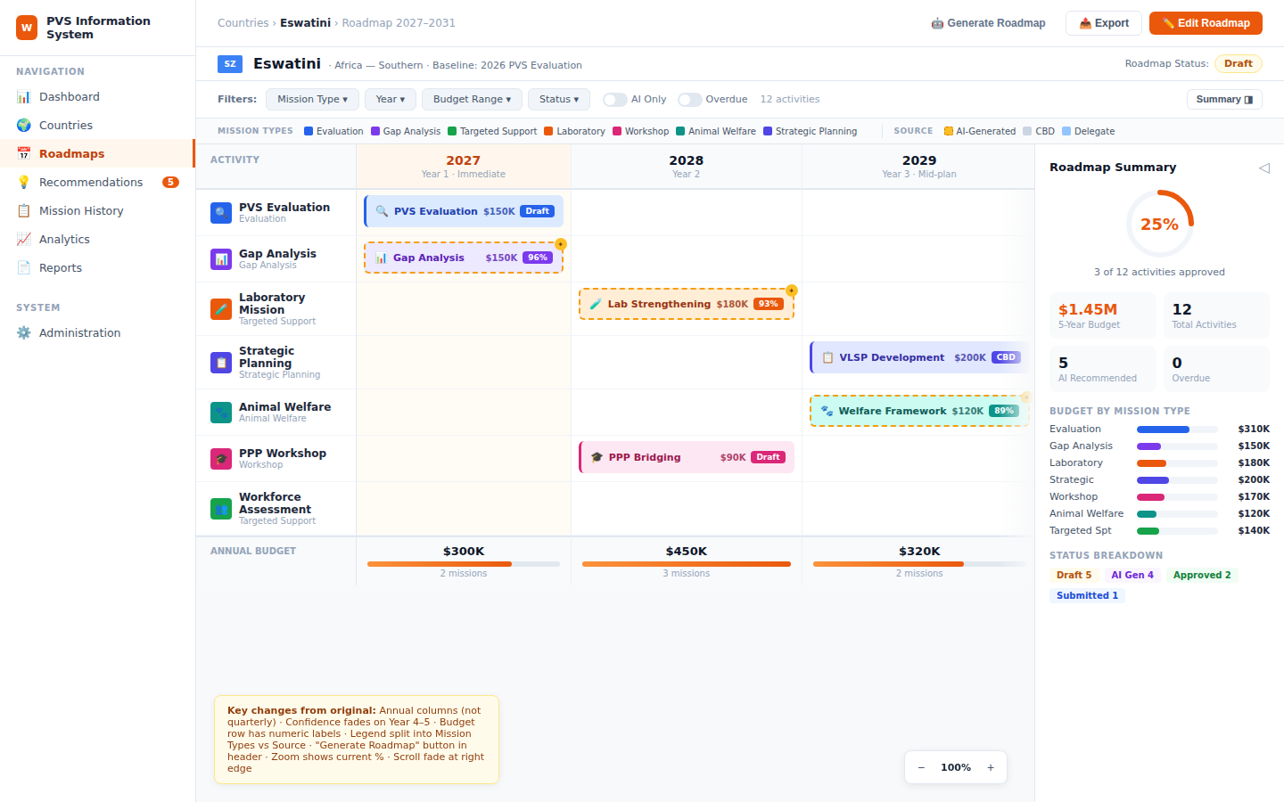
Ideal Screen 1 — Annual timeline with programme-level budget in summary panel, no per-activity dollar amounts

Screen 2 — Activity Cards

Issues
# | Issue | Severity
1 | Per-activity budget ($150K, $180K) on every card — FR10 doesn't require this and it's fabricated precision | Critical
2 | Standard and AI cards have wildly different heights — ragged rows in grid | Major
3 | "Drag to reposition" is a permanent label, not a hover tooltip | Minor
4 | Delete in overflow menu uses same colour as non-destructive actions | Major
5 | Emoji for source attribution renders inconsistently across platforms | Major
6 | Inline bars shown at one width only — no truncation behaviour demonstrated | Major

Ideal Screen 2 — Cards Without Budget
Cards show mission type, name, target year, duration, source, and status. No dollar amount. AI rationale is collapsible to maintain consistent card height. SVG icons replace emoji. Delete action separated in red. Inline bars at 3 widths.
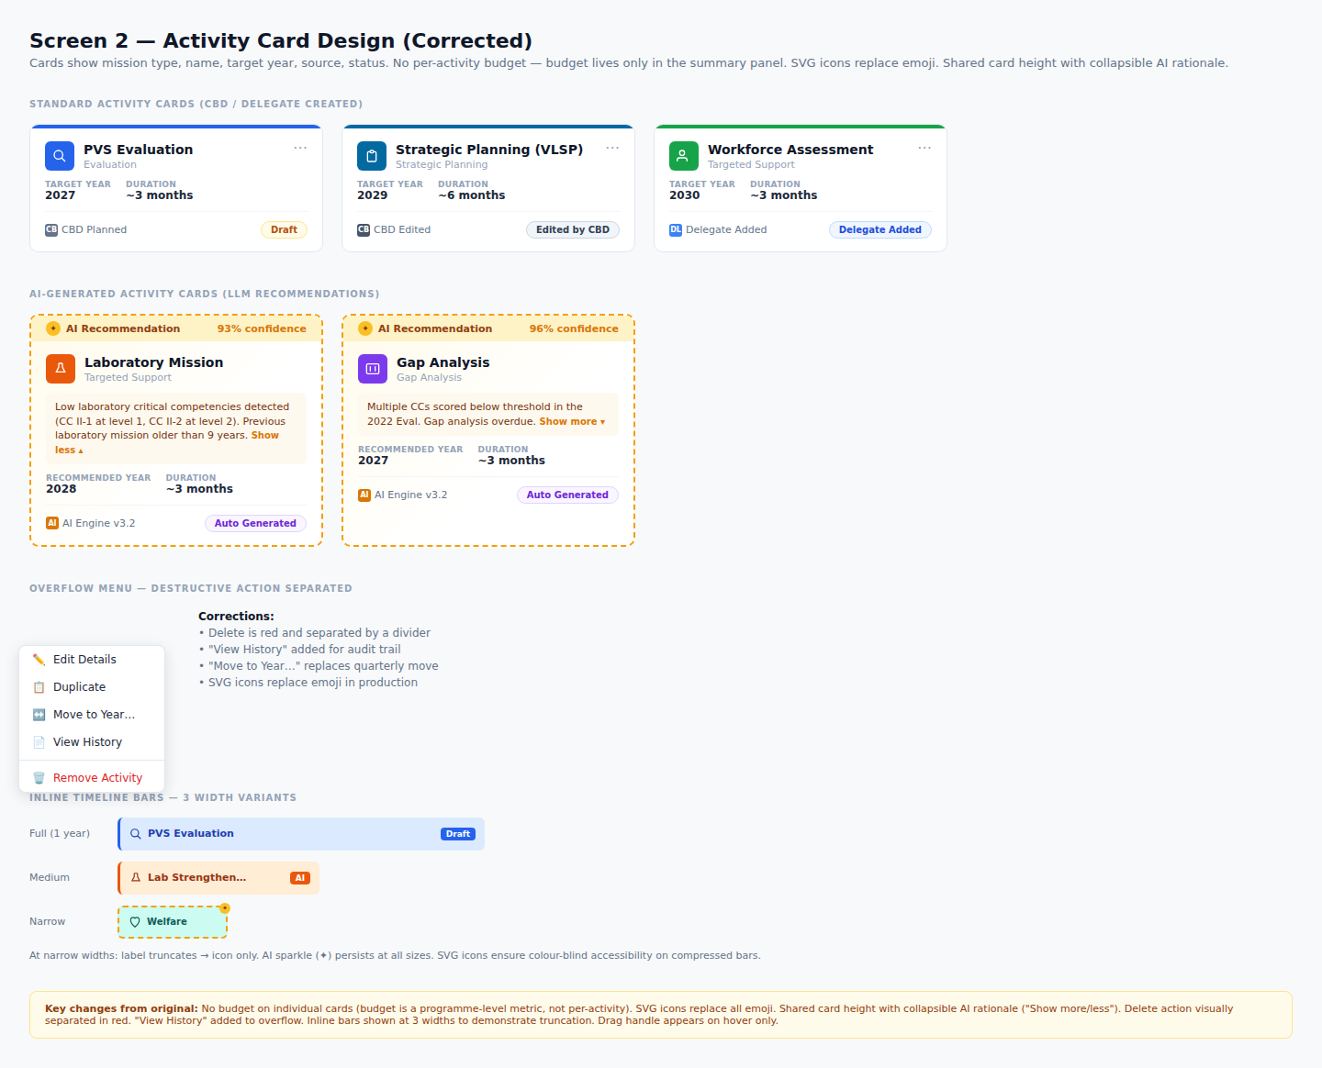
Ideal Screen 2 — Activity cards with no per-activity budget, SVG icons, collapsible AI rationale, 3-width inline bars

Screens 3–7 — Text Reviews

Screen 3 — Colour Coding
- Critical: Evaluation blue (#2563EB) and Strategic Planning indigo (#4F46E5) are too close — replace indigo with #0369A1 (dark cyan).
- Critical: Colours shown as isolated squares, never in context on a populated timeline row.
- Major: No colour-blind simulation panel (Protanopia, Deuteranopia).
- Major: Source abbreviations (CB, DL, AI) inconsistent with card labels (CBD Planned, Delegate).

Screen 4 — Status Badges
- Major: 9 statuses is heavy — consider collapsing Draft and Edited by CBD for the Delegate view.
- Major: Auto Generated and Draft pastel backgrounds nearly indistinguishable at Small badge size.
- Major: Cancelled strikethrough illegible at 10px in Small pill.
- Minor: Step numbering implies linear flow but Overdue/Cancelled branch from any status.

Screen 5 — Executive Summary
- Critical: Shown full-width but in production it's a 280px sidebar — every spatial relationship is wrong.
- Critical: "25% Progress" ring misleads — approval ≠ execution.
- Major: Cohort widget (Countries Due to Request) embedded in a single-country panel — scope leak.
- Major: Budget should show programme-level totals derived from historical averages by mission type, not summed from per-activity amounts that don't exist in FR10.

Screen 6 — Filters & Export
- Critical: Quarter filter must be removed (annual model).
- Critical: Approved toggle conflicts with Status dropdown — ambiguous compound state.
- Major: Filtered result shows detached cards, not the actual timeline with filter applied.
- Major: Budget range slider filters per-activity amount that shouldn't exist on cards.

Screen 7 — Edit Flow
- Critical: Presented as 5 documentation sections, not one composed editing screen.
- Critical: Approve/Reject (Delegate) and Save/Cancel (CBD) in the same button group — role confusion.
- Major: Drawer takes ~60% of viewport, obscuring the timeline.
- Major: No confirmation dialogs for Delete or Reject.

Missing Screens — Ideal References

Screen 8 — Generate Roadmap Flow (NEW)
The most critical missing screen. FR10's defining feature is LLM auto-generation. Shows three states: Empty/Trigger with "Generate Roadmap with AI" CTA, step-by-step loading with progress indicators, and generation result preview with activity list and confidence scores before landing on the timeline.
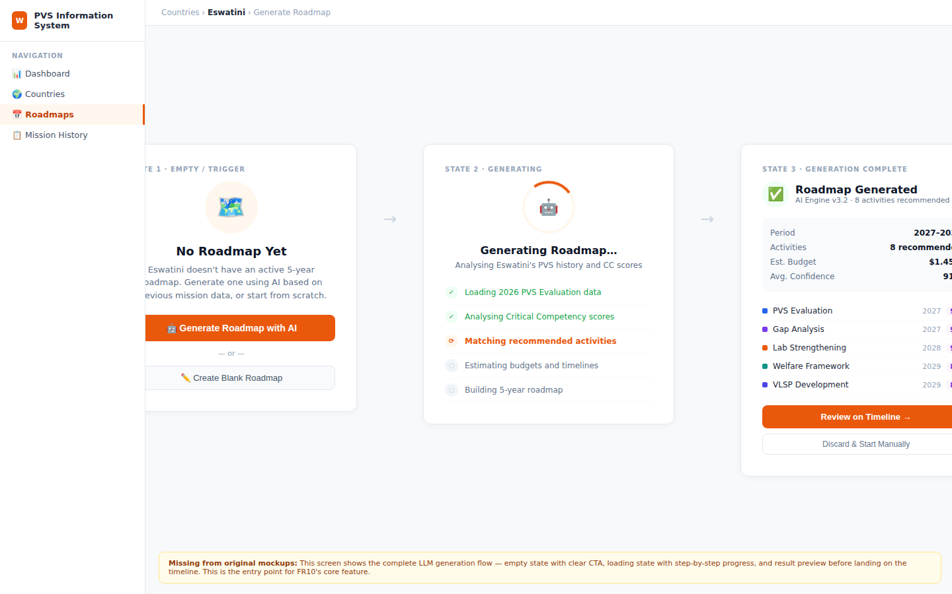
Ideal Screen 8 — LLM generation flow: empty state → step-by-step loading → result preview with "Review on Timeline" CTA

Screen 9 — Whole-Roadmap Approval Flow (NEW)
FR10's core governance flow. CBD submits the entire roadmap (not card-by-card). Delegate receives a review screen with a diff panel showing what changed since the last version, a read-only timeline preview, and Approve/Reject with mandatory comments on rejection. Approved state locks the roadmap with a next-review date.
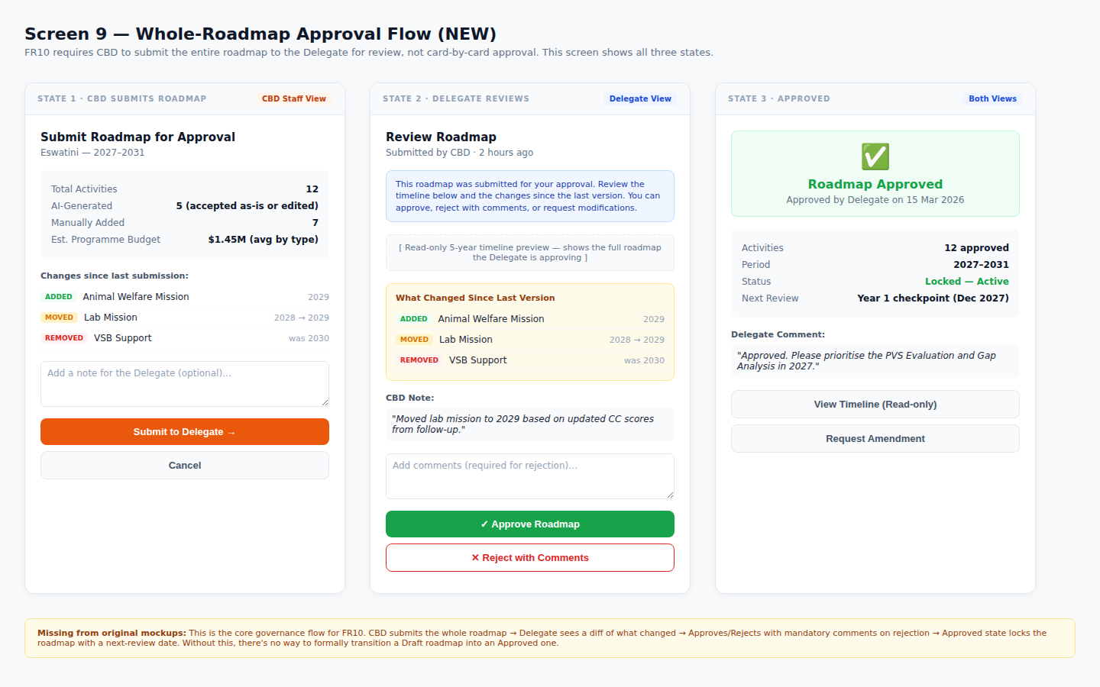
Ideal Screen 9 — CBD submit → Delegate review with diff → Approved state with lock

Screen 10 — Notifications & Reminders (NEW)
FR10 mandates automated reminders for approaching milestones and overdue activities. This screen covers three channels: a notification bell dropdown in the header bar, inline banners positioned on the relevant year column in the timeline, and the automated email template sent to Delegates.
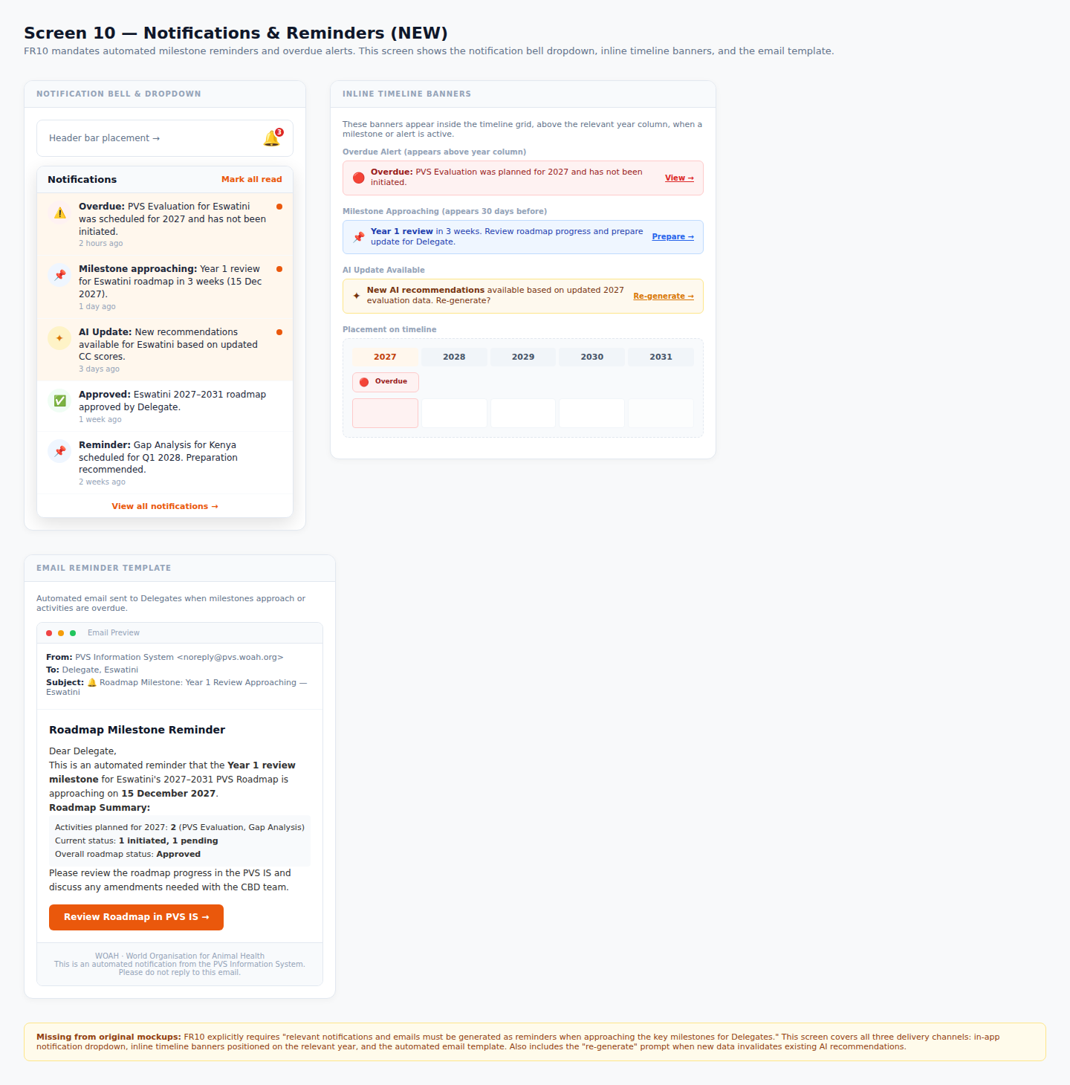
Ideal Screen 10 — Notification bell dropdown, inline timeline banners (overdue + milestone), and email template

Screen 11 — Mobile Responsive Layout (NEW)
375px viewport. The horizontal timeline is replaced with a vertical year-accordion where each year is a collapsible section with cards stacked full-width. Summary becomes a separate tab instead of a sidebar. Filter bar collapses to a single "Filters" button opening a bottom sheet. FAB for adding activities in edit mode. Year opacity fades for 4–5 to match confidence degradation. All touch targets minimum 44×44px.
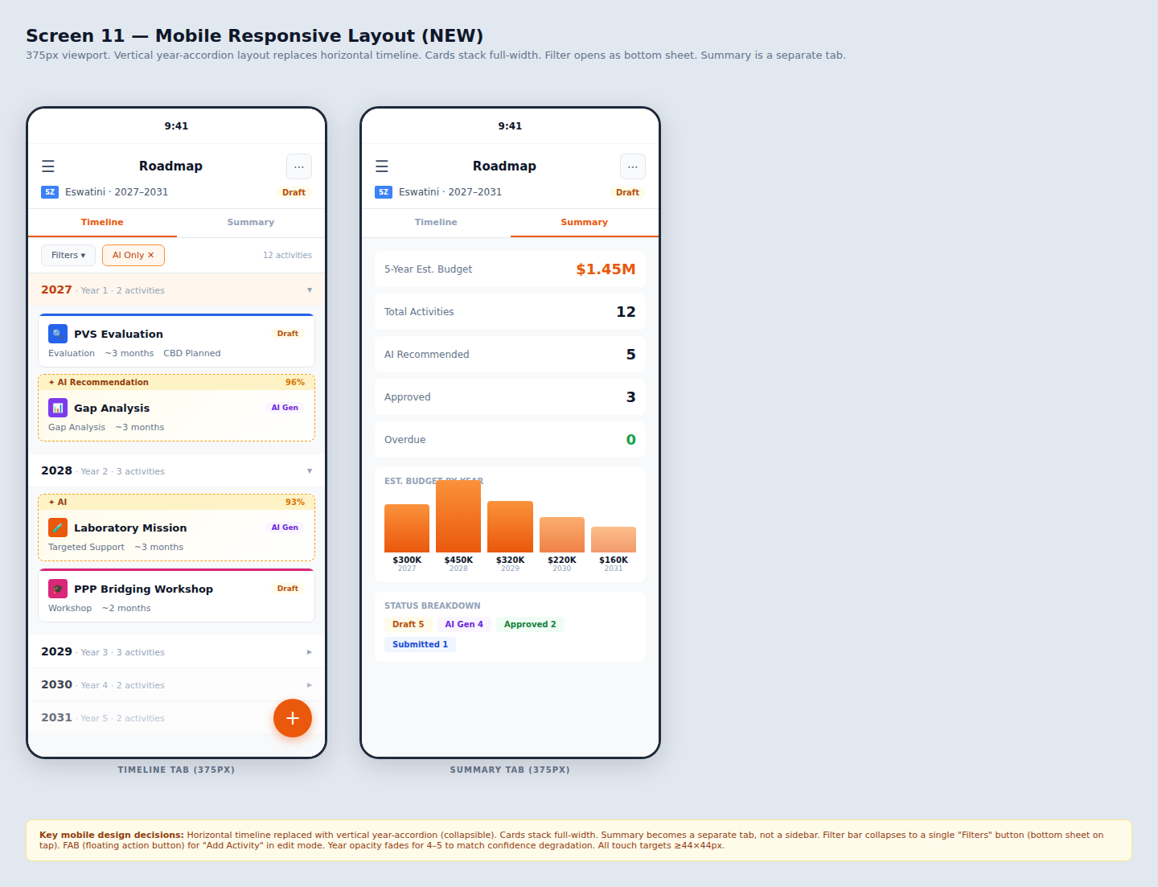
Ideal Screen 11 — Mobile at 375px: year-accordion timeline tab + summary tab, with FAB

Screen 12 — Cohort / Programme View (Spec Only)
A multi-country aggregation screen for CBD staff. Not mocked up here but must include:
- Table of all countries with active roadmaps, status, activity count, and programme-level budget estimates (derived from historical mission-type averages).
- Filters by region, status, year, mission type.
- Aggregated budget projection chart across all countries by year.
- Exportable list per FR10's requirement for "filters to produce lists for export."
- This is where the programme-level budget analytics live — not on individual country cards.

Screen 13 — Role-Based View Annotations (Spec Only)
Side-by-side annotations of the same timeline for each role:
- Delegate: Read-only timeline (unless in review mode). No "Generate Roadmap." Sees Approve/Reject on submitted roadmaps. No cohort analytics.
- CBD Staff: Full edit controls, "Generate Roadmap," all filters, "Submit to Delegate." Cannot see cohort analytics.
- Admin: Everything — all countries, cohort analytics, generate on behalf of any country.

Budget Correction — Where Budget Data Actually Belongs
FR10 says: "Analytics at the cohort level should also provide a 5-year PVS Programme projection with budgets projection, which countries should request over the next 5 years, annual budgets, breakdowns by mission type."
This means budget is a programme analytics feature, not a per-card attribute. The correction:
- Remove: Dollar amounts from individual activity cards ($150K, $180K, etc.). The LLM recommends activity types based on CC scores — it does not generate budget estimates.
- Remove: Budget range filter from the filter bar. It has nothing to filter against.
- Remove: Per-quarter budget heatmap row from the timeline.
- Keep: Annual budget totals in the summary panel, derived from historical averages by mission type (e.g. "Evaluations historically cost ~$140K–$160K").
- Keep: Budget breakdown by mission type in the summary panel.
- Add: A note on the summary panel stating "Estimates based on historical mission-type averages" so users understand the figures are projections, not confirmed budgets.
- Move: Cohort-level budget projections (all countries aggregated) to Screen 12 (Programme View).

Developer Handoff Checklist
 | Item | Priority
☐ | Replace quarterly grid with annual (5-column) model | Blocking
☐ | Remove per-activity budget from cards, inline bars, and filter bar | Blocking
☐ | Build Screen 8: Generate Roadmap flow (empty → loading → result) — use ideal-screen-8 HTML | Blocking
☐ | Build Screen 9: Whole-roadmap approval (CBD submit → Delegate review → Approved lock) — use ideal-screen-9 HTML | Blocking
☐ | Build Screen 10: Notifications (bell dropdown, inline banners, email template) — use ideal-screen-10 HTML | Blocking
☐ | Build Screen 11: Mobile responsive at 375px (year-accordion) — use ideal-screen-11 HTML | Blocking
☐ | Fix activity cards per ideal-screen-2: no budget, SVG icons, collapsible AI rationale, red Delete | Blocking
☐ | Fix sidebar navigation to be identical across all screens | Required
☐ | Replace Strategic Planning indigo with dark cyan (#0369A1) | Required
☐ | Document design tokens: type ramp, spacing scale, colour palette, radii | Required
☐ | Build Screen 12: Cohort/programme view with aggregated budget analytics | Required
☐ | Annotate role-based visibility per Screen 13 spec | Required
☐ | Mock up all status badges at Small size on grey background | Required
☐ | Show composed edit-mode screen, not 5 separated documentation sections | Required
☐ | Add confirmation dialogs for Delete, Reject, and Remove actions | Required
☐ | Define keyboard interaction spec for timeline grid (WCAG 2.1 AA) | Recommended
☐ | Add colour-blind simulation to colour spec | Recommended
☐ | Add prefers-reduced-motion kill switch for Overdue pulse animation | Recommended

Deliverables Included
The following files accompany this document. The developer should open each HTML file in a browser to inspect exact colours, spacing, and component structure.
- FR10-Design-Review.docx — this document
- ideal-screen-1-timeline.html — corrected annual timeline with summary panel (no per-activity budget)
- ideal-screen-2-cards.html — corrected activity cards (no budget, SVG icons, collapsible AI rationale, 3-width bars)
- ideal-screen-8-generate-roadmap.html — LLM generation flow (empty → loading → result)
- ideal-screen-9-approval.html — whole-roadmap approval flow (CBD submit → Delegate review → Approved)
- ideal-screen-10-notifications.html — notification bell, inline banners, email template
- ideal-screen-11-mobile.html — mobile responsive at 375px (year-accordion + summary tab)

